**READINGS and QUESTIONS: WWI and the TREATY OF VERSAILLES**

**SOURCE: AMSCO- World War One (1914-1918)**

*The sequence of events leading from peace in Europe to the outbreak of a general war occurred with stunning rapidity:*

* *SARAJEVO, June 28, 1914: A Serbian terrorist assassinates Austrian Archduke Francis Ferdinand- the heir apparent to the throne of the Austro-Hungarian Empire- and his wife.*
* *VIENNA, July 23: The Austrian government issues an ultimatum threatening war against Serbia and invades that country four days later.*
* *BERLIN, August 1: As Austria’s ally, the German government under Kaiser Wilhelm I declares war against Russia, an ally of Serbia.*
* *BERLIN, August 3: Germany declares war against France, an ally of Russia, and immediately begins an invasion of neutral Belgium because it offers the fastest route to Paris.*
* *LONDON, August 4: Great Britain, as an ally of France, declares war against Germany.*

*In the United States, the American people were shocked that the European nations were actually at war. True, since 1898, the US had acted as a major power by intervening in the Caribbean and asserting an Open Door policy in China. Yet it strongly held to the tradition begun by Washington and Jefferson of not allying the nation with any European power or becoming involved in a war on the other side of the Atlantic. President Wilson’s first response to the outbreak of the European war was therefore predictable. He issued a declaration of US neutrality and called upon the American people to support his policy by not taking sides. In trying to steer a neutral course, however, Wilson soon found that it was difficult- if not impossible- to protect US trading rights and maintains a policy that favored neither the Allied Powers (Great Britain, France, Russia) nor the Central Powers (Germany, Austria-Hungary, Ottoman Empire/Turkey). During a relatively short period (1914-1919), the US and its people rapidly moved through a wide range of roles: first as a contented neutral country, next as a country waging a war for peace, then as a victorious world power, and finally, as an alienated, isolationist nation.*

**US NEUTRALITY**

*In WWI (as in the War of 1812), the trouble for the US arose from the efforts of the belligerent powers to stop supplies from reaching the enemy. Having the stronger navy, Great Britain was the first to declare a naval blockade against Germany by mining the North Sea and seizing ships- including US ships- attempting to run the blockade. President Wilson protested British seizure of American ships as a violation of a neutral nation’s right to freedom of the seas.*

Submarine Warfare:

Germany’s one hope for challenging British power at sea lay with a new naval weapon, the submarine. In February 1915, Germany answered the British blockade by announcing a blockade of its own and warned that ships attempting to enter the “war zone” (waters near the British Isles) risked being sunk on sight by German submarines.

“LUSITANIA” CRISIS- The first major crisis challenging US neutrality and peace was the torpedoing and sinking of a British passenger liner, the *Lusitania*, on May 7, 1915. Most of the passengers drowned, including 128 Americans. Wilson responded by sending Germany a strongly worded diplomatic message warning that Germany would be held to “strict accountability” if it continued its policy of sinking unarmed ships. Secretary of State William Jennings Bryan objected to this message as too warlike and resigned from the president’s cabinet.

OTHER SINKINGS- In August 1915, two more Americans lost their lives at sea as a result of a German submarine attack on another passenger ship, the *Arabic*. This time, Wilson’s note of protests prevailed upon the German government to pledge that no other unarmed passenger ships would be sunk without warning (that is, without time being allowed for passengers to get into lifeboats). Germany kept its word until March 1916 when a German torpedo struck an unarmed merchant ship, the *Sussex*, injuring several American passengers. Wilson threatened to cut off US diplomatic relations with Germany- a step preparatory to war. Once again, rather than risk US entry into the war on the British side, Germany backed down. Its reply to the president, known as the *Sussex* pledge, promised not to sink any merchant or passenger ships without giving due warning. For the remainder of 1916, Germany was true to its word.

Economic Links with Britain and France:

*Even though the US was officially a neutral nation, its economy became closely tied to that of the Allied powers, Great Britain and France. In early 1914, before the war began, the US had been in a business recession. Soon after the outbreak of war, the economy rebounded in part because of orders for war supplies from the British and the French. By 1915, US businesses had never been so prosperous. In theory, US manufacturers could have shipped supplies to Germany as well, but the British blockade effectively prevented such trade. Wilson’s policy did not deliberately favor the Allied powers. Nevertheless, because the president more or less tolerated the British blockade while restricting Germany’s submarine blockade, US economic support was going to one side (Britain/France) and not the other. Between 1914 and 1917, US trade with the Allies quadrupled while its trade with Germany dwindled to the vanishing point.*

LOANS- In addition, when the allies found they could not fiancé the purchase of everything they needed, the US government permitted JP Morgan and other bankers to extend as much as $3 billion in secured credit to Great Britain and France. These loans maintained US prosperity, and at the same time they sustained the Allies’ war effort.

Public Opinion:

*If Wilson’s policies unintentionally favored Britain, so did the attitudes of the majority of Americans. In August 1914, as Americans read in their newspapers about German armies marching ruthlessly through Belgium, they perceived Germany as a cruel bully whose armies were commanded by a mean-spirited autocrat, Kaiser Wilhelm. This view of German ruthlessness was reinforced by the sinking of the* Lusitania *in 1915.*

ETHNIC INFLUENCES- In 1914, first and second generation immigrants made up over 30% of the US population. They were glad to be out of the fighting and strongly supported neutrality. Even so, their sympathies were committed to their nationality of origin. When Italy joined the Allies in 1915, Italian Americans began cheering on the Allies in their desperate struggle to fend off German assaults on the Western Front (entrenched positions in France). German Americans, on the other hand, strongly sympathized with the struggles of their “homeland.” Another large ethnic group, the Irish Americans, hated Britain because of its oppressive rule of Ireland. Their sympathies were openly committed to the Central Powers. Still, the great majority of native-born Americans wanted Britain and France to win the war. Positive US relations with France since the Revolutionary War bolstered public support for the French. Americans also tended to sympathize with Britain and France because of their democratic governments. President Wilson himself, as a person of Scotch-English descent, had long admired the British political system.

BRITISH WAR PROPAGANDA- Not only did Britain command the seas but it also commanded the war news that was cabled daily to US newspapers and magazines. Fully recognizing the importance of influencing US public opinion, the British government made sure the American press was well supplied with stories of German soldiers committing atrocities in Belgium and the German-occupied part of eastern France.

**THE WAR DEBATE**

*After the* Lusitania*, a small but vocal minority of influential Republicans from the East- including Teddy Roosevelt- argued for US entry into the war against Germany. The majority of Americans, however, were thankful for a booming economy and peace.*

Preparedness:

Eastern Republicans like Roosevelt were the first to recognize that the US Army and Navy were hopelessly unprepared for a major war. They clamored for “preparedness” (greater defense expenditures) soon after the European war broke out. Leading the campaign was the National Security League, organized by a group of business leaders to promote preparedness and to extend direct US aid to the Allies, if needed. At first, President Wilson opposed the call for preparedness, but in late 1915, he changed his policy and urged Congress to approve an ambitious expansion of the armed forces. The president’s proposal provoked a storm of controversy, especially among Democrats who until then were largely opposed to military increases. After a nationwide speaking tour on behalf of preparedness, Wilson finally convinced Congress to pass the National Defense Act in June 1916, which increased the regular army to a force of nearly 175,000. A month later, Congress approved the construction of more than 50 warships (battleships, cruisers, destroyers, and submarines) in just one year.

Opposition to War:

Many Americans, esp. in the Midwest/West, were adamantly opposed to preparedness, fearing that it would soon lead to US involvement in the war. The antiwar activists included Populists, Progressives, and Socialists. Leaders among the peace-minded Progressives were William Jennings Bryan, Jane Addams, and Jeanette Rankin- (1st woman elected to Congress). Woman suffragists actively campaigned against any military buildup (after the US declaration of war in 1917, they would loyally support the war effort).

The Election of 1916:

President Wilson was well aware that, as a Democrat, he had won election to the presidency in 1912 only because of the split in Republican ranks between Taft conservatives and Roosevelt Progressives. Despite his own Progressive record, Wilson’s changes for reelection did not seem strong after Theodore Roosevelt declined the Progressive party’s nomination for president in 1916 and rejoined the Republicans (Roosevelt’s decision virtually destroyed any chance of the Progressive party surviving). Charles Evans Hughes, a Supreme Court justice/former governor of NY, became the presidential candidate of a reunited Republican Party.

“HE KEPT US OUT OF WAR”- The Democrats adopted as their campaign slogan: “He kept us out of war.” The peace sentiment in the country, Wilson’s record of Progressive leadership, and Hughes’ weakness as a candidate combined to give the president the victory in an extremely close election. Democratic strength in the South/West had overcome Republican dominance in the East.

Peace Efforts:

Wilson made repeated efforts to fulfill his party’s campaign promise to keep out of the war. Before the election, in 1915, he had sent his chief foreign policy advisor, Colonel Edward House of Texas, to London, Paris, and Berlin to negotiate a peace settlement. This mission, however, had been unsuccessful. Other efforts at mediation also were turned aside by both the Allies and the Central Powers. Finally, in January 1917, Wilson made a speech to the Senate declaring US commitment to the idea of “peace without victory.”

**DECISION FOR WAR**

*In April 1917, only one month after being sworn into office a second time, President Wilson went before Congress to ask for a declaration of war against Germany. What had happened to change his policy from neutrality to war?*

Unrestricted Submarine Warfare:

Most important in the US decision for war was a sudden chance in German military strategy. The German high command had decided in early January 1917 to resume unrestricted submarine warfare. They recognized the risk of the United States entering the war but believed that, by cutting off supplies to the Allies, Germany could win the war before Americans could react. Germany communicated its decision to the US government on January 31. A few days later, Wilson broke off US diplomatic relations with Germany.

Immediate Causes:

Wilson still hesitated, but a series of events in March 1917 as well as the president’s hopes for arranging a permanent peace in Europe convinced him that US participation in the war was now unavoidable.

ZIMMERMANN TELEGRAM- On March 1, US newspapers carried the shocking news of a secret offer made by Germany to Mexico. Intercepted by British intelligence, a telegram to Mexico from the German foreign minister, Arthur Zimmerman, proposed that Mexico ally itself with Germany in return for Germany’s pledge to help Mexico recover lost territories: Texas, New Mexico, and Arizona. The Zimmermann Telegram aroused the nationalist anger of the American people and convinced Wilson that Germany fully expected a war with the United States.

RUSSIAN REVOLUTION- Applying the principle of moral diplomacy, Wilson wanted the war to be fought for a worthy purpose: the triumph of democracy. It bothered him that one of the Allies was Russia, a nation governed by an autocratic czar. This barrier to US participation was suddenly removed on March 15, when Russian revolutionaries overthrew the czar’s government and proclaimed a republic (only later in November would the revolutionary government be taken over by Communists).

RENEWED SUBMARINE ATTACKS- In the first weeks of March, German submarines sank five unarmed US merchant ships.

Declaration of War:

On April 2, 1917, President Wilson stood before a special session of senators and representatives and solemnly asked that Congress recognize a state of war existed between Germany and the USA. His speech condemned Germany’s submarine policy as “warfare against mankind” and declared” “The world must be made safe for democracy.” On April 6, an overwhelming majority in Congress voted for a declaration of war; a few pacifists, including Robert La Follette and Jeanette Rankin, defiantly voted no.

**MOBILIZATION**

*US mobilization for war in 1917 was a race against time. It was understood that Germany was preparing to deliver a knockout blow to end the war on German terms. On land, Germany planned a major offensive against Allied lines on the Western Front; at sea, the unleashed power of German submarines could now do serious damage to British sources of supply. Could the US mobilize its vast economic resources fast enough to make a difference? That was the question Wilson and his advisers confronted in the critical early months of US involvement in war.*

Industry and Labor:

Since it would take many months to train US troops, the first American contribution to the Allies would be in shipping needed supplies: chiefly munitions (rifles/gunpowder) and food. For this purpose, Wilson created a number of war agencies staffed by volunteers. For example: Bernard Baruch, a Wall Street broker, volunteered to use his extensive contacts in industry to help win the war. Under his direction, the War Industries Board set production priorities and established centralized control over raw materials and prices. Herbert Hoover, a distinguished engineer, took charge of the Food Administration, which encouraged American households to eat less meat and bread so that more food could be shipped abroad for the French and British troops. The conservation drive paid off; in two years, US overseas shipment of food tripled. Harry Garfield volunteered to head the Fuel Administration, which directed efforts to save coal. Nonessential factories were closed, and daylight savings time went into effect for the first time. Former president William Howard Taft helped arbitrate disputes between workers and employers as head of the National War Labor Board. Labor won concessions during the way that had earlier been denied. Wages rose, the eight hour day became more common, and union membership increased.

Finance:

Paying for something as costly as war is always a huge problem. Wilson’s war government managed to raise $33 billion in two years by a combination of loans and taxes. It conducted four massive drives to convince Americans to put their savings into federal government Liberty Bonds. Congress also increased both personal income and corporate taxes and placed an excise tax on luxury goods.

Public Opinion and Civil Liberties:

The US government used techniques of both patriotic persuasion and legal intimidation to ensure public support for the war effort. Progressive journalist George Creel took charge of a propaganda agency called the Committee on Public Information, which enlisted the voluntary services of artists, writers, vaudeville performers, and movie starts to depict the heroism of the “boys” (US soldiers) and the villainy of the Kaiser. The vast amount of war propaganda created under Creel’s direction consisted of films, posters, pamphlets, and volunteer speakers- all urging Americans to watch out for German spies and to “do your bit” for the war. War hysteria and patriotic enthusiasm too often provided an excuse for nativist groups to take out their prejudices on “disloyal” minorities. Of such group, the American Protective League, mounted “Hate the Hun” campaigns and used vigilante action in attacking all things German- from the performing of Beethoven’s music to the cooking of sauerkraut.

ESPIONAGE AND SEDITION ACTS- A number of socialists and pacifists took the risk of criticizing the government’s war policy. After the passage of the Espionage Act of 1917 and the Sedition Acts in 1918, the penalty for speaking out in this way was often a stiff prison sentence. The Espionage Act provided for the imprisonment of up to 20 years for persons who either tried to incite rebellion in the armed forces or obstruct the operation of the draft. The Sedition Act went much further by prohibiting anyone from making “disloyal” or “abusive” remarks about the US government. About 2,000 people were prosecuted under these laws, half of whom were convicted and jailed. Among them was the Socialist leader, Eugene V. Debs, who was sentenced to ten years in federal prison for speaking against the war.

CASE OF “SCHENCK v. UNITED STATES”- The Supreme Court upheld the constitutionality of the Espionage acts in a case involving a man who had been imprisoned for distributing pamphlets against the draft. In 1919, Oliver Wendell Homes concluded that the right of free speech could be limited when it represented a “clear and present danger” to the public safety.

Armed Forces:

As soon as war was declared, thousands of young men voluntarily enlisted for military service. The largest number of recruits, however, were conscripted (drafted) into the army by a system requiring all men between 21 and 30 (and later between 18 and 45) to register with the government for possible induction.

SELECTIVE SERVICE ACT 1917- The system of “selective service” was devised by Secretary of War Newton D. Baker as a democratic method for ensuring that all groups in the population would be called into service. Under the Selective Service Act, passed by Congress in June 1917, about 2.8 million men were eventually called by lottery. The draftees provided over half the total of 4.7 million Americans who were issued a uniform during the war. Of these, more than 2 million were transported overseas to join the British and the French in the trenches on the Western Front.

AFRICAN AMERICANS- Racial segregation applied to the army as it did to civilian life. Almost 400,000 African Americans served in WWI in segregated units. Only a few were permitted to be officers, and all were barred from the Marine Corps. Nevertheless, WEB DuBois believed that the record of service by African Americans, fighting to “make the world safe for democracy,” would earn them equal rights at home when the war ended (his hopes, however, would be bitterly disappointed).

Effects on American Society:

All groups in American society- business and labor, women and men, immigrants and native-born- were required to adjust to the unusual demands of a wartime economy.

MORE JOBS FOR WOMEN- As men were drafted into the army, the jobs they vacated were often taken by women, thousands of whom entered the workforce for the first time. Their contributions to the war effort, both as volunteers and wage earners, finally convinced President Wilson and Congress to support the 19th Amendment.

MIGRATION OF MEXICANS AND AFRICAN AMERICANS- Job opportunities in wartime America, together with the upheavals of the revolution in Mexico, caused thousands of Mexicans to cross the border to work in agriculture and mining. Most were employed in the Southwest, but a significant number also traveled to the Midwest for factory jobs. African Americans also took advantage of job opportunities opened up by the war and migrated north.

**FIGHTING THE WAR**

*By the time the first US troops were shipped overseas in late 1917, millions of European soldiers on both sides had already been killed by murderous artillery barrages, machine-gun fire, and poison gas attacks. A second revolution in Russia by Bolsheviks (or Communists) took that nation out of the war. With no Eastern Front to divide its forces, Germany could now concentrate on one all-out push to break through Allied lines in France.*

Naval Operations:

Germany’s policy of unrestricted submarine warfare was having its intended effect. Merchant ships bound for Britain were being sunk at a staggering rate: 900,000 tons of shipping was lost in just one month (April 1917). US response to this Allied emergency was to undertake a record-setting program of ship construction. The US Navy also implemented a convoy system of armed escorts for groups of merchant ships. By the end of 1917, the system was working well enough to ensure that Britain and France would not be starved into submission.

American Expeditionary Force:

Unable to imaging the grim realities of trench warfare, US troops were eager for action. The idealism of both the troops and the public is reflected in the popular song of George M. Cohan that many were singing:

Over there, over there/ Send the word, send the word over there/

That the Yanks are coming, The Yanks are coming/The drums are rum-tumming ev’ry where-

The American Expeditionary Force (AEF) was commanded by General John J. Pershing. The first US troops to see action were used to plug weaknesses in the French and British lines, but by the summer of 1918, as American forces arrived by the hundreds of thousands, the AEF assumed independent responsibility for one segment of the Western Front.

LAST GERMAN OFFENSIVE- Enough US troops were in place in the spring of 1918 to hold the line against the last ferocious assault by German forces. At Château-Thierry on the Marne River, Americans stopped the German advance (June 1918) and struck back with a successful counterattack at Belleau Wood.

DRIVE TO VICTORY- In August, September, and October, an Allied offensive along the Meuse River and through the Argonne Forest (the Meuse-Argonne offensive) succeeded in driving an exhausted German army backward toward the German border. US troops participated in this drive at St. Mihiel- the southern sector of the Allied line. On November 11, 1918, the Germans signed an armistice in which they agreed to surrender their arms, give up much of their navy, and evacuate occupied territory.

US CASUALTIES- After only a few months of fighting, US combat deaths totaled nearly 49,000. Many more thousands died of disease, including a flu epidemic in the training camps, bringing the total US fatalities in WWI to 112, 432.

**MAKING THE PEACE**

*During the war, Woodrow Wilson never lost sight of his ambition to shape the peace settlement when the war ended. In January 1917 he had said that the US would insist on a “peace without victory.” A year later (January 1918), he presented Congress a detailed list of war aims, known as the Fourteen Points.*

The Fourteen Points:

Several of the president’s Fourteen Points related to specific territorial questions: for example, the return of Alsace and Lorraine to France and the German evacuation of Belgium in the west and Romania and Serbia in the east. Of greater significance were the following broad principles for securing the peace (the last point was the one that Wilson valued the mos. The international peace association that he envisioned would soon be named the League of Nations):

* Recognition of freedom of the seas
* An end to the practice of making secret treaties
* Reduction of national armaments
* An “impartial adjustment of all colonial claims”
* Self-determination for the various nationalities within the Austro-Hungarian empire
* “A general association of nations… for the purpose of affording mutual guarantees of political independence and territorial integrity to great and small states alike”

The Treaty of Versailles:

The peace conference following the armistice took place in the Palace of Versailles outside Paris, beginning in January 1919. Every nation that had fought on the Allied side in the war was represented. Before this, no US president had ever traveled abroad to attend a diplomatic conference, but to defend his Fourteen Points, President Wilson decided that his personal participation at Versailles was vital. Republicans criticized him for being accompanied to Paris by several Democrats, but only one Republican, whose advice was never sought.

THE “BIG FOUR”- Other heads of state at Versailles made it clear that their nations wanted both revenge against Germany and compensation in the form of indemnities and territory. They did not share Wilson’s idea of a peace without victory. David Lloyd George of Great Britain, Georges Clemenceau of France, and Vittorio Orlando of Italy met with Wilson almost daily to compromise on most of his Fourteen Points. He insisted, however, that the other delegations accept his plan for a League of Nations.

PEACE TERMS- When the peace conference adjourned in June 1919, the Treaty of Versailles including the following terms:

1. Germany was disarmed and stripped of its colonies in Asia and Africa. It was also forced to admit guilt for the war, accept French occupation of the Rhineland for 15 years, and pay a huge sum of money in reparations to Great Britain and France.
2. Applying the principle of self-determination, territories once controlled by Germany, Austria-Hungary, and Russia were taken by the Allies, independence was granted to Estonia, Latvia, Lithuania, Finland, and Poland, and the new nations of Czechoslovakia and Yugoslavia were established.
3. Signers of the treaty would join an international peacekeeping organization, the League of Nations. Article X of the covenant (charter) of the League called on each member to stand ready to protect the independence and territorial integrity of other nations.

The Battle for Reunification:

Returning to the United States, President Wilson had to win approval of two-thirds of the Senate for all parts of the Treaty of Versailles, including the League of Nations covenant. Republican senators raised objections to the League, arguing that US membership in such a body might interfere with US sovereignty and might also cause European nations to interfere in the Western Hemisphere (a violation of the Monroe Doctrine).

INCREASED PARTISANSHIP AFTER THE WAR- Wilson was partly to blame for his trouble in winning Senate ratification. He had made the mistake in October 1918 of asking the American people to vote Democratic in the midterm elections as an act of patriotic loyalty. This political appeal had backfired badly. In the 1918 election, Republicans had won a solid majority in the House and a majority of two in the Senate. Now in 1919 Wilson needed Republican cooperation in the Senate for the Treaty of Versailles to be ratified. Instead, he faced the determined hostility of a leading Senate Republican, Henry Cabot Lodge.

OPPONENTS: IRRECONCILABLES AND RESERVATIONISTS- Senators opposed to the Treaty of Versailles were divided into two groups. The irreconcilable faction, consisting of about a dozen Republican senators, could not accept US membership in the League, no matter how the covenant was worded. The reservationist faction, a larger group led by Senator Lodge, said they could accept the League if certain reservations were added to the covenant. Wilson had the option of either accepting Lodge’s reservations or fighting for the treaty as it stood. He chose to fight.

WILSON’S WESTERN TOUR AND BREAKDOWN- Believing that his policy could prevail if he could personally rally public support, Wilson boarded a train and went on an arduous speaking tour to the West to make speeches for the League of Nations. On September 23, 1919, he collapsed after delivering a speech in Colorado. He returned to Washington and a few days later suffered a massive stroke from which he never fully recovered.

REJECTION OF THE TREATY- The Senate voted twice on the treaty questions in November 1919. The treaty was defeated both times, with and without reservations. In 1920, a number of Democrats joined the reservationists Republicans in voting for the treaty *with* reservations. The ailing Wilson directed his loyal supporters to reject any reservations, and they joined with the irreconcilables in defeating the treaty. Not until after Wilson left office in 1921 did the United States officially end the war and make a separate peace with Germany. It never ratified the Treaty of Versailles, nor did it ever join the League of Nations.

**POSTWAR PROBLEMS**

Demobilization:

During the war, 4 million American men had been taken from civilian life and the domestic economy. Now, suddenly, they were back home and out of uniform. Not all the returning soldiers could find jobs right away, but many who did took employment from the women and African Americans who, for a short time, had thrived on war work. The business boom of wartime also went flat, as factory orders for war production fell off. With European farm products back on the market, US farmers suffered from falling prices. In the cities, consumers went on a buying spree leading to inflation and a short boom in 1920. The spree did not last. In 1921, business plunged into a recession, and 10% of the American workforce was unemployed.

The Red Scare:

In 1919, there was widespread unhappiness with the peace process and also growing fears of socialism fueled by the Communist takeover in Russia and labor unrest at home. The anti-Germany hysteria of the war years turned suddenly into anti-Communist hysteria known as the Red Scare.

PALMER RAIDS- A series of unexplained bombings caused Attorney General A. Mitchell Palmer to establish a special office under J. Edgar Hoover to gather information on radicals. Palmer also ordered mass arrests of anarchists, Socialists, and labor agitators. From November 1919 through January 1920, over 6,000 people were arrested, based on limited criminal evidence. Most of the suspects were foreign born, and 500 of them, including the outspoken radical Emma Goldman, were deported. The scare faded almost as quickly as it arose. Palmer warned of huge riots on May Day, 1920, but they never took place. His loss of credibility coupled with rising concerns about civil liberties, caused the hysteria to recede.

Labor Conflict:

In a nation that valued free enterprise and rugged individualism, a large part of the American public regarded unions with distrust. Their antiunion attitude softened during the Progressive era. Factory workers and their unions were offered a square deal under Theodore Roosevelt and protection from lawsuits under the Clayton Antitrust Act of 1914. During the war, unions made important gains. In the postwar period, however, a series of strikes in 1919 as well as fear of revolution turned public opinion against unions.

STRIKES OF 1919- The first major strike of 1919 was in Seattle in February. Some 60,000 unionists joined shipyard workers in a peaceful strike for higher pay. Troops were called out, but there was no violence. In Boston, in September, police went on strike to protest the firing of a few police officers who tried to unionize. Massachusetts Governor Calvin Coolidge sent in the National Guard to break the strike. Also in September, workers for the US Steel Corporation struck. State and federal troops were called out and, after considerable violence, the strike was broken in January 1920.

Race Riots:

The migration of African Americans to northern cities during the war increased racial tensions. Whites resented the increased competition for jobs and housing. During the war, race riots had erupted, the largest in East St. Louis, Illinois, in 1917. In 1919, racial tensions led to violence in many cities. The worst riot was in Chicago, where 40 people were killed and 500 were injured. Conditions were no better in the South, as racial prejudice and fears of returning African American soldiers led to an increase in racial violence and lynchings by whites.

**The Treaty of Versailles- The Peace that Failed**

THE UNITED STATES AND THE LEAGUE OF NATIONS

*The US became a world power as a result of overseas expansion in the years of American imperialism at the turn of the century. Puerto Rico, Guam, and the Philippines were acquired at the end of the Spanish-American War. The “open-door” policy asserted American influence in Asia. And the decade preceding World War I saw the US flaunting its new might in Mexico, the Caribbean, and northern South America. But the US still was not a major world power and studiously avoided involvement in the affairs of sophisticated European nations. WWI, however, forced America to take an active political role throughout the world. Initially neutral, limiting its assistance to trade, loans, and supplies to the belligerent countries, the US in 1917 entered the war on the Allies side. The Central Powers did not have that long history of cultural and political ties with the US that the Allied countries had enjoyed; and after the reports of German atrocities in the invasion of Belgium, and the continuation of Germany’s policy of unrestricted submarine warfare, American sentiments were decidedly drawn toward the Allies. To President Wilson it seemed impossible to preserve American honor and still remain at peace; and, though some Americans believed that the US should enter the war to protect American interests, in President Wilson’s view, “We entered the war as the disinterested champions of right.” It was with this same idealism that President Wilson pressed for a “just peace” at the Versailles peace conference following the war. Wilson championed all the principles he had stated in his Fourteen Points, hoping that the statesmen gathered at Versailles would base their settlements on such ideals as self-determination for all peoples, no secret diplomacy, freedom of the seas and trade, and reduction of armaments. But, as many of these principles were either rejected or drastically modified during the peace negotiations, Wilson worked even harder to have his 14th point, a “general association of nations,” or the League of Nations, as it came to be called, written into the final treaty. In this, he was successful. The American people and the US Senate, however, proved even harder to convince than the statesmen at Versailles. When President Wilson returned to the US in June, 1919, he found that strong opposition to the League of Nations had already solidified, both across the nation and within the Senate. Among the people generally, some opposition came from isolationists who objected to further US involvement in European affairs. Other resistance stemmed from citizens who opposed Wilson for personal or partisan reasons. And opposition also came from people who felt that the Versailles Treaty was either too harsh or too lenient toward the defeated Central Powers. Within the Senate, opposition came from two main groups. One group, called the “irreconcibles” and led by Senators Borah, Johnson, Knox, and LaFollete, rigidly opposed Wilson and the League of Nations because of either isolationist or partisan sentiments or both. Another group, led by Senator Lodge, opposed the League in part but was willing to vote for it with certain reservations or limiting conditions. President Wilson, however, was just as rigidly for the League as the irreconcibles were against it. He looked upon every proposed reservation as a nullification of the treaty, and absolutely refused compromise. The readings for this chapter represent the major points of view which were presented for and against the League of Nations Covenant and for and against reservations to the Covenant during the long and bitter Senate debates that followed. Conflict over Article X, which required members of the League to “respect and preserve as against external aggression the territorial integrity and existing political independence of all members of the League,” was especially intense. In the end, President Wilson failed to win the necessary support for the League. In November 1919, and then again by a final vote in March 1920, the Senate rejected the Versailles Treaty and the League of Nations Covenant, both with and without reservations. The majority of Americans, it seemed, were still unwilling to abandon the tradition of isolationism which the country had followed and to assume the burdensome and hazardous role of a world leader.*

The 14 Points: Toward a New World Politics- from Woodrow Wilson’s Address to Congress Jan 18, 1918:

*Woodrow Wilson was at once a strong, efficient war President and the chief evangelist of the Allied cause. In his speeches the war was transformed from a bitter, grinding struggle for power into a noble crusade for liberty, democracy, and permanent peace. There was nothing cynical in Wilson’s appeals. He was deeply persuaded that he voiced the ideals of America, of “liberals and friends of humanity in every nation,” and indeed of “the silent mass of mankind everywhere who have as yet had no place or opportunity to speak their real hearts out concerning the death and ruin they seem to have come already upon the persons and the homes they hold most dear.” Wilson’s peace aims were developed in a long series of speeches and public papers from 1914 to 1918. The “Fourteen Points” enumerated in an address to Congress (Jan 8, 1918) provided a memorable summary that would be circulated among the peoples of Europe in millions of leaflets. The Allies were strengthened and the Central Powers weakened by this stirring promise of a new world order, based on open diplomacy, freedom of the seas, free economic exchange, national self-determination, colonial reform, and a League of Nations to maintain the peace.*

*By the fall of 1918 the Allied armies, reinforced by fresh American contingents, were advancing toward the German border. Political discontent was rising inside Germany. The Berlin government opened negotiations with Wilson for a peace on the basis of the Fourteen Points. The President’s insistence on a change of government in Germany was met on November 9, when the Kaiser abdicated. On November 11, 1917, the Allied high command imposed armistice terms that made further German resistance impossible. Under pressure from the US, England and France offered to base the peace negotiation on the Fourteen Points, but they entered two major qualifications. France declared its right to collect war reparations from Germany, and England refused to commit itself to the principle of freedom of the seas. The Fourteen Points were further undermined by a set of secret treaties among the Allies providing for a division of the spoils of victory. In December 1918, Woodrow Wilson sailed for Paris with the high ambition of writing his Fourteen Points- and principally the League of Nations scheme- into the peace treaty.*

… We entered this war because violations of right had occurred which touched us to the quick and made the life of our people impossible unless they were corrected and the world secured once for all against their recurrence. What we demand in this war, therefore, is nothing peculiar to ourselves. It is that the world be made fit and safe to live in; and particularly that it be made safe for every peace-loving nation, which, like our own, wishes to live its own life, determine its own institutions, be assured of justice and fair dealing by the other peoples of the world as against force and selfish aggression. All the peoples of the world are in effect partners in this interest, and for our own part we see very clearly that unless justice be done to others it will not be done to us. The program of the world’s peace, therefore, is our program; and that program, the only possible program, as we see it, is this:

Open covenants of peace, openly arrived at, after which there shall be no private international understandings of any kind but diplomacy shall proceed always frankly and in the public eye.

Absolute freedom of navigation upon the seas, outside territorial waters, alike in peace and in war, except as the seas may be closed in whole or in part by international action for the enforcement of international covenants.

The removal, so far as possible, of all economic barriers and the establishment of an equality of trade conditions among all the nations consenting to the peace and associating themselves for its maintenance.

Adequate guarantees given and taken that national armaments will be reduced to the lowest point consistent with domestic safety.

A free, open-minded, and absolutely impartial adjustment of all colonial claims, based upon a strict observance of the principle that in determining all such questions of sovereignty the interests of the populations concerned must have equal weight with the equitable claims of the government whose title is to be determined.

The evacuation of all Russian territory and such a settlement of all questions affecting Russia as will secure the best and freest cooperation of the other nations of the world in obtaining for her an unhampered and unembarrassed opportunity for the independent determination of her own political development and national policy and assure her of a sincere welcome into the society of free nations under institutions of her own choosing; and, more than a welcome, assistance also of every kind that she may need and may herself desire. The treatment accorded Russia by her sister nations in the months to come will be the acid test of their good will, of their comprehension of her needs as distinguished from their own interests, and of their intelligent and unselfish sympathy.

Belgium, the whole world will agree, must be evacuated and restored, without any attempt to limit the sovereignty which she enjoys in common with all other free nations. No other single act will serve as this will serve to restore confidence among the nations in the laws which they have themselves set and determined for the government of their relations with one another. Without this healing act the whole structure and validity of international law is forever impaired.

All French territory should be freed and the invaded portions restored, and the wrong done to France by Prussia in 1871 in the matter of Alsace-Lorraine, which has unsettled the peace of the world for nearly 50 years, should be righted, in order that peace may once more be made secure in the interest of all.

A readjustment of the frontiers of Italy should be effected along clearly recognizable lines of nationality.

The peoples of Austria-Hungary, whose place among the nations we wish to see safeguarded and assured, should be accorded the freest opportunity of autonomous development.

Romania, Serbia, and Montenegro should be evacuated; occupied territories restored; Serbia accorded free and secure access to the sea; and the relations of the several Balkan states to one another determined by friendly counsel along historically established lines of allegiance and nationality; and international guarantees of the political and economic independence and territorial integrity of the several Balkan states should be entered into.

The Turkish portions of the present Ottoman Empire should be assured a secure sovereignty, but the other nationalists which are now under Turkish rule should be assured an undoubted security of life and an absolutely unmolested opportunity of autonomous development, and the Dardanelles should be permanently opened as a free passage to the ships and commerce of all nations under international guarantees.

An independent Polish state should be erected which should include the territories inhabited by indisputably Polish populations, which should be assured a free and secure access to the sea, and whose political and economic independence and territorial integrity should be permanently opened as a free passage to the ships and commerce of all nations under international guarantees.

A general association of nations must be formed under specific covenants for the purpose of affording mutual guarantees of political independence and territorial integrity to great and small states alike.

In regard to these essential rectifications of wrong and assertions of right we feel ourselves to be intimate partners of all the governments and peoples associated together against the Imperialists. We cannot be separated in interest or divided in purpose. We stand together until the end. For such arrangements and covenants we are willing to fight and to continue to fight until they are achieved; but only because we wish the right to prevail and desire a just and stable peace such as can be secured only by removing the chief provocations of war, which this program does remove. We have no jealousy of German greatness, and there is nothing in this program that impairs it. We grudge her no achievement or distinction of learning or of pacific enterprise such as have made her record very bright and very enviable. We do not wish to injure her or to block in any way her legitimate influence or power. We do not wish to fight her either with arms or with hostile arrangements of trade if she is willing to associate herself with us and the other peace-loving nations of the world in covenants of justice and law and fair dealing. We wish her only to accept a place of equality among the peoples of the world- the new world in which we now live- instead of a place of mastery.

Neither do we presume to suggest to her any alteration or modification of her institutions. But it is necessary, we must frankly say, and necessary as a preliminary to any intelligent dealings with her on our part, that we should know whom her spokesmen speak for when they speak to us, whether for the Reichstag majority or for the military party and the men whose creed is imperial dominations.

We have spoken now, surely, in terms too concrete to admit of any further doubt or question. An evident principle runs through the whole program I have outlined. It is the principle of justice to all peoples and nationalities, and their right to live on equal terms of liberty and safety with one another, whether they by strong or weak. Unless this principle be made its foundation no part of the structure of international justice can stand. The people of the United States could act upon no other principle; and to the vindication of this principle they are ready to devote their lives, their honor, and everything that they possess. The moral climax of this the culminating and final war for human liberty has come, and they are ready to put their own strength, their own highest purpose, their own integrity and devotion to the test.

The League of Nations: Perpetual Peace from Woodrow Wilson, Address to the US Senate July 10, 1919:

*Woodrow Wilson justified his neutrality policy of 1914-1917 and his war policy of 1917-1918 as the means to a great end: the creation of a new order among nations. The military victory over Germany November 1918meant for Wilson not the completion but only the beginning of his task. “What of our pledges to the men that lie dead in France? We said that they went over there, not to prove the prowess of America or her readiness for another war but to see to it that there never was such a war again.” Perhaps it is precisely Wilson’s sense of mission, of speaking for “the silent mass of mankind,” that best explains both his successes and his failures in the rough political battles in Paris and Washington over the peace settlement. General Jan Smults called Wilson “the nobles figure… in the history of the war.” The unsentimental French leader Georges Clemenceau allegedly complained that “talking to Wilson is something like talking to Jesus Christ!” The two judgments are not unrelated. Worried about legislative support in the approaching peace negotiations, the President appealed for a Democratic Congress in the midterm elections of 1918. The move boomeranged. The opposition party captured both houses, and Republican leaders who had supported the administration through the war resented the President’s partisan tactic. Wilson further weakened his position at home by slighting two powerful bodies, the Republican Party and the Senate, in his selection of the American Peace Commission. If the country had not repudiated a Wilsonian peace settlement in advance, the disaffected Republican Senate leadership had done so.*

*The Paris Peace Conference began its work in January 1919 under the direction of the Big Four delegates: Wilson, David Lloyd George of Great Britain, Georges Clemenceau of France, and Vittorio Orlando of Italy. Wilson’s dogged fight for his Fourteen Points moderated to some degree the final terms of the Treaty of Versailles, which was signed protestingly by the German delegates on June 28, 1919. But major provisions of the treaty declared German war guilt, expropriated Germany’s colonial empire, assigned Alsace-Lorraine and (provisionally) the Saar basin to France, carved away additional territories to form the buffer states of Poland and Czechoslovakia, demilitarized Germany, and exacted reparations for war damage. Supplementary treaties redrew the Balkan map, chiefly at the expense of the old Austro-Hungarian Empire. Wilson managed to swallow many provisions that seemed to him vindictive and unjust in order to gain acceptance of the League of Nations Covenant as an integral part of the Treaty. “It was not easy,” Wilson reported to the Senate (July 10, 1919), “to graft the new order of ideas on the old, and some of the fruits of the grafting may, I fear, for a time be bitter.” Compromise was necessary. And it could be justified by the creation of “such a continuing concert of free nations as would make wars of aggression and spoliation… forever impossible.”*

*The League Covenant provided for an international organization consisting of an Assembly to represent all member nations, a Council controlled by the great powers, a permanent Secretariat, and a separate Permanent Court of International Justice. Under the Covenant the members were pledged to seek disarmament, to arbitrate their difference, and to act together against aggressors or covenant-breakers within the League. This system of “collective security” represented to Wilson a radically new basis for world politics: “the terror that lay concealed in every Balance of Power must not end in a mere victory of arms and a new balance.”*

GENTLEMEN OF THE SENATE:

The treaty of peace with Germany was signed at Versailles on the 28th of June. I avail myself of the earliest opportunity to lay the treaty before you for ratification and to inform you with regard to the work of the Conference by which that treaty was formulated…

In one sense, no doubt, there is no need that I should report to you what was attempted and done at Paris. You have been daily cognizant of what was going on there- of the problems with which the Peace Conference had to deal and of the difficulty of laying down straight lines of settlement anywhere on a field on which the old lines of international relationship, and the new alike, followed so intricate a pattern and were for the most part cut so deep by historical circumstances which eliminated action even where it would have been best to ignore or reverse them. The cross currents of politics and of interest must have been evident to you. It would be presuming in me to attempt to explain the questions which arose or the many diverse elements that entered into them. I shall attempt something less ambitious than that and more clearly suggested by my duty to report to the Congress the part it seemed necessary for my colleagues and me to play as the representatives of the Government of the United States.

That part was dictated by the role America had played in the war and by the expectations that had been created in the minds of the peoples with whom we had associated ourselves in that great struggle. The US entered the war upon a different footing from every other nation except our associates on this side of the sea. We entered it, not because our material interests were directly threatened or because any special treaty obligation to which we were parties had been violated, but only because we saw the supremacy, and even the validity, of right everywhere put in jeopardy and free government likely to be everywhere imperiled by the intolerable aggression of a power which respected neither right nor obligation and whose very system of government flouted the rights of the citizen as against the autocratic authority of his governors. And in the settlements of the peace we have sought no special reparation for ourselves, but only the restoration of right and the assurance of liberty everywhere that the effects of the settlement were to be felt. We entered the war as the disinterested champions of right and we interested ourselves in the terms of the peace in no other capacity.

The hopes of the nations allied against the Central Powers were at a very low ebb when our soldiers began to pour across the sea. There was everywhere amongst them, except in their stoutest spirits, a somber foreboding of disaster. The war ended in November, 8 months ago, but you have only to recall what was feared in midsummer last, 4 short months before the armistice, to realize what it was that our timely aid accomplished alike for their morale and their physical safety. That first, never-to-be-forgotten action at Chateau-Thierry had already taken place. Our redoubtable soldiers and marines had already closed the gap the enemy had succeeded in opening for their advance upon Paris- had already turned the tide of battle back towards the frontiers of France and began the rout that was to save Europe and the world. Thereafter the Germans were to be always forced back, back, were never to thrust successfully forward again. And yet there was no confident hope. Anxious men and women, leading spirits of France, attended the celebration of the Fourth of July last year in Paris out of generous courtesy- with no heart for festivity, little zest for hope. But they came away with something new at their hearts; they have themselves told us so. The mere sight of our men- of their vigor, of the confidence that showed itself in every movement of their stalwart figures and every turn of their swinging march, in their steady comprehending eyes and easy discipline, in the indomitable air that added spirit to everything they did- made everyone who saw them that memorable day realize that something had happened that was much more than a mere incident in the fighting, something very different from the mere arrival of fresh troops. A great moral force had flung itself into the struggle. The fine physical force of those spirited men spoke of something more than bodily vigor. They carried the great ideals of a free people at their hearts and with that vision were unconquerable. Their very presence brought reassurance; their fighting made victory certain.

They were recognized as crusaders, and as their thousands swelled to millions their strength was seen to mean salvation. And they were fit men to carry such a hope and make good the assurance it forecast. Finer men never went into battle; and their officers were worthy of them. This is not the occasion upon which to utter a eulogy of the armies America sent to France, but perhaps, since I am speaking of their mission, I may speak also of the pride I shared with every American who saw or dealt with them there. They were the sort of men America would wish to be represented by; the sort of men every American would wish to claim as fellow countrymen and comrades in a great cause. They were terrible in battle, and gentle and helpful out of it, remembering the mothers and the sisters, the wives and the little children at home. They were free men under arms, not forgetting their ideals of duty in the midst of tasks of violence. I am proud to have had the privilege of being associated with them and of calling myself their leader.

But I speak now of what they meant to the men by whose sides they fought and to the people with whom they mingled with such utter simplicity, as friends who asked only to be of service. They were for all the visible embodiment of America. What they did made America and all that she stood for a living reality in the thoughts not only of the people of France but also of tens of millions of men and women throughout all the toiling nations of a world standing everywhere in peril of its freedom and of the loss of everything it held dear, in deadly fear that its bonds were never to be loosed, its hopes forever to be mocked and disappointed.

And the compulsion of what they stood for was upon us who represented America at the peace table. It was our duty to see to it that every decision we took part in contributed, so far as we were able to influence it, to quiet the fears and realize the hopes of the peoples who had been living in that shadow, the nations that had come by our assistance to their freedom. It was our duty to do everything that was within our power to do to make the triumph of freedom and of right a lasting triumph in the assurance of which men everywhere live without fear.

Old entanglements of every kind stood in the way- promises which Governments had made to one another in the days when might and right were confused and the power of the victor was without restraint. Engagements which contemplated any dispositions of territory, any extensions of sovereignty that might seem to be to the interest of those who had the power to insist upon them, had been entered into without though of what the peoples concerned might wish of profit by; and these could not always be honorably brushed aside. It was not easy to graft the new order of ideas on the old, and some of the fruits of the grafting may, I fear, for a time be bitter. But, with very few exceptions, the men who sat with us at the peace table desired as sincerely as we did to get away from the bad influences, the illegitimate purposes, the demoralizing ambitions, the international counsels and expedients out of which the sinister designs of Germany had sprung as a natural growth.

It had been our privilege to formulate the principles which were accepted as the basis of the peace, but they had been accepted, not because we had come in to hasten and assure the victory and insisted upon them, but because they were readily acceded to as the principles to which honorable and enlightened minds everywhere had been bred. They spoke the conscience of the world as well as the conscience of America, and I am happy to pay my tribute of respect and gratitude to the able, forward-looking men with whom it was my privilege to cooperate for their unfailing spirit of cooperation, their constant effort to accommodate the interests they represented to the principles we were all agreed upon. The difficulties, which were many, lay in the circumstances, not often in the men. Almost without exception the men who led had caught the true and full vision of the problem of peace as an indivisible whole, a problem, not of mere adjustments of interest, but of justice and right action.

The atmosphere in which the Conference worked seemed created, not by the ambitions of strong governments, but by the hopes and aspirations of small nations and of peoples hitherto under bondage to the power that victory had shattered and destroyed. Two great empires had been forced into political bankruptcy, and we were the receivers. Our task was not only to make peace with the Central Empires and remedy the wrongs their armies had done. The Central Empires had lived in open violation of many of the very rights for which the war had been fought, dominating alien peoples over whom they had no natural right to rule, enforcing, not obedience, but veritable bondage, exploiting those who were weak for the benefit of those who were masters and overlords only by force of arms. There could be no peace until the whole order of Central Europe was set right.

That meant that new nations were to be created- Poland, Czechoslovakia, Hungary itself. No part of ancient Poland had ever in any true sense become a part of Germany, or of Austria, or of Russia. Bohemia was alien in every thought and hope to the monarchy of which she had so long been an artificial part; and the uneasy partnership between Austria and Hungary had been one rather of interest than of kinship or sympathy. The Slavs whom Austria had chosen to force into her empire on the south were kept to their obedience by nothing but fear. Their hearts were with their kinsmen in the Balkans. These were all arrangements of power, not arrangements of natural union or association. It was the imperative task of those who would make peace and make it intelligently to establish a new order which would rest upon the free choice of peoples rather than upon the arbitrary authority of Hapsburgs or Hohenzollerns.

More than that, great populations bound by sympathy and actual kin to Romania were also linked against their will to the conglomerate Austro-Hungarian monarchy or to other alien sovereignties, and it was part of the task of peace to make a new Romania as well as a new Slavic state clustering about Serbia.

And no natural frontiers could be found to these new fields of adjustment and redemption. It was necessary to look constantly forward to other related tasks. The German colonies were to be disposed of. They had not been governed; they had been exploited merely, without thought of the interest or even the ordinary human rights of their inhabitants.

The Turkish Empire, moreover, had fallen apart, as the Austro-Hungarian had. It had never had any real unity. It had been held together only by pitiless, inhuman forces. Its peoples cried aloud for release, for succor from unspeakable distress, for all that the new day of hope seemed at last to bring within its dawn. Peoples hitherto in utter darkness were to be led out into the same light and given at last a helping hand. Undeveloped peoples and peoples ready for recognition but not yet ready to assume the full responsibilities of statehood were to be given adequate guarantees of friendly protection, guidance and assistance.

And out of the execution of these great enterprises of liberty sprang opportunities to attempt what statesmen had never found the way before to do; an opportunity to throw safeguards about the rights of racial, national, and religious minorities by solemn international covenant; an opportunity to limit and regulate military establishments where they were most likely to be mischievous; an opportunity to effect a complete and systematic internalization of waterways and railways which were necessary to the free economic life of more than one nation and to clear many of the normal channels of commerce of unfair obstructions of law or of privilege; and the very welcome opportunity to secure for labor the concerted protection of definite international pledges of principle and practice.

These were not tasks which the Conference looked about to find and went out of its ways to perform. They were inseparable from the settlements of peace. They were thrust upon it by circumstances which could not be overlooked. The war had created them. In all quarters of the world old-established relationships had been disturbed or broken and affairs were at loose ends, needing to be mended or united again, but could not be made what they were before. They had to be set right by applying some uniform principle of justice or enlightened expediency. And they could not be adjusted by merely prescribing in a treaty what should be done. New states were to be set up which could not hope to live through their first period of weakness without assured support by the great nations that had consented to their creation and won for them their independence. Ill-governed colonies could not be put in the hands of governments which were to act as trustees for their people and not as their masters if there was to be no common authority among the nations to which they were to be responsible in the execution of their trust. Future international conventions with regard to the control of waterways, with regard to illicit traffic of many kinds, in arms or in deadly drugs, or with regard to the adjustment of many varying international administrative arrangements could not be assured if the treaty were to provide no permanent common international agency, if its execution in such matters was to be led to the slow and uncertain processes of cooperation by ordinary methods of negotiation. If the Peace Conference itself was to be the end of cooperative authority and common counsel among the governments to which the world was looking to enforce justice and give pledges of an enduring settlement, regions like the Saar basin could not be put under a temporary administrative regime which did not involve a transfer of political sovereignty and which contemplated a final determination of its political connections by popular vote to be taken at a distant date; no free city like Danzig could be created which was, under elaborate international guarantees, to accept exceptional obligations with regard to the use of its port and exceptional relations with a State of which it was not to form a part; properly safeguarded plebiscites could not be provided for where populations were at some future date to make choice what sovereignty they would live under; no certain and uniform method of arbitration could be secured for the settlement of anticipated difficulties of final decision with regard to many matters dealt with in the treaty itself; the long-continued supervision of the task of reparation with Germany was to undertake to complete within the next generation might entirely break down; the reconsideration and revision of administrative arrangements and restrictions which the treaty prescribed but which it was recognized might not prove of lasting advantage or entirely fair if too long enforced would be impracticable. The promises governments were making to one another about the way in which labor was to be dealt with, by law not only but in fact as well, would remain a mere humane thesis if there was to be no common tribunal of opinion and judgment to which liberal statesmen could resort for the influences which alone might secure their redemption. A league of free nations had become a practical necessity. Examine the treaty of peace and you will find that everywhere throughout its manifold provisions its farmers have felt obliged to turn to the League of Nations as an indispensable instrumentality for the maintenance of the new order it has been their purpose to set up in the world- the world of civilized men.

That there should be a League of Nations to steady the counsels and maintain the peaceful understandings of the world, to make, not treaties alone, but the accepted principles of international law as well, the actual rule of conduct among the governments of the world, had been one of the agreements accepted from the first as the basis of peace with the Central Powers. The statesmen of all the belligerent countries were agreed that such a league must be created to sustain the settlements that were to be effected. But at first I think there was a feeling among some of them that, while it must be attempted, the formation of such a league was perhaps a counsel of perfection which practical men, long experienced in the world of affairs, must agree to very cautiously and with many misgivings. It was only as the difficult work of arranging an all but universal adjustment of the world’s affairs advanced from day to day from one stage of conference to another that it became evident to them that what they were seeking would be little more than something written upon paper, to be interpreted and applied by such methods as the changes of politics might make available if they did not provide a means of common counsel which all were obliged to accept, a common authority whose decisions would be recognized as decisions which all must respect.

And so the most practical, the most skeptical among them turned more and more to the League as the authority through which international action was to be secured, the authority without which, as they had come to see it, it would be difficult to give assured effect either to this treaty or to any other international understanding upon which they were to depend for the maintenance of peace. The fact that the Covenant of the League was the first substantive part of the treaty to be worked out and agreed upon, while all else was in solution, helped to make the formulation of the rest easier. The Conference was, after all, not to be ephemeral. The concert of nations was to continue, under a definite Covenant which had been agreed upon and which all were convinced was workable. They could go forward with confidence to make arrangements intended to be permanent. The most practice of the conferees were at last the most ready to refer to the League of Nations the superintendent of all interests which did not admit of immediate determination, of all administrative problems which were to require a continuing oversight. What had seemed a counsel of perfection had come to seem a plain counsel of necessity. The League of Nations was the practical statesman’s hope of success in many of the most difficult things he was attempting.

And it had validated itself in the thought of every member of the Conference as something much bigger, much greater every way, than a mere instrument for carrying out the provisions of a particular treaty. it was universally recognized that all the peoples of the world demanded of the Conference that is should create such a continuing concert of free nations as would make wars of aggression and spoliation such as this that has just ended forever impossible. A cry had gone out from every home in every stricken land from which sons and brothers and fathers had gone forth to the great sacrifice that such a sacrifice should never again be exacted. It had been exacted because one nation desired dominion and other nations had known no means of defense except armaments and alliances. War had lain at the heart of every arrangement of the Europe- of every arrangement of the world- that preceded the war. Restive peoples had been told that fleets and armies, which they toiled to sustain, meant peace; and they now knew that they had been lied to: that fleets and armies had been maintained to promote national ambitions and meant war. They knew to no old policy meant anything else by force, force- always force. And they knew that it was intolerable. Every true heart in the world, and every enlightened judgment demanded that, at whatever cost of independent action, every government that took thought for its people or for justice or for ordered freedom should lend itself to a new purpose and utterly destroy the old order of international politics. Statesmen might see difficulties, but the people could see none and could brook no denial. A war in which they had been bled white to beat the terror that lay concealed in every Balance of Power must not end in a mere victory of arms and a new balance. The monster that had restored to arms must be put in chains that could not be broken. The united power of free nations must put a stop to aggression, and the world must be given peace. If there was not the will or the intelligence to accomplish that now, there must be another and a final war and the world must be swept clean of every power that could renew the terror. The League of Nations was not merely an instrument to adjust and remedy old wrongs under a new treaty of peace; it was the only hope for mankind. Again and again had the demon of war been cast out of the house of the peoples and the house swept clean by a treaty of peace; only to prepare a time when he would enter in again with spirits worse than himself. The house must now be given a tenant who could hold it against all such. Convenient, indeed indispensable, as statesmen found the newly planned League of Nations to be for the execution of present plans of peace and reparation, they saw it in a new aspect before their work was finished. They saw it as the main object of the peace, as the only thing that could complete it or make it worthwhile. They saw it as the hope of the world, and that hope they did not dare to disappoint. Shall we or any other free people hesitate to accept this great duty? Dare we reject it and break the heart of the world?...

America may be said to have just reached her majority as a world power. It was almost exactly 21 years ago that the results of the war with Spain put us unexpectedly in possession of rich islands on the other side of the world and brought us into association with other governments in the control of the West Indies. It was regarded as a sinister and ominous thing by the statesmen of more than one European chancellery that we should have extended our power beyond the confines of our continental dominions. They were accustomed to think of new neighbors as a new menace, of rivals as watchful enemies. There were persons amongst us at home who looked with deep disapproval and avowed anxiety on such extensions of our national authority over distant lands and over peoples whom they feared we might exploit, not serve and assist. But we have no exploited them. We have been their friends and have sought to serve them. And our dominion has been a menace to no other nation. We redeemed our honor to the utmost in our dealings with Cuba. She is weak but absolutely free; and it is her trust in us that makes her free. Weak peoples everywhere stand ready to give us any authority among them that will assure them a like friendly oversight and direction. They know that there is no ground for fear in receiving us as their mentors and guides. Our isolation was ended 21 years ago; and now fear of us is ended also, our counsel and association sought after and desired. There can be no question of our ceasing to be a world power. The only question is whether we can refuse the moral leadership that is offered us, whether we shall accept or reject the confidence of the world.

The war and the Conference of Peace now sitting in Paris seem to me to have answered that question. Our participation in the war established our position among the nations and nothing but our own mistaken action can alter it. It was not an accident or a matter of sudden choice that we are no longer isolated and devoted to a policy which has only our own interest and advantage for its object. It was our duty to go in, if we were indeed the champions of liberty and of right. We answered to the call of duty in a way so spirited so utterly without thought of what we spent of blood or treasure, so effective, so worthy of the admiration of true men everywhere, so wrought out of the stuff of all that was heroic, that the whole world saw at last, in the flesh, in noble action, a great deal asserted and vindicated, by a Nation they had deemed material and now found to be compact of the spiritual forces that must free men of every nation from every unworthy bondage. It is thus that a new role and a new responsibility have come to this great Nation that we honor and which we would all wish to lift to yet higher levels of service and achievement.

The stage is set, the destiny disclosed. It has come about by no plan of our conceiving, but by the hand of God who led us into this way. We cannot turn back. We can only go forward, with lifted eyes and freshened spirit, to follow the vision. It was of this that we dreamed at our birth. American shall in truth show the way. The light streams upon the path ahead, and nowhere else.

The League of Nations: Deformed Experiment- from Henry Cabot Lodge, Speech to US Senate, August 12, 1919:

*The struggle over American ratification of the Versailles Treaty (including the League of Nations Covenant) became a bitter duel between Woodrow Wilson and Henry Cabot Lodge of Massachusetts, Republican Chairman of the Senate Committee on Foreign Relations. While the Peace Conference was still in session, Lodge had got more than a third of the Senators to sign a “round robin” declaration condemning the original draft of the League Covenant and calling for the separation of the League proposal from the general peace settlement. The President defiantly insisted that the League must remain part of the treaty, but he did persuade the Allied delegates to revise the Covenant in accordance with Senate demands for explicit recognition of the Monroe Doctrine and for a formal arrangement under which member nations could resign.*

*Lodge was far from satisfied. For his relentless campaign against the Wilson scheme, he could call upon a substantial group of “moderates” who preferred a watered-down version of the League, and a hard core of “irreconcilables” (including Borah of Idaho, La Follette of Wisconsin, and Johnson of California), who wanted no part of an international organization. Lodge’s motives are still a matter of controversy. He claimed that he favored adherence to the League with essential reservations to protect American national interests. Critics have charged that his purpose was simply to wreck the League proposal and to humble Wilson. Lodge kept the treaty locked up in committee from July to September 1919, while opponents of the League labored to turn public sentiment against Wilson. The exhausted President decided in September 1919 to appeal from the Senate to the country. Wilson suffered a collapse in the midst of his arduous Western speaking tour and remained an invalid during the critical period of debate on the League.*

*The Republican majority in the Senate attracted fourteen reservations to the League Covenant. Their general effect was to assert the sovereign power of the US (and of Congress in particular) to determine how far we would be bound by League decisions on vital questions. The spirit of the reservations is revealed in the following selection from Senator Lodge’s speech of August 12, 1919. Wilson’s Democratic supporters combined with the “irreconcilables” to defeat the treaty with the Lodge reservations (November 19, 1919). The reservationists and the irreconcilables then voted down the treaty in its original form. A second attempt to break the stalemate in February and March of 1920 brought similar results. Depending on one’s point of view, the defeat of the League of Nations proposed in the Senate can be charged against Wilson for rigidly refusing to accept reservations (which he said would mutilate the League) or against Lodge for rigidly insisting upon his reservations (which he said would preserve American sovereignty).*

*The President, convinced that the Senate misrepresented public opinion, called for a “solemn referendum” in the 1920 elections. His party and his cause met humiliating defeat. Republican Senator Warren G. Harding, a routine Ohio politician who promised a return to “normalcy” and adroitly dodged the League question, won the presidency with an unprecedented plurality of 6 million votes. He interpreted the result as a final verdict against American membership in the League of Nations. On August 25, 1921, Congress by joint resolution officially ended the war with Germany.*

… Turn to the preamble of the covenant of the League of Nations now before us, which states the object of the league. It is formed “in order to promote international cooperation and to achieve international peace and security by the acceptance of obligations not to resort to war, by the prescription of open, just, and honorable relations between nations, by the firm establishment of the understandings of international laws as the actual rule of conduct among governments, and by the maintenance of justice and a scrupulous respect for all treaty obligations in the dealings of organized peoples with one another.”

No one would contest the loftiness or the benevolence of these purposes. Brave words, indeed! They do not differ essentially from the preamble of the Treaty of Paris, from which sprang the Holy Alliance. But the covenant of this league contains a provision which I do not find in the Treaty of Paris, and which is as follows: “The assembly may deal at its meetings with any matter within the sphere of action of the league or affecting the peace of the world.” There is no such sweeping or far-reaching provision as that in the Treaty of Paris, and yet able men developed from that treaty the Holy Alliance, which England, and later France, were forced to abandon, and which, for 35 years, was an unmitigated curse to the world…

No revolutionary movement, no internal conflict, of any magnitude can fail to affect the peace of the world. The French Revolution, which was wholly internal at the beginning, affected the peace of the world so such an extent that it brought on a world war which lasted some 25 years. Can anyone say that our Civil War did not affect the peace of the world? At this very moment, who would deny that the condition of Russia, with internal conflicts raging in all parts of that great Empire, does not affect the peace of the world and therefore come properly within the jurisdiction of the league? “Any matter affecting the peace of the world,” is a very broad statement which could be made to justify almost any interference on the part of the league with the internal affairs of other countries… If Europe desires such an alliance or league with a power of this kind, so be it. I have no objection, provided they do not interfere with the American Continents or force us against our will but bound by a moral obligation into all the quarrels of Europe. If England, abandoning the policy of Canning, desires to be a member of a league which has such powers as this, I have not a word to say. But I object in the strongest possible way to have the US agree, directly or indirectly, to be controlled by a league which may at any time, and perfectly lawfully and in accordance with the terms of the covenant, be drawn in to deal with internal conflicts in other countries, no matter what those conflicts may be. We should never permit the US to be involved in any internal conflict in another country, except by the will of her people expressed through the Congress which represents them.

With regard to wars of external aggression on a member of the league, the case is perfectly clear. There can be no genuine dispute whatever about the meaning of the first clause of Article 10. In the first place, it differs from every other obligation in being individual and place upon each nation without the intervention of the league. Each nation for itself promises to respect and preserve as against external aggression in the boundaries and the political independence of every member of the league… In Article 10 the US is bound on the appeal of any member of the league not only to respect but to preserve its independence and its boundaries, and that pledge, if we give it, must be fulfilled.

There is to me no distinction whatever in a treaty between what some persons are pleased to call legal and moral obligations. A treaty rests and must rest, except where it is imposed under duress and securities and hostages are taken for its fulfillment, upon moral obligations. No doubt a great power impossible of coercion can cast aside a moral obligation if it sees fir and escape from the performance of the duty which it promises. The pathway of dishonor is always open. I for one, however, cannot conceive of voting for a clause of which I disapprove because I know it can be escaped in that way. Whatever the US agrees to, by that agreement she must abide. Nothing could so surely destroy all prospects of the world’s peace as to have any powerful nation refuse to carry out an obligation, direct or indirect, because it rests only on moral grounds. Whatever we promise we must carry out to the full, “without mental reservation or purpose of evasion.” To me any other attitude is inconceivable. Without the most absolute and minute good faith in carrying out a treaty to which we have agreed, without ever resorting to doubtful interpretations or to the plea that it is only a moral obligation, treaties are worthless. The greatest foundation of peace is the scrupulous observance of every promise, express or implied, of every pledge, whether it can be described as legal or moral. No vote should be given to any clause in any treaty or to any treaty except in this spirit and with this understanding.

I return, then, to the first clause of Article 10. It is, I repeat, an individual obligation. It requires no action on the part of the league, except that in the second sentence the authorities of the league are to have the power to advise as to the means to be employed in order to fulfill the purpose of the first sentence. But that is a detail of execution, and I consider that we are morally and in honor bound to accept and act upon that advice. The broad fact remains that if any member of the league suffering from external aggression should appeal directly to the US for support the US would be bound to give that support in its own capacity and without reference to the action of other powers, because the US itself is bound, and I hope the day will never come when the US will not carry out its promises. If that day should come, the US or any other great country should refuse, no matter how specious the reasons, to fulfill both in letter and spirit every obligation in this covenant, the US would be dishonored and the league would crumble into dust, leaving behind it a legacy of wars. If China should rise up and attack Japan in an effort to undo the great wrong of the cession of the control of Shantung to that power, we should be bound under the terms of Article 10 to sustain Japan against China, and a guarantee of that sort is never invoked except when the question has passed beyond the stage of negotiation and has become a question for the application of force. I do not like the prospect. It shall not come into existence by any vote of mine…

Let me now briefly point out the insuperable difficulty which I find in Article 15. It begins: “If there should arise between members of the league any dispute likely to read to a rupture.” “Any dispute” covers every possible dispute. It therefore covers a dispute over tariff duties and over immigration. Suppose we have a dispute with Japan or with some European country as to immigration. I put aside tariff disputes as less important than immigration. This is not an imaginary case. Of late years there has probably been more international discussion and negotiation about questions growing out of immigration laws than any other one subject. If comes within the definition of “any dispute” at the beginning of Article 15. In the 8th paragraph of that Article it is said that “If the disputes between the parties is claimed by one of them, and is found by the council to arise out of a matter which, by international law, is solely within the domestic jurisdiction of that party, the council shall so report and shall make no recommendation as to its settlement.” That is one of the statements, of which there are several in this treaty, where words are used which it is difficult to believe their authors could have written down in seriousness. They seem to have been put in for the same purpose as what is known in natural history as protective coloring. Protective coloring is intended so to merge the animal, the bird, or the insect in its background that it will be indistinguishable from its surroundings and difficult, if not impossible, to find the elusive and hidden bird, animal, or insect. Protective coloring here is used in the form of worlds to give an impression that we are perfectly safe upon immigration and tariffs, for example, because questions which international law holds to be solely within domestic jurisdiction are not to have any recommendation from the council, but the dangers are there just the same, like the cunningly colored insect on the tree or the young bird crouching motionless upon the sand. The words and the coloring are alike intended to deceive. I wish somebody would point out to me those provisions of international law which make a list of questions which are hard and fast within the domestic jurisdiction. No such distinction can be applied to tariff duties or immigration nor indeed finally and conclusively to any subject. Have we not seen the school laws of California, most domestic of subjects, rise to the dignity of a grave international dispute? No doubt both import duties and immigration are primarily domestic questions, but they both constantly involve and will continue to involve international effects…

If other nations are willing to subject themselves to such a domination, the US, to which many immigrants have come and many more will come, ought never to submit to it for a moment. They tell is that so far as Asiatic emigration is concerned there is not the slightest danger that will ever be forced upon us by the league, because Australia and Canada and New Zealand are equally opposed to it. I think it highly improbable that it would be forced upon us under those conditions, but it is by no means impossible. It is true the US has one vote, and that England, if you count the King of the Hedjaz, has seven- in all eight-votes; yet it might not be impossible for Japan and China and Siam to rally enough other votes to defeat us; but whether we are protected in that way or not does not matter. The very offering of that explanation accepts the jurisdiction of the league, and personally I cannot consent to putting the protection of my county and of her workingmen against undesirable immigration our of our own hands. We and we alone must say who shall come into the US and become citizens of this Republic, and no one else should have any power to utter one world in regard to it.

Article 21 says: “Nothing in this covenant shall be deemed to affect the validity of international engagements, such as treaties or arbitration or regional understandings like the Monroe Doctrine for securing the maintenance of peace…” The instant that the US, who declared, interpreted, and sustained the doctrine, ceases to be the sole judge of what it means, that instant the Monroe Doctrine ceases and disappears from history and from the face of the earth. I think it is just as undesirable to have Europe interfere in American affairs now as Mr. Monroe thought it was in 1823, and equally undesirable that we should be compelled to involve ourselves in all the wars and brawls of Europe… Why, in the name of peace, should we extinguish it? Why, in the name of peace, should we be called upon to leave the interpretation of the Monroe doctrine to other nations? It is an American policy. It is our own. It has guarded us well, and I for one can never find consent in my heart to destroy it by a clause in a treaty and hand over its body for dissection to the nations of Europe. If we need authority to demonstrate what the Monroe Doctrine has meant to the US we cannot do better than quote the worlds of Grover Cleveland, who directed Mr. Olnev to notify the world that “today the US is practically sovereign on this continent, and its fiat is law to which it confines its interposition.” Theodore Roosevelt, in the last article written before his death, warned us, his countrymen, that we are “in honor bound to keep ourselves so prepared that the Monroe Doctrine shall be accepted as immutable international law.” Grover Cleveland was a Democrat and Theodore Roosevelt was a Republican, but they were both Americans, and it is the American spirit which has carried this country always to victory and which should govern us today, and not the international spirit, which would in the name of peace hand the US over bound hand and foot to obey the fiat of other powers.

Another point in this covenant where change must be made in order to protect the safety of the US in the future is in Article 1, where withdrawal is provided for. This provision was an attempt to meet the very general objection to the first draft of the league, that there was no means of getting out of it without denouncing the treaty; that is, there was no arrangement for the withdrawal of any nation. As it now stands it reads that- “Any member of the league may, after two years’ notice of its intentions to do so, withdraw from the league, provided that all its international obligations and all its obligations under this covenant shall have been fulfilled at the time of its withdrawal.”

The right of withdrawal is given by this clause, although the time for notice, two years, is altogether too long. Six months or a year would be found, I think, in most treaties to be the normal period fixed for notice of withdrawal. But whatever virtue there may be in the right thus conferred is completely nullified by the provision. The right of withdrawal cannot be exercised until all the international obligations and all the obligations of the withdrawing nations have been fulfilled. The league alone can decided wither “all international obligations and all obligations under this covenant” have been fulfilled, and this would require, under the provisions of the league, a unanimous vote, so that any nation desiring to withdraw could not do so, even on the two years’ notice, if one nation voted that the obligations had not been fulfilled. Remember that this gives the league not only power to review all our obligations under the covenant but all our treaties with all nations, for every one of those is an “international obligation.”

Are we deliberately to put ourselves in fetters and be examined by the League of Nations as to whether we have kept faith with Cuba or Panama before we can be permitted to leave the league? This seems to me humiliating, to say the least. The right of withdrawal, if it is to be of any value whatsoever, must be absolute, because otherwise a nation desiring to withdraw could be held in the league by objections from other nations until the very act which induces the nation to withdraw have been completed, until the withdrawing nation had been forced to send troops to take part in a war with which it had no concern and upon which it did not desire to enter. It seems to me vital to the safety of the US not only that this provision should be eliminated and the right to withdraw be made absolute but that the period of withdrawal should be much reduced. As it stands it is practically no better in this respect than the first league draft, which contained no provision for withdrawal at all, because the proviso here inserted so encumbers it that every nation to all intents and purposes must remain a member of the league indefinitely unless all the other members are willing that it should retire. Such a provision as this, ostensibly framed to meet the objection, has the defect which other similar gestures to give an impression of meeting objections have, that it apparently keeps the promise to the ear but most certainly breaks it to the hope.

I have dwelt only upon those points which seem to me most dangerous. There are, of course, many others, but these points, in the interest not only of the safety of the US but of the maintenance of the treaty and the peace of the world, should be dealt with here before it is too late. Once in the league the chance of amendment is so slight that it is not worth considering. Any analysis of the provisions of this league covenant, however, brings out in startling relief one great fact. Whatever may be said, it is not a league of peace; it is an alliance, dominated at the present moment by five great powers, really by three, and it has all the marks of an alliance. The development of international law is neglected. The court which is to decide disputes brought before it fills but a small place. The conditions for which this league really provides with the utmost care are political conditions, not judicial questions, to be reached by the executive council and the assembly, purely political bodies, without any trace of a judicial character about them. Such being its machinery, the control being in the hands of political appointees whose votes will be controlled by interest and expediency, it exhibits that most marked characteristic of an alliance- that its decisions are to be carried out by force. Those articles upon which the whole structure rests are articles which provide for the use of force; that is, for war. This league to enforce peace does a great deal for enforcement and very little for peace. It makes more essential provisions looking to war than to peace for the settlement of disputes…

Taken altogether, these provisions for war present what to my mind is the gravest objection to this league in its present form. We are told that of course nothing will be done in the way of warlike acts without the assent of Congress. If that is true let us say so in the covenant. But as it stands there is no doubt whatever in my mind that American troops and American ships may be ordered to any part of the world by nations other than the US, and that is a proposition to which I for one can never assent. It must be made perfectly clear that no American soldiers, not even a corporal’s guard, that no American sailors, not even the crew of a submarine, can ever be engaged in war or ordered anywhere except by the constitutional authorities of the United States. To Congress is granted by the Constitution the right to declare war, and nothing that would take the troops out of the country at the bidding or demand of other nations should ever be permitted except through congressional action. The lives of Americans must never be sacrificed except by the will of the American people expressed through their chosen Representative in Congress. This is a point upon which no doubt can be permitted. American soldiers and American sailors have never failed the country when the country called upon them. They went in their hundreds of thousands into the war just closed. They went to die for the great cause of freedom and of civilization. They went at their service. We were late in entering the war. We made no preparation, as we ought to have done, for the ordeal which was clearly coming upon us; but we went and we turned the wavering scale. It was done by the American soldier, the American sailor, and the spirit and energy of the American people. They overrode all obstacles and all shortcomings on the part of the administration or of Congress and gave to their country a great place in the great victory. It was the first time we had been called upon to rescue the civilized world. Did we fail? On the contrary, we succeeded, succeeded largely and nobly, and we did it without any command from any League of Nations. when the emergency came we met it, and we were able to meet it because we had built up on this continent the greatest and most powerful Nation in the world, built it up under our own policies, in our own way, and one great element of our strength was the fact that we had held aloof and had not thrust ourselves into European quarrels; that we had no selfish interest to serve. We made great sacrifices. We have done splendid work. I believe that we do not require to be told by foreign nations when we shall do work which freedom and civilization require. I think we can move to victory much better under our own command than under the command of others. Let us unite with the world to promote the peaceable settlement of all international disputes. Let us try to develop international law. Let us associate ourselves with the other nations for these purposes. But let us retain in our own hands and in our own control the lives of the youth of the land. Let no American be sent into battle except by the constitutional authorities of his own country and by the will of the people of the United States…

We hear much of visions and I trust we shall continue to have visions and dream dreams of a fairer future for the race. But visions are one thing and visionaries are another, and the mechanical appliances of the rhetorician designed to give a picture of the present which does not exist and of a future which no man can predict are as unreal and short-lived as the steam or canvas clouds, the angels suspended on wires and the artificial lights of the stage. They pass with the moment of effect and are shabby and tawdry in the daylight. Let us at least be real. Washington’s entire honesty of mind and his fearless look into the face of all facts are qualities which can never go out of fashion and which we should all do well to imitate.

Ideals have been thrust upon us as an argument for the league until the healthy mind which rejects cant revolts from them. Are ideals confined to this deformed experiment upon a noble purpose, tainted, as it is, with bargains and tied to a peace treaty which might have been disposed of long ago to the great benefit of the world if it had not been compelled to carry this rider on its back? “Post equitem sedet atra cura,” Horace tells us, but no blacker care ever sat behind any rider than we shall find in this covenant of doubtful and disputed interpretations as it now perches upon the treaty of peace.

No doubt many excellent and patriotic people see a coming fulfillment of noble ideals in the words “League for Peace.” We all respect and share these aspirations and desires, but some of us see no hope, but rather defeat, for them in this murky covenant. For we, too, have our ideals, even if we differ from those who have tried to establish a monopoly of idealism. Our first ideal is our country, and we see her in the future, as in the past, giving service to all her people and to the world. Our ideal of the future is that she should continue to render that service of her own free will. She has great problems of her own to solve, very grim and perilous problems, and a right solution, if we can attain to it, would largely benefit mankind. We would have our country strong to resist a peril from the West, as she has flung back the German menace from the East. We would not have our politics distracted and embittered by the dissensions of other lands. We would not have our country’s vigor exhausted, or her moral force abated, by everlasting meddling and muddling in every quarrel, great and small, which afflicts the world. Our ideals is to make her stronger and better and finder, because in that way alone, as we believe, can she be of the greatest service to the world’s peace and to the welfare of mankind. [Prolonged applause in the galleries].

Closing Speech of William Borah on the League of Nations in the US Senate Nov 19, 1919

LEAGUE OF NATIONS: The Senate had under final consideration the resolution of ratification of the peace treaty.

Mr. BORAH. Mr. President, I am not misled by the debate across the aisle into the view that this treaty will not be ratified. I entertain little doubt that sooner or later—and entirely too soon—the treaty will be ratified with the League of Nations in it, and I am of the opinion with the reservations in it as they are now written. There may possibly be some change in verbiage in order that there may be a common sharing of parentage, but our friends across the aisle will likely accept the League of Nations with the reservations in substance as now written. I think, therefore, this moment is just as appropriate as any other for me to express my final views with reference to the treaty and the League of Nations. It is perhaps the last opportunity I shall have to state, as briefly as I may, my reasons for opposing the treaty and the league.

Mr. President, after Mr. Lincoln had been elected President before he assumed the duties of the office and at a time when all indications were to the effect that we would soon be in the midst of civil strife, a friend from the city of Washington wrote him for instructions. Mr. Lincoln wrote back in a single line, “Entertain no compromise; have none of it." That states the position I occupy at this time and which I have, in a humble way, occupied from the first contention in regard to this proposal.

My objections to the league have not been met by the reservations. I desire to state wherein my objections have not been met. Let us see what our attitude will be toward Europe and what our position will be with reference to the other nations of the world after we shall have entered the league with the present reservations written therein. With all due respect to those who think that they have accomplished a different thing mid challenging no man's intellectual integrity or patriotism, I do not believe the reservations have met the fundamental propositions which are involved in this contest. When the league shall have been formed, we shall be a member of what is known as the council of the league. Our accredited representative will sit in judgment with the accredited representatives of the other members of the league to pass upon the concerns not only of our country but of all Europe and all Asia and the entire world. Our accredited representatives will be members of the assembly. They will sit there to represent the judgment of these 110.000,000 of people, more then, just as we are accredited here to represent our constituencies. We cannot send our representatives to sit in council with the representatives of the other great nations of the world with mental reservations as to what we shall do in case their judgment shall not be satisfactory to us. If we go to the council or to the assembly with any other purpose than that of complying in good faith and in absolute integrity with all upon which the council or the assembly may pass, we shall soon return to our country with our self-respect forfeited and the public opinion of the world condemnatory.

Why need you gentlemen across the aisle worry about a reservation here or there, when we are sitting in the council and in the assembly and bound by every obligation in morals, which the President said was supreme above that of law, to comply with the judgment which our representative and the other representatives finally form? Shall we go there, Mr. President, to sit in judgment, and in case that judgment works for peace join with our allies, but in case it works for war withdraw our cooperation? How long would we stand as we now stand, a great Republic commanding the respect and holding the leadership of the world, if we should adopt any such course?

So, sir, we not only sit in the council and in the assembly with our accredited representatives, but bear in mind that article 11 is untouched by any reservation which has been offered here; and with article 11 untouched, and its integrity complete, article 10 is perfectly superfluous. If any war or threat of war shall be a matter of consideration for the league, and the league shall take such action as it deems wise to deal with it, what is the necessity of article 10? Will not external aggression be regarded as a war or threat of war? If the political independence of some nation in Europe is assailed will it be regarded as a war or threat of war? Is there anything in article 10 that is not completely covered by article 11? It remains complete, and with our representatives sitting in the council and the assembly, and with article 11 complete, and with the assembly and the council having jurisdiction of all matters touching the peace of the world, what more do you I need to bind the United States if you assume that the United States is a Nation of honor?

We have said, Mr. President, that we would not send our troops abroad without the consent of Congress. Pass by now for a moment the legal proposition. If we create executive functions, the Executive will perform those functions without the authority of Congress. Pass that question by and go to the other question. Our members of the council are there. Our members of the assembly are there. Article 11 is complete, and it authorizes the league, a member of which is our representative, to deal with matters of peace and war, and the league through its council and its assembly deals with the matter, and our accredited representative joins with the others in deciding upon a certain course, which involves a question of sending troops. What will the Congress of the United States do? What right will it have left, except the bare technical right to refuse, which as a moral proposition it will not dare to exercise?

Have we not been told day by day for the last nine months that the Senate of the United States, a coordinate part of the treaty-making power, should accept this league as it was written because the wise men sitting at Versailles had so written it, and has not every possible influence and every source of power in public opinion been organized and directed against the Senate to compel it to do that thing? How much stronger will be the moral compulsion upon the Congress of the United States when we ourselves have indorsed the proposition of sending our accredited representatives there to vote for us?

Ah, but you say that there must be unanimous consent, and that there is vast protection in unanimous consent. I do not wish to speak disparagingly; but has not every division and dismemberment of every nation which has suffered dismemberment taken place by unanimous consent for the last 00 years? Did not Prussia and Austria and Russia by unanimous consent divide Poland? Did not the United States and Great Britain and Japan and Italy and France divide China, and give Shantung to Japan? Was that not a unanimous decision? Close the doors upon the diplomats of Europe, let them sit in secret, give them the material to trade on, and there always will be unanimous consent.

How did Japan get unanimous consent? I want to say here, in my parting words upon this proposition, that I have no doubt the outrage upon China was quite as distasteful to the President of the United States us it is to me. But Japan said: “I will not sign your treaty unless you turn over to me Shantung, to be turned back at my discretion," and you know how Japan's discretion operates with reference to such things. And so, when we are in the league, and our accredited representatives are sitting at Geneva, and a question of great moment arises, Japan, or Russia, or Germany, or Great Britain will say, "Unless this matter is adjusted in this way I will depart from your league." It is the same thing, operating in the same way, only under a different date and under a little different circumstance.

Mr. President, if you have enough territory, if you have enough material, if you have enough subject peoples to trade upon and divide, there will be no difficulty about unanimous consent. Do our Democratic friends ever expect any man to sit as a member of the council or us a member of the assembly equal in Intellectual power and in standing before the world with that of our representative at Versailles? Do you expect a man to sit in the council who will have made more pledges, and I shall assume made them in sincerity, for self-determination and for the rights of small peoples, than had been made by our accredited representative? And yet, what became of it? The unanimous consent is obtained nevertheless.

But take another view of it. We are sending to the council one man. That one man represents 110,000,000 people. Here, sitting in the Senate, we have two from every State in the Union, and over in the other House we have Representatives in accordance with population, and though responsibility is spread out in accordance with our obligations to our constituency. But now we are transferring to one man the stupendous power of representing the sentiment and convictions of 110,000,000 people in tremendous questions which may involve the peace or may involve the war of the world. However you view the question of unanimous consent, it does not protect us.

What is the result of all this? We are in the midst of all of the affairs of Europe. We have entangled ourselves with all European concerns. We have joined in alliance with all the European nations which have thus far joined the league, and all nations which may be admitted to the league. We are sitting there dabbling in their affairs and intermeddling in their concerns. In other words, Mr. President—and this comes to the question which is fundamental with me:—we have forfeited and surrendered, once and for all, the great policy of "no entangling alliances" upon which the strength of this Republic has been founded for 150 years.

My friends of reservations, tell me where is the reservation in these articles which protects us against entangling alliances with Europe? Those who are differing over reservations, tell me what one of them protects the doctrine laid down by the Father of our Country. That fundamental proposition is surrendered, and we are a part of the European turmoils and conflicts from the time we enter this league. Let us not underestimate that. There has never been an hour since the Venezuelan difficulty that there has not been operating in this country, fed by domestic and foreign sources, a powerful propaganda for the destruction of the doctrine of no entangling alliances.

Lloyd-George is reported to have said just a few days before the conference met at Versailles that Great Britain could give up much, and would be willing to sacrifice much, to have America withdraw from that policy. That was one of the great objects of the entire-conference at Versailles, so far as the foreign representatives were concerned. Clemenceau and Lloyd-George and others like them were willing to make any reasonable sacrifice which would draw America away from her isolation and into the Internal affairs and concerns of Europe. This league of nations, with or without reservations, whatever else it does or does not do, does surrender and sacrifice that policy; and once having surrendered and become a part of the European concerns, where, my friends, are you going to stop?

You have put in here a reservation upon the Monroe doctrine. I think that, in so far as language could protect the Monroe doctrine, it has been protected. But as a practical proposition, as a working proposition, tell me candidly, as men familiar with the history of your country and of other countries, do you think that you can intermeddle in European affairs and keep Europe from intermeddling in your affairs? When Mr. Monroe wrote to Jefferson, he asked him his view upon the Monroe doctrine, and Mr. Jefferson said, in substance, our first and primary obligation should be never to interfere in European affairs; and, secondly, never to permit Europe to interfere in our affairs. He understood, as every wise and practical man understands, that if we intermeddle in her affairs, if we help to adjust her conditions, inevitably and remorselessly Europe then will be carried into our affairs, in spite of anything you can write upon paper. We cannot protect the Monroe doctrine unless we protect the basic principle upon which it rests, and that is the Washington policy. I do not care how earnestly you may endeavor to do so, as a practical working- proposition, your league will come to the United States. Will you permit me to digress long enough to read a paragraph from a great French editor upon this particular phase of the matter, Mr. Stephen Lausanne, editor of Le Matin, of Paris:

0 lure When the executive council of the league of nations fixes " the reasonable limits of the armament of Peru " ; when it shall demand Information concerning the naval program of Brazil; when it shall tell Argentina what shall be the measure of the " contribution to the armed forces to protect the signatures of the social covenant " ; when it shall demand 1 Ml the immediate registration of the treaty between the United States and, Canada at the seat of the league, it will control, whether it wills or no, the destines of America. And when the American States shall be from obliged to take a hand in every war or menace of war in Europe (art. 11), they will necessarily fall afoul of the fundamental principle laid down by Monroe, which was that Americans should never take part in a European war. If the league takes in the world, then Europe must mix in the affairs of America; if only Europe is included, then America will violate of necessity her own doctrine by intermixing in the affairs of Europe. If the league includes the affairs of the world, does it not include the affairs of all the world? Is there any limitation of the jurisdiction of the council or of the assembly upon the question of pence or war? Does it not have now, under the reservations, the same as it had before, the power to deal with all matters of peace or war throughout the entire world? How shall you keep from meddling in the affairs of Europe or keep Europe from meddling in the affairs of America?

Mr. President, there is another and even a more commanding reason why I shall record my vote against this treaty. It imperils what I conceive to be the underlying, the very first principles of this Republic. It is in conflict with the right of our people to govern themselves free from all restraint, legal or moral, of foreign powers. It challenges every tenet of my political faith. If this faith were one of my own contriving, if I stood hero to assert principles of government of my own resolve, I might well be charged with intolerable presumption, for we all recognize the ability of those who urge it different course. But I offer in justification of my course nothing of my own— save the deep and abiding reverence I have for those whose policies I humbly but most ardently support. I claim no merit save fidelity to American principles and devotion to American ideals as they were wrought out from time to time by those who built the Republic and as they have been extended and maintained throughout these years. In opposing the treaty I do nothing more than decline to renounce and tear out of my life the sacred traditions which throughout 50 years have been translated into my whole intellectual and moral being. I will not, I cannot, give up my belief that America must, not alone for the happiness of her own people, but for the moral guidance and greater contentment of the world, be permitted to live her own life. Next to the tie which binds a man to his God is the tie which binds a man to his country, and all schemes, all plans, however ambitious and fascinating they seem in their proposal, but which would embarrass or entangle and impede or shackle her sovereign will, which would compromise her freedom of action I unhesitatingly put behind me.

'" Sir, since the debate opened months ago those of us who have stood against this proposition have been taunted many times with being little Americans. Leave us the word American, keep that in your presumptuous impeachment, and no (mint can disturb us, no gibe discompose our purposes. Call us little Americans if you will, but leave us the consolation and the pride which the term American, however modified, still imparts. Take away that term and though you should coin in telling phrase your highest eulogy would hurl it back as common slander. We have been ridiculed because, forsooth, of our limited vision. Possibly that charge may be true. Who is there here that can read the future? Time, and time alone, unerring and remorseless, will give us each our proper place in the affections of our countrymen and in the esteem and commendation of those who are to come after us. We neither fear nor court her favor. But if our vision has been circumscribed it has at all times within its compass been clear and steady.

We have sought nothing save the tranquility of our own people and the honor and independence of our own Republic. No foreign flattery, no possible world glory and power have disturbed our poise or come between us and our devotion to the traditions which have made us a people or the policies which have made us a Nation, unselfish and commanding. If we have erred we have erred out of too much love for those things which from childhood you and we together have been taught to revere—yes, to defend even at the cost of limb and life. If we have erred it is because we have placed too high an estimate upon the wisdom of Washington and Jefferson, too exalted an opinion upon the patriotism of the sainted Lincoln. And blame us not therefore If we have, in our limited vision, seemed sometimes bitter and at all times uncompromising, for the things for which we have spoken, feebly spoken, the things which we have endeavored to defend have been the things for which your fathers and our fathers were willing to die.

Senators, even in an hour so big with expectancy we should not close our eyes to the fact that democracy is something more, vastly more, than a mere form of government by which society is restrained into free and orderly life. 1It is a moral entity, a spiritual force as well. And these are things which have only and alone in the atmosphere of liberty. The foundation upon which democracy rests is faith in the moral instincts of the people. Its ballot boxes, the franchise, its laws, and constitutions are but the outward manifestations of the deeper and more essential thing—a continuing trust in the moral purposes of the average man and woman. When this is lost or forfeited your outward forms, however democratic in terms, are a mockery. Force may find expression through institutions democratic in structure equal with the simple and more direct processes of a single supreme ruler. These distinguishing virtues of a real republic you cannot commingle with the discordant and destructive forces of the Old World and still preserve them. You cannot yoke a government whose fundamental maxim is that of liberty to a government whose first law is that of forced hope to preserve the former. These things are in eternal war, and one must ultimately destroy the other. You may still keep for a time the outward form, you may still delude yourself, as others have done in the past, with appearances and symbols, but when you shall have committed this Republic to a scheme of world control based upon force, upon the combined military force of the four great nations of the world, you will have soon destroyed the atmosphere of freedom, of confidence in the self-governing capacity of the masses, in which alone a democracy may thrive. We may become one of the four dictators of the world, but we shall no longer be master of our own spirit. And what shall it profit us as a Nation if we shall go forth to the dominion of the earth and share with others the glory of world control and lose that fine sense of confidence in the people, the soul of democracy.

Look upon the scene as it is now presented. Behold the task we are to assume, and then contemplate the method by which we are to deal with this task. Is the method such as to address itself to a Government "conceived in liberty and dedicated to the proposition that all men are created equal"? When this league, this combination, is formed four great powers representing the dominant people will rule one-half of the inhabitants of the globe as subject peoples—rule by force, and we shall be a party to the rule of force. There is no other way by which you can keep people in subjection. You must either give them independence, recognize their rights as nations to live their own life and to set up their own form of government, or you must deny them these things by force. That is the scheme, the method proposed by the league. It proposes no other. We will in time become inured to its inhuman precepts and its soulless methods, strange as this doctrine now seems to a free people. If we stay with our contract, we will come in time to declare with our associates that force—force, the creed of the Prussian military oligarchy—is after all the true foundation upon which must rest all stable governments. Korea, despoiled and bleeding at every pore; India, sweltering in ignorance and burdened with inhuman (even after more than a hundred years of dominant rule; Egypt, trapped and robbed of her birthright; Ireland, with 700 years of sacrifice for independence—this is the task, this is the atmosphere, and this is the creed in and under which we arc to keep alive our belief in the moral purposes and self-governing capacity of the people, a belief without which the Republic must disintegrate and die. The maxim of liberty will soon give way to the rule of blood and iron. We have been pleading here for our Constitution. Conform this league, it has been said, to the technical terms of our charter and nil will be well. But I declare to you that we must go further and conform to those sentiments and passions for justice and freedom which are essential to the existence of democracy. You must respect not territorial boundaries, not territorial integrity, but you must respect and preserve the sentiments and passions for justice and for freedom which God in his infinite wisdom has planted so deep in the human heart that no form of tyranny however brutal, no persecution however prolonged can wholly uproot and kill. Respect nationality, respect Justice, respect freedom, and you may have some hope of peace, but not so if you make  
your standard the standard of tyrants and despots, the protection of real estate regardless of how it is obtained.

Sir, we are told that this treaty means peace. Even so, I would not pay the price. Would you purchase peace at the cost of any part of our independence? We could have had peace in 1776— the price was high, but we could have had it. James Otis, Sam Adams, Hancock, and Warren were surrounded by those who wanted peace and British rule. All through that long and trying struggle, particularly when the clouds of adversity lowered upon the cause there was a cry of peace—let us have peace. We could have had peace in 1860; Lincoln was counseled by men of great influence and accredited wisdom to let our brothers— and, thank heaven, they are brothers—depart in peace. But the tender, loving Lincoln, bending under the fearful weight of impending civil war, an apostle of peace, refused to pay the price, and a reunited country will praise his name forever more—bless it because he refused peace at the price of national honor and national integrity. Peace upon any other basis than national independence, peace purchased at the cost of any part of our national integrity, is fit only for slaves, and even when purchased at such a price it is a delusion, for it cannot last.

But your treaty does not mean peace—far, very far, from it. If we are to judge the future by the past it means war. l£ there any guaranty of peace other than the guaranty which comes of the control of the war-making power by the people? Yet what great rule of democracy does the treaty leave unassailed? The people in whose keeping alone you can safely lodge the power of peace or war nowhere, at no time and in no place, have any voice in this scheme for world peace. Autocracy which has bathed the world in blood for centuries reigns supreme. Democracy is everywhere excluded. This, you say, means peace.

Can you hope for peace when love of country is disregarded in your scheme, when the spirit of nationality is rejected, even scoffed at? Yet what law of that moving and mysterious force does your treaty not deny? With a ruthlessness unparalleled your treaty in a dozen instances runs counter to the divine law of nationality. Peoples who speak the same language, kneel at the same ancestral tombs, moved by the same traditions, animated by a common hope, are torn asunder, broken in pieces, divided, and parceled out to antagonistic nations. And this you call justice. This, you cry, means peace. Peoples who have dreamed of independence, struggled and been patient, sacrificed and been hopeful, peoples who were told that through this peace conference they should realize the aspirations of centuries, have again had their hopes dashed to earth. One of the most striking and commanding figures in this war, soldier and statesman, turned away from the peace table at Versailles declaring to the  
world, " The promise of the new life, though victory of the great humane ideals for which the peoples have shed their blood and their treasure without stint, the fulfillment of their aspirations toward a new international order and a fairer and better world are not written into the treaty." No; your treaty means injustice. It means slavery. It means war. And to all this you ask this Republic to become a party. You ask it to abandon the creed under which it has grown to power and accept the creed of autocracy, the creed of repression and force.

Mr. President, I turn from this scheme based upon force to another scheme, planned 143 years ago in old Independence Hall, in the city of Philadelphia, based upon liberty. I like it better. I have become so accustomed to believe in it that it is difficult for me to reject it out of hand. I have difficulty in subscribing to the new creed of oppression, the creed of dominant and subject peoples. I feel a reluctance to give up the belief that all men are created equal—the eternal principle in government that all governments derive their just powers from the consent of the governed. I cannot give my consent to exchange the doctrine of George Washington for the doctrine of Frederick the Great translated into mendacious phrases of peace. I go back to that serene and masterful soul who pointed the way to power and glory for the new and then weak Republic, and whose teachings and admonitions even in our majesty and dominance we dare not disregard. I know well the answer to ray contention. It has been piped about of late from a thousand sources—venal sources, disloyal sources, sinister sources—that Washington's wisdom was of his day only and that his teachings are out of fashion— things long since sent to the scrap heap of history—that while he was great in character and noble in soul he was untrained In the arts of statecraft and unlearned in the science of government. The puny demagogue, the barren editor, the sterile professor now vie with each other in apologizing for the temporary and commonplace expedients which the Father of our Country felt constrained to adopt in building a republic!

What is the test of statesmanship? Is it the formation of theories, the utterance of abstract and incontrovertible truths, or is it the capacity and the power to give to a people that concrete thing called liberty, that vital and indispensable thing in human happiness called free institutions and to establish overall and above all the blessed and eternal reign of order and law? If this be the test, where shall we find another whose name is entitled to be written beside the name of Washington? His judgment and poise in the hour of turmoil and peril, his courage and vision in times of adversity, his firm grasp of fundamental principles, his almost inspired power to penetrate the future and read there the result, the effect of policies, have never been excelled, if equaled, by any of the world's commonwealth builders. Peter the Great, William the Silent, and Cromwell the Protector, these and these alone perhaps are to be associated with his name as the builders of States and the founders of governments. But in exaltation of moral purpose, in the unselfish character of his work, in the durability of his policies, in the permanency of the institutions which he more than anyone else called into effect, his service to mankind stands out separate and apart in a class by Itself. The works of these other great builders, where are they now? But the work of Washington is still the most potent influence for the advancement of civilization and the freedom of the race.

Reflect for a moment over his achievements, tie led the Revolutionary Army to victory. He was the very first to suggest a union instead of a confederacy. He presided over and counseled with great wisdom the convention which framed the Constitution. He guided the Government through its first perilous years. He gave dignity and stability and honor to that which was looked upon by the world as a passing experiment, and finally, my friends, as his own peculiar and particular contribution to the happiness of his countrymen and to the cause of the Republic, he gave us his great foreign policy under which we have lived and prospered and strengthened for nearly a century and a half. This policy is the most sublime confirmation of his genius as a statesman. It was then, and it now is, an indispensable part of our whole scheme of government. It is to-day a vital, indispensable element in our entire plan, purpose, and mission as a nation. To abandon it is nothing less than a betrayal of the American people. I say betrayal deliberately, in view of the suffering and the sacrifice which will follow in the wake of such a course.

But under the stress and strain of these extraordinary days, when strong men are being swept down by the onrushing forces of disorder and change, when the most sacred things of life, the most cherished hopes of a Christian world seem to yield to the mad forces of discontent—just such days as Washington passed through when the people of Paris, wild with new liberty and drunk with power, challenged the established institutions of all the world, but his steadfast soul was unshaken—under these conditions come again we are about to abandon this policy so essential to our happiness and tranquility as a people and our stability as a Government. Xo leader with his commanding influence and his unfailing courage stands forth to stem the current. But what no leader can or will do experience, bitter experience, and the people of this country in whose keeping, after all, thank God, is the Republic, will ultimately do. If we abandon his leadership and teachings, we will go back. We will return to this policy. Americanism shall not, cannot die. We may go back in sackcloth and ashes, but we will return to the faith of the fathers. America will live her own life. The independence of this Republic will have its defenders. Thousands have suffered and died for it, and their sons and daughters are not of the breed who will be betrayed into the hands of foreigners. The noble face of the Father of his Country, so familiar to every boy and girl, looking out from the walls of the Capitol in stern reproach, will call those who come here for public service to a reckoning. The people of our beloved country will filially speak, and we will return to the policy which we now abandon. America disenthralled and free In spite of all these things will continue her mission in the cause of peace, of freedom, and of civilization.

Bottom of Form

Bottom of Form

**READINGS- The 1920s**

**AMSCO- The Era of the 1920s**

*The armistice ending World War I was two years in the past in November 1920 when the American people- women as well as men- went to the polls to cast their votes for president. Their choice was between two men from Ohio, Governor James Cox, a Democrat who urged the adoption of the League of Nations, and Senator Warren G. Harding, a Republican who was unclear about where he stood on every issue. The only memorable phrase in Harding’s campaign was his assertion that the American people wanted a “return to normalcy.” Harding apparently was right, because he was elected by a landslide. It was a sign that the idealism and activism that had characterized the prewar years of the Progressive era were over.*

**REPUBLICAN CONTROL**

*Through the 1920s, three Republican presidents could control the executive branch. Congress too was solidly Republican through a decade in which US business boomed, while farmers and unions struggled.*

Business Doctrine:

The great leader of the progressive wing of the Republican Party, Teddy Roosevelt, died in 1919. This loss, combined with public disillusionment over the war, allowed the return of the old-guard (conservative) Republicans. Unlike the Republicans of the Gilded Age, Republican leadership in the 1920s did not preach laissez-faire economics but rather accepted the idea of limited government regulation as an aid to stabilizing business. The regulatory commissions established in the Progressive Era were now administered by appointees who were more sympathetic to business than the general public. The prevailing idea of the Republicans was that the nation would benefit if business and the pursuit of profits took the lead in developing the economy.

The Presidency of Warren Harding:

Harding had been a newspaper publisher in Ohio before entering politics. He was handsome and well-liked among the Republican political cronies with whom he regularly played poker. His abilities as a leader, however, were less than presidential. When the Republican national convention of 1920 deadlocked, the party bosses decided “in a smoke-filled room” to deliver the nomination to Harding as a compromise choice.

A FEW GOOD CHOICES- Harding recognized his limitations and hoped to make up for them by appointing able men to his cabinet. He appointed the former presidential candidate and Supreme Court Justice Charles Evan Hughes to be secretary of state; the greatly admired former mining engineer and Food Administration leader Herbert Hoover to be secretary of commerce; and the Pittsburgh industrialist and millionaire Andrew Mellon to be secretary of the treasury. When the Chief Justice’s seat on the Supreme Court became vacant, Harding filled it by appointing former President William Howard Taft. The one surprise decision of Harding’s presidency was his pardoning of Socialist leader Eugene V. Debs and winning his release from federal prison (while a prisoner for violating the Espionage Act in wartime, Debs had won 920,000 votes in the 1920 election as the Socialist candidate for president). Harding’s pardoning of Debs was prompted by his generous spirit- not his ideology, since he was a conservative.

DOMESTIC POLICY-Harding did little more than sign into law the measures adopted by the Republican Congress. He approved (1) a reduction in income tax, (2) an increase in tariff rates (Fordney-McCumber Tariff 1922) and (3) establishment of the Bureau of the Budget, with procedures for all government expenditures to be placed in a single budget for Congress to review and vote on.

SCANDALS AND DEATH- Curiously, Harding’s postwar presidency was marked by scandals and corruption similar to those that had occurred under an earlier postwar president, Ulysses S. Grant. Having appointed some excellent officials, Harding also selected a number of incompetent and dishonest men to fill important positions, including Secretary of the Interior Albert B. Fall and Attorney General Harry M. Daugherty. In 1924, Congress discovered that Fall had accepted bribes for granting oil leases near Teapot Dome, Wyoming. Daugherty also took bribes for agreeing not to prosecute certain criminal suspects. Shortly before these scandals were uncovered Harding died suddenly in August 1923 while traveling in the West. He was never implicated.

The Presidency of Calvin Coolidge:

Harding’s vice president and successor, Calvin Coolidge, had won popularity in 1919 as the Massachusetts governor who broke the Boston police strike. He was a man of few words who richly deserved the nickname “Silent Cal.” Coolidge once explained why silence was good politics. “If you don’t say anything,” he said, “you can’t be called on to repeat it.” Also unanswerable was the president’s sage comment: “When more and more people are thrown out of work, unemployment results.” Coolidge summarized both his presidency and his era in the phrase: “The business of America is business.”

THE ELECTION OF 1924- After less than a year in office, Coolidge was the overwhelming choice of the Republican Party as their presidential nominee in 1924. The Democrats nominated a conservative lawyer from West Virginia, John W. Davis, and tried to make an issue of the Teapot Dome scandal. Unhappy with conservative dominance in both parties, liberals formed a new Progressive party led by its presidential candidate, Robert La Follette of Wisconsin. Coolidge won the election easily, but the Progressive ticket did extremely well for a 3rd party in a conservative era. La Follette received nearly 5 million votes, chiefly from discontented farmers and laborers.

VETOES AND INACTION- Coolidge believed in limited government that stood aside while business conducted its own affairs. Little was accomplished in the White House except keeping a close watch on the budget. Cutting spending to the bone, Coolidge vetoed even the acts of the Republican majority in Congress. He would not allow bonuses for WWI veterans and vetoed a bill (the McNary-Haugen Bill of 1928) to help farmers cope with falling crop prices.

Hoover, Smith, and the Election of 1928:

Coolidge declined to run for the presidency a second time. The Republicans therefore turned to an able leader with a spotless reputation, self-made millionaire and Secretary of Commerce Herbert Hoover. Hoover had served three presidents (Wilson, Harding, and Coolidge) in administrative roles but had never before campaigned for elective office. Nevertheless, in 1928, he was made the Republican nominee for president. Hoover’s Democratic opponent was the governor of New York, Alfred E. Smith. As a Roman Catholic and an opponent of prohibition, Smith appealed to many immigrant voters in the cities. Many Protestants, however, were openly prejudiced against Smith. Republicans boasted of “Coolidge Prosperity,” which Hoover promised to extend. He even suggested ironically, that poverty would soon be ended altogether. Hoover won in a landslide and even took a large number of the electoral votes in the South. In several Southern states- including Texas, Florida, and Virginia- the taste of prosperity and general dislike for Smith’s religion outweighed the voters’ usual allegiance to the Democratic Party.

**MIXED ECONOMIC DEVELOPMENT**

*Politics took a backseat in the 1920s, as Americans concentrated on adapting to economic growth and social change. The decade began with a brief postwar recession (1921), entered a lengthy period of business prosperity (1922-28), and ended in economic disaster (October 1929) with the nation’s worst stock market crash. During the boom years, unemployment was generally below 4%. The standard of living for most Americans improved significantly. Indoor plumbing and central heating became commonplace. By 1930, two-thirds of all homes had electricity. Real income for both the middle class and the working class increased substantially. The prosperity, however, was far from universal. In fact, during the 1920s as many as 40% of US families in both rural and urban areas had incomes in the poverty range- they struggled to live on less than $1,500 a year. Farmers in particular did not share in the booming economy.*

Causes of Business Prosperity:

The business boom- led by a spectacular rise of 64% in manufacturing output between 1919 and 1929- resulted from several factors.

INCREASED PRODUCTIVITY- There was greater use of research, as with the expanded application of Frederick W. Taylor’s time-and-motion studies and principles of scientific management. The manufacturing process was made more efficient by the adoption of improved methods of mass production. In 1914, Henry Ford had perfected s system for manufacturing automobiles by means of an assembly line. Instead of losing time moving around a factory as in the past, Ford’s workers remained at one place all day and performed the same simple operation over and over again at rapid speed. In the 1920s, most major industries adopted the assembly line and realized major gains in worker productivity.

ENERGY TECHNOLOGIES- Another cause of economic growth was the increased use of oil and electricity, although coal was still used for the railroads and to heat most homes. Increasingly, oil was used to power factories and to provide gasoline for the rapidly increasing numbers of automobiles. By 1930, oil would account for 23% of US energy (up from a mere 3% in 1900). Electric motors in factories and new appliances at home increased electrical generation over 300% during the decade.

GOVERNMENT POLICY- Government at all levels in the 1920s favored the growth of big business by offering corporate tax cuts and doing almost nothing to enforce the antitrust laws of the Progressive Era.

Farm Problems:

Farmers did not share in the Coolidge prosperity. Their best years had been 1916-1918, when crop prices had been kept artificially high by (1) wartime demand in Europe and (2) the US government’s wartime policy of guaranteeing a minimum price for wheat and corn. When the war ended, so did farm prosperity. Farmers who had borrowed heavily to expand during the war were now left with a heavy burden of debt. New technologies (chemical fertilizers, gasoline tractors) helped farmers increased their production in the 1920s, but did not solve their problems. In fact, productivity only served to increase their debts, as growing surpluses produced falling prices.

Labor Problems:

Wages rose during the 1920s, but the union movement went backward. Membership in unions declined 20%, partly because most companies insisted on an *open shop* (keeping jobs open to nonunion workers). Some companies also began to practice welfare capitalism- voluntarily offering their employees improved benefits and higher wages to remove the need for organizing unions. In the South, efforts to unionize the textile industry were violently resisted by police, state militia, and local mobs. In an era that so strongly favored business, union efforts at strikes usually failed. The United Mine Workers, led by John L. Lewis, suffered setbacks in a series of violent and ultimately unsuccessful strikes in Pennsylvania, West Virginia, and Kentucky. Conservative courts routinely issued injunctions against strikes and nullified labor laws aimed at protecting workers’ welfare.

**A NEW CULTURE**

*The Census of 1920 reported that, for the first time, more than half of the American population lived in urban areas. The culture of the cities was based on popular tastes, morals, and habits of mass communication that were increasingly at odds with the strict religious and moral codes of rural Americans.*

The Jazz Age:

High school and college youth expressed their rebellion against their elders’ culture by dancing to jazz music. Brought north by African American musicians, jazz became a symbol of the “new” and “modern” culture of the cities. The proliferation of phonographs and radios made this new style of music available to a huge (and chiefly youthful) public.

Consumerism:

Electricity in their homes enabled millions of Americans to purchase the new consumer appliances of the decade- refrigerators, vacuum cleaners, and washing machines. Automobiles became more affordable and sold by the millions, making the horse-and-buggy era a thing of the past. Advertising expanded as business found that consumers’ demands for new products could be manipulated by appealing to their desires for status and popularity. Stores increased sales of the new appliances and automobiles by allowing customers to buy on credit. Chain stores proliferated. Their greater variety of products were attractively displayed and often prices lower than the neighborhood stores, which they threatened to displace.

IMPACT OF THE AUTOMOBILE- More than anything else, the automobile changed the pattern of American life. By 1929, a total of 26.5 million automobiles were registered, compared to 1.2 million in 1913. The enormous increased in automobile sales meant that, by the end of the decade, there was an average of nearly one car per American family. In economic terms, the production of automobiles replaced the railroad industry as the key promoter of economic growth. Other industries- steel, glass, rubber, gasoline, and highway construction- now depended on automobile sales. In social terms, the automobile affected all that Americans did: shopping traveling for pleasure, commuting to work, even courting (or “dating”) the opposite sex. Of course, there were also new problems as well: traffic jams in the cities, injuries and deaths on roads and highways.

ENTERTAINMENT- Newspapers had once been the only medium of mass communication and entertainment. In the 1920s, a new medium- the radio- suddenly appeared. The first commercial radio station went on the air in 1920 and broadcast music to just a few thousand listeners. By 1930 there were over 800 stations broadcasting to 10 million radios- about a third of all US homes. The organization of the National Broadcasting Company (NBC) in 1924 and the Columbia Broadcasting System (CBS) in 1927 provided networks of radio stations that enabled people from one end of the country to the other to listen to the same programs: news broadcasts, sporting events, soap operas, quiz shows, and comedies. The movie industry centered in Hollywood, California, became big business in the 1920s. Going to the movies became a national habit in cities, suburbs, and small towns. Sexy and glamorous movie stars such as Greta Garbo and Rudolf Valentino were idolized by millions. Elaborate movie theater “palaces” were built for the general public. With the introduction of talking (sound) pictures in 1927, the movie industry reached new heights. By 1929, over 80 million tickets to the latest Hollywood movies were sold each week.

POPULAR HEROES- In an earlier era, politicians like William Jennings Bryan, Teddy Roosevelt, and Woodrow Wilson had been popularly viewed as heroic figures. In the new age of radio and movies, Americans radically shifted their viewpoint and adopted as role models the larger-than-life personalities celebrated on the sports page and movie screen. Every sport had its superstars who were nationally known. In the 1920s, people followed the knockouts of heavyweight boxer Jack Dempsey, the swimming records of Gertrude Ederle, the touchdowns scored by Jim Thorpe, the homeruns hit by Babe Ruth, and the golf tournaments won by Bobby Jones. The most celebrated was a young aviator who, in 1927, thrilled the nation and the entire world by flying nonstop across the Atlantic from Long Island to Paris. Americans listened to the radio for news of Charles Lindbergh’s flight and welcomed his return to the US with ticker tape parades larger than the welcome given to the returning soldiers of WWI.

Gender Roles, Family, and Education:

The passage of the 19th Amendment did not change either women’s lives or US politics as much as had been anticipated. Voting patterns in the election of 1920 showed that women did not vote as a bloc, but adopted the party preferences of the men in their families. With few exceptions, for examples, wives of Republican husbands voted Republican.

WOMEN AT HOME- The traditional separation of labor between men and women continued into the 1920s. Most middle-class women expected to spend their lives as homemakers and mothers. The introduction into the home of such laborsaving devices as the washing machine and vacuum cleaner eased but did not substantially change the daily routines of the homemaker.

WOMEN IN THE LABOR FORCE- Participation of women in the workforce remained about the same as before the war. Employed women usually lived in cities, were limited to certain jobs (clerks/nurses/teachers/domestics) & received lower wages than men.

REVOLUTION IN MORALS- Probably the most significant change in the lives of young men and women of the 1920s was their revolt against sexual taboos. Some were influenced by the writings of the Austrian psychiatrist Sigmund Freud, who stressed the role of sexual repression in mental illness. Others, who perhaps had never heard of Freud, took to premarital sex as if it were- like radio and jazz music- one of the inventions of the modern age. Movies, novels, automobiles, and new dance steps (the fox-trot and the Charleston) also encouraged greater promiscuity. The use of contraceptives for birth control was still against the law in almost every state. Even so, the work of Margaret Sanger and other advocates of birth control achieved growing acceptance in the twenties. A special fashion that set young people apart from older generations was the flapper look. Influenced by movie actresses as well as their own desires for independence, young women shocked their elders by wearing dresses hemmed at the knee (instead of the ankle), “bobbing” (cutting short) their hair, smoking cigarettes, and driving cars. High school and college graduates also took office jobs until they married. Then, as married women, they were expected to abandon the flapper look, quit their jobs, and settle down as wives and mothers.

DIVORCE- as a result of women’s suffrage, state lawmakers were now forced to listen to feminists, who demanded changes in the divorce laws to permit women to escape abusive and incompatible husbands. Liberalized divorce laws were one reason that one in six marriages ended in divorce by 1930- a dramatic increase over the one-in-eight ration of 1920.

EDUCATION- Widespread belief in the value of education, together with economic prosperity, stimulated more state governments to enact compulsory school laws. By the end of the 1920s, the number of high school graduates had doubled to over 25% of the school-age young adults.

Religion:

Divisions among Protestants reflected the tensions in society between the traditional values of rural areas and the modernizing forces of the cities.

MODERNISM- A range of influences, including the changing role of women, Social Gospel movement, and scientific knowledge, caused large numbers of Protestants to define their faith in new ways. Modernists took a historical and critical view of certain passage in the Bible and believed they could accept Darwin’s theory of evolution without abandoning their religious faith.

FUNDAMENTALISM- Protestant preachers in rural areas condemned the modernists and taught that every word in the Bible must be accepted as literally true. A key point in fundamentalist doctrine was that creationism (the idea that God had created the universe in seven days, as stated in the Book of Genesis) explained the origin of all life. Fundamentalists blamed the liberal views of modernists for causing a decline in morals.

REVIVALISTS ON THE RADIO- Ever since the Great Awakening of the early 1700s, there had been periodic religious revivals in America. Revivalists of the 1920s preached a fundamental message but did so for the first time making full use of the new instrument of mass communication, the radio. The leading radio evangelists were Billy Sunday, who drew large crowds as he attacked drinking, gambling, and dancing; and Aimee Semple McPherson, who condemned the twin evils of communism and jazz music from her pulpit in Los Angeles.

The Literature of Alienation:

Scorning religion as hypocritical and bitterly condemning the sacrifices of wartime as a fraud perpetrated by money interests were the dominant themes of the leading writers of the postwar decade. This disillusionment caused the writer Gertrude Stein to call these writers a “lost generation.” The novels of F. Scott Fitzgerald, Ernest Hemingway, and Sinclair Lewis, the poems of Ezra Pound and T.S. Eliot, and the plays of Eugene O’Neill expressed disillusionment with the ideals of an earlier time and with the materialism of a business-oriented culture. Fitzgerald and O’Neill took to a life of drinking, while Eliot and Hemingway expressed their unhappiness by moving into exile in Europe.

Art:

The widely held belief in scientific efficiency and business was reflected in many areas. A new profession, industrial design, developed; it was devoted to making products look as well as they functioned. In architecture, Frank Lloyd Wright expanded on the idea of his mentor Louis Sullivan in applying functionalism (form follows function). Many architects followed this philosophy in building a generation of skyscrapers with little decoration. A more critical view of the impact of this new technology and urban life is found in the stark paintings of Edward Hopper and Georgia O’Keefe.

Harlem Renaissance:

By 1930, almost 20% of African Americans lived in the North, as migration from the South continued. In the North, African Americans still faced discrimination in housing and jobs, but for most, there was at least some improvement in their earnings and material standard of living. The largest African American community developed in the Harlem section of New York City. With a population of almost 200,000 by 1930, Harlem became famous in the 1920s for its concentration of talented actors, artists, musicians, and writers. So promising was their artistic achievement that it was referred to as the Harlem Renaissance.

POETS AND MUSICIANS- The leading Harlem poets included Countee Cullen, Langston Hughes, James Weldon Johnson, and Claude McKay. Commenting on the African American heritage, their poems expressed a range of emotions, from bitterness and resentment to joy and hope. The Jazz Age resulted from the broad popularity among whites and African Americans of jazz music and artists such as Duke Ellington and Louis Armstrong. African American artists received acclaim in many areas, including the great blues singer Bessie Smith, and the multitalented singer and actor Paul Robeson. Yet while they might perform before integrated audiences in Harlem, they often found themselves and their audiences segregated in much of the rest of the nation.

MARCUS GARVEY- In 1916, the United Negro Improvement Association (UNIA) was brought to Harlem from Jamaica by a charismatic immigrant, Marcus Garvey. Garvey advocated individual and racial pride for African Americans and developed political ideals of black-nationalism. Going beyond the efforts of WEB Du Bois, Garvey established an organization for black separatism, economic self-sufficiency, and a back-to-Africa movement. Garvey’s sale of stock in the Black Star Steamship line led to federal charges of fraud. In 1925, he was tried, convicted, and jailed. Later, he was deported to Jamaica and his movement collapsed. WEB Du Bois and other African American leaders disagreed with Garvey’s back-to-Africa idea but endorsed his emphasis on racial pride and self-respect. In the 1960s, Garvey’s thinking helped to inspire a later generation to embrace the cause of black pride and nationalism.

**CULTURES IN CONFLICT**

*The dominant social and political issues of the 1920s expressed sharp divisions in US society between the young and the old, urban modernists and rural fundamentalists, prohibitionists and anti-prohibitionists, and natives and the foreign-born.*

Fundamentalism and the Scopes Trial:

More than any other single event, a much-publicized trial in Tennessee focused the debate between religious fundamentalists in the rural South and modernists of the northern cities. Tennessee was one of several southern states that made it illegal to teach Darwin’s theory of evolution in the public schools. To challenge the constitutionality of such laws, the American Civil Liberties Union persuaded a Tennessee biology teacher, John Scopes, to teach the theory of evolution to his high school class. For doing so, Scopes was duly arrested and brought to trial in 1925.

THE TRIAL- The entire nation followed the Scopes trial both in their newspapers and on the radio. Defending Scopes was the famous lawyer Clarence Darrow. Representing the fundamentalists was three-time Democratic candidate for president William Jennings Bryan, who testified as an expert on the Bible. In the most sensational moment of the trial, Bryan was made to look foolish by Darrow’s clever questioning. Soon afterward, Bryan died of a stroke.

AFTERMATH- As expected, Scopes was convicted, but the conviction was later overturned on a technicality. Laws banning the teaching of evolution remained on the books for years, although they were rarely enforced. The northern press asserted that Darrow and the modernists had thoroughly discredited fundamentalism. To this day, however, the basic question of religion and the public schools remains controversial and unresolved.

Prohibition:

Another controversy that helped define the 1920s concerned people’s conflicting attitudes toward the 18th Amendment. Wartime concerns to conserve grain and maintain a sober workforce moved Congress to pass this amendment, which strictly prohibited the manufacture and sale of alcoholic beverages, including liquors, wines, and beers. It was ratified in 1919. The adoption of the Prohibition amendment and a federal law enforcing it (the Volstead Act 1919), were the culmination of many decades of crusading by temperance forces.

DEFYING THE LAW- By no means did Prohibition stop people from drinking alcohol either in public places or at home. In fact, especially in the cities, it became fashionable to defy the law by going to clubs or bars known as speakeasies, where bootleg (smuggled) liquor was sold. City police were paid to look the other way. Even elected officials like President Harding served alcoholic drinks to guests. Liquors, beers, and wines were readily available from bootleggers who smuggled them from Canada or made them in their garages or basements. Rival groups of gangsters, including a Chicago gang headed by Al Capone, fought for control of the lucrative bootlegging trade. Organized crime became big business. The millions made from the sale of illegal booze allowed the gangs to expand their illegal activities involving prostitution, gambling, and narcotics.

POLITICAL DISCORD AND REPEAL- Most Republicans publicly supported the “noble experiment” of Prohibition (although in private, many politicians would drink). Democrats divided on the issue, with southerners supporting it and northern city politicians calling for repeal. Supporters of the 18th Amendment pointed to declines in alcoholism and alcohol-related deaths, but as the years passed, they gradually weakened in the face of growing public resentment and clear evidence of increased criminal activity. With the coming of the Great Depression, economic arguments for repeal were added to the others. In 1933, the 21st Amendment repealing the 18th Amendment was ratified; millions celebrated the New Year by toasting the end of Prohibition.

Nativism:

The world war had interrupted the flow of immigrants to the United States, but as soon as the war ended, immigration shot upward. Over a million foreigners entered the country between 1919 and 1921. Like the immigrants of the prewar period, the new arrivals were mainly Catholics and Jews from eastern and southern Europe. Once again, nativist prejudices of native-born Protestants were aroused. Workers feared competition for jobs. Isolationists wanted minimal contact with Europe and saw the immigrants as radicals who might foment revolution. In this climate of anti-foreign reaction, public demands for restrictive legislation were quickly acted upon by Congress.

QUOTA LAWS- Congress passed two laws that severely limited immigration by setting quotas based on nationality. The first quota act of 1921 limited immigration to 3% of the number of foreign-born persons from a given nation counted in the 1910 Census (a maximum of 357,000). To ensure that the law would discriminate against immigrants from southern and eastern Europe, Congress passed a second quota act in 1924 that set quotas of 2% based on the Census of 1890 (before the arrival of the “new” immigrants). Although there were quotas for all European and Asia nationalities, the law chiefly restricted those groups considered “undesirable” by the nativists. By 1927, the quota for all Asians and eastern and southern Europeans had been limited to 150,000, with all Japanese immigrants barred. With these acts, the traditional United States policy of unlimited immigration ended. Canadians and Latin Americans were exempt from restrictions. This fact enabled almost 500,000 Mexicans to migrate legally to the Southwest during the 1920s.

CASE OF SACCO AND VANZETTI- Although liberal American artists and intellectuals were few in number, they were a vocal minority who protested against racist and nativist prejudices. They rallied to the support of two Italian immigrants, Nicola Sacco and Bartolomeo Vanzetti, who in 1921 had been convicted in a Massachusetts court of committing robbery and murder. Liberals protested that the two men were innocent, and that they had been accused, convicted, and sentenced to die simply because they were poor Italians and anarchists (who were against all government). After six years of appeals and national and international debates over the fairness of the trial, Sacco and Vanzetti were executed in 1927.

Ku Klux Klan:

The most extreme expression of nativism in the 1920s was the resurgence of the Ku Klux Klan. Unlike the original Klan of the 1860s and the 1870s, the new Klan founded in 1915 was as strong in the Midwest as in the South. Northern branches of the KKK directed their hostility not only against African Americans but also against Catholics, Jews, foreigners, and suspected Communists. The new Klan used modern advertising techniques to grow to 5 million members by 1925. It drew most of its support from the lower middle class in small cities and towns.

TACTICS- The Klan employed various methods for terrorizing and intimidating anyone targeted as “un-American.” Dressed in white hoods to disguise their identity, Klan members would burn crosses and apply vigilante justice, punishing their victims with whips, tar and feathers, and even the hangman’s noose. In its heyday in the early 1920s, the Klan developed strong political influence. In Indiana and Texas, its support became crucial for candidates hoping to win election to state and local offices.

DECLINE- At first, the majority of native-born white Americans appeared to tolerate the Klan because it vowed to uphold high standards of Christian morality and drive out bootleggers, gamblers, and adulterers. Beginning in 1923, however, investigative reports in the northern press revealed that fraud and corruption in the KKK were rife. In 1925, the leader of Indiana’s Klan, Grand Dragon David Stephenson, was convicted of murder. After that, the Klan’s influence and membership declined rapidly. Nevertheless, it continued to exist and remained a force for white supremacy into the 1960s.

**Henry Ford: Symbol of an Age** (***Portrait of America, Vol. II: From 1865*;Robert Nash- 1999)**

*The election of Warren G. Harding as president reflected a massive popular reaction against the missionary idealism of Woodrow Wilson and the reformist zeal of the Progressive Era. Harding would take the county back to “normalcy,” so that Americans might continue their “normal, onward way.” Essentially, this meant that federal regulations of industry would be reduced to a minimum, that the business of government, as Calvin Coolidge put it, would be big business. The popular stereotype of the 1920s is that it was a decade of political corruption, speculative orgies, violence, and the last happy fling before the Great Depression crushed American innocence. But in reality this decade of “normalcy” was a good deal more complex than that. True, business consolidation under Republican rule continued throughout the decade. True, excessive and irresponsible speculation on the NY Stock Exchange culminated in the crash of 1929. True, organized crime was widespread, and gang wars rocked Chicago and NYC. And true, a revolution in manners and morals challenged traditional standards and profoundly upset Americans who clung to the old morality. Yet for many contemporaries, the 1920s were a time of exhilarating hope and high expectation for the United States. In fact, a number of intellectuals found much in American life to celebrate. Most optimistic of all were the businesspeople, who believed they were living in a new era- a time not only of conservative Republican leadership in Washington but of striking innovation and change in business itself. As industrial officials happily observed, corporate managers were bringing scientific procedures and efficient techniques to industry. This change, they contended, would raise production so high that poverty would soon be eliminated and the American dream of abundance for all would be attained at last. Their expectations, alas, perished in the crash of 1929 and the ensuing Depression, the worst the country had ever known.*

*During the 1920s, however, the United States seemed enormously prosperous, and the American businessperson enjoyed the new preeminence in American life. One businessman became a leading figure of the decade. Indeed, his technological genius, love of country, and old-fashioned Americanism made him a folk hero to a large segment of American society. This was car maker Henry Ford, who introduced the first car built for the common person- the Model T- and whose technique of assembly-line production revolutionized American technology. What Ford wrought, ad David Halberstam has said, also profoundly altered the way Americans lived: it made them far more mobile than they had been in the railroad age, and it created a culture of leisure in which people though as much about recreation as they did about their jobs. The automobile dramatically changed American customs of courtship.*

*Ironically, Ford himself despised most of the social changes he helped bring about. A champion of the Protestant work ethic, he abhorred the very idea of leisure. “Work,” he contended, “is the salvation of the race, morally, physically, socially. Work does more than get us our living; it gets us our life.” He could be remarkably contradictory and unpredictable. He introduced the $5 wage for an 8-hour day (which revolutionized labor policy in industrial America) and yet opposed the union movement. He owned a 56-room mansion and built the Ford Motor Company into what one author described as the biggest “family-owned industrial empire in the world,” accumulating a total of $1 billion in profits, and yet he claimed to care little for material things and pleasure. “I have never known,” he said, “what to do with money after my expenses were paid.” In the end, he donated $40 million to philanthropic enterprises. He considered himself a pacifist, so much so that in 1915 he dispatched a “peace ship” to Europe in a futile if honorable attempt to stop the First World War. Yet this same man had what Roderick Nash calls a rural, “Bible-belt morality.” He expatiated on the evils of jazz (it was all “monkey talk” and “jungle squeals”) and blamed it and the new dances on a Jewish conspiracy. In fact, he published anti-Semitic diatribes in his Dearborn, Michigan newspaper (he did retract his anti-Semitic statements in 1927). The key to Ford’s contradictory mind, as Nash says… was ambivalence. He was both “old and new.” He looked backward and forward at the same time, defending technology while extolling the old rural values and attitudes of a bygone era. In this respect, he symbolized the America of his age- a changing, industrial America that longed for the security of the old days as it struggled with the complexities of the new.*

Few names were better known to Americans from 1917 to 1930 than that of Henry Ford. Whether one read his publications or followed his headline-making public life, or merely drove the car his company manufactured, Ford was inescapable in the twenties. Indeed it is possible to think of these years as he automobile age and Henry Ford as it czar. The flivver, along with the flask and the flapper, seemed to represent the 1920s in the minds of people as well as its historians. Cars symbolized change. They upset familiar patterns of living, working, recreating, even thinking. Much of the roar of the twenties came from the internal combustion engine. While providing portable bedrooms in which to enjoy the decade’s alleged sexual freedom, cars also assisted gangsters and bootleggers in getting away. The image of two of them in every garage helped elect a President in 1928. The rise of widespread use of the automobile, in a word, contributed significantly to setting the twenties apart. And Henry Ford, calling machinery the “new Messiah” (as he did in 1929), seemed to herald the new era.

Beneath the surface, however, such generalizations ring hollow. Neither Ford nor the twenties merited the clichés with which each has been so frequently discussed. In the case of the man, both old and new mingled in his mind. On the one hand Ford was a builder and bulwark of the modern, mechanized nation; on the other he devoted a remarkable amount of effort and expense to sustaining old-fashioned America. In fact, the nostalgic, backward-looking Henry Ford repeatedly deplored the very conditions that Ford the revolutionary industrialist did so much to bring about. The ambivalence did not signify a lack of values so much as a superfluity. His faith was strong if bigoted and contradictory. His prescription for America were clear if simple-minded. He seemed to the masses to demonstrate that there could be change without disruption, and in so doing he eased the twenties’ tensions. “The average citizen”, editorialized the *New Republic* in 1923, “sees Ford as a sort of enlarged crayon portrait of himself; the man able to fulfill his own suppressed desires, who has achieved enormous riches, fame and power without departing from the pioneer-and-homespun tradition.” IN this nervous clinging to old values even while undermining them Ford was indeed a “crayon portrait” of his age. But was Ford typical of the twenties? Can he really be said to symbolize the age? He was, after all, in his mid-fifties when the decade began. However, a great many Americans were also middle-aged in the 1920s, far more in fact than the twenty-year-old collegians who have hitherto characterized these years. And at one point even a group of college students ranked Ford as the third greatest figure of all time behind Napoleon and Jesus Christ.

The Dearborn, Michigan into which Henry Ford was born in 1863 was a small farming community only a generation removed from the frontier. Both sides of the Ford family had agrarian backgrounds and the children grew up on the farm. Henry’s formal education began and ended in the Scotch Settlement School which he attended for eight years. The staple of his academic diet was the McGuffey reader with its moral-coated language lessons. When Ford left school to become an apprentice mechanic in Detroit, he also left the farm. But the farm never left Henry. Agrarian ideals and values shaped his thought even as he became an industrial king. The 1880s for Ford were a time of aimlessness, his only real interest being in tinkering with watches and other engines. In 1892 he joined the Edison Company in Detroit as an engineer. During his spare time he struggled with the problem of building a gasoline engine compact enough to power a moving vehicle. By 1896 Ford had his automobile. Soon he had it ninety miles per hour! It required seven years more, however, for him to secure the necessary financial and administrative backing to launch the Ford Motor Company. The rest was pure Horatio Alger.

The first Model T appeared in 1908, and it soon made good Ford’s boast that he could build a car for the masses. Six thousand sold the first year. Six years later, after the introduction of assembly line production, the figure was 248,000. From May to December 1920 almost 700,000 Model T’s rolled out of the Fort plants. The total for 1921 was one million. In 1923, 57 percent of all cars manufactured in the United States were Fords. Three years later the Ford Motor Company produced its thirteen millionth car. From the perspective of efficient production the Ford organization was also something of a miracle. In 1913 it required twelve hours to make a car. The following year, after the introduction of the assembly line techniques, the figure dropped to ninety-three minutes. In 1920 Ford achieved his long-time dream of building one car for every minute of the working day. And still he was unsatisfied. On October 31, 1925, the Ford Motor Company manufactured 9,109 Model T’s, one every ten seconds. This was the high point, and competition was rising to challenge Ford’s preeminence, but by the end of the twenties Henry Ford was a legend, a folk hero, and reputedly the richest man who ever lived. Transcending the role of automobile manufacturer, he had became an international symbol of the new industrialism. The Germans coined a word to describe the revolutionary mass production technique: *Fordismus*. At home Ford’s popularity reached the point where he could be seriously considered a presidential possibility for the election of 1924.

Fortunately for the historian of his thought, if not always for himself, Henry Ford had a propensity for forthrightly seating his opinions on a wide variety of subjects outside his field of competence. He also had the money to publish and otherwise implement his ideas. The resulting intellectual portrait was that of a mind steeped in traditional Americanism. For Ford agrarian simplicity, McGuffey morality, and Algerian determination were sacred objects. Nationalism was writ large over all Ford did, and America was great because of its heritage of freedom, fairness, and hard, honest work. Ford’s confidence in the beneficence of old-fashioned virtues verged on the fanatical. The “spirit of ’76,” equal opportunity democracy, rugged individualism, the home, and motherhood were Ford’s touchstones of reality. He deified pioneer ethics and values. “more men are beaten than fail,” he declared in 1928. “It is not wisdom they need, or money, or brilliance, or pull, but just plain gristle and bone.” A decade earlier, “Mr. Ford’s Page” in the *Dearborn Independent* stated that “one of the great things about the American people is that they are pioneers.” This idea led easily to American messianism. “No one can contemplate the nation to which we belong,” the editorial continued, “without realizing the distinctive prophetic character of its obvious mission to the world. We are pioneers. We are pathfinders. We are the roadbuilders. We are the guides, the vanguards of Humanity.” Theodore Roosevelt and Woodrow Wilson had said as much, but Ford was writing *after* the war that allegedly ended the nation’s innocence and mocked its mission.

Ford’s intense commitment to the traditional American faith led him to suspect and ultimately to detest whatever was un-American. The same loyalties compelled him to search for explanations for the unpleasant aspects of the American 1920s that exonerated the old-time, “native” citizen. The immigrant, and particularly the Jew, were primary targets of Ford’s fire. In editorial after editorial in the *Dearborn Independent* and in several books Ford argued that aliens who had no knowledge of “the principles which have made our civilization” were responsible for its “marked deterioration” in the 1920s. They were, moreover, determined to take over the country if not the world. Spurred by such fears, Ford became a subscriber to the tired legend of an international Jewish conspiracy. When he couldn’t find sufficient evidence for such a plot, Ford dispatched a number of special detectives to probe the affairs of prominent Jews and collect documentation. The search resulted in the “discovery” of the so-called “Protocols of the Learned Elders of Zion,” an alleged exposition of the scheme by which the Jews planned to overthrow Gentile domination. Although the “Protocols” was exposed as a forgery in 191, Ford continued to use the spurious document to substantiate his anti-Semitism until late in the decade. Everything wrong with modern American civilization, from the corruption of music to the corruption of baseball, was attributed to Jewish influence. Unable to admit that America as a whole might be blamed for its problems unwilling to question the beneficence of time-honored ways, Ford searched for a scapegoat. He found it in the newcomers who, he believed, had no conception of or appreciation for American ideals.

The tension in Henry Ford’s thought between old and new, between a belief in progress and a tendency to nostalgia, is dramatically illustrated in his attitude toward farming and farmers. On the one hand he believed farm life to be a ceaseless round of inefficient drudgery. Indeed, he had abundant personal evidence, remarking at one point, “I have traveled ten thousand miles behind a plow. I hated the grueling grind of farm work.” With the incentive of sparing others this painful experience, Ford addressed himself to the problem of industrializing agriculture. The farmer, in Ford’s opinion, should become a technician and a businessman. Tractors (Ford’s, of course) should replace horses. Mechanization would make it possible to produce in twenty-five working days what formerly required an entire year. Fences would come down and vast economies of scale take place. Ford’s modern farmer would not even need to live on his farm but instead could commute from a city home. To give substance to these ideals Ford bought and operated with astonishing success a nine-thousand-acre farm near Dearborn.

Still Ford, the “Father of Modern Agriculture,” as he has been dubbed, was only part of the man. He also retained a strong streak of old-fashioned, horse-and-buggy agrarianism. Farming, from this standpoint, was more than a challenge in production: it was a moral act. Constantly in the twenties, even while he was helping make it possible, Ford branded the modern city a “pestiferous growth.” He delighted in contrasting the “unnatural,” “twisted,” and “cooped up” lives of city-dwellers with the “wholesome” life of “independence” and “sterling honesty” that the farm environment offered. In Ford’s view the importance of cities in the nation’s development had been greatly exaggerated. Early in the 1920s the *Dearborn Independent* editorialized: “when we all stand up and sing, “My Country ‘Tis of Thee,” we seldom think of the cities. Indeed, in that old national hymn there are no references to the city at all. It sings of rocks and rivers and hills- the great American Out-of-Doors. And that is really The Country. That is, the country is THE Country. The real United States lies outside the cities.” As such a manifesto suggests, a bias toward nature and rural conditions was an important element in Henry Ford’s thought. “What children and adults need,” he told one reporter, “is a chance to breathe God’s fresh air and to stretch their legs and have a little garden in the soil.” This ideal led Ford to choose small towns instead of cities as the sites of his factories. “Turning back to village industry,” as Ford put it in 1926, would enable people to reestablish a sense of community- with nature and with men- that urbanization had destroyed. Ford believed that cities were doomed as Americans discovered the advantages of country life.

Ford’s enthusiasm for nature did not stop with ruralism. From 1914 to 1924 he sought a more complete escape from civilization on a series of camping trips with Thomas A. Edison. John Burroughs, the naturalist, and Harvey Firestone, the time king, also participated. Although the equipment these self-styled vagabonds took into the woods was far from primitive, they apparently shared a genuine love of the outdoors. In the words of Burroughs, they “cheerfully endured wet, cold, smoke, mosquitoes, black flies, and sleepless nights, just to touch naked reality once more.” Ford had a special fondness for birds. With typical exuberance he had five hundred birdhouses built on his Michigan farm, including one with seventy-six apartments which he called, appropriately, a “bird hotel.” There were also electric heaters and electric brooders for Ford’s fortunate birds. The whole production mixed technology and nature in a way that symbolized Ford’s ambivalence. When he could not camp or visit his aviary, Ford liked to read about the natural world. Indeed he preferred the works of Emerson, Thoreau, and Burroughs to the Bible. Ford so admired Burroughs’ variety of natural history that even become becoming acquainted with him he sent him a new Ford car.

As for roads and automobiles, Ford saw hem not as a threat to natural conditions but rather as a way for the average American to come into contact with nature. The machine and the garden were not incompatible. “I will build a motor car for the great multitude…” Ford boasted, “so low in price that no man… will be unable to own one- and enjoy with his family the blessings of hours of pleasure in God’s great open spaces.” In *My Life and Work* of 1923 Ford again confronted the tension between nature and modern civilization. He declared that he did not agree with those who saw mechanization leading to a “cold, metallic sort of world in which great factories will drive away the trees, the flowers, the birds and the green fields.” According to Ford, “unless we know more about machines and their use… we cannot have the time to enjoy the trees and the birds, and the flowers, and the green fields.” Contradictions persisted in his thinking. The same man who envisaged fenceless bonanza farms could say, “I love to walk across country and jump fences.” The lover of trees could state in utmost seriousness, “better wood can be made than is grown.”

Ford’s attitude toward history has been subject to wide misunderstanding. The principal source of confusion is a statement Ford made in 1919 at the trial resulting from his libel suit against the *Chicago Tribune*. “History,” he declared, “is more or less the bunk. It is tradition. We don’t want tradition. We want to live in the present, and the only history hat is worth a tinker’s dam is the history we make today.” On another occasion he admitted that he “wouldn’t give a nickel for all he history in the world.” Complementing this sentiment is Ford’s reputation as a forward-looking inventor and revolutionary industrialist unsatisfied with the old processes. Here seems a man fully at home in the alleged new era of the 1920s. But in fact Ford idolized the past. His “history… is bunk” remark came in response to a question about ancient history and Napoleon Bonaparte and had reference to written history. For history itself- what actually happened in the nation’s past and its tangible evidence- Ford had only praise.

The most obvious evidence of Ford’s enthusiasm for history was his collector’s instinct. He began with the bastion of his own youth, the McGuffey readers. Sending agents out to scout the countryside and putting aside considerations of cost, Ford owned by 1925 one of the few complete collections of the many McGuffey editions. Hoping to share his treasures with his contemporaries, Ford had five thousand copies of *Old Favorites from the McGuffey Readers* printed in 1926. The book continued such classic stories as “Try, Try Again’ and the “Hare and the Tortoise.” It dispensed an ideal of individualism and self-reliance as the same time that Ford’s assembly lines were making men cogs in an impersonal machines.

From books Ford turned to things, and during the 1920s amassed a remarkable collection of American antiques. He bought so widely and so aggressively that he became a major factor in prices in the antiques market. Everything was fair game. Lamps and dolls, bells and grandfather clock made their way to Dearborn. Size as no problem. Ford gathered enough machines to show the evolution of the threshing operation from 1849 to the 1920s. Another exhibit traced the development of wagons in America. Eventually the entire heterogeneous collection went into the Edison Museum at Dearborn, a pretentious building designed to resemble, simultaneously, Independence Hall, Congress Hall, and the old City Hall of Philadelphia. Ford delighted in showing visitors around the five-acre layout. Asked on one occasion why he collected, Ford replied, “so that they will not be lost to America.” Later, on the same tour, Ford played a few bars on an antique organ and observed, “that takes me back to my boyhood days. They were beautiful days.”

The sentiment undoubtedly figured in Ford’s 1920s decision to restore his boyhood home. Everything had to be exactly as he remembered it. Furniture, china, and rugs were rehabilitated or reconstructed. Ford even used archeological techniques to recover artifacts around the family homestead. The ground was dug to a depth of six feet and the silverware, wheels, and other equipment used by his parents in the 1860s were recovered. In 1922 Ford purchased the Wayside Inn at Sudbury, Massachusetts, to preserve it from destruction. Celebrated by the poet Henry Wadsworth Longfellow, the old inn appealed to Ford as a symbol of pioneer days. He opened it for the public’s edification in 1924. But a new highway ran too near. Roaring cars disturbed the horse-and-buggy atmosphere. So, turning against the age he helped created, Ford had the state highway rerouted around the shrine at a cost of $250,000. He also bought and restored the schoolhouse in Sudbury alleged to be the site where Mary and her little lamb gamboled. Naturally the shop of the “Village Blacksmith,” also in Sudbury, had to be included in Ford’s antique empire.

Beginning in 1926 with the construction of Greenfield Village near Dearborn, Ford embarked on a career of large-scale historical restorations. This time not a building but a whole community was the object of his attention. Greenfield, named after the Michigan hamlet in which Ford’s mother grew up, was a monument to his agrarianism as well as his reverence for the past. “I am trying in a small way,” Ford explained with unwarranted modesty, “to help America take a step… toward the saner and sweeter idea of life that prevailed in pre-war days.” Greenfield Village had gravel roads, gas street lamps, a grassy common, and an old-fashioned country store. The automobile mogul permitted only horse-drawn vehicles on the premises. The genius of assembly line mass production engaged a glass blower, blacksmith, and cobbler to practice their obsolete crats in the traditional manner. Ford dispatched his agents to seek out, purchase, and transport to Greenfield the cottages of Walt Whitman, Noah Webster, and Patrick Henry. In time they even secured the crowning glory: the log cabin in which William Holmes McGuffey had been born and raised.

History, then, was not “bunk” to Henry Ford. The speed of change seemed to increase proportionately to his desire to retain contact with the past. As Ford declared in 1928, a year before completing Greenfield Village, “improvements have been coming so quickly that the past is being lost to the rising generation.” To counter this tendency Ford labored to put history into a form “where it may be seen and felt.” But values and attitudes were also on display. Ford looked back with nostalgia to the pioneer ethic. With it, he believed, the nation had been sound, wholesome, happy, and secure. “The Old Ways,” as the *Dearborn Independent* declared, “Were Good.”

Ford’s opinion of the new morality of the jazz age was, not surprisingly, low. He deplored the use of tobacco and even went so far as to publish for mass circulation a tract, entitled *The Case Against the Little White Slaves,* which excoriated cigarettes. When Ford had the power he went beyond exhortation. “No one smokes in the Ford Industries,” their leader proclaimed in 1929. As for alcohol, Ford was equally unyielding. Twice he threatened to make his international labor force teetotalers at the risk of their jobs. Any workman detected drinking publicly or even keeping liquor at home was subject to dismissal. The prohibition policy of the 1920s, in Ford’s estimation, was a great triumph. “There are a million boys growing up in the United States,” he exulted in 1929, “who have never seen a salon and who will never know the handicap of liquor.” When confronted with evidence of widespread violation of the Eighteenth Amendment, Ford had a ready explanation. A Jewish conspiracy was to blame for illicit booze. The mass of real Americans, Ford believed, were, like himself, dry by moral conviction as well as by law.

Sex was too delicate a matter to be addressed directly, but Ford conveyed his opinion through a discussion of music and dancing. Few aspects of the American 1920s worried him more than the evils of jazz. The new music clashed squarely with his ruralism and Bible-belt morality. In 1921 Ford struck out in anger at “the waves upon waves of musical slush that invaded decent parlors and set the young people of this generation imitating the drivel of morons.” Organized Jewry, once again, was blamed for the musical degeneracy. “The mush, the slush, the sly suggestion, the abandoned sensuousness of sliding notes,” declared the *Dearborn Independent* “are of Jewish origin.” The problem, obviously, was not only musical but sexual as well. The loosening of morals in the 1920s appalled Ford. He expressed his feelings in reference to jazz: “monkey talk, jungle squeals, grunts and squeaks and gasps suggestive of cave love are camouflaged by a few feverish notes.” What Ford could only bring himself to call “the thing” appeared also in song titles such as *In Room 202* and *Sugar Baby*. Pointing to the Jewish origin of these tunes (Irving Berlin was a frequent target of attacks), Ford called on his countrymen to crush the serpent in their midst.

The reform of dancing fitted nicely into Ford’s campaign to elevate the nation’s morals to old-time standards. His interest began with the collection of traditional folk dances. Not only the scores but the backwoods fiddlers themselves were invited to Dearborn to play *Old Zip Coon* and *Arkansas Traveler*. To Ford’s delight, here was something both wholesome and historical. He also manifested concern over social dancing, publishing in 1926 a guidebook entitled *“Good Morning: After a Sleep of Twenty-Five Years Old-Fashioned Dancing is Being Revived by Mr. and Mrs. Henry Ford*. The book also endeavored to revive old-fashioned morality. It began by condemning as promiscuous the newer dances such as the Charleston and the whole flapper syndrome. “A gentleman,” the book explained, “should be able to guide his partner through a dance without embracing her as if he were her lover.” Proper deportment, according to Ford, minimized physical contact. “[The gentleman’s] right hand should be place at his partner’s waist, thumb and forefinger alone touching her- that is, the hand being in the position of holding a pencil.” There were also rules regarding gloves, handkerchiefs, and the way to request a partner for a dance. Ford’s dance manual, in short, was a monument to the old conceptions of morality, decorum, and order, and the dances he and his wife hosted at Dearborn were implementations. Precisely at nine Ford’s guests convened in evening dress in a lavish ballroom for a paean to Victorianism.

Ambivalence is the key to the mind of Henry Ford. He was both old and new; he looked both forward and backward. Confidently progressive as he was in some respects, he remained nervous about the new ways. The more conditions changed, the more the nostalgic Ford groped for the security of traditional values and institutions. He was not lost; on the contrary, he had too many gods, at least for consistency. Neither was he dissipated and roaring. And he hated jazz. But Ford was popular, indeed a national deity, in the twenties even if his senatorial and presidential bids fell short. As a plain, honest, old-fashioned billionaire, a technological genius who loved to camp out, he seemed to his contemporaries to resolve the moral dilemmas of the age. Like Charles A. Lindbergh, another god of the age, Ford testified to the nation’s ability to move into the future without losing the values of the past.

**Flappers, Freudians, and All That Jazz**

*In the following selection, historian Sara M. Evans provides a vivid portrait of the “Roaring Twenties” from a woman’s viewpoint. In 1920, some 50 years after the Wyoming Territory had enfranchised its female citizens, American suffragists won a momentous victory with the ratification of the 19th Amendment, which gave American women everywhere the right to vote. The 20s also witnessed the appearance of the legendary flapper: an uninhibited young woman who wore her hair bobbed, dabbed rouge on her cheeks, wore shorter skirts, smoked in public, danced the Charleston, and dedicated herself generally to having fun and doing as she pleased.*

*To understand the social and political currents of the 20s, it would be well to review what women had accomplished in the preceding years. Women reformers had played important roles in the great movements that had changed American from the conservative, pro-business Gilded Age of the late 19th century to the Progressive Era of the early 20th century, an era that spawned Theodore Roosevelt’s Square Deal and Woodrow Wilson’s New Freedom. Muckraking journalists like Ida Tarbell and social workers like Jane Addams had made Americans aware of the dire problems of the new urban industrial state. Women reformers, as Evans says, believed they “would bring a nurturing sensibility and reforming vision to the political arena.” Jane Addams called it “enlarged housekeeping”; they meant to clean up the country with the same fervor and dedication with which they cleaned their homes. As energetic as they were determined, women reformers pressured politicians to support public education and strict child labor laws that benefited children.*

*Women were also instrumental in winning the Great War, as WWI was called in that day. Women worked in defense plants and distributed medical supplies to evacuation hospitals in France. With the war won, many young women- and men as well- had had enough of sacrifice. For those fortunate enough to be white, middle class, and urban, the new consumer age provided unbelievable luxuries and the time to indulge in them. Henry Ford’s motor car… proved to be more than an inexpensive means of transportation. When parked, it allowed dating couples unprecedented privacy... One disapproving journal described the automobile as nothing more “than a house of prostitution on wheels.” … The flapper who “danced, smoked, and flaunted her sexuality” came to symbolize the uninhibited new woman of the 20s. Many became “working girls” in order to afford fashionable clothes and cosmetics with which to attract men who would show them a good time. Dating couples, in addition to the intimacy of the automobile, enjoyed silent movies in theaters and raucous jazz clubs, where they could smoke cigarettes and dance the hours away. But one traditional standard remained unchanged: the goal of many young women was not a career, but the perfect marriage as a “wife-companion.”*

*Evans’s account of the youth-oriented sexual revolution of the 20s is a bit misleading. One might infer from her narrative that sexual permissiveness was well-nigh universal in the decade, that almost everybody drank bathtub gin, did the Charleston, and fornicated in closed-top cars. Thousands did, of course. But thousands more clung tenaciously to the old Victorian moral code. So the sexual revolution was a minority revolt, and one that enlisted more support in the cities than in the countryside. Nevertheless, minority revolts throughout history have often had a tremendous impact on the societies that spawned them. And so it was with the sexual revolution of the 1920s: it brought about significant alterations in American attitudes, ones that led to more revolutionary changes in the 1960s and 1970s.*

*Evans reminds us that the 20s had a dark side. Anti-Semite and anti-Catholic prejudice led to discriminatory immigration quotas and the emergence of a new and more vicious Ku Klux Klan. Moreover, reform-minded women neglected the problems of African Americans, Mexican Americans, and other minorities, who lived in searing poverty. “Miss America Pageants” and competitions for the perfect husband pitted women against each other and destroyed the “sisterly bonds” that had offered women a measure of solidarity in previous generations. The high good times of this decade of surface prosperity would not last. Ahead lay the stock market crash of 1929 and the onset of the most devastating depression the country had ever known.*

Suffragists celebrated their great victory in a nation out of war and emerging from a postwar depression to the first flush of newfound power and affluence. In this setting younger women seemed to turn their backs on the achievements of their mothers and grandmothers. Politics bored them. They wanted to have fun. Newspapers, magazines, movies, and novels all told Americans that womanhood had changed, again. Young, hedonistic, sexual, the flapper soon became a symbol of the age with her bobbed hair, powdered nose, rouged cheeks, and shorter skirts. Lively and energetic, she wanted experience for its own sake. She sought out popular amusements in cabarets, dance halls, and movie theaters that no respectable, middle-class woman would have frequented a generation before. She danced, smoked, and flaunted her sexuality to the horror of her elders.

“I like the jazz generation,” said Zelda Fitzgerald in 1924, “and I hope my daughter’s generation will be jazzier. I want my girl to do as she pleases, be what she pleases regardless of Mrs. Grundy.” Zelda, wife of novelist F. Scott Fitzgerald, had become a popular symbol of the new female expressiveness; she consciously set herself against the image of generations of feminist reformers and career women. “Mrs. Grundy” represented prudery and sacrifice as opposed to the new standards of pleasure and consumption. As Zelda spelled out the contrast: “I think a woman gets more happiness out of being happy, light-hearted, unconventional, mistress of her own fate, than out of a career that calls for hard work, intellectual pessimism and loneliness. I don’t want [my daughter] Pat to be a genius. I want her to be a flapper, because flappers are brave and [happy] and beautiful.” Movie star Colleen Moore, heroine of the 1923 film *Flaming Youth*, echoed Zelda’s rebellious tone. “Don’t worry girls,” she reassured her fans. “Long skirts, corsets, and flowing tresses have gone… the American girl will see to this. She is independent, a thinker [who] will not follow slavishly the ordinances of those who in the past have decreed this or that for her to wear.”

Yet for all their bravado, the triumph these flappers proclaimed was a complicated and contradictory one. The 20s formed an era when changes long under way emerged into an urban mass culture emphasizing pleasure, consumption, sexuality, and individualism. On virtually every specific, the changes proclaimed as “new” in the 20s can be traced back to the period before WWI. After all, “sex o’clock” had struck in 1913 with dance crazes, rising hemlines and slimmer silhouettes, public amusements, jazz, and bohemian culture. The difference was the activities once on the fringes of society or associated with specific subcultures became normative for white middle-class America in the 1920s. Jazz came out of the black ghetto and into the mainstream. Sexual experimentation and new Freudian ideas spread from Greenwich Village to college campuses. Public amusements frequented by the working class at the turn of the century now attracted middle-class women as well as men. Rouge, powder, and eyeshadow, once the mark of prostitutes, now adorned the most respectable young woman.

The sensuality of the flappers marked a powerful current of behavioral and ideological change in American culture. Youth were a force in American life as never before. Organized into educational institutions (a process enhanced by the passage of child labor laws in the 1910s) such as high schools and college, young people found environments in which they could experiment with new norms and challenge tradition with relative freedom. The dramatic growth of coeducational state universities created a setting in which young women and men created a setting in which young women and men created new rituals for courtship and new patterns for heterosexual relations. Heady with their newfound freedom, they flaunted new forms of pleasure-seeking such as dating, dancing, smoking, and drinking. “Are we as bad as we’re painted?” asked a young woman at The Ohio State University. “We are. We do all the things that our mothers, fathers, aunts and uncles do no sanction, and we do them knowingly. We are not young innocents…” Yet the college generation of the 20s was not nearly as rebellious as they and their elders believed. The new norms they created reworked the older values with which they had been raised. And the power of peer culture created a degree of conformity in behavior previously unknown. How much individualism is there in a fad? Indeed, the emergence of youth culture, where courtship commonly took place within the youthful institutions of college and high school, dramatically narrowed the age range within which most women and men married, creating far more uniformity than ever before.

To Victorian mothers and fathers, however, the public acceptance of female sexuality was indeed revolutionary. Ideas expounded earlier only by radicals like Emma Goldman or Greenwich Village bohemians were now widely disseminated. An elite of psychologists, particularly the followers of Sigmund Freud, declared war on Victorian ideology, labeling it superstitious, unscientific, and unhealthy. They pronounced sexuality a positive, energy-producing (rather than depleting) and pervasive force in human life, and they redefined “normal” adulthood to include sexual expression. At the same time, they drew careful boundaries around the definition of “normal sex”: it must be heterosexual and marital. Indeed, birth control moved into the middle-class mainstream as part of a new ideal of marriage as an emotionally fulfilling companionship. Leaders like Margaret Sanger no longer advocated birth control as a source of female and working-class autonomy, but rather worked for its dissemination under the watchful control of doctors.

If such ideas constituted a revolution for women, it was certainly a complex and restricted one. After a century of denial, middle-class culture acknowledged the existence of female sexuality, and indeed prescribed sexual pleasure separate from procreative intention. At the same time, it reinforced the traditional goal of marriage in the context of an increasingly competitive “marriage market.” By emphasizing the emotional centrality of romance and marriage and the competition among women for male attention, the emphasis on female sexuality undermined and called into question some of the powerful bonds among women. Indeed, it stigmatized homosexuality, and by inference most intimate relationships between women, as “deviant.”

New courtship patterns presumed a new kind of marriage in which romantic love, sexual pleasure, and companionship were central. Responsibility for such relationships, however, rested primarily on the shoulders of women, who had the most to lose. Male identity and economic security still rested primarily on work, whereas women understood that their economic security, emotional fulfillment, and social status all depended on a successful marriage. If they failed to marry, they risked becoming “dried-up old maids.” The very epithets used insinuated a new valuation of the single and presumably celibate life as unfulfilled, worthless, deviant.

Anxieties about marital success curbed some of the flappers’ new physical freedoms. If a young woman hoped to find a mate, she could not put all her energies into other pursuits such as sports and careers. Female athletes had grown dramatically in the 20s, providing new heroines such as tennis star Helen Wills and Gertrude Ederle, who swam the English Channel in 1928 breaking previous world records set by men. As the decade wore on, many expressed fears that competitive athletics could make young women too masculine to be acceptable as wives and, perhaps, even uninterested in marriage. As a result many colleges abandoned intercollegiate competition for “play days” in which there would be no “stars” and no unwomanly behavior.

Womanliness, in turn, had a growing commercial dimension. By the 1920s, Americans were aware of themselves as consumers and of consumption as a central facet of American life. Marketing experts used sexuality, especially female sexuality, to sell all manner of products. In this sexualized consumer economy young women learned to market themselves as products. Sales of cosmetics skyrocketed. Magazines tutored women on the ingredients of an attractive “personality.” Social sororities flourished on campuses where they coached their select few in the social skills, proper appearance, and behavioral boundaries of the future wife-companion. Beginning in 1921 the Miss America Beauty Pageant in Atlantic City emphasized the competitive display of female beauty, cloaked in rhetoric about wholesome femininity. Samuel Gompers of the American Federation of Labor described the first Miss America for the *New York Times*: “She represents the type of womanhood America needs- strong, red-blooded, able to shoulder the responsibilities of home-making and motherhood. It is in her type that the hope of the country resides.” As advice books urged married couples to “be friends,” advertisements and movies warned women that the task of remaining an attractive and interesting wife required constant vigilance. According to Penryhn Stanlaws, costume designer for the movie industry, “a woman who is properly gowned can rule nations, while a misplaced hairpin has caused more tragic mistakes than a misplaced commandment!” And movie star Dorothy Phillips announced that “Women are matrimonial ostriches. They… refuse to admit that marriage is a competitive game in which *getting* a husband is merely the first trick.”

Advertisements played on anxieties, warning women of failure due to “household hands,” “halitosis,” or body odor and offering products to ward off the dangers. Movies, in turn, demonstrated the proper use of new products and clothes with models like the “it” girl, Clara Bow. Or Gloria Swanson, the dowdy housewife who lost her husband and then, transformed into a flapper, won him back again. Zelda Fitzgerald summarized the calculated marketing of self when she praised “flapperdom” for “teaching [young women] to capitalize their natural resources and get their money’s worth. They are merely applying business methods to being young.” Gloria Swanson hinted at contempt for the objects of all this manipulation when she said, in *Why Change Your Wife?*, “The more I see of men, the more I like dogs.”

Companionate marriage was supposed to supply the emotional support and companionship which women and men had previously found most often with members of their own sex. As women broke out of the strictures of Victorian morality, their experience of female community diminished and they lost the conviction of a common female mission. At work, in the home, or in politics, women were on their own, individuals yet still defined and limited by their gender… The image of the ideal wife-companion presumed an intense focus on private life and specifically on the marital relationship. Emotionally centered as much on her husband as on her children, the “modern” housewife presided over a shrinking household in which modern technology replaced domestic servants and consumption itself had become a major task.

Housework had always been labor-intensive, harsh work. From the colonial goodwife to the rural farm woman to the domestic servant in the middle-class home, women had produced food and clothing with calloused hands and sweated brows. As electricity and indoor plumbing reached the majority of homes (and over 2/3 of nonfarm homes) in the 1920s, however, the nature and organization of that work changed. Perhaps it changed so rapidly because the expanding middle class could no longer find servants to do the work excerpt in the south where black women had few other job options. Young white women flocked to new jobs in sales and clerical work and there were few new immigrants to replace them. Ads after WWI no longer presumed the presence of servants at home. Instead, they urged housewives to let electricity be their servant. “Electric servants can be depended on- to do the muscle part of the washing, ironing, cleaning, and sewing. They will cool the house in summer and help heat the cold corners in winter. There are electrical servants to percolate your coffee, toast your bread and fry your eggs. There’s a big, clean electrical servant that will do all your cooking- without matches, without soot, without coal, without argument- in a cool kitchen.” The urban housewife no longer produced, or supervised production. Rather, purchasing and using the new technologies became a form of personal expression and an opportunity for guarding the health and welfare of her family. Vigilantly she attended to family nutrition with new canned and packaged products, cleaned the new bathroom to guard against germs, and decorated to enhance the cheer of her home. If she followed the advice of home economists she could become an expert at her main job, consumption, and ensure that her family had the best possible within her budget. In 1928 the *Ladies Home Journal* depicted the happy housewife who showed her commitment and creativity in her bright, happy kitchen décor: “It is a rainbow, in which the cook sings at her work and never thinks of household tasks as drudgery.” With science at her side she could remain interesting, slender, and elegant.

Motherhood itself became a job to be scientifically managed. It elicited a flood of advice from experts. Do it yourself, mother; don’t allow anyone else (i.e. servants) to raise your children, they urged. At the same time they rushed in to teach her how to carry out responsibilities for which, they presumed, she was ill-equipped. For example, researchers like Robert and Helen Lynd described mothers in Muncie, Indiana, who devoted their lives to their children, giving up church and club work and social activities. The experts in scientific child rearing warned against too much emotional involvement and prescribed scheduled feedings and other methods of regulating what had previously been seen as a “natural” relationship. No longer could a “good mother” simply feed and clothe her little ones and send them off to school on time. Now she weighed her babies and visited doctors on a regular schedule, oversaw children’s clubs and music lessons, studied nutrition, and participated in the PTA.

While preparing herself for a companionate marriage, the young woman in the 1920s who was not in college was likely to be working. Between 1920 and 1930 the proportion of women in the labor force remained stationary at about one in four. The most dramatic gains had been in the 2 previous decades. Yet the 20s glamorized and enshrined the working girl, consolidating a new ideology about the proper public places for women. The growth in the female labor force before WWI had been viewed largely as an unfortunate and certainly unwomanly activity on the part of women outside the while middle-class mainstream. Women’s participation in the war effort had broken a few barriers and certainly earned some public approval, but factory workers and domestics remained marginal and negative figures in popular culture. Nevertheless, with one in four women over 16 in the labor force, some accommodation was in order. The changes in the working woman’s locations offered an opportunity to reweave the working girl back into the fabric of socially approved womanhood. By 1920, 30% of women workers were in clerical and sales work. Clerical work- white collar, respectable, and available primarily to while, native-born women- provided the opportunity for a new ideology that recognized a period of work outside the home in many women’s lives but separated that work from the idea of career so valued by 19th and early 20th century new women seeking economic independence.

The image of the secretary as the quintessential modern working girl joined the youthful independence and consumer orientation of the flapper to the wife-companion ideology. Magazines portrayed her as glamorous and offered her advice on how to get ahead. They also prescribed in both fiction and features her ultimate goal: marriage. Like the college girl, she needed “personality” to get ahead. And indeed, the office, like the university, represented a marriage market rife with opportunities. Floyd Dell, a prominent exponent of the new sexuality, argued that “The idea of work as a *goal* would be repudiated by working women; to them it is a *means to an end*, and the end is love, marriage, children, and homemaking.” Movies about working girls emphasized romance at the expense of sisterly bonds. Common scenes included the roommate left alone on Saturday night while her companions are out on dates or a group of working girls before a mirror, each absorbed in her own reflection.

The glamour of the working girl lay in her proximity to men in the office context. Indeed, the secretary worked so closely with her boss that their relationship could be described in familiar, domestic terms. At the turn of the century when secretaries still were most commonly male, they were apprentices preparing for a long climb into managerial ranks. The boss was a mentor, a father figure. By 1930 the metaphor had changed from father/son to husband/wife, and, as the title of one popular film proclaimed, *The Office Wife* was at the top, not the bottom, of her professional possibilities. *Fortune* magazine described the needs of the businessman in these terms: “What he wanted in the office was something as much like the vanished wife of his father’s generation as could be arranged- someone to balance his checkbook, buy his railroad tickets, check his baggage, get him seats in the 4th row, take his daughter to the dentist, listen to his side of the story, give him a courageous look when things were the blackest, and generally know all, understand all.”

Clerical work thus redefined offered an excellent vehicle for the new image of the young working women. It solved the growing needs of corporate bureaucracies while offering women jobs with limited possibilities for ambitions or careers. The office was no longer a male preserve but a public environment in which males and females were accorded separate and unequal roles analogous to their traditional roles in the home. At the same time the office was critically and fundamentally different precisely because the environment itself was public. Rife was potentially disruptive romantic opportunities, officers were redesigned to control this sexualization. Clerical workers operated in separate rooms, often adorning reception and information desks at the entrance. Many employers complained that young women dressed too frivolously for the serious business of the office. Indeed, give their low horizons of opportunity at work and popular culture’s encouragement to find meaning in romance and leisure activities, they were expressing in their dress a very different sense of priorities. They were dressed for a party because that is where they wanted to go.

Some writers at the time compared the beauty of women in the office to other aspects of the environment, to be controlled and used productively. An article in the *New York Times Magazine* in 1924 remarked that “consciously and at a cue beauty has entered into the world of business… Not mere casual, sporadic beauty, blond or brunette, but the selected kind, chosen for type, stature, manner and personality and arranged in patterns about the establishment from the information desk to the offices at the back, as harmonious a whole as one might find on the stage.” To the skeptical the author said “it pays dividends in morale and in salesmanship and in prestige.” Somewhat tongue-in-check the author then discussed the process of matching employees to office décor and personalities to company image. The office worker, like the college girl, fit the image of the flapper. Flirtatious, fun-loving, the flapper had resources; she was middle or even upper class. Her working-class sister, however, also experienced some of these changes. Decades before it was respectable she danced in public halls. As working girls became acceptable, more and more of them lived separately from their families of origin and retained a growing proportion of their earnings to spend as they pleased.

… Generally, the atmosphere of consumerism and optimism obscured continuing realities of economic hardship for rural women and working-class families. Income was rising, as were expectations, but hunger and hardship remained the lot of many. Salesgirls found it difficult to maintain the required ingratiating friendliness as they sold wealthy women goods that they themselves could never afford to buy. Racist hiring policies prevented black women who joined the great migration out of the rural south form experiencing the economic fruits of an expanding service sector. After a brief experience of enhanced opportunity during WWI, they found themselves forced into a very narrow range of job possibilities: the least desirable factory jobs and domestic service. Racist and anti-immigrant attitudes also underlay immigration restriction, the virtual exclusion of black women and men from political participation in southern states, and the revival of the KKK in northern cities. Although immigration from overseas virtually stopped, a new immigration from Mexico developed in the aftermath of the Mexican Revolution in 1910, fueled by the demand for labor in the US during WWI.

Recruited by agricultural businesses like the Great Western Sugar Company, most Mexicans came in family groups, and like other immigrants, familial and ethnic patterns insulated them from the individualism so prevalent in popular culture. Women in such families labored not only in the fields but also to bring forth large numbers of children to join them and their husbands there. Their traditional subordination within the family was reinforced by the agribusinesses’ practice of paying women’s wages to their husbands. Economist Ruth Allen observed in 1924 that “She does not collect her own money; she does not know how much is paid for her services; she seldom knows how much cotton she picks a day or how many acres she crops. The wage paid is a familiar wage, and the family is distinctly patriarchal…” Though the cash economy had been primarily the province of men, a community of women, in fact, had been the core of Mexican village life as they ministered to spiritual needs, produced a substantial portion of the diet in their gardens, plastered homes, and participated in an active barter economy. Migrant women in communities of farm laborers often found their traditional sources of autonomy, power, and authority undermined. But in the older Hispanic communities in southwestern cities, younger women experienced new possibilities.

Like black women, Mexicans found severely limited options in the realm of wage work because they faced the dual obstacles of racial and sexual discrimination. Most of them worked in domestic and personal service (44.3% in 1930) or agriculture (21.2%). A growing proportion found low-skilled jobs in industries such as sewing garments or pecan-shelling (19.3% in 1930). On the whole, despite desperately poor living conditions, cultural preferences meant that Mexican-American women were far less likely to work outside the home than either black or white women. Yet the powerful currents of individualism in American culture affected them as well. Interviewers in the 1920s received frequent complaints from Mexican men about women who had lived and worked in the US. They were too independent, “like American women,” no longer content with subservient domesticity. That new independence would encourage the transfer of the strength Mexican women traditionally exerted within the family and the church to more public and visible roles. One result was important female leadership in labor struggles such as the Texas pecan strike in 1927 and later in the massive farm strikes of the 30s.

The cultural emphasis on surface appearances, on competition, and on consumption helped to undermine the prewar reform agenda developed by a broad range of women’s organizations and premised on female sensibility and the collective strength of women. As urban life triumphed over rural, automobiles, movies, and radio brought urban mass culture even into the countryside. Urban culture eroded the traditional dependence on and authority of the family and facilitated youthful self-expression and individualism. Yet as the internal strictures of Victorian repression lifted, external forces of governmental repression and conservatism grew, and an era of Progressive reform came to a sudden end. Red scares jailed and deported thousands. Race riots in places like Chicago brought crowds of whites into black neighborhoods shooting and beating the new migrants in random violence. The KKK revived in northern cities to promote “100% Americanism” and hostility to immigrants, Jews, and Catholics. In 1924 the National Origins Act stemmed the flow of immigration from Eastern Europe and Asia. Republicans brought business leaders back to the center of government, proclaiming “the chief business of America is business.”

Suffragists seemed to recognize the changed context when they transformed the National American Woman Suffrage Association in 1920 into the League of Women Voters (LWV). They presumed that enfranchised women should be understood as individuals, citizens with a direct relationship to the state via the franchise. Their duty was to train women to be good citizens. The training they provided, rather like earlier work of groups such as the National Consumers’ League, emphasized an issue-oriented politics based on thorough research and effective public education.

The National Women’s Party (NWP), by contrast, announced that its commitment to “the removal of all forms of the subjection of women” required a renewed commitment to end legal discrimination against women. The NWP claimed the banner of prewar feminists, to win “the final release of women from the class of a dependent, subservient being to which early civilization committed her.” In practice, however, the single-minded focus on legal discrimination narrowed the meaning of feminism. In 1921 the NWP began a state-by-state campaign for Equal Rights Bills and in 1923 secured the first congressional hearings on the Equal Rights Amendment (ERA) which stated that “men and women shall have equal rights throughout the United States and every place subject to its jurisdiction.”

In an important sense the ERA represented another version of female individualism. Its premise was equal treatment of the individual before the law so that working women could have “an equal chance with men to compete in the labor market for their livelihood.” NWP supporters tended to be professional women for whom the barriers to individual success and advancement in the public arena were most onerous. Their campaign effectively narrowed the feminist vision, rejecting links to other reform issues. When black women, for example, demanded that the National Woman’s Party protest the systematic denial of voting rights to black women in southern states, Alice Paul asserted that this was a “race issue” not a “woman’s issue.” Although their former allies in the suffrage movement were almost as reluctant as the National Woman’s Party to deal with the oppression of black women, NWP’s restricted version of women’s rights clashed sharply on other issues with the continuing drive for female progressive reform.

Former suffragists like Carrie Chapman Catt in the League of Women Voters believed there was no more need for an organization specifically concerned with women’s rights, but they also assumed that women would bring a nurturing sensibility and reforming vision into the political arena. Most of them continued to work within a very wide range of reform organizations to better the conditions of working women, to curb child labor, to investigate and humanize prison systems, and to provide services to the urban poor. Their reform vision remained rooted in politicized domesticity, and they focused on cross-class alliances in which middle-class women fought for the “protection” of their poor and working-class sisters by nurturing a feminized state. As a result, they could not imagine women as simply another selfish “interest group.” The conflict between these two very different visions of female solidarity was deep and bitter. It permeated the continuing activities of feminists even as their base eroded among the broader female populations.

The female reform impulse, nourished especially in the intensely female environments of settlement houses and in the activities of religious women’s organizations, the YWCA, women’s clubs, the National Women’s Trade Union League and the National Consumers’ League, continued to spark social and political innovations in spite of the increasingly hostile environment. Communities of women proved strong enough to sustain such organizations though they could no longer provide a broad, unified vision like the nurturant cooperation of maternal commonwealth to counterpose to the rising power and diminished civic participation of the bureaucratic state. These organizations, in turn, trained a new generation of leaders who were ready to seize the new opportunities that emerged in the 1930s.

… A more visible political victory for women reformers was the Sheppard-Towner bill for maternal and infant health education passed by Congress in 1921. Proponents argued that high infant mortality rates could be lowered by educating mothers in prenatal and early childhood nutrition, sanitation, and child care practices. Careful to avoid encroaching on the growing professional power of physicians, they proposed that public health nurses under the supervision of the Children’s Bureau provide education but no direct medical services. Nevertheless, the program met sustained opposition from those opposed to state-supported health and welfare activity. The opposition to Sheppard-Towner marked yet another area within which female collective concerns and capacities gave way to a more individualized, scientific, and male-dominated profession. The most vociferous opposition came from physicians who were in the process of consolidating their newly won hegemony over medical practice. They did not want nurses to function in an autonomous way, outside their direction and direct supervision, nor did they want government-sponsored programs that might want government-sponsored programs that might compete with their own practices. Sheppard-Towner, they implied, was a Bolshevik plot. By the end of the decade the funds for Sheppard-Towner had been cut entirely and doctors took over the preventative health care practices such as physical examinations and well-baby clinics pioneered by women.

Similarly in the 1920s, the emerging specialty of obstetrics finally eradicated the work of midwifery. Accused of being dirty, uneducated, and responsible for maternal and child mortality, midwives- most of whom were blacks or immigrants- were drive out of business except in remote, rural areas. As a result, the experience of giving birth moved from the home to scientifically controlled urban hospitals. In that transfer the woman giving birth was further isolated from the support and proximity of other women who traditionally attended the birthing mother at home. Although the practices of experienced midwives, particularly those who trained in Europe, resulted in far lower maternal and infant mortality than most hospitals could report, the hospital birth became the acceptable form.

In a context of growing political conservatism, most female reformers ran into right-wing smear campaigns labeling their efforts alien and subversive. Peace, for example, had been a central issue for many women’s organizations. Though peace activists disagreed in their degree of opposition to the world war, they shared a view emphasizing the perspective of motherhood as an essential point of view on world affairs. Women’s consciousness of the value of life, they believed, must be brought to bear in the international arena where men too easily turn to militarism and war when disputes arise…

When the NWP [National Woman’s Party] proposed an Equal Rights Amendment they pointed to the continued existence of discriminatory legislation in every state. For instance, remnants of the old common law tradition gave husbands in some state control over the earnings of their wives and minor children; denied women the right to serve on juries; allowed husbands to determine their wives’ legal residence; placed the burden of responsibility for illegitimate children on the mother; limited women’s inheritance from a husband without a will to one-third of his property while granting widowers complete control over a deceased wife’s real estate. The NWP catalogued continuing discrimination against women professionals who were barred from many of the finest schools and relegated to subordinate roles within their professions… Progressive women reformers responded with horror and anger at this treat to decades of reform activity. They charged that the NWP consisted of professional women who wanted all doors open for their own advancement but who had neither sympathy nor understanding for working-class women trapped in sweatshops and factories. What, they argued, does equality mean when women are disadvantaged to begin with?...

[T]he independent woman evoked increasing hostility as the decade wore on. And yet, female reformers themselves frequently pursued public roles as unmarried social workers, nurses, or teachers whose status was more and more precarious. Opponents of the Sheppard-Towner bill like Senator James Reed of Missouri ridiculed as “unnatural” the unmarried, professional women employees of the Children’s Bureau. “Female celibates,” he sneered, “women too refined to have a husband… It seems to be the established doctrine of the bureau that the only people capable of caring for babies and mothers of babies are ladies who have never had babies.” Waxing eloquent about the natural delights of “mother love,” he attacked the “bespectacled lady, nose sharpened by curiosity, official chin pointed and keen… [Who] sails majestically and authoritatively to the home of the prospective mother and demands admission in the name of the law.” While his colleagues chortled, he proposed that a better plan would be to set up a mothers’ committee “to take charge of the old maids and teach them how to acquire a husband and have babies of their own.”

This reemergence of the domestic ideal in its more privatized form occurred, ironically, as younger women announced their intention of pursuing a new style of feminism including both a career and marriage. In many ways they shared Senator Reed’s denigration of the suffragist generation. In 1927 Dorothy Dunbar Bromley wrote in *Harper’s Magazine*: “’Feminism’ has become a term of opprobrium to the modern young woman. For the word suggests either the old school of fighting feminists who wore flat heels and had very little feminine charm, or the current species who antagonize men with their constant clamor about maiden names, equal rights, woman’s place in the world, and many another cause… *ad infinitum*.”

Yet she claimed for “modern young women” the right to economic independence, individual choice, and the combination of marriage and career. Popular magazines contained numerous feature stories about this new breed and their optimistic claim that they could “have it all.” Their individualism left them painfully alone in a world that continued to discriminate against women. Yet the cultural gap between themselves and their more Victorian predecessors left a gulf of misunderstanding and a dearth of generosity on both sides. If they sniffed at “the old school of fighting feminists,” women like Charlotte Perkins Gilman, in turn, criticized their “selfish and fruitless indulgence” in romantic sexuality displaying “an unmistakable tendency to imitate the vices of men.” Clearly the space for collective female action had eroded but not disappeared.

Perhaps the new freedoms and new attitudes of the 20s represented a necessary experimentation with individualism especially on the part of young women. Yet they were shaped and bounded by economic and cultural forces to such a degree that in retrospect some of these freedoms seem illusory. Changes in public life in the 20s accompanied the disintegration of the Victorian female community and the incorporation of women into the individualistic ethos of a consumer economy. The “separate spheres” of public and private were no longer so separate as women visibly worked and played in public places and as they refashioned domesticity into the “public” roles of professionalized social work, nursing, teaching, and white collar clerical work… Consumer culture defined public spaces- department stores or popular entertainment centers- in terms of purchases meeting privatized, individualized needs. And politics increasingly moved away from the daily life of communities to become the arena of experts, specialists, and hidden interests. Indeed, instead of the emergence of a “mother state” as female reformers had hoped, the domestic realm itself became increasingly contingent on a technical, corporate, and professionalized state. Yet female reform had in many ways reshaped the political landscape- laying the groundwork for what would be called, in the 1930s, the “welfare state.”

**The Golden Twenties: Prosperity and Depression**

1. **The Confidence vs. the Disillusionment of the 1920s**

**Erich Maria Remarque on the Disillusionment of the Postwar Years:**

*Erich Maris Remarque was a German-American novelist who had served in the German army in WWI and in 1928 published one of the first antiwar novels,* All Quiet on the Western Front*, which realistically viewed the horrors of war on the front lines. Remarque dedicated the novel to “a generation of man who, even though they may have escaped its shells, were destroyed by the war.” In the following excerpt, Paul Baumer, through whose eyes the story is told, explains the disillusionment of his “lost generation.”*

It is strange to think that at home in the drawer of my writing table there lies the beginning of a play called “Saul” and a bundle of poems. Many an evening I have worked over them- we all did something of the kind- but that has become so unreal to me that I cannot comprehend it any more. Our early life is cut off from the moment we came here, and that without our lifting a hand. We often try to look back on it and to find an explanation, but never quite succeed. For us young men of 20 everything is extraordinarily vague, for Kropp, Muller, Leer, and me [Paul Baumer], for all of us whom Kantorek [the schoolmaster] calls the “Iron Youth.” All the older men are linked up with their previous life. They have wives, children, occupations, and interests, they have a background which is so strong that the war cannot obliterate it. We young men of 20, however, have only our parents, and some, perhaps, a girl- that is not much, for at our age the influence of parents is at its weakest and girls have not yet got a hold over us. Besides this there was little else- some enthusiasm, a few hobbies, and out school. Beyond this life did not extend…

Kantorek would say that we stood on the threshold of life. And so it would seem. We had as yet taken no root. The war swept us away. For the others, the older men, it is but an interruption. They are able to think beyond it. We, however, have been gripped by it and do not know what the end may be. We know only what the end may be. We know only that in some strange and melancholy way we have become a wasteland… We are forlorn like children, and experienced like old men, we are crude and sorrowful and superficial- I believe we are lost…

[Two years later]. It is autumn. There are not many of the old hands left. I am the last of the seven fellows from our class. Everyone talks of peace and armistice. All wait. If it again proves an illusion, then they will break up; hope is high, it cannot be taken away again without an upheaval. If there is not peace, then there will be revolution.

I have 14 days’ rest, because I have swallowed a bit of gas; in a little garden I sit the whole day long in the sun. The armistice is coming soon, I believe it now too. Then we will go home. Here my thoughts stop and will not go any further. All that meets me, all that floods over me are but feelings- greed of life, love of home, yearning of the blood, intoxication of deliverance. But no aims. Had we returned home in 1916, out of the suffering and the strength of our experiences, we might have unleashed a storm. Now if we go back we will be weary, broken, burnt out, rootless, and without hope. We will not be able to find our way anymore.

And men will not understand us- for the generation that grew up before us, though it has passed there years with us here, already had a home and a calling; now it will return to its old occupations, and the war will be forgotten- and the generation that has grown up after us will be strange to us and push us aside. We will be superfluous even to ourselves, we will grow older, a few will adapt themselves, some others will merely submit, and most will be bewildered; the years will pass by and in the end we shall fall into ruins.

But perhaps all this that I think is mere melancholy and dismay, which will fly away as the dust, when I stand once again beneath the poplars and listen to the rustling of their leaves. It cannot be that it has gone, the yearning that made our blood unquiet, the unknown, the perplexing, the oncoming things, the thousand faces of the future, the melodies from dreams and from books, the whispers and divinations of women, it cannot be that this has vanished in bombardment, in despair…

Here the trees show gay and golden, the berries of the rowan stand red among the leaves, country roads run white out to the skyline, and the canteens hum like beehives with rumors of peace.

I stand up. I am very quiet. Let the months and years come, they bring me nothing more, they can bring me nothing more. I am so alone, and so without hope that I can confront them without fear. The life that has borne me through these years is still in my hands and my eyes. Whether I have subdued it, I know not. But so long as it is there it will seek its own way out, heedless of the will that is within me.

He fell in October 1918, on a day that was so quiet and still on the whole front, that the army report confined itself to the single sentence: All quiet on the Western Front.

He had fallen forward and lay on the earth as though sleeping. Turning him over one say that he could not have suffered long; his face had an expression of calm, as though almost glad the end had come.

**Calvin Coolidge on the Optimism of the Prosperous Years:**

*On December 4, 1928, President Coolidge delivered his annual message to Congress. In the message, excerpted below, Coolidge expressed the optimism felt by many during the prosperous years of the decade that “our faith in man and God is the justification for the belief in our continuing success.”*

No Congress of the United States ever assembled, on surveying the state of the Union, has met with a more pleasing prospect than that which appears at the present time. In the domestic field there is tranquility and contentment, harmonious relations between management and wage earner, freedom from industrial strike, and the highest record of years of prosperity. In the foreign field there is peace, the goodwill which comes from mutual understanding, and the knowledge that the problems which a short time ago appeared so ominous are yielding to the touch of manifest friendship.

The great wealth created by our enterprise and industry, and saved by our economy, has had the widest distribution among our own people, and has gone out in a steady stream to serve the charity and the business of the world. The requirements of existence have passed beyond the standard of necessity into the region of luxury. Enlarging production is consumed by an increasing demand at home and an expanding commerce abroad. The country can regard the present with satisfaction and anticipate the future with optimism. The main source of these unexampled blessings lies in the integrity and character of the American people. They have had great faith, which they have supplemented with mighty works. They have been able to put trust in each other and trust in their government. Their candor in dealing with foreign governments has commanded respect and confidence. Yet these remarkable powers would have been exerted almost in vain without the constant cooperation and careful administration of the Federal Government…

When we turn from our domestic affairs to our foreign relations, we likewise perceive peace and progress… One of the most important treaties ever laid before the Senate of the US will be that which the 15 nations recently signed at Paris, and to which 44 other nations have declared their intention to adhere, renouncing war as a national policy and agreeing to resort only to peaceful means for the adjustment of international differences. It is the most solemn declaration against war, the most positive adherence to peace, that it is possible for sovereign nations to make. It does not supersede our inalienable sovereign right and duty of national defense or undertake or commit us before the event to any mode of action which the Congress might decide to be wise if ever the treaty should be broken. But it is a new standard in the world around which can rally the informed and enlightened opinion of nations to prevent their governments from being forced into hostile action by the temporary outbreak of international animosities. The observance of this covenant, so simple and so straightforward, promises more for the peace of the world than any other agreement ever negotiated among the nations…

The end of government is to keep open the opportunity for a more abundant life. Peace and prosperity are not finalities; they are only methods. It is too easy under their influence for a nation to become selfish and degenerate. This test has come to the United States. Our country has been provided with the resources with which it can enlarge its intellectual, moral, and spiritual life. The issue is in the hands of the people. Our faith is man and God is the justification for the belief in our continuing success.

1. **THE CONFLICT OF IDEAS IN THE 1920s:**

**William Jennings Bryan and Edwin Grant Conklin on Fundamentalism vs. Modernism:**

*During the 1920s religious fundamentalism, and the belief in the literal interpretation of the Bible’s account of man’s creation, became strong and even militant in its opposition to religious modernism, which tended to support Darwin’s theory of evolution. William Jennings Bryan, who had become a fundamentalist leader, led a crusade to prevent the teaching of evolution in public schools. On February 26, 1922, Bryan, in an article in the Sunday* New York Times *explained his objections to Darwinism. The following Sunday, Edwin Grant Cronklin, a professor of zoology at Princeton University and a scientist who had been researching Darwin’s theory, answered Bryan’s arguments in the* New York Times*. Both articles are excerpted below.*

**WILLIAM JENNINGS BRYAN:**

… Darwinism is a definite hypothesis. In his “Descent of Man” and “Origin of Species” Darwin has presumed to outline a family tree that begins, according to his estimate, about 200 million years ago with marine animals. He attempts to trace man’s line of descent from this obscure beginning up through fish, reptile, bird and animal to man… Darwin set fort two (so-called) laws by which he attempts to explain the changes which he thought had taken place in the development of life from the earlier forms to man. One of these is called “natural selection” or “survival of the fittest,”… The second law that he assumed to declare was called “sexual selection,” by which he attempted to account for every change that was not accounted for by natural selection…

The first objection to Darwin is that it is only a guess and was never anything more. It is called a “hypothesis,” but the word “hypothesis,” though euphonious, dignified and high-sounding, is merely a scientific synonym for the old-fashioned word “guess.” If Darwin had advanced his views as a *guess* they would not have survived for a year, but they have floated for a half century, buoyed up by the inflated word “hypothesis”…

The second objection to Darwin’s guess is that it has not one syllable in the Bible to support it. This ought to make Christians cautions about accepting it without thorough investigation. The Bible not only describes man’s creation, but gives a reason for it; man is a part of God’s plan and is placed on earth for a purpose. Both the Old and New Testament deal with man and with man only. They tell of God’s creation of him, of God’s dealings with him and of God’s plans for him. Is it not strange that a Christian will accept Darwinism as a substitute for the Bible when the Bible not only does not support Darwin’s hypothesis but directly and expressly contradicts it?

Third- neither Darwin nor his supporters have been able to find a fact in the universe to support their hypothesis. With millions of species, the investigators have not been able to find *one single instance* in which one species has changed into another, although, according to the hypothesis, *all* species have developed from one or a few germs of life, the development being through the action of “resident forces” and without outside aid. Wherever a form of life, found in the rocks, is found among living organisms, there is no material change from the earliest form in which it is found. With millions of examples, nothing imperfect is found- nothing in the process of change…

Fourth- Darwinism is not only without foundation, but it compels its believers to resort to explanations that are more absurd than anything found in the “Arabian Nights.” Darwin explains that man’s mind became superior to woman’s because, among our brute ancestors, the males fought for their females and thus strengthened their minds. If he had lived until now, he would not have felt it necessary to make so ridiculous an explanation, because woman’s mind is now not believed to be inferior to man’s.

Darwin also explained that the hair disappeared from the body, permitting man to become a hairless animal because, among our brute ancestors, the females preferred the males with the least hair and thus in the course of ages, bred the hair off. It is hardly necessary to point out that these explanations conflict; the males and the females could not both select at the same time… I simply mention these explanations to show what some people can believe who cannot believe the Bible. Evolution seems to close the heart of some to the plainest spiritual truths while it opens the mind to the wildest of guesses advanced in the name of science.

Guesses are not science. Science is classified knowledge, and a scientist ought to be the last person to insist upon a guess being accepted until proof removes if from the field of hypothesis into the field of demonstrated truth. Christianity has nothing to fear from any *truth*; no *fact* disturbs the Christian religion or the Christian. It is the unsupported *guess* that is substituted for science to which opposition is made, and I think the objection is a valid one.

But, it may be asked, why should one object to Darwinism *even though it is not* true?... The objection to Darwinism is that it is *harmful*, as well as groundless. It entirely changes one’s view of life and undermines faith in the Bible. Evolution has no place for the miracle or the supernatural… Evolution attempts to solve the mystery of life by suggesting a process of development commencing “in the dawn of time” and continuing uninterrupted up until now. Evolution does not explain creation: it simply diverts attention from it by hiding it behind eons of time. If a man accepts Darwinism, or evolution applied to man, and is consistent, he rejects the miracle of the supernatural as impossible. He commences with the first chapter of Genesis and blots out the Bible story of man’s creation, not because the evidence is insufficient, but because the miracle is inconsistent with evolution. If he is consistent, he will go through the Old Testament step by step and cut out all the miracles and all the supernatural- the virgin birth of Christ, His miracles and His resurrection, leaving the Bible a storybook without binding authority upon the conscience of man…

… Those who teach Darwinism are undermining the faith of Christians; they are raising questions about the Bible as an authoritative source of truth; they are teaching materialistic views that rob the life of the young of spiritual values… The Bible has in many places been excluded from the schools on the ground that religion should not be taught by those paid by public taxation. If this doctrine is sound, what right have the enemies of religion to teach irreligion in public schools? If the Bible cannot be taught, why should Christian taxpayers permit the teaching of guesses that make the Bible a lie?...

We stamp upon our coins “In God We Trust;” we administer to witnesses an oath in which God’s name appears, our President takes his oath of office upon the Bible. Is it fanatical to suggest that public taxes should not be employed for the purpose of undermining the nation’s God? When we defend the Mosaic account of man’s creation and contend that man has no brute blood in him, but was made in God’s image by separate act and placed on earth to carry out a divine decree, we are defending the God of the Jews as well as the God of the Gentiles, the God of the Catholics as well as the God of the Protestants. We believe that faith in a Supreme Being is essential to civilization as well as to religion and that abandonment of God means ruin to the world and chaos to society.

Let these believers in “the tree man” come down out of the trees and meet the issue. Let them defend the teachings of agnosticism or theism if they date. If they deny that the natural tendency of Darwinism is to lead many to a denial of God, let them frankly point out the portions of the Bible which they regard as consistent with Darwinism, or evolution applied to man… As religion is the only basis of morals, it is time for Christians to protect religion from is most insidious enemy.

**EDWIN GRANT CONKLIN:**

Mr. Bryan makes much of the idea that evolution is only a hypothesis, or as he prefers to call it, a guess. But unless he uses the word “guess” in the Yankee sense of practical certainty, this is an enormous and misleading statement. Evolution is a guess in the same sense as is the doctrine of universal gravitation, or any other great generalization of science. Can one honestly call that doctrine a guess which is supported by all the evidence available, which continually receives additional support from new discoveries and which is not contradicted by any scientific evidence? It is true that we do not know as much as we should like about the causes of evolution (though we know a good deal more than Mr. Bryan assumes), but the same may be said with regard to the causes of gravitation, light, electricity, chemical affinity, life or any other natural phenomenon. The problem of cause is never finally solved by science, for no sooner is one cause discovered than it gives rise to questions concerning the cause of this cause. Strange as it may seem, it is only the causes of supernatural phenomena that are supposed to be fully known.

… When he [Mr. Bryan] says, as he does repeatedly in his article in the *New York Times*, that there are no evidences of the evolution of man; that “neither Darwin nor his supporters have been able to find a fact in the universe to support their hypothesis,” it is hard to understand what he means. Darwin’s works are filled with facts in support of evolution. They are composed of little except such facts, and multitudes of similar facts have been accumulated since Darwin’s day… The evidences for the major transformations in the evolution of man are not personal demonstrations, since they do not fall within the lifetime of a single individual, but they are the same sort of evidence as those for mountain building, stream erosion, glacial action or any other secular change.

The minor stages in evolution, known as mutations and elementary species, have been repeatedly observed in plants, animals, and man. DeVries, Morgan, and many others have demonstrated that sudden and very great changes or mutations sometimes occur, that these mutations may be combined to form races or elementary species, and there can be no reasonable doubt that these elementary species are combined to form Linnaean species. Among our domestic animals and cultivated plants such changes have been wrought as amount to specific differences. Darwin says that any naturalist, if he should find our races of domestic pigeons wild in nature, would classify them in not less than 20 species and 3 different genera. A similar statement could be made regarding fowls and dogs, as well as many fruits, grains and vegetables. In short, evolution has occurred under domestication. Everything which speaks for the evolution of plants and animals speaks plainly for the evolution of man. In the structure of the human body there is scarcely a bone, muscle, nerve, or any other organ that does not have its counterpart in the higher primates and especially the anthropoid apes…

Not only the structure but the functions of the human body are fundamentally like those of other animals. We are born, nourished and develop, we reproduce, grow old and die, just as do other mammals. Specific functions of every organ are the same; drugs, diseases, injuries affect man as they do animals, and all the wonderful advances of experimental medicine are founded upon this fact. Development from a fertilized egg to birth goes through the same stages in man and other mammals even to the repeating of fish-like gill slits, kidneys, heart and blood vessels. Indeed, development from the egg recapitulates some of the main stages of evolution- in it we see evolution repeated before our eyes… If we admit the fact of the development of the entire individual from en egg, surely it matters little to our religious beliefs to admit the development or evolution of the race. The discovery of fossil remains of man have proved conclusively that other species of men, more brute-like than any existing at the present time, preceded the present species, and the older these species are the more ape-like they are. Likewise their handiwork, implements and flints, are coarser and cruder the earlier they occur…

Against all this mountain of evidence which Mr. Bryan tries to blow away by a word, what does he bring in support of his view of special creation? Only this, that evolution denies the Biblical account of the creation of man. What is that account? Here it is in a sentence: “And the Lord God formed man of the dust of the ground, and breathed into his nostrils the breath of life; and man became a living soul.” Observe, ye literalists, that this does not say that God spoke man into existence, as when He said, “Let there be light; and there was light.” But a process is described by which man was formed or molded from the dust, as the Egyptian and Babylonian deities are said to have molded man from clay on a potter’s wheel, and then to have breathed life into his nostrils…

Is it any more degrading to hold that man was made through a long line of animal ancestry than to believe that he was made directly from dust? Surely the horse and the dog and the monkey belong to higher orders of existence than do the clod and the stone. Whether we accept the teachings of evolution or the most literal interpretation of the Biblical account we are compelled to recognize the fact that our bodily origin has been a humble one; as Sir Charles Lyell once said, “It is mud or monkey.” But this lowly origin does not destroy the dignity of man; his real dignity consists not in his origin but in what he is and in what he may become…

Scientific investigators and productive scholars in almost every field have long since accepted evolution in the broadest sense as an established fact. Science now deals with the evolution of the elements, of the stars and solar system of the earth, of life upon the earth, of various types and species of plants and animals, of the body, mind and society of man, of science, art, government, education, and religion. In the light of this great generalization all sciences, and especially those which have to do with living things, have made more progress in the last half century than in all the previous centuries of human history. Even progressive theology has come to regard evolution as an ally rather than as an enemy. In the face of all these facts, Mr. Bryan and his kind hurl their medieval theology. It would be amusing if it were not so pathetic and disheartening to see these modern defenders of the faith beating their gongs and firing their giant crackers against the ramparts of science.

**John Haynes Holmes and Clarence Darrow On Prohibition:**

*Prohibition was also a major area of controversy during the 1920s. The 18th Amendment, which prohibited the manufacture, sale, and transportation of alcoholic beverages in the United States, was ratified in 1919 and remained in force until repealed by the 21st Amendment in 1933. During this period, however, bootlegging- the illegal sale of liquor- was widespread, and gangsters thrived on the large profits from this type of racketeering. In 1924 a public debate was held in NYC between John Haynes Holmes, who defended prohibition, and Clarence Darrow, who opposed it. Holmes was a Unitarian clergyman and a well-known liberal who was active in the NAACP and ACLU. Darrow was one of the most famous trial lawyers in the US. Excerpts from their debate follow.*

**JOHN WAYNE HOLMES:**

When the state declares, as it used to in the old Puritan days, that a man shouldn’t kiss his wife between sunrise and sunset on Sunday, when the state prescribes that a woman must wear her skirts not more than 6 inches or 7 inches from the ground, when the state undertakes to prescribe that a man’s neck-tie shall be red and not black or black and not red- when the states does things of that kind, it passes sumptuary legislation [legislation regulating personal habits for moral or religious reasons], it invades the sanctities of the individual life and deals with those habits and standards of the individual life which limit themselves absolutely to the conduct and ideas of the individual… But when we go on and analyze this question, we discover this interesting fact: that there are a whole lot of habits of individual life, things which individuals may do, which affect other people and therefore affect society, habits and standards which cannot be confined within the borders of the individual life but overflow and run out into the precincts of society.

Whether a man shall smoke or not is of no concern to anybody, but whether a man shall smoke or not in a garage is the business of the state- and the state legislature prohibits smoking in garages. Whether a man shall drink a cup of tea or coffee or even water is of no concern to anyone but himself. If any legislation is passed concerning that, it is sumptuary legislation. But when a man drinks poisoned water, when the Health Commissioner discovers that a certain part of the water in the town is poisoned, the citizens of that town are prohibited from drinking that poisoned water- and all the power of the law is behind the prohibition of the Health Commissioner. Now you see the conclusion to which I am coming in the presentation of my case. We all approve of social legislation. We all agree, do we not, that the liberty of the individual must bow in a complex society to the safety and the happiness of all of us together?

We all agree to that. That being the case, where is there any difference between us? Mr. Darrow believes, if I understand his writings upon the question, that prohibition is an instance of sumptuary legislation; it is the invasion of the private precincts of the individual life and the denial to a man of the liberty of the control of his individual life which belongs to him as a citizen of a free democracy. To that definition of the Prohibition Amendment, I say briefly, to the point- “tommyrot.” The 18th Amendment to the Constitution is not sumptuary legislation. It has nothing to do with sumptuary legislation. From beginning to end, it is social legislation.

You say, “Why has the state any right to dictate to me what I shall drink?” The State hasn’t any right to dictate to you what you shall drink, provided that what you drink affects yourself alone and does not affect society at large. If any man should say to me or prove to me upon the basis of social experience and laboratory experiments that the drinking of a cup of coffee does to society what the drinking of a glass of whiskey does, then I should say that legislation against coffee, like legislation against whiskey, was justified- justified by its social effects, justified by the fact that the safety and happiness of us all must be protected from the invasion of the one or the two…

Liquor, in the first place, is dangerous to the public safety… We are living in the automobile age. Great automobiles are driven at rapid speed through the streets of our cities and the highways of our country. Do you think it is compatible with public safety to allow the driver of an automobile, under any circumstances, to get liquor? Not at all!... Liquor is dangerous to public safety because it creates poverty, it cultivates crime, it establishes social conditions generally which are a burden to society.

Secondly, liquor legislation is social legislation because liquor constitutes a deliberate exploitation of the weak by the strong. The real thing that the 18th Amendment was after- the real thing- was the liquor business, the manufacturing of liquor, the distribution of liquor, the sale of liquor under a public license- a business in the hands of a few for the amassing of great millions which preyed upon the weaknesses of the people as a tenement-house owner would prey upon the weaknesses of the people if he were allowed to do so in the absence of tenement-house legislation.

For these two reasons- because liquor is a menace to public safety, and an exploitation of the weak- we have got to get rid of it. And if you show me any way of doing that thing apart from what we did to the slave trade, to chattel slavery, to the white slave trade, to the opium trade, I would like to know what it is… I believe in liberty- absolute liberty of speech, absolute liberty of assembly, absolute liberty of the press- all of these essential liberties. But I have never believed that democracy involved the liberty to guzzle when that liberty to guzzle was a menace to me and to all other men and to the integrity of that society which constitutes the America we love together.

**CLARENCE DARROW:**

… What is sumptuary law? A law regulating your personal habits or your personal conduct. He [Mr. Holmes] says it would be a sumptuary law if you passed a law against drinking coffee. Then why not if you passed one against drinking beer? It is a sumptuary law if it is against drinking coffee, but it is not a sumptuary law if it is against drinking beer. Why didn’t he tell us why that was? Nobody could tell us which of the two is better or worse for the constitution. And if it is worse, what of it? I might take a little chance on my constitution for something I wanted to do. What is the use of taking such good care of your constitution anyhow?

Let’s see about this question of liquor. It has always been on the earth and always been used- many times to excess, of course. Food has also been on the earth and also used, generally to excess. I never say anybody that didn’t eat too much, if he could afford it. And if you go down to the graveyard and look them over and learn their history, I will guarantee you will find that there are ten funerals pulled off where the corpses would have lived longer if they hadn’t had so much to eat, to everyone that would have lived longer if it hadn’t drank so much.

In this world it is a pretty good thing to mind your own business, if you have any. The first instinct of everyone is to do what he wants to do. Now, I am not going to argue that the collective organization [government] shouldn’t at some time keep him from doing what he wants to do, in order to protect his own life. I am not going to argue that, but every human being ought to be left to follow his own inclinations and his own emotions, unless he clearly interfered with the rest to an extent that was so injurious that it would be manifest to most anybody else.

There are certain things that for long periods of time, in all countries, have been considered criminal- like murder. Suppose the question were put up to the community. There probably wouldn’t be one in a thousand who would say it shouldn’t be the subject of a criminal statute. There is almost a universal agreement on that, with regard to burglary, larceny and murder. Suppose the question of eating certain kinds of food or drinking certain kinds of liquid were put up to the community and 40% of the people thought it was right. Who are the other 60% who would have the audacity to send those 40% to jail for doing something that 60% didn’t believe in. On how many questions do two people think alike? They can go only a certain way, when they branch off and leave each other. Men ought to hesitate a long time before they vote that a certain thing is a crime- and prohibition means crime…

If the doctrine should prevail that when 60% of the people of a country believe that certain conduct should be a criminal offense and for that conduct they must send the 40% to jail, then liberty is dead and freedom is gone… In this world of ours we cannot live with our neighbors without a broad tolerance. We must tolerate their religion, their social life, their customs, their appetites of eating and drinking, and we should be very slow, indeed, when we make criminal conduct of what is believed by vast numbers of men and women to be honest and fair and right.

This Prohibition Law has filled our jails with people who are not criminals, who have no conception of feeling that they are doing wrong. It has turned our Federal Courts into Police Courts, where important business is put aside for cases of drunkenness and disorderly conduct. It has made spies and detectives, snooping around doors and windows. It has made informers of thousands of us. It has made grafters and bootleggers of men who otherwise would be honest. It is hateful, it is distasteful, it is an abomination, and we ought to get rid of it, and we will if we have the courage and the sense.

**Edward Sanford and Oliver Wendell Holmes on Freedom of Speech:**

*During the “red scare” after WWI, several cases which involved the issue of freedom of speech came before the Supreme Court of the US. One of the most famous cases was the case of* Schenck v. US *in 1919, in which Justice Oliver Wendell Holmes, giving the opinion of the court, stated that a person cannot be punished for criticizing the government or even advocating revolution unless there is “a clear and present danger of some substantial evil” which would result from the speech or writing. In the case of* Gitlow v. NY *in 1925, however, the Supreme Court, in a stricter interpretation of the rights involved under freedom of speech, ruled that the defendant, Gitlow, could be convicted under the NY Criminal Anarchy Act of 1902, because his revolutionary writings, while they had no visible effects, could tend toward an evil effect. In the following excerpts from the opinions rendered in the case, Justice Edward Sanford delivers the opinion of the court, while Justice Oliver Wendell Holmes, known as “The Great Dissenter,” gives his dissenting opinion.*

**JUSTICE SANFORD:**

The indictment was in two counts. The first charged that the defendants had advocated, advised, and taught the duty, necessity, and propriety of overthrowing and overturning organized government by force, violence, and unlawful means, by certain writings therein set forth, entitled, “The Left Wing Manifesto”; the second, that the defendants had printed, published, and knowingly circulated and distributed a certain paper called “The Revolutionary Age,” containing the writings set forth in the first count, advocating, advising, and teaching the doctrine that organized government should be overthrown by force, violence, and unlawful means…

There was no evidence of any effects resulting from the publication and circulation of the Manifesto… The precise question presented… is whether the [New York] statute, as construed and applied in this case by the state courts, deprived the defendant of his liberty of expression, in violation of the due process clause of the 14th Amendment.

The statue does not penalize the utterance or publication of abstract “doctrine” or academic discussion having no quality of incitement to any concrete action. It is not aimed against mere historical or philosophical essays. It does not restrain the advocacy of changes in the form of government by constitutional and lawful means. What it prohibits is language advocating, advising, or teaching the overthrow of organized government by unlawful means…

The Manifesto, plainly, is neither the statement of abstract doctrine nor, as suggested by counsel, mere prediction that industrial disturbances and revolutionary mass strikes will result spontaneously in an inevitable process of evolution in the economic system. It advocates and urges in fervent language mass action which shall progressively foment industrial disturbances, and, through political mass strikes and revolutionary mass action, overthrow and destroy organized parliamentary government…

The means advocated for bringing about the destruction of organized parliamentary government, namely, mass industrial revolts usurping the functions of municipal government, political mass strikes directed against the parliamentary state, and revolutionary mass action for its final destruction, necessarily imply the use of force and violence, and in their essential nature are inherently unlawful in a constitutional government of law and order. That the jury was warranted in finding that the Manifesto advocated not merely the abstract doctrine of overwhelming organized government by force, violence, and unlawful means, but action to that end, is clear…

It is a fundamental principle, long established, that the freedom of speech and of the press which is secured by the Constitution does not confer an absolute right to speak or publish, without responsibility, whatever one may choose, or an unrestricted and unbridled license that gives immunity for every possible use of language, and prevents the punishment of those who abuse this freedom…

That a state, in the exercise of its police power, may punish those who abuse this freedom by utterances inimical to the public welfare, tending to corrupt public morals, incite to crime, or disturb the public peace, is not open to question…

And, for yet more imperative reasons, a State may punish utterances endangering the foundations of organized government and threaten its overthrow by unlawful means. These imperil its own existence as a constitutional state. Freedom of speech and press, said [Justice] Story… does not protect disturbances of the public peace or the attempt to subvert or imperil the government, or to impede of hinder it in the performance of its governmental duties. It does not protect publications prompting the overthrow of government by force; the punishment for those who publish articles which tend to destroy organized society being essential to the security of freedom and the stability of the state…

By enacting the present statute the State has determined, through its legislative body, that utterances advocating the overthrow of organized government by force, violence, and unlawful means, are so inimical to the general welfare, and involve such danger of substantial evil, that they may be penalized in the exercise of its police power. That determination must be given great weight. Every presumption is to be indulged in favor of the validity of the statute… That utterance inciting to the overthrow of organized government by unlawful means present a sufficient danger of substantive evil to bring them punishment within the range of legislative discretion is clear. Such utterances, by their very nature, involved danger to the public peace and to the security of the state. They threaten breaches of peace and ultimate revolution… A single revolutionary spark may kindle a fire that, smoldering for a time, may burst into a sweeping and destructive conflagration. It cannot be said that the state is acting arbitrarily or unreasonably when, in the exercise of its judgment as to the measures necessary to protect the public peace and safety, it seeks to extinguish the spark without waiting until it has enkindled the flame or blazed into conflagration. It cannot reasonably be required to defer the adoption of measure for its own peace and safety until the revolutionary utterances lead to actual disturbances of the public peace or imminent and immediate danger of its own destruction; but it may, in the exercise of its judgment, suppress the threatened danger in its incipiency…

We cannot hold that the present statute is an arbitrary or unreasonable exercise of the police power of the state, unwarrantably infringing the freedom of speech or press; and we must and do sustain its constitutionality.

**JUSTICE HOLMES:**

Mr. Justice Brandeis and I are of opinion that this judgment should be reversed… I think that the criterion sanctioned by the full court in *Schenck v. US*… applies: “The question in every case is whether the words are used in such circumstances and are of such a nature as to create a clear and present danger that they will bring about the substantive evils that [the state] has a right to prevent”… If what I think the correct test is applied, it is manifest that there was no present danger of an attempt to overthrow the government by force on the part of the admittedly small minority who shared the defendant’s views. It is said that this Manifesto was more than a theory, that it was an incitement. Every idea is an incitement. It offers itself for belief, and, if believed, it is acted on unless some other belief outweighs it, or some failure of energy stifles the movement at its birth. The only difference between the expression of an opinion and an incitement in the narrower sense is the speaker’s enthusiasm for the result. Eloquence may set fire to reason. But whatever may be thought of the redundant discourse before us, it had no chance of starting a present conflagration.

If the publication of this document had been laid as an attempt to induce an uprising against government at once, and not some indefinite time in the future, it would have presented a different question. The object would have been once with which the law might deal, subject to the doubt whether there was any danger that the publication could produce any result; or, in other words, whether it was not futile and too remote from possible consequences. But the indictment alleges the publication and nothing more.

**Fundamentalism vs. Modernism**

Timeline: Remembering the Scopes Monkey Trial by Noah Adams July 5, 2005

In July 1925, the mixture of religion, science and the public schools caught fire in Dayton, Tenn. The Scopes trial — or "Monkey Trial," as it was called — dominated headlines across the country. The trial lasted just a week, but the questions it raised are as divisive now as they were back then. NPR looks back at the Scopes trial, the events that led up to it and its aftermath:

**1859** – Charles Darwin's *The Origin of Species* is published. Darwin argues in his introduction that "the view which most naturalists entertain, and which I formerly entertained — namely, that each species has been independently created — is erroneous."

**1871** – Darwin publishes his second book, *The Descent of Man*. In this work, Darwin directly addresses the debate over the origin of mankind, arguing that "man is descended from a hairy, tailed quadruped, probably arboreal in its habits, and an inhabitant of the Old World."

**1914** – George William Hunter's *A Civic Biology*, the book that is later used in biology courses in Dayton, Tenn., is published. *A Civic Biology* describes evolution as "the belief that simple forms of life on the earth slowly and gradually gave rise to those more complex and that thus ultimately the most complex forms came into existence."

**1921** – Former congressman and ex-Secretary of State William Jennings Bryan becomes a leader in the anti-evolution movement, delivering speeches entitled "The Menace of Darwinism" and "The Bible and its Enemies." Bryan declares in one address that "[i]t is better to trust in the Rock of Ages, than to know the age of the rocks; it is better for one to know that he is close to the Heavenly Father, than to know how far the stars in the heavens are apart."

**1924** – Bryan delivers a lecture in Nashville entitled "Is the Bible true?" Copies of the speech are delivered to members of the Tennessee legislature, including Rep. John Washington Butler.

**Jan. 21, 1925** – Rep. Butler introduces legislation in the Tennessee House of Representatives calling for a ban on the teaching of evolution. The proposed law, known as the Butler bill, would prohibit the teaching of "any theory that denies the story of the Divine Creation of man as taught in the Bible, and to teach instead that man has descended from a lower order of animals."

**Jan. 27, 1925** – The Tennessee House of Representatives approves the Butler bill on a 71-to-5 vote.

**March 13, 1925** – After several hours of heated debate, the Tennessee Senate approves the Butler bill 24 to 6.

**March 21, 1925** – Tennessee Gov. Austin Peay signs the Butler bill into law. The new law is the first in the United States to ban the teaching of evolution.

**May 4, 1925** – A Chattanooga newspaper runs an item noting that the American Civil Liberties Union is seeking teachers willing to challenge the Butler law. The item says that the ACLU is "looking for a Tennessee teacher who is willing to accept our services in testing this law in the courts. Our lawyers think a friendly test case can be arranged without costing a teacher his or her job... All we need now is a willing client."

**May 5, 1925** – A group of town leaders in Dayton, Tenn., read the news item about the ACLU's search. They quickly hatch a plan to bring the case to Dayton, a scheme that they hope will generate publicity and jump-start the town's economy. They ask 24-year-old science teacher and football coach John Thomas Scopes if he'd be willing to be indicted to bring the case to trial. Scopes agrees, even though he has only taught biology as a substitute teacher and later says he isn't sure he covered evolution in his classes.

**May 12, 1925** – Bryan agrees to participate in the trial on the side of the prosecution, ensuring that the case will receive significant national interest. Several days later, well-known attorneys Clarence Darrow and Dudley Field Malone announce their interest in representing Scopes.

**May 25, 1925** – Scopes is indicted by a grand jury for violating Tennessee's anti-evolution law.

**May-July, 1925** – Preparations begin in Dayton for an expected onslaught of trial-related publicity. Six blocks of Dayton's main road are transformed into a pedestrian mall; a speaker's platform is built on the lawn of the courthouse; and a tourist camp is constructed. The courtroom is outfitted with the latest technology to transmit the story to the world: telegraph and telephone wiring, movie-newsreel camera platforms and radio microphones. WGN Radio broadcasts the trial live at a cost of more than $1,000 a day just for telephone lines — the first such broadcast of its kind.

**July 10, 1925** – The trial begins with jury selection. Judge John Raulston asks the Rev. Lemuel M. Cartright to open the proceedings with a prayer.

**July 13, 1925** – In an effort to have the Butler law declared unconstitutional, defense attorney Clarence Darrow delivers a long, fiery speech arguing that the law violates freedom of religion. Darrow argues that "we find today as brazen and as bold an attempt to destroy learning as was ever made in the Middle Ages."

**July 14, 1925** – In the third day of the trial, Darrow objects to the practice of opening the trial with a prayer. Judge Raulston overrules the objection, noting that he has instructed the ministers who offer the prayer to "make no reference to the issues involved in this case."

**July 15, 1925** – Judge Raulston overrules the defense's motion to have the Butler law declared unconstitutional. Raulston says in his ruling that the law "gives no preference to any particular religion or mode of worship. Our public schools are not maintained as places of worship, but, on the contrary, were designed, instituted, and are maintained for the purpose of mental and moral development and discipline."

In an afternoon session that day, a not guilty plea is entered on Scopes' behalf. Each side presents its opening statements. The prosecution questions the superintendent of schools and two of Scopes' students, who testify that Scopes taught his class about evolution. The defense questions zoologist Maynard Metcalf, who testifies that evolution is a widely embraced theory in the scientific community.

**July 17, 1925** – Judge Raulston rules in favor of a motion by prosecutors to bar expert testimony by scientists. Raulston argues that the experts' opinions on evolutionary theory would "shed no light" on the issue at hand in the trial — whether Scopes violated the state's anti-evolution laws. Many reporters leave town, believing that the trial is effectively over. Scopes is recruited to write news stories on the trial for some of the delinquent journalists.

**July 20, 1925** – With the proceedings taking place outdoors due to the heat, the defense — in a highly unusual move — calls Bryan to testify as a biblical expert. Clarence Darrow asks Bryan a series of questions about whether the Bible should be interpreted literally. As the questioning continues, Bryan accuses Darrow of making a "slur at the Bible," while Darrow mocks Bryan for "fool ideas that no intelligent Christian on earth believes."

**July 21, 1925** – The final day of the trial opens with Judge Raulston's ruling that Bryan cannot return to the stand and that his testimony should be expunged from the record. Raulston declares that Bryan's testimony "can shed no light upon any issues that will be pending before the higher courts." Darrow then asks the court to bring in the jury and find Scopes guilty — a move that would allow a higher court to consider an appeal. The jury returns its guilty verdict after nine minutes of deliberation. Scopes is fined $100, which both Bryan and the ACLU offer to pay for him.

After the verdict is read, John Scopes delivers his only statement of the trial, declaring his intent "to oppose this law in any way I can. Any other action would be in violation of my ideal of academic freedom — that is, to teach the truth as guaranteed in our constitution, of personal and religious freedom."

**July 26, 1925** – Five days after the Scopes trial ends, Bryan dies in his sleep in Dayton.

**July 31, 1925** – Bryan is buried in Arlington National Cemetery. The words "He Kept the Faith" are inscribed on his tombstone.

**1926** – Mississippi becomes the second state to pass a law banning the teaching of evolution in public schools.

**May 31, 1926** – The appeal hearing in the Scopes case begins.

**Jan. 15, 1927** – The Tennessee Supreme Court rules that the Butler law is constitutional. However, it overturns Scopes' verdict on a technicality, ruling that his fine should have been set by the jury hearing the case instead of by Judge Raulston. The justices declare in their ruling that "[n]othing is to be gained by prolonging the life of this bizarre case."

**1927** – George William Hunter publishes *A New Civic Biology*, an updated version of the biology book used in the Dayton high school where Scopes taught. The new text deals with the concept of evolution cautiously and avoids explicitly naming the theory.

**1928** – A third state, Arkansas, enacts legislation banning instruction on evolution.

**1930** – The William Jennings Bryan Memorial University opens in Dayton, Tenn. Known today as Bryan College, the institution describes itself as "a highly ranked, nationally competitive college that puts Christ above all."

**March 13, 1938** – Clarence Darrow dies at the age of 80.

**Jan. 10, 1955** – The play *Inherit the Wind*, which is loosely based on the Scopes trial, opens on Broadway.

**1960** – Thirty-five years after the Scopes trial, the film version of *Inherit the Wind* opens at a drive-in movie theater in Dayton. Scopes returns to the town for the premiere and is given the key to the city.

**May 17, 1967** – Tennessee repeals the Butler Act, the law that banned the teaching of evolution in public schools.

**1967** – John Scopes publishes *Center of the Storm*, his memoir of the trial.

**1968** – In *Epperson v. Arkansas*, the Supreme Court strikes down an Arkansas law banning the teaching of evolution.

**Oct. 21, 1970** – John Scopes dies at the age of 70.

**1973** – Tennessee becomes the first state in the United States to pass a law requiring that public schools give equal emphasis to "the Genesis account in the Bible" along with other theories about the origins of man. The bill also requires a disclaimer be used any time evolution is presented or discussed in public schools. It demands evolution be taught as theory and not fact.

**1975** – Two years after it is passed, Tennessee's "equal time" law is declared unconstitutional by a federal appeals court.

**1977** – The National Park Service designates Rhea County Courthouse in Dayton a National Historic Landmark.

**1982** — In *McLean v. Arkansas Board of Education*, a U.S. district judge strikes down an Arkansas law that required public schools to give "balanced treatment" to evolution and creationism whenever either was taught.

**1987** – In *Edwards v. Aguillard*, the Supreme Court rules that a Louisiana law requiring public schools to give "balanced treatment" to creationism and evolution is unconstitutional.

**2005** – School boards and legislatures across the country are continuing to debate how to teach students about the origins of life on Earth. Policymakers in at least 16 states are currently examining the controversy.

**Bill Nye Defends Evolution- February 2014**

**PETERSBURG, KY.** — TV’s “Science Guy” Bill Nye and the leader of a Kentucky museum who believes in creationism debated a question Tuesday that has nagged humankind: “How did we get here?”

Ken Ham, the founder of the Creation Museum, believes the Earth was created 6,000 years ago and that the Bible tells the factual account of the universe’s beginnings and the creation of humans. Nye said he, and the rest of the scientific community, believe the Earth was created by a big bang billions of years ago and people have evolved over time.

“I just want to remind us all there are billions of people in the world who are deeply religious, who get enriched by the wonderful sense of community by their religion,” said Nye, who wore his trademark bow tie. “But these same people do not embrace the extraordinary view that the Earth is somehow only 6,000 years old.”

Nye said technology keeps the U.S. ahead as a world leader and he worried that if creationism is taught to children the country would fall behind.

“If we continue to eschew science … we are not going to move forward,” Nye said. “We will not embrace natural laws. We will not make discoveries. We will not invent and innovate and stay ahead.”

Ham showed the theater audience of about 800 people — and those watching the debate live on the Internet — slides backing up his assertions.

“Creation is the only viable model of historical science confirmed by observational science in today’s modern scientific era,” Ham said. He also introduced scientists who he said were also creationists. “I believe the word ‘science’ has been high-jacked by secularists,” Ham said.

Some scientists were critical of Nye for agreeing to debate the head of a Christian ministry that is dismissive of evolution. Jerry Coyne, a professor of ecology and evolution at the University of Chicago, wrote on his blog that “Nye’s appearance will be giving money to organizations who try to subvert the mission Nye has had all his life: science education, particularly of kids.” Coyne pointed out that the Creation Museum will be selling DVDs of the event.

The museum quickly sold out its 800 seats, thanks in part to Nye’s celebrity as the former host of “Bill Nye The Science Guy,” a 1990s science education TV program that is still played in some classrooms. Some people in the audience wore “Bill Nye is my home boy” T-shirts. Another fan wore a bow tie and Nye’s signature lab coat.

Ham said there were hundreds of thousands of visitors to his Facebook page Tuesday, and the Creation Museum hasn’t had the spotlight shined on it like this since its opening in May 2007.

Nye waded into the evolution debate in an online video in 2012 that urged parents not to pass their religious-based doubts about evolution on to their children. Ham rebutted Nye’s statements with his own online video with comments from scientists who work at the museum.

Since the debate was announced in early January, attention has been heaped on the Creation Museum and its directing ministry, Answers in Genesis, which is raising money for a theme park built around a replica of Noah’s Ark. The project was announced in 2011 but fundraising has been slow and its groundbreaking date is in limbo.

The Creation Museum said visitors from 29 states bought seats for the debate.

**The Volstead Act, Prohibition, and Organized Crime**

By the turn of the 20th century, temperance societies were prevalent in the US. Concerned citizens had begun warning others about the effects of alcohol nearly 100 years earlier. In 1826 the American Temperance Society was founded to convince people to abstain from drinking. Not long after, the Women's Christian Temperance Union pledged not only to ban alcohol and drugs, but to improve public morals. The anti-Saloon League was formed in 1893 and eventually became a powerful political force in passing a national ban on alcoholic beverages. Women were strongly behind the temperance movement, for alcohol was seen as the destroyer of families and marriages. Men would often spend their money on alcohol, leaving women with no money to provide for their children. Factory owners also supported temperance as well because of the new work habits that were required of industrial workers - early mornings and long nights. Progressive reformers also took to Prohibition for they saw it as a continuation of their efforts to improve society in general. Temperance societies and Progressives alike saw the need for more governmental control and involvement in citizens' lives. They were successful in passing several laws at the local level. Between 1905 and 1917, states across the nation were imposing laws that prohibited the manufacture and sale of intoxicating beverages. They did not stop there, however. The temperance societies began to push to change American society and elevate morality through national legislation. In 1917, the House of Representatives wanted to make Prohibition the 18th Amendment to the Constitution. Congress sent the amendment to the states for ratification, where it needed three-fourths approval. The amendment stipulated a time limit of seven years for the states to pass this amendment. In just 13 months enough states said yes to the amendment that would prohibit the manufacture, sale, and transportation of alcoholic liquors.

**AMENDMENT XVIII**

*Passed by Congress December 18, 1917. Ratified January 16, 1919. Repealed by amendment 21.*

**Section 1.**  
After one year from the ratification of this article the manufacture, sale, or transportation of intoxicating liquors within, the importation thereof into, or the exportation thereof from the United States and all territory subject to the jurisdiction thereof for beverage purposes is hereby prohibited.

**Section 2.**  
The Congress and the several States shall have concurrent power to enforce this article by appropriate legislation.

**Section 3.**  
This article shall be inoperative unless it shall have been ratified as an amendment to the Constitution by the legislatures of the several States, as provided in the Constitution, within seven years from the date of the submission hereof to the States by the Congress.

The amendment worked at first, liquor consumption dropped, arrests for drunkenness fell, and the price for illegal alcohol rose higher than the average worker could afford. Alcohol consumption dropped by 30% and the US Brewers' Association admitted that the consumption of hard liquor was off 50% during Prohibition. These statistics however, do not reflect the growing disobedience toward the law and law enforcement. The intensity of the temperance advocates was matched only by the inventiveness of those who wanted to keep drinking. Enforcing Prohibition proved to be extremely difficult. The illegal production and distribution of liquor, or bootlegging, became rampant, and the national government did not have the means or desire to try to enforce every border, lake, river, and speakeasy in America. In fact, by 1925 in New York City alone there were anywhere from 30,000 to 100,000 speakeasy clubs. The demand for alcohol was outweighing (and out-winning) the demand for sobriety. People found clever ways to evade Prohibition agents. They carried hip flasks, hollowed canes, false books, and the like. While Prohibition assisted the poor factory workers who could not afford liquor, all in all, neither federal nor local authorities would commit the resources necessary to enforce the Volstead Act. For example, the state of Maryland refused to pass any enforcement issue. Prohibition made life in America more violent, with open rebellion against the law and organized crime.

Working-class consumption largely moved from saloons into the home. “Bathtub gin” and moonshine took the place of mass-produced liquor, and hosts might use additives to turn grape juice into wine for their guests. Americans who sought to remain in the liquor business found ways to redistill the alcohol in perfume, paint, and carpentry supplies. They continued redistilling even after learning that many of these products contained poisons meant to deter such transformations.

Whether smuggled from Canada, homemade, or redistilled from industrial alcohol, liquor commanded high prices on the black market. Gangsters like Al Capone and George Remus provided alcohol to many consumers, and some became folk heroes. But their celebrity images obscured the reality of how liquor profits underwrote organized crime’s development. Criminal organizations profited from Americans’ insatiable desire for liquor, and then defended those profits by murdering hundreds of their competitors and infiltrating legitimate businesses, labor unions, and government.

Why did Prohibition fail, and why was it repealed? The roots of this problem lay in the wording of 1920’s Volstead Act, a piece of federal legislation. Specifically, the Volstead Act mandated “concurrent enforcement” of prohibition—that is, enforcement through federal laws and agencies as well as by state and local laws and agencies. While lawmakers argued that the Volstead Act would translate into extensive enforcement, in practice it meant the opposite. For example, in states where many residents did not desire prohibition, such as New York, New Jersey, and Massachusetts, state “prohibition” laws actually violated the Volstead Act by permitting some wines and beer. There were many strategies for circumventing federal law: some states might refuse to pass prohibition laws, repeal existing laws, or underfund enforcement agencies. Federal law enforcement agencies were stretched too thin—and were too poorly funded by Congress—to make a substantial impact on American drinking habits when local and state agencies were uncooperative. The federal Prohibition Bureau never had more than 3000 agents, and about 10 percent of those agents were fired for corruption. Henry Ford recommended putting enforcement in the hands of the Army and Navy. That suggestion never had much traction, but it suggested the extent of dry frustration.

Without the financial or personnel resources to make a bold and comprehensive assault upon the liquor traffic, law enforcement agencies used “sting” operations. Prohibition agent Elliot Ness famously used wire-tapping to discern the secret locations of breweries. Prohibition agents Izzy Einstein and Moe Smith drew upon less sophisticated tactics. Once inside an illegal barroom, they would place an order, pour the liquor down a funnel and into their pockets, and then arrest the bartender. When word of their tricks spread among bar owners, Einstein and Smith began to wear elaborate disguises. By some estimates the pair made four thousand arrests in five years.

Ultimately, only a small percentage of liquor distributors found themselves arrested. But even this limited number of accused—there were approximately 65,000 federal criminal actions in the first two years of Prohibition—was enough to cripple the justice system. Prisons grew crowded, and judges tried to incentivize quick “guilty” pleas by promising very small fines. And if a liquor seller did wind up on trial, juries filled with liquor drinkers were often reluctant to find the defendants guilty; only about 60 percent of cases ended with a conviction.

The persistent problems wrought by poor law enforcement inspired Americans not only to ignore the Eighteenth Amendment, but to overturn it. The Association Against the Prohibition Amendment (AAPA) and the National Organization of Women for Prohibition Reform (NOWPR) were single-issue pressure groups that opposed Prohibition upon the grounds that it provoked lawlessness; members of these organizations were business-minded elites suspicious of expanding federal power, and they put a respectable face on repeal. By 1928 the Democratic Party’s presidential candidate, Al Smith, spoke openly of the need to repeal the prohibition amendment. In 1931 the Wickersham Commission reported to President Herbert Hoover that the costs of prohibition were greater than its benefits, giving the amendment’s opponents an additional source of support and authority. Hoover grudgingly announced his support for repeal in 1932.

The Twenty-First Amendment repealing the Eighteenth Amendment was ratified in 1933.

Most Americans greeted the end of the Prohibition era with relief. While the end of the conflict and lawlessness was a relief there was also a clear benefit that Americans could recognize. The legalization of alcohol meant that alcohol could be taxed by government; the United States was in the midst of the Great Depression and state and federal governments needed revenue to create relief programs.

***Lisa Andersen*** *teaches in the Liberal Arts Department at the Juilliard School in New York City and is working on* Politics Distilled: The Prohibition Party and American Governance, 1869–1933 *for publication.*

**Al Capone and Organized Crime**

Born of an immigrant family in Brooklyn, New York in 1899, Al Capone quit school after the sixth grade and associated with a notorious street gang, becoming accepted as a member. Johnny Torrio was the street gang leader and among the other members was Lucky Luciano, who would later attain his own notoriety. About 1920, at Torrio’s invitation, Capone joined Torrio in Chicago where he had become an influential lieutenant in the Colosimo mob. The rackets spawned by enactment of the Prohibition Amendment, illegal brewing, distilling and distribution of beer and liquor, were viewed as “growth industries.” Torrio, abetted by Al Capone, intended to take full advantage of opportunities. The mob also developed interests in legitimate businesses in the cleaning and dyeing field and cultivated influence with receptive public officials, labor unions, and employees’ associations. Torrio soon succeeded to full leadership of the gang with the violent demise of Big Jim Colosimo, and Capone gained experience and expertise as his strong right arm. In 1925, Capone became boss when Torrio, seriously wounded in an assassination attempt, surrendered control and retired to Brooklyn. Capone had built a fearsome reputation in the ruthless gang rivalries of the period, struggling to acquire and retain “racketeering rights” to several areas of Chicago. That reputation grew as rival gangs were eliminated or nullified, and the suburb of Cicero became, in effect, a fiefdom of the Capone mob. The St. Valentine’s Day Massacre on February 14, 1929, might be regarded as the culminating violence of the Chicago gang era, as seven members or associates of the “Bugs” Moran mob were machine-gunned against a garage wall by rivals posing as police. The massacre was generally ascribed to the Capone mob, although Al himself was in Florida.

The investigative jurisdiction of the Bureau of Investigation during the 1920s and early 1930s was more limited than it is now, and the gang warfare and depredations of the period were not within the Bureau’s investigative authority. The FBI’s investigation of Al Capone arose from his reluctance to appear before a federal grand jury on March 12, 1929 in response to a subpoena. On March 11, his lawyers formally filed for postponement of his appearance, submitting a physician’s affidavit dated March 5, which attested that Capone had been suffering from bronchial pneumonia in Miami, had been confined to bed from January 13 to February 23, and that it would be dangerous to Capone’s health to travel to Chicago. His appearance date before the grand jury was re-set for March 20.

On request of the U.S. Attorney’s Office, Bureau of Investigation agents obtained statements to the effect that Capone had attended race tracks in the Miami area, that he had made a plane trip to Bimini and a cruise to Nassau, that he had been interviewed at the office of the Dade County Solicitor, and that he had appeared in good health on each of those occasions. Capone appeared before the federal grand jury in Chicago on March 20, 1929 and completed his testimony on March 27. As he left the courtroom, he was arrested by agents for contempt of court, an offense for which the penalty could be one year in prison and a $1,000 fine. He posted $5,000 bond and was released. On May 17, 1929, Al Capone and his bodyguard were arrested in Philadelphia for carrying concealed deadly weapons. Within 16 hours they had been sentenced to terms of one year each. Capone served his time and was released in nine months for good behavior on March 17, 1930. On February 28, 1931, Capone was found guilty in federal court on the contempt of court charge and was sentenced to six months in Cook County Jail. His appeal on that charge was subsequently dismissed. Meanwhile, the U.S. Treasury Department had been developing evidence on tax evasion charges—in addition to Al Capone, his brother Ralph “Bottles” Capone, Jake “Greasy Thumb” Guzik, Frank Nitti, and other mobsters were subjects of tax evasion charges. On June 16, 1931, Al Capone pled guilty to tax evasion and prohibition charges. He then boasted to the press that he had struck a deal for a two-and-a-half year sentence, but the presiding judge informed him he, the judge, was not bound by any deal. Capone then changed his plea to not guilty. On October 18, 1931, Capone was convicted after trial and on November 24, was sentenced to eleven years in federal prison, fined $50,000 and charged $7,692 for court costs, in addition to $215,000 plus interest due on back taxes. The six-month contempt of court sentence was to be served concurrently.

While awaiting the results of appeals, Capone was confined to the Cook County Jail. Upon denial of appeals, he entered the U.S. Penitentiary in Atlanta, serving his sentence there and at Alcatraz. On November 16, 1939, Al Capone was released after having served seven years, six months and fifteen days, and having paid all fines and back taxes. Suffering from paresis derived from syphilis, he had deteriorated greatly during his confinement. Immediately on release he entered a Baltimore hospital for brain treatment and then went on to his Florida home, an estate on Palm Island in Biscayne Bay near Miami, which he had purchased in 1928. Following his release, he never publicly returned to Chicago. He had become mentally incapable of returning to gangland politics. In 1946, his physician and a Baltimore psychiatrist, after examination, both concluded Capone then had the mentality of a 12-year-old child. Capone resided on Palm Island with his wife and immediate family, in a secluded atmosphere, until his death due to a stroke and pneumonia on January 25, 1947.

**AMENDMENT XXI**

*Passed by Congress February 20, 1933. Ratified December 5, 1933.*

**Section 1.**  
The eighteenth article of amendment to the Constitution of the United States is hereby repealed.

**Section 2.**  
The transportation or importation into any State, Territory, or Possession of the United States for delivery or use therein of intoxicating liquors, in violation of the laws thereof, is hereby prohibited.

**Section 3**.  
This article shall be inoperative unless it shall have been ratified as an amendment to the Constitution by conventions in the several States, as provided in the Constitution, within seven years from the date of the submission hereof to the States by the Congress.

Booze blues: Utah's laws make it tricky to get a drink By [Alicia Acuna](http://www.foxnews.com/archive/alicia-acuna)

*Published January 31, 2013 FoxNews.com*

If you like Utah, and also like to imbibe, better get used to the rules. The list is long. In the Beehive State, it is illegal to have an alcoholic drink while looking at a restaurant menu and preparing to order. Any server caught bringing a drink to a patron before taking the order could get his or her boss in big trouble: The State Bureau of Investigation could suspend the restaurant’s liquor license for up to a month or impose a fine of up to $3,000. And don’t even think about ordering glass No. 2 before finishing the first one. It’s illegal.

The locals generally live with it, but for visitors, the quaint rules can be a surprise, said Francis Liong, an LA transplant who owns Lamb's Grill in Salt Lake City.

"They basically forbid drinking."

- Jake Shannon, chair of the Utah Libertarian Party

"Some people get upset about it, especially when you are coming from a big city on business and you want a martini or a glass of wine before you order," said Liong. It seems there’s no end to Utah’s pesky booze rules. Prefer to have the vino at home? The only place to buy it is a state-run store where the markup, by some estimates, is 86 percent. And if your tastes run toward beer, you can buy that at the same store – but it only comes at room temperature. Enjoy a martini? Fine, but the hard stuff is measured by machine, dispensed through systems calibrated to pour exactly 1.5 ounces, according to Vickie Ashby of the Utah Department of Alcoholic Beverage Control.

Utah is by no means the nation's only place with strict regulations on getting a drink. Dry counties scatter the country and the U.S. Department of Treasury categorizes 18 states as 'control' states, meaning in places like, West Virginia, for instance, when you buy a bottle of liquor, the state is the wholesaler.

But no state seems to take alcohol control to the level that Utah does. Some business owners, residents and politicians in Utah agree with visitors who say it’s downright weird. "You can't get a double shot here," said Liong, who said he misses the bars in California, but relocated for family reasons.

The recent Outdoor Retailer convention drew some 20,000 to Salt Lake City, in an event the city hopes to bring back in the future. But Liong said apprising the visitors of the do's and don'ts of getting a drink "makes it hard for a restaurant to appease guests and to make money, too."

Liong said the hoops his guests must jump through also seems to diminish their thirst – which hurts his bottom line.

The laws aren’t even simply the vestiges of a bygone era. More recent regulations require that new restaurants and bars keep a curtain over the location of alcohol in restaurants and bars. Mixed drinks must be concocted away from sight in what is known as a 'service area.' This bit of drapery has been dubbed the 'Zion Curtain' by many in the local restaurant industry, in reference to the Mormon population, which also holds a majority in the state legislature.

"They basically forbid drinking," said Jake Shannon, chair of the Utah Libertarian Party. "They consider it defiling your body, that sort of thing, and so because of that it's rippled out. And unfortunately, because they want to live that way, they vote that way...there are those of us who aren't Mormon, it affects us as well." In 2009, former governor and Republican presidential candidate Jon Huntsman, a Mormon, signed some of the biggest transformations to the states laws in four decades. Thanks to the teetotaling former governor, it is no longer necessary to pay a fee and fill out paperwork to get into a private club for a beer or other intoxicating refreshment.

Huntsman said at the time, he signed the legislation for economic and touristic reasons. Restaurant owners say the current situation is still bad for business in a state that hosts world class skiing and an endless stream of convention visitors and tourists. For instance, the annual Sundance Film Festival just wrapped. But Republican Gov. Gary Herbert's administration defends the laws. “We find that businesses who are looking to relocate or expand in Utah quickly find that Utah laws have been generally normalized over the years,” Office of Economic Development Executive Director Spencer Eccles told FoxNews.com. “Many business leaders first experience Utah as a tourist, and then they return to consider Utah for business expansion." There was an outcry by businesses after media reports at the beginning of the year revealed in the month of December, the booze cops had gone undercover and upped the number of violations they distributed. Afterward, the state said it would no longer continue on that path. But the Utah Department of Alcoholic Beverage Control makes no apologies. It says it's just enforcing laws that have been there for decades. "The purpose of control is to make liquor available to those adults who choose to drink responsibly -- but not to promote the sale of liquor,” the department states on its website. “By keeping liquor out of the private marketplace, no economic incentives are created to maximize sales, open more liquor stores or sell to underage persons."

Shannon says he believes that in ten years time, Utah's laws will loosen up. Right now, he just hopes for shorter lines at the state run store. "It creates a tremendous bottle neck," Shannon said, especially when it comes to holidays, like New Year's, when lines were out the door. "It's almost like the Soviet Union with toilet paper."

*Alicia Acuna joined Fox News Channel (FNC) in 1997 and currently serves as a general assignment reporter based in the network's Denver bureau.*

**Nativism in the US in the 1920s**

“America Belongs to Americans”- The Resurgence of the KKK *(Hiram Evans)*

*Immigration to the United States rose after World War I, and so did nativism. During the 1920s, the Ku Klux Klan revived itself by promoting “100% Americanism,” gaining more than 4 million members and significant political influence in many states. Imperial Wizard Hiram Evans, a dentist from Dallas, describes the mission of the Klan in the 1920s.*

The Klan can be evaluated only by starting from the point of view of what it means to the average Klansman. The real value of the Klan, or the real evil, is to be found in the needs, the purposes, and the convictions of the great mass of Americans of the old stock. It is only because the Klan has met these needs and voiced these convictions that it has won strength. There is no possibility of trying to prove the soundness of the Klan position, or of the controlling instincts and beliefs of the common people of American descent, to any of those who insist on measuring either by the purely theoretic philosophy of cosmopolitanism: of universal equality in character, social value, and current rights. I will not attempt to argue about that doctrine. Sciences does not support it, and certainly the average American does not believe it. Our attitude toward the Orientals proves this, no matter what our oral profession may be, as well as does our treatment of the Negro… Neither will we argue at all about the questions of white supremacy. We may be intolerant in this, but we will not delude other races into looking forward to privileges that will, in truth, be forever denied…

We believe that the pioneers who built America bequeathed to their own children a priority right to it, the control of it and of its future, and that no one on earth can claim any part of this inheritance expect through our generosity. We believe, too, that the mission of America under Almighty God is to perpetuate and develop just the kind of nation and just the kind of civilization which our forefathers created.

Also, we believe that races of men are as distinct as breeds of animals; that any mixture between races of any great divergence is evil; that the American stock, which was bred under highly selective surroundings, has proved its value and should not be mongrelized; that it has automatically and instinctively developed the kind of civilization which is best suited to its own healthy life and growth; and that this cannot safely be changed expect by ourselves and along the lines of our own character.

Finally, we believe that all foreigners were admitted with the idea, and on the basis of at least an implied understanding, that they would become a part of us, adopt our ideas and ideals, and help in fulfilling our destiny along those lines, but never that they should be permitted to force us to change into anything else. That is the basic idea of the Klan. We hold firmly that America belongs to Americans and should be kept American.

Plain recognition of facts supports our opposition to the Roman Catholic Church. I have watched with interest the discussion whether the Roman Church is fighting Americanism, but there is another case where facts are more eloquent than any argument. The facts are that the Roman Church has always opposed the fundamental principle of liberty for which America stands. It has made certain compromises, taking advantage of the tolerance we give but which the Roman Church itself denies, and is trying through these compromises to win control of the nation. But it has made no admission that it has abandoned its old position.

Another ground for our opposition to the Roman Catholic Church is that most of its members in this country are aliens, and that the Church not only makes no effort to help them become assimilated to Americanism, but actually works to prevent this and to keep the Catholics as a group apart…

The Jew the Klan considers a far smaller problem. For one thing, he is confined to a few cities and is no problem at all to most of the country. For another thing, his exclusiveness, political activities, and refusal to become assimilated are racial rather than religious, based on centuries of persecution. They cannot last long in the atmosphere of free America, and we may expect that with the passage of time the serious aspects of this problem will fade away.

To sum up: The Klan speaks for the plain people of America, who believe in an American nation, built on that unity of mind and spirit which is possible only to a homogenous people, and growing out of the purposes, spirit, and instincts of our pioneer ancestors. We know that the melting pot has failed; the reasons are unimportant now. We believe that definite steps must now be taken to prevent ours from becoming a mongrel nation, or a milling and distraught mass of opposed groups, in which the mental and spiritual qualities that made America great will be lost forever. Therefore, we oppose all alienism in any form and the excessive liberalism that supports it. We grant to all the right to their own ideas, but we claim the same right for ourselves and a prior right to control America.

“Africa Wants You”: Promoting the Back to Africa Movement (Emily Christmas Kinch)

*Faced with intense prejudice and the growth of the Klan, many African Americans during the 1920s believed that their only hope was to return to Africa. Marcus Garvey, a Jamaican immigrant, founded the Universal Negro Improvement Association (UNIA) to create an independent black nation in Africa. The UNIA collapsed after Garvey was convicted of mail fraud and deported in 1927. Emily Christmas Kinch, a missionary to Africa from the African Methodist Episcopal (AME) Church, rallied support for the “Back to Africa” movement.*

It is one of my great ambitions, especially since returning from Africa, to meet a group of people who have an idealism similar to my own, and that is “Back to Africa.” And somehow, in my travels throughout the United States, I feared the people had lost the vision of their opportunity- of going back to Africa and possessing the land. Is it time? Is the time ripe? Yes, it is time. It is quite time. This is the noon hour of our opportunity.

First of all, because Africa never was in a more susceptible, receptive mood for the UNIA than today. Before the world-wide war, practically every door was closed to the Negroes of America. But God has mysteriously moved on the heart of the world, and everywhere there is unrest: and because of conditions brought about through the Belgians and Germans and other nations who had a strong and powerful grip on Africa, today that grip has been gradually loosened, and everywhere the African wants to know why we in America do not come home…

I have never had very much use of the man or woman who said they have lost nothing in Africa. It has been a great pleasure for me to tell them they found nothing here… If lynchings and burning and disfranchisement and Jim Crow law has given you a disposition to remain there, then remain. But there is a land that flows with milk and honey. There is a land that would receive you gladly- a land that you have turned your back on, a land to which men have gone over and come back brining the joyful tidings that we are fully able to go up and posse the land. Let us go forward in His name and take it.

Now if there are men of vision and men of brains and men of character and men who will gladly die for this cause, then I want you to know that there are women also who will join you and will gladly die with you that Africa might be redeemed… I want you men to remember that while you are the stronger part of the great whole, that the larger numbers in this great group are the women…

… Now then, if you want to grind out your life over the washtub, if you wish to spend the rest of your days upon the cooking table, if you are satisfied with these conditions, why, you can do nothing better than to remain here. But those of you who believe, who know that what I have said is the truth- Africa wants you. How I should have liked to be in Monrovia [Liberia] when the delegation [from UNIA] arrived there and seen the welcome which they received. The Africans waited long and patiently for the delegation that would come from the descendants of the men and women who were slaves, and they have often said to us: “Why have you stayed so long? What has civilization and freedom meant to you if not to come back and give your life… [You have] bridged the rivers, thrown up skyscrapers for America, and yet you cannot go into a first-class hotel because you are black. You cannot ride in the Pullmans if you are tired, but must sit up or do the next best thing. Why not come back to Africa and make this great country for ourselves, our children, and our children’s children?”…

You think it is a wonderful thing to be in Harlem, but you have never enjoyed your manhood until you have walked in Liberia and have come in contact with the black president of that country and received invitations to come to the banquet that is prepared in the State House. You surely cannot go to Washington to one. And so, after all, I would rather be in Liberia tonight, all things being equal, without her trolley cars, without her subways, without her elevated system, and to feel and know that I am a woman for all of that. Black skins or short hair, money or no money, you are a man and have the opportunity of being the greatest person in that republic; for the only requirement of Liberia is that you are black. Let us therefore join hands and back up the man who is leading us out of this wilderness into the Promised Land.

**Sacco and Vanzetti (AFTER THE FACT)**

*In the years after World War I, crime statistics curved sharply upward. Armed robberies rose at an alarming rate, and anyone handling large sums of money had reason to exercise caution. On most paydays Frederick Parmenter, paymaster for the Slater and Morrill Shoe Company of South Braintree, Massachusetts, would have used a truck to deliver his money boxes to the lower factory building. Only a few months earlier, in December 1919, a brazen gang of bandits had attempted a daylight payroll heist in nearby Bridgewater. The bandits had fled empty-handed and no one was hurt in the gunfight; still, area businesses were uneasy. On the morning of April 15, 1920, however, the robbery attempt must have been far from Parmenter's mind. It was a mild spring day and he set out on foot for the lower factory building with his assistant, Alessandro Berardelli, walking ahead. Halfway to their destination, a man approached Berardelli from the side of the road, spoke to him briefly, and then suddenly shot him dead. As Parmenter turned to flee, the bandits fired again, mortally wounding him. A blue Buick pulled from its parking place. The two assailants and their lookout jumped into the car and fled toward Bridgewater. To discourage pursuers, the bandits threw tacks onto the streets. Two miles from Braintree they abandoned the Buick and escaped in another car.*

*Bridgewater Police Chief Michael Stewart thought he recognized a familiar pattern in the Braintree crime. The same foreigners who bungled the December heist, he guessed, had probably pulled off the Braintree job. Stewart's investigation put him on the trail of Mike Boda, an Italian anarchist. Unable to locate Boda, Stewart kept watch on a car Boda had left at Simon Johnson's garage for repairs. Whoever came to get the car would, according to Stewart's theory, become a prime suspect in both crimes. His expectations were soon rewarded. On May 5, 1920, Boda and three other Italians called for the car. Mrs. Johnson immediately slipped next door to alert the police, but the four men did not wait for her return. Boda and one friend, Riccardo Orciani, left on a motorcycle, while their companions walked to a nearby streetcar stop. Apparently nervous, they moved on to another stop a half mile away. There they boarded the trolley for Brockton. As the car moved down Main Street, Police Officer Michael Connolly climbed on. Having spotted the two foreigners, he arrested them. When they asked why, he replied curtly, "suspicious characters."*

*Thus began the epic story of Nicola Sacco and Bartolomeo Vanzetti, two obscure Italian aliens who became the focal point of one of the most controversial episodes in American history. Within little more than a year after their arrest a jury deliberated for just five hours before convicting both men of robbery and murder. Such a quick decision came as a surprise, particularly in a trial that had lasted seven weeks, heard more than 160 witnesses, and gained national attention.*

*Nor did the controversy end with the jury's decision. Six years of appeals turned a small-town incident of robbery and murder into a major international uproar. The Italian government indicated that it was following the case with interest. Thousands of liberals, criminal lawyers, legal scholars, civil libertarians, radicals, labor leaders, prominent socialites, and spokespersons for immigrant groups rallied to Sacco and Vanzetti's cause. Arrayed against them was an equally imposing collection of the nation's legal, social, academic, and political elite.*

*The case climaxed on April 9, 1927. Having denied some eight appeals, trial judge Webster Thayer sentenced Sacco and Vanzetti to die in the electric chair. His action triggered months of protests and political activities. Around Charleston Prison (where the two men were held) and the State House in Boston, Sacco and Vanzetti's supporters marched, collected petitions, and walked picket lines. Occasionally violence erupted between protesters and authorities, as mounted police attacked crowds in Boston, clubbed them off the streets in New York. On August 22, the morning before Sacco and Vanzetti were scheduled to die, Charleston Prison appeared like an embattled fortress. Ropes circled the prison grounds to keep protesters at bay as eight hundred armed guards walked the walls. In New York's Union Square, 15,000 people gathered to stand in silent vigil. Similar crowds congregated in major European cities. All awaited the news of the fate of "a good shoemaker and a poor fish peddler."*

*The historian confronting that extraordinary event faces some perplexing questions. How did a case of robbery and murder become an international cause célèbre? How was it that two Italian immigrants living on the fringe of American society had become the focus of a debate that brought the nation's cherished legal institutions under attack? Or as one eminent law professor rhetorically posed the question:*

***Why all this fuss over a couple of "wops," who after years in this country had not even made application to become citizens; who had not learned to use our language even modestly well; who did not believe in our form of government; . . . who were confessed slackers and claimed to be pacifists but went armed with deadly weapons for the professed purpose of defending their individual personal property in violation of all the principles they preached?***

THE QUESTION OF LEGAL EVIDENCE

Lawyers reviewing events might answer those questions by arguing that the Sacco and Vanzetti case raised serious doubts about the tradition of Anglo-Saxon justice so venerated in the United States. More specifically, many legal scholars then and since have asserted that the trial and appeals process failed to meet minimum standards of fairness, particularly for a criminal case in which the defendants' lives hung in the balance.

In the first flush of Sacco and Vanzetti's arrest, prosecutors seemed to have good reason to label the two men "suspicious characters." Both Sacco and Vanzetti were carrying loaded revolvers. Not only that, Sacco had 23 extra cartridges in his pockets, while Vanzetti carried several shotgun shells. When questioned, both men lied about their activities. They claimed not to know Mike Boda or to have been at the garage to pick up Boda's car. But suspicious behavior was one matter; proof that Sacco and Vanzetti had committed the Braintree murders was another. As the police and prosecutors went about making their case, they followed distinctly irregular procedures.

To be sure, in 1920 the police were allowed to conduct an investigation with far greater latitude than the law permits today. The Supreme Court decisions in ‘Miranda’ (1966) and ‘Escobedo’ (1964) established that criminal suspects have the right to remain silent, to be informed of their rights, and to stand in an impartial lineup for identification. None of those guarantees existed in 1920. Even so, District Attorney Frederick Katzmann and Chief Stewart showed unusual zeal in constructing a case against Sacco and Vanzetti. At no time during the first two days of questioning did they tell either suspect why they had been arrested. Chief Stewart repeatedly asked them not about the robbery, but about their political beliefs and associates. The district attorney did obliquely inquire about their activities on April 15, though he never mentioned the Braintree crimes. Furthermore, when the police asked witnesses to identify the suspects, they did not use a lineup. Instead, they forced Sacco and Vanzetti to stand alone in the middle of a room posing as bandits.

As the investigation continued, the case came close to collapsing for lack of evidence. Of the five suspected gang members, all but Vanzetti could prove they had not been in Bridgewater during the December holdup attempt. Despite an intensive search of the suspects' belongings, including a trunk sent to Italy, Katzmann was never able to trace the money, even among radical political groups with whom the suspects were associated. Fingerprint experts found no matches between prints lifted from the abandoned Buick and those taken from the suspects.

Faced with those gaps in the evidence, Katzmann still decided, first, to prosecute Vanzetti for the December Bridgewater holdup and, second, to charge both Sacco and Vanzetti with the Braintree murders in April. Arguing the Bridgewater case in June 1920 before Judge Webster Thayer, Katzmann presented a weak case against Vanzetti on the charge of assault with intent to rob. Still, he did manage to make the jury aware of Vanzetti's anarchist views and persuade them to convict. Judge Thayer then meted out an unusually severe sentence (twelve to fifteen years) to a defendant with no criminal record for a crime in which no one was hurt and nothing was stolen.

That conviction allowed Katzmann to proceed with the second trial, to be held in the suburban town of Dedham. Since this trial would be a special session of the superior court, a judge had to be appointed to hear the case. Judge Thayer asked his old college friend, Chief Justice John Aiken, for the assignment, even though he had presided over Vanzetti's earlier trial and could scarcely consider himself impartial. Thus, the second trial opened with a judge who already believed unequivocally in the defendants' guilt.

At Dedham, District Attorney Katzmann built his case around three major categories of evidence: (1) eyewitness identification of Sacco and Vanzetti at the scene; (2) expert ballistics testimony establishing Sacco's gun as the weapon that fired the fatal shot at Berardelli and Vanzetti's gun as one taken from Berardelli during the robbery; (3) the defendants' evasive behavior both before and after arrest as evidence of what is legally termed "consciousness of guilt."

The prosecution, however, had a difficult time making its case. Of the "eyewitnesses" claiming to place Sacco and Vanzetti at the scene, one, Mary Splaine, claimed to have observed the shooting from a window in the Slater and Morrill factory for no longer than three seconds at a distance of about sixty feet. In that time she watched an unknown man in a car traveling about eighteen miles an hour. Immediately after the crime Splaine had difficulty describing any of the bandits, but one year later she picked out Sacco, vividly recalling such details as his "good-sized" left hand. She refused to recant her testimony even after the defense demonstrated that Sacco had relatively small hands.

Louis Pelzer testified for the prosecution that upon hearing shots he had observed the crime from a window for at least a minute. He pointed to Sacco as the "dead image" of the man who shot Berardelli. Two defense witnesses, however, controverted Pelzer's story. Upon hearing the shots, they recalled, the intrepid Pelzer had immediately hidden under his workbench — hardly a vantage point from which to make a clear identification.

Lola Andrews, a third witness, claimed that on the morning of the crime she had stopped near the factory to ask directions from a dark-haired man working under a car. She later identified Sacco as that man. But a companion, Mrs. Julia Campbell, denied that Andrews had ever spoken to the man under the car. Instead, Campbell testified, Andrews had approached a pale, sickly young man who was standing nearby. Other witnesses had recalled the same pale person. A second friend swore that he had heard Andrews say after she returned from police headquarters that "the government took me down and wanted me to recognize those men and I don't know a thing about them." Nor did Andrews's reputation as a streetwalker enhance her credibility. Yet in his summation prosecutor Katzmann told the jury that in eleven years as district attorney he had not "ever before . . . laid eye or given ear to so convincing a witness as Lola Andrews."

Against Katzmann's dubious cast the defense produced seventeen witnesses who provided the defendants with alibis for the day or who had seen the crime, but not Sacco or Vanzetti. One, an official of the Italian Consulate in Boston, confirmed Sacco's claim that he had been in Boston on April 15 acquiring a passport. The official remembered Sacco because he had tried to use a picture over ten inches square for his passport photo. "Since such a large photograph had never been presented before," the official recalled, "I took it in and showed it to the Secretary of the Consulate. We laughed and talked over the incident. I remember observing the date ... on a large pad calendar." Others said they had met Sacco at a luncheon banquet that day. Witnesses for Vanzetti claimed to have bought fish from him. Katzmann could only try to persuade the jury that the witnesses had little reason to connect such a mundane event with a specific date.

In the face of contradictory eyewitness testimony, the ballistics evidence might have decided the case. To prove murder, Katzmann wished to show that the fatal shot striking Berardelli had come from Sacco's gun. Ballistics specialists can often identify the gun that fired a bullet by characteristic marks, as distinct as fingerprints, that the barrel and hammer make on the projectile and casing. Two experts, Captains William Proctor and Charles Van Amburgh, connected the fatal bullet to a Colt pistol similar to and possibly the same as Sacco's. But neither of Katzmann's witnesses made a definitive link. "It is consistent with being fired by that pistol," Proctor replied to Katzmann. Van Amburgh also indicated some ambiguity: "I am inclined to believe that it was fired . . . from this pistol."

For unknown reasons defense attorneys never pursued the equivocation of those testimonies. Instead, they called their own ballistics specialists who stated with absolute certainty that the fatal bullet could not have come from Sacco's gun. In addition they controverted the prosecutor's claim that Vanzetti had taken Berardelli's gun during the holdup. Shortly before his murder Berardelli had left his pistol at a repair shop to have the hammer fixed. Shop records, though imprecise, indicated that the gun was .32 caliber, not a .38 such as Vanzetti was carrying. The records also supported Mrs. Berardellis' sworn testimony that her husband had never reclaimed his pistol. The defense then argued that the hammer on Vanzetti's gun had never been repaired.

Since the defense had weakened the ballistics evidence, Katzmann based his case primarily on "consciousness of guilt." To convict on those grounds, he had to convince the jury that Sacco and Vanzetti had behaved like men guilty of the crime, both before and after arrest. Here, Katzmann made his case with telling effect. Why had the defendants been carrying guns when they were arrested? They had gone hunting that morning, they claimed. But if that were the case, why were they still carrying hunting weapons and extra ammunition at night, when they set out to pick up Mike Boda's car? They were in such a hurry, Sacco and Vanzetti replied, that they forgot to leave their revolvers at home. But Katzmann continued his onslaught. Why did the two men lie at first about knowing Mike Boda or having visited the garage? Surely this evasion indicated a clear consciousness of guilt.

To explain such evasive behavior, defense lawyers were forced to introduce the inflammatory issue of Sacco and Vanzetti's political beliefs. For indeed, both men proudly proclaimed themselves to be anarchists, rejecting the authority of any government. Capitalism, they believed, was little more than an organized system of banditry under which the rich and powerful extorted the poor. Sacco and Vanzetti had both been active in the strikes and labor unrest of the era. As a result, they had been alarmed by the government crackdown on radicals that began in 1919. When Officer Connolly arrested them, the two men assumed that they, too, had been snared in the government's dragnet. They acted evasively, defense lawyers argued, not because they were criminals but because radicals were being persecuted and deported. Once arrested, Sacco and Vanzetti's fears were only confirmed by the police's constant questions about their political beliefs.

Similar worries accounted for their peculiar actions at Johnson's garage, the defense argued. Shortly before his arrest, Vanzetti had conferred with the Italian Defense Committee of New York, then inquiring into the fate of a fellow anarchist, Andrea Salsedo. The committee knew only that Salsedo was being held by Justice Department agents; members warned Vanzetti that he and his friends might be in danger of being jailed or deported. Only a week later, newspapers across the nation reported that Salsedo had fallen to his death from a twelfth-floor window. The police insisted the case had been a suicide, but many anarchists thought Salsedo had been pushed. Before he died, had he provided the government with the names of other anarchists? If so, Vanzetti and Sacco were at risk. Anyone found with anarchist literature could be arrested and deported. It was for that reason, Sacco and Vanzetti told the court, that they had gone to retrieve Mike Boda's car: they needed it to carry away the radical pamphlets stored in their homes — something they hardly wished to admit to police questioning them about radical activities.

The revelations of the defendants' radical politics could hardly have raised the jury's opinion of the two men. And their explanations did not stop Katzmann from focusing on consciousness of guilt in his final summation. So too did Judge Thayer in his charge to jury. In theory, a judge's charge guides the jury as it interprets conflicting evidence: in separating the relevant from the irrelevant and in establishing the grounds for an objective verdict. But Thayer made his sympathies all too clear. In discussing the ballistics testimony, he wrongly assumed that Katzmann's expert witnesses had unequivocally identified Sacco's gun as having fired the fatal shot. And he spent no time weighing the defense's argument that prosecution eyewitnesses had been unreliable. Only when he discussed consciousness of guilt did the judge become expansive and specific. He lingered over the evidence offered by the police and the garage owner while ignoring Sacco and Vanzetti's explanations.

Lawyers and legal historians have raised other telling criticisms — excesses in the trial procedures, prejudice on the part of both judge and prosecutor, bungling by the defense lawyer. Inevitably, these criticisms have influenced the way historians have approached the controversy. Most of them have centered on the issue of “proof of guilt“. Contrary to popular opinion, the courts do not determine whether a person is guilty or innocent of a crime. They decide merely whether the prosecutor has assembled sufficient evidence to establish guilt. The judge may even suspect a defendant is guilty, but if the evidence does not meet minimum standards of legal proof, the court must set the accused free. As one court concluded, "the commonwealth demands no victims . . . and it is as much the duty of the district attorney to see that no innocent man suffers, as it is to see that no guilty man escapes."

Thus lawyers tend to focus on narrow, yet admittedly important, questions. They are all the more crucial when human lives are at stake, as was the case with Sacco and Vanzetti. Believing that the legal system maintains vital safeguards of individual rights, lawyers in general seek to ensure that proper legal procedures have been followed, that evidence is submitted according to established rules, and, in accordance with those procedures, that guilt has been adequately determined. A lawyer answering the question, "Why all the fuss?" over the Sacco and Vanzetti case would most likely reply, "Because the trial, by failing to prove guilt beyond reasonable doubt, perpetrated a serious miscarriage of justice."

**BEYOND GUILT OR INNOCENCE**

So far in these essays we have considered enough historical methods to understand that history affords far more latitude in weighing and collecting evidence than does the legal system. The law attempts to limit the flow of evidence in a trial to what can reasonably be construed as fact. A judge will generally exclude hearsay testimony, speculation about states of mind or motives, conjecture, and vague questions leading witnesses to conclusions. But those same elements are sources of information upon which historians can and do draw in their research. Historians can afford to speculate more freely, because their conclusions will not send innocent people to jail or let the guilty go free. In one instance, for example, appeals judges refused to act on defense claims that Judge Thayer had allowed his prejudices against Sacco and Vanzetti to influence his conduct of the trial. They ruled that remarks made outside the courtroom, no matter how inappropriate, had no bearing on what occurred inside. By contrast, the historian can accept the fact of Judge Thayer's prejudice regardless of where he revealed it.

Given their broader canons of evidence, historians might be tempted to go the lawyers one step further by establishing whether Sacco and Vanzetti actually did commit the robbery and murders at Braintree. To succeed in such an investigation would at least lay the controversy to its final rest. Yet that approach does not take us beyond the lawyers' questions. We are still dealing with only two men — Sacco and Vanzetti — and one central question — guilty or innocent?

We must remember, however, that when historians confront such either-or questions, their overriding obligation is to construct an interpretation that gives full play to all aspects of the subject being investigated, not just the question of guilt or innocence. They must look beyond Sacco and Vanzetti to the actions of the people and society around them. What political currents led the prosecutor to bring those two men to trial? How much were Judge Thayer, District Attorney Katzmann, and the men in the jury box representative of Massachusetts or of American society in general? Of just what crime did the jury actually convict the defendants? In answering those questions, historians must lift their drama out of the Dedham courtroom and into a larger theater of action. In short, we cannot answer our original question, "Why all the fuss?" merely by proving the defendants guilty or innocent. Historians want to know why this case provoked such sharp controversy for so many years.

Any historian who studies the climate of opinion in the early 1920s cannot help suspecting that those who persecuted Sacco and Vanzetti were far more concerned with who the defendants were and what they believed than with what they might have done. Throughout the nation's history, Americans have periodically expressed hostility toward immigrants and foreign political ideas that were perceived as a threat to the "American way of life." Nativism, as such defensive nationalism has been called, has been a problem at least since the first waves of Irish immigrants came ashore in the first half of the nineteenth century [and probably as early as the first decade of the country‘s existence, as evidence by the Naturalization Act of 1798 -- Ed.]. Until then, the United States had been a society dominated by white Protestants with a common English heritage. The influx of the Catholic Irish and then political refugees from the 1848 German revolution diversified the nation's population. Native-born Americans became alarmed that immigration threatened their cherished institutions. Successive waves of newcomers from Asia, Mediterranean countries, and Eastern Europe deepened their fears.

In analyzing nativist ideology, historian John Higham has identified three major attitudes: anti-Catholicism, antiradicalism, and Anglo-Saxon nationalism. Anti-Catholicism reflected northern European Protestants' distrust of the Catholic Church, rejection of its hierarchical and undemocratic structure, and its fear of the pope as a religious despot. Nativists often viewed Catholic immigrants as papal agents sent to bring the United States under the tyranny of Rome. Antiradicalism stemmed in part from an increasing rejection of America's own revolutionary tradition and in part from the American tendency to associate violence and criminal subversion with Europe's radical political creeds such as Marxism, socialism, and anarchism. Anglo-Saxon nationalism was a more amorphous blend of notions about the racial superiority of the northern European people and pride in the Anglo-Saxon heritage of legal, political, and economic institutions. One of the most cherished has always been the Anglo-Saxon tradition of justice.

The tides of nativism tend to rise and fall with the fortunes of the nation. During periods of prosperity, Americans often welcome immigrants as a vital source of new labor. In the 1860s, for example, many Californians cheered the arrival of the strange Chinese coolies without whom the transcontinental railroad could not have been so quickly completed. In the 1870s, as the nation struggled through a severe industrial depression, nativism became a virulent social disease. The same Californians who once welcomed the Chinese now organized vigilante groups to harass them and clamored for laws to restrict the number of Asian immigrants.

The period following World War I, which Higham labeled the "Tribal Twenties," marked the high tide of nativism. No group more fully embodied the nativist impulse than the reborn Ku Klux Klan. By 1924 it claimed large chapters not only in its traditional southern strongholds but also in major cities, in Oregon, and in the states of the upper middle west — Indiana, Ohio, and Illinois in particular. The Klan's constitution unabashedly advertised the organization's commitment to all three nativist traditions: “***to unite white, male persons, native born gentile citizens of the United States of America, who owe no allegiance of any nature to any foreign government, nation, institution, sect, ruler, person or people; whose morals are good, whose reputations and vocations are exemplary . . . ; to shield the sanctity of white womanhood; to maintain forever white supremacy.”*** Loyalty to the Church, the pope, a motherland, old world culture, or any other tie outside the United States eliminated almost all immigrants from possible Klan membership.

Several factors accounted for the resurgence of nativism. World War I had temporarily interrupted the flow of immigrants who, since the 1880s, had increasingly included a preponderance of Catholics and Jews from countries with strong radical traditions. In 1914 alone, more than 138,000 of a total of 1.2 million immigrants to the United States were Jews. During the war, the number fell to just 3,672 newcomers in 1918 (out of a total of 110,000), but then rose to 119,000 (out of 805,000) in 1921, the last year of unrestricted immigration. A similar pattern occurred among Italians. In the entire decade of the 1870s fewer than 50,000 Italians came to the United States. In the first fifteen years of the twentieth century almost 3 million made the crossing. That torrent, which slowed to a trickle during the war years, swelled again with the return of peace. The approximately 221,000 Italians who immigrated in 1921 made up, with the Jews, more than 42 percent of the total immigrants. More than ever, nativists protested that these undesirable foreigners threatened to destroy cherished institutions, weaken the genetic pool, or in other ways undermine the American way of life.

The rocky transition to a peacetime economy only aggravated resentment toward immigrants. Returning veterans expected jobs from a grateful nation; instead, they found crowds of unemployed workers around factory gates. The army had discharged millions of soldiers almost overnight. The government dismissed hundreds of thousands of temporary wartime employees and canceled millions of dollars' worth of contracts with private businesses. As the economy plunged downward, native-born Americans once again looked on new immigrants as a threat to their livelihoods. Organized labor joined other traditional nativist groups in demanding new restriction laws.

Union leaders called for relief on another front. During the war they had cooperated with the government to control inflation by minimizing wage increases. At the same time, high wartime employment had attracted millions of new recruits to the union movement. The government had orchestrated labor-management harmony to ensure uninterrupted production schedules. Once the war ended, labor set out to consolidate its gains. Union leaders asked for higher wages, improved working conditions, and the recognition of collective bargaining.

Most business leaders were in no mood to compromise. They resented the assistance the government had given organized labor during the war. Now, they not only rejected even the mildest union demands but also sought to cripple the labor movement. Conservatives launched a national campaign to brand all organized labor as Bolsheviks, “Reds”, and anarchists. They called strikes "crimes against society," "conspiracies against the government," and "plots to establish communism." As the market for manufactures declined, employers had little reason to avoid a showdown. Strikes saved them the problem of laying off unneeded workers.

In 1919 American industry lost more labor hours to strikes than ever before in history. March brought 175 significant strikes, followed by 248 in April, 388 in May, 303 in June, 360 in July, and 373 in August. By September, strikes in the coal and steel industries alone had idled more than 700,000 workers and led to repeated violence. The average strike lasted thirty-four days, while some exceeded four months. Even employers who made minor concessions on wages or hours refused to yield on the question of collective bargaining.

Radicals played a minor role in the postwar labor unrest. Most union leaders were as archly conservative as the employers they confronted. Still, the constant barrage of anti-Red propaganda turned public opinion against the unions. And American radicals fed that hostility by adopting highly visible tactics. The success of a small band of Bolsheviks in capturing Russia's tottering government in October 1917 had rekindled waning hopes and at the same time startled most Americans. Two years later, the Bolsheviks boldly organized the Third Communist International to carry the revolution to other countries. Communist-led worker uprisings in Hungary and Germany increased conservative anxiety that a similar revolutionary fever might infect American workers, especially after a Comintern official bragged that the money spent in Germany "was as nothing compared to the funds transmitted to New York for the purpose of spreading Bolshevism in the United States."

Only a few shocks were needed to inflame the fears of Americans caught in the midst of economic distress, labor unrest, and renewed immigration from southern and Eastern Europe. Those shocks were provided by a series of anarchist bombings inspired by Luigi Galleani, an Italian immigrant who had settled in New England. Although authorities at the time did not know it, members of Galleani's circle were the source of a series of thirty parcels mailed in April 1919 to eminent officials, including Attorney General A. Mitchell Palmer, Supreme Court Justice Oliver Wendell Holmes, members of Congress, mayors, as well as the industrial magnates John D. Rockefeller and J. P. Morgan. Only one of the deadly packages detonated (blowing off the hands of the unsuspecting servant who opened it), but in June a series of even more lethal explosions rocked seven cities. The most spectacular explosion demolished the entire front wall of Attorney General Palmer's home. The device exploded prematurely, blowing to bits the man who was crouching by the front steps.

The American public had already learned to associate such deeds with anarchists: the Haymarket Square explosion of 1886 as well as the assassination of President William McKinley in 1901 by radical Leon Czolgosz. ("The anarchist is the enemy of humanity, the enemy of all mankind," proclaimed McKinley's successor, Teddy Roosevelt.) Following the bombings of 1919 Attorney General Palmer reacted swiftly, launching a roundup of as many radicals as he could find, branding each "a potential murderer or a potential thief." That the majority were only philosophical anarchists who had never undertaken any violent acts toward the government did not deter Palmer. That the majority were foreign-born served only to raise his patriotic bile: "Out of the sly and crafty eyes of many of them leap cupidity, cruelty, insanity, and crime; from their lopsided faces, sloping brows, and misshapen features may be recognized the unmistakable criminal types."

For more than a year, Palmer and his young, red-hunting assistant J. Edgar Hoover organized government raids on homes, offices, union halls, and alien organizations. Seldom did the raiders pay even passing attention to civil liberties or constitutional prohibitions against illegal search and seizure. One particularly spectacular outing netted more than 4,000 alleged subversives in some thirty-three cities. Most of those arrested, though innocent of any crime, were detained illegally by state authorities either for trial or Labor Department deportation hearings. Police jammed suspects in cramped rooms with inadequate food and sanitation. They refused to honor the suspects' rights to post bail or obtain a writ of habeas corpus.

The public quickly wearied of Palmer and the exaggerated stories of grand revolutionary conspiracies. Not one incident had produced any evidence of a serious plot. Palmer predicted that on May 1, 1920, radicals would launch a massive attempt to overthrow the government. Alerted by the Justice Department, local police and militia girded for the assault. But May Day passed without incident. The heightened surveillance did, however, have profound consequences for Nicola Sacco and Bartolomeo Vanzetti. Both men were on a list of suspects the Justice Department had sent to District Attorney Katzmann and Chief Stewart. Just four days after the May Day scare, Officer Connolly arrested the two aliens.

Sacco and Vanzetti fit the stereotypes that nativists held of foreigners. Sacco arrived in the United States in 1908 at the age of seventeen. Like so many other Italians he had fled the oppressive poverty of his homeland with no intention of making a permanent home in America. Most of the young men planned to stay only until they had saved enough money to return home and improve their family fortunes. Though born into a modestly well-to-do family, Sacco was no stranger to hard labor. Shortly after his arrival he found steady work in the shoe factories around Milford, Massachusetts.

Sacco's resourcefulness and industry marked him as the kind of foreign worker whose competition American labor feared. Though he lacked formal schooling, Sacco understood that skilled labor commanded steadier work and higher wages and he paid $50 out of his earnings to learn the specialized trade of edge trimming. His wages soon reached as high as $80 per week. By 1917 he had a wife and child, his own home, and $1,500 in savings. His employer at the "3 K" shoe factory described him as an excellent worker and recalled that Sacco often found time, despite his long work days, to put in a few hours each morning and evening in his vegetable garden.

Vanzetti conformed more to the nativist stereotype of shiftless foreigners who drifted from one job to the next. Born in 1888 in the northern Italian village of Villafalletto, he had come to America in 1908 where, like many other immigrants, he found a limited range of jobs open to him. He took a job as a dishwasher in hot, stinking kitchens. "We worked twelve hours one day and fourteen the next, with five hours off every other Sunday," he recalled. "Damp food hardly fit for a dog and five or six dollars a week was the pay." Fearing an attack of consumption, Vanzetti migrated to the countryside in search of open air work. "I worked on farms, cut trees, made bricks, dug ditches, and quarried rocks. I worked in a fruit, candy and ice cream store and for a telephone company," he wrote his sister in Italy. By 1914 he had wandered to Plymouth where he took a job in a cordage factory.

If that sketch captured the essence of Sacco and Vanzetti's lives, they would most likely never have come to the attention of Justice Department agents. But because they were aliens and anarchists, they embodied the kind of foreign menace American nativists most feared. Though not a student of politics like Vanzetti, Sacco was a rebel. He identified closely with the workers' struggle for better wages and the right to organize. In 1912 he and Vanzetti had independently participated in a violent textile strike at Lawrence, Massachusetts. Three years later plant owners around Plymouth had blacklisted Vanzetti for his role in a local strike. Sacco had walked off his job to express sympathy for the cordage workers. Soon after a local labor leader organized a sympathy strike to support workers in Minnesota, authorities arrested Sacco and convicted him of disturbing the peace. All this time, he and his wife regularly joined street theater productions performed to raise money for labor and radical groups.

American entry into World War I created a crisis for both men. Their anarchist beliefs led them to oppose any war that did not work to overthrow capitalism. Sacco even refused the patriotic pressures to buy war bonds. He quit his job rather than compromise his principles. Both began to dread the law requiring them to register (though in fact as aliens they were ineligible for military service). They decided to join a group of pacifists who in May 1917 fled to Mexico, where the two first became personal friends. The hard life and absence from his family finally drove Sacco to return home under an alias, though he did resume his name and former job after the war. Vanzetti returned to Plymouth and soon outfitted himself as a fish peddler.

So in the eyes of many Americans, Sacco and Vanzetti were guilty in at least one important sense. As self-proclaimed enemies of the capitalist system, they had opposed "the American way of life" that nativists cherished. Their suspicious behavior, which Katzmann successfully portrayed as consciousness of guilt, was all too real, for they knew that their radical beliefs might subject them to arrest and deportation, the fate hundreds of other friends and political associates had already faced.

Certainly, the trial record shows that nativism influenced the way judge and jury viewed the defendants. Almost all the eyewitnesses who identified Sacco and Vanzetti were native-born Americans. That they saw a resemblance between the Italian suspects and the foreign-looking criminals proved only, as Harvard law professor Felix Frankfurter remarked, that there was much truth in the popular racist song, "All Coons Look Alike to Me." On the other hand, almost all the witnesses substantiating the defendants' alibis were Italians who answered through an interpreter. The jury, also all native-born Americans, would likely accept Katzmann's imputation that foreigners stuck together to protect each other from the authorities.

The choice of Fred Moore as chief defense counsel guaranteed that radicalism would become a central issue in the trial. In his earlier trial, Vanzetti had been defended by a conservative criminal lawyer, George Vahey. His conviction persuaded Vanzetti that Vahey had not done all he could, especially when Vahey entered into a law partnership with Katzmann shortly after the trial. For the Dedham trial, friends, local labor leaders, and anarchists created a defense fund to see that no similar betrayal by counsel occurred. From Elizabeth Gurley Flynn, an Industrial Workers of the World agitator and wife of anarchist publisher Carlo Tresca, the committee learned of Moore, who had participated in the trials of numerous radicals, including two Italian anarchists charged with murder during the Lawrence strike. Only later did the committee learn that Moore had contributed little to the acquittal of the Lawrence defendants.

Moore's participation must have reinforced the impression that Sacco and Vanzetti were dangerous radicals. He spent the bulk of defense funds to orchestrate a propaganda campaign dramatizing the plight of his clients and the persecution of radicals. He gave far less attention to planning defense strategy, left largely in the hands of two local co-counsels, Thomas and Jeremiah McAnarney.

Yet in the courtroom Moore insisted on playing the major role. The McAnarneys soon despaired of making a favorable impression on the jury. An outsider from California, Moore wore his hair long and sometimes shocked the court by parading around in his shirtsleeves and socks. Rumors abounded about his unorthodox sex life. And at critical moments he sometimes disappeared for several days. Judge Thayer once became so outraged at Moore that he told a friend, "I'll show them that no long-haired anarchist from California can run this court." Not until 1924 did Moore finally withdraw in favor of William Thompson, a respected Massachusetts criminal lawyer.

Nativism, particularly antiradicalism, obviously prejudiced Judge Thayer and District Attorney Katzmann. We have already seen how Thayer used his charge to the jury to underscore Katzmann's construction of the evidence in the trial. Outside the courtroom, Thayer consistently violated the canons of judicial discretion by discussing his views of the case. George Crocker, who sometimes lunched with Thayer, testified that on many occasions the judge "conveyed to me by his words and manner that he was bound to convict these men because they were 'reds.'" Veteran court reporter Frank Silbey had been forced to stop lunching at the Dedham Inn to avoid Thayer and his indiscreet remarks. Silbey later recalled, "In my thirty-five years I never saw anything like it. ... His whole attitude seemed to be that the jurors were there to convict these men."

From the moment the trial opened, Thayer and Katzmann missed few opportunities to strike a patriotic pose or to remind the jury that both defendants were draft dodgers. Thayer told the prospective jurors at the outset, "I call upon you to render this service . . . with the same patriotism as was exhibited by our soldier boys across the sea." Katzmann opened his cross-examination of Vanzetti with a cutting statement dressed up as a question: "So you left Plymouth, Mr. Vanzetti, in May 1917 to dodge the draft did you?" Since Vanzetti was charged with murder, not draft evasion, the question served to arouse the jury's patriotic indignation.

Katzmann struck hardest in his questioning of Sacco, whose poor command of English often left him confused or under a misapprehension. Judge Thayer never intervened to restrain the overzealous prosecutor even when it became clear that Sacco could neither follow a question nor express his thoughts clearly. Playing again upon the residual patriotic war fervor, Katzmann hammered away at the defendant's evident disloyalty:

***KATZMANN: And in order to show your love for this United States of America when she was about to call upon you to become a soldier you ran away to Mexico. Did you run away to Mexico to avoid being a soldier for the country that you loved?***

***SACCO: Yes.***

***KATZMANN: And would it be your idea of showing love for your wife that when she needed you, you ran away from her?***

***SACCO: I did not run away from her.***

When the defense objected, Thayer ruled that this line of questioning would help establish Sacco's character. But instead of showing Sacco's philosophical opposition to war, Katzmann made the defendant appear, as one critic expressed it, "an ingrate and a slacker" who invited the jury's contempt. With such skillful cross-examination Katzmann twisted Sacco's professed love of "a free country" into a preference for high wages, pleasant work, and good food.

The prosecutor summed up his strategy in his final appeal to the jury: "Men of Norfolk do your duty. Do it like men. Stand together you men of Norfolk." There was the case in a nutshell — Native American solidarity against alien people and their values. Whether he had proved Sacco and Vanzetti guilty of murder mattered little, for he had revealed their disloyalty. In case the point was lost, Judge Thayer reiterated it in his charge:

"Although you knew such sendee would be arduous, painful, and tiresome, yet you, like the true soldier, responded to the call in the spirit of supreme American loyalty. There is no better word in the English language than 'loyalty.'"

And just who were those "men of Norfolk" to whom the judge and prosecutor appealed? Could they put aside inflammatory rhetoric and render a just verdict? Not a single foreign name, much less an Italian one, appeared on the juror's list. Because Fred Moore had rejected any "capitalists" during jury selection, a few prospective jurors whom the McAnarneys knew to be fair-minded were kept off the jury. Those jurors selected were drawn from the tradespeople and other respectable Protestants of the town. None would share the defendants' antipathy to capitalism; few would have had any compassion for the plight of Italian immigrants or union members. Even worse, the jury foreman, Harry Ripley, was a former police chief who outdid himself in persuading his fellow jurors to convict. He violated basic rules of evidence in a capital case by bringing into the jury room cartridges similar to those placed in evidence. A short time before, he had told his friend William Daly that he would be on the jury in "the case of the two 'ginneys' charged with murder at South Braintree." When Daly suggested that they might be innocent, Ripley replied, "Damn them, they ought to hang anyway."

**READINGS- The New Deal**

**The Cruelest Year** (click on the link below to access this reading):

<http://sp.rpcs.org/faculty/HillJ/AP%20US%20History/Manchester%20New%20Deal%20reading.pdf>

**FRANKLIN D. ROOSEVELT’S NEW DEAL**

*The new president was a distant cousin of Theodore Roosevelt and was married to Teddy’s niece, Eleanor. More than any other president, Franklin Delano Roosevelt- popularly known as FDR- expanded the size of the federal government, altered its scope of operations, and greatly enlarged the powers of the presidency. He would dominate the nation and the US government for an unprecedented stretch of time, 12 years and two months. He would be one of the most influential world leaders of the 20th century.*

FDR- The Man:

FDR was the only child of a wealthy New York family. He personally admired cousin Theodore and followed in his footsteps as a NY state legislator and then as US assistant secretary of the navy. Unlike Republican Theodore, however, Franklin was a Democrat. In 1920 he was the Democratic nominee for vice president. He and James Cox, the presidential candidate, lost badly in Warren G. Harding’s landslide victory.

DISABILITY- In 1921, in the midst of a promising career, FDR was paralyzed by polio. Although he was wealthy enough to retire, he labored instead to resume his career in politics and eventually regained the full power of his upper body, though he could never again walk unaided and required the assistance of crutches, braces, and a wheelchair. FDR’s greatest strengths were his warm personality, his gifts as a speaker, and his ability to work with and inspire people. In 1928, campaigning from a car and wheelchair, he was elected NY governor. In this office, he instituted a number of welfare and relief programs to help the jobless.

ELEANOR ROOSEVELT- Roosevelt’s wife, Eleanor, emerged as a leader in her own right. She became the most active first lady in history, writing a newspaper column, giving speeches, and traveling the country. Though their personal relationship was strained, Eleanor and Franklin Roosevelt had a strong mutual respect. She served as the president’s social conscience and influenced him to support minorities and the less fortunate.

New Deal Philosophy:

In his 1932 campaign, FDR offered vague promises but no concrete programs. He did not have a detailed plan for ending the depression, but was committed to action and willing to experiment with political solutions to economic problems.

THE THREE R’S- In his acceptance speech at the Democratic convention in 1932, Roosevelt had said: “I pledge you, I pledge myself, to a new deal for the American people.” He had further promised in his campaign to help the “forgotten man at the bottom of the economic pyramid.” During the early years of his presidency, it became clear that the New Deal programs were to serve three R’s: RELIEF for people out of work, RECOVERY for business and the economy as a whole, and REFORM of American economic institutions.

BRAIN TRUST AND OTHER ADVISERS- In giving shape to his New Deal, FDR relied on a group of advisers who had assisted him while he was governor of NY. Louis Howe was to be his chief political adviser. For advice on economic matters, FDR turned to a group of university professors, (the “Brain Trust”) which included Rexford Tugwell, Raymond Moley, and Adolph A. Berle, Jr. The people that FDR appointed to high administrative positions were the most diverse in US history, with a record number of African Americans, Catholics, Jews, and women. His secretary of state, Frances Perkins, was the first woman to serve in a cabinet.

The First Hundred Days:

With the nation desperate and close to the brink of panic, the Democratic Congress looked to the new president for leadership, which Roosevelt was eager to provide. Immediately after being sworn into office on March 4, 1933, Roosevelt called Congress into a hundred-day-long special session. During this brief period, Congress passed into law every request of President Roosevelt, enacting more major legislation than any single Congress in history. So numerous were the new laws and agencies that they were commonly referred to by their initials: WPA, AAA, CCC, NRA.

BANK HOLIDAY- In early 1933, banks were failing at a frightening rate, as depositors flocked to withdraw funds. As many banks failed in 1933 (over 5,000) as had failed in all the previous years of the depression. To restore confidence in those banks that were still solvent, the president ordered the banks closed for a bank holiday on March 6, 1933. He went on the radio to explain that the banks would be reopened after allowing enough time for the government to reorganize them on a sound basis.

REPEAL OF PROHIBITION- The new president kept a campaign promise to enact repeal of Prohibition and also raised needed tax money by having Congress pass the Beer-Wine Revenue Act, which legalized the sale of beer and wine. Later in 1933, the ratification of the 21st Amendment repealed the 18th Amendment, bringing Prohibition to an end.

FIRESIDE CHATS- FDR went on the radio on March 12, 1933, to present the first of many fireside chats to the American people. He assured his listeners that the banks which reopened after the bank holiday were now safe. The public responded as hoped, with the money deposited in the reopened banks exceeding the money withdrawn.

FINANCIAL RECOVERY PROGRAMS- As the financial part of his New Deal, the new president persuaded Congress to enact the:

* *Emergency Banking Relief Act:* authorized the government to examine the finances of banks closed during the bank holiday and reopen those judged to be sound.
* *Federal Deposit Insurance Corporation (FDIC):* guaranteed individuals bank deposits up to $5,000
* *Home Owners Loan Corporation (HOLC):* provided refinancing of small homes to prevent foreclosures
* *Farm Credit Administration:* provided low-interest farm loans/mortgages to prevent foreclosures on the property of indebted farmers.

PROGRAMS FOR RELIEF OF THE UNEMPLOYED- A number of programs created during the Hundred Days related to the needs of the millions of unemployed workers.

* *Federal Emergency Relief Administration (FERA):* offered outright grants of federal money to states and local governments that were operating soup kitchens and other forms of relief for the jobless and homeless. The director of FERA was Harry Hopkings, one of the president’s closest friends and advisers.
* *Public Works Administration (PWA):* directed by Secretary of the Interior Harold Ickes, allotted money to state and local governments for building roads, bridges, dams, and other public works. Such construction projects were a source of thousands of jobs.
* *Civilian Conservation Corps (CCC):* employed young men on projects on federal lands; paid their families small monthly sums.
* *Tennessee Valley Authority (TVA):* a huge experiment in regional development and public planning. As a government corporation, it hired thousands of people in one of the nation’s poorest regions, the Tennessee Valley, to build dams, operate electric power plants, control flooding and erosion, and manufacture fertilizer. The TVA sold electricity to residents of the region at rates that were well below those previously charged by a private power company.

INDUSTRIAL RECOVERY PROGRAM- The key measure in 1933 to combine immediate relief and long-term reform was the National Recovery Administration (NRA). Directed by Hugh Johnson, the NRA was an attempt to guarantee reasonable profits for business and fair wages and hours for labor. With the antitrust laws temporarily suspended, the NRA could help each industry (ie steel, oil, paper) set codes for wages, hours, production levels, and prices of goods. The law also gave workers the right to organize and bargain collectively. It had limited success for 2 years before the Supreme Court ruled it unconstitutional (*Schechter v US. )*

FARM PRODUCTION CONTROL PROGRAM- Farmers were offered a program similar in concept to what the NRA did for industry. The Agricultural Adjustment Administration (AAA) encouraged farmers to reduce production (and thereby boost prices) by offering to pay government subsidies for every acre they plowed under. In 1935 it was ruled unconstitutional.

Other Programs of the First New Deal:

Congress adjourned briefly after its extraordinary legislative record in the first Hundred Days of the New Deal. FDR, however, was not finished devising new remedies for the nation’s ills. In late 1933 and through much of 1934, the Democratic Congress was easily persuaded to enact the following:

* *Civil Works Administration (CWA):* added to the PWA and other New Deal programs for creating jobs. This agency hired laborers for temporary construction projects sponsored by the federal government.
* *Securities and Exchange Commission (SEC):* created to regulate the stock market and to place strict limits on the kind of speculative practices that had led to the Wall Street crash in 1929.
* *Federal Housing Administration (FHA):* gave both the construction industry and homeowners a boost by insuring bank loans for building new houses and repairing old ones.
* Another new law took the United States off the gold standard in an effort to halt deflation (falling prices). The value of the dollar was set at $35 per ounce of gold (but no longer were paper dollars redeemable in gold).

**THE SECOND NEW DEAL**

*FDR’s first two years in office were largely focused on achieving one of the three R’s: recovery. Democratic victories in the congressional elections of 1934 gave the president the popular mandate he needed to seek another round of laws and programs. In the summer of 1935, the so-called Second New Deal was launched. This batch of new legislation concentrated on the other two R’s: relief and reform.*

Relief Programs:

Harry Hopkins became even more prominent in Roosevelt’s administration with the creation in 1935 of a new relief agency, which Hopkins headed.

WORKS PROGRESS ADMINISTRATION (WPA)- Much larger than the relief agencies of the first New Deal, the WPA spent billions of dollars between 1925 and 1940 to provide people with jobs. After its first year of operation under Hopkins, it employed 3.4 million men and women who had formerly been on the relief rolls of state and local governments. It paid them double the relief rate but less than the going wage for regular workers. Most WPA workers were put to work constructing new bridges, roads, airports, and public buildings. Unemployed artists, writers, and actors were paid by the WPA to paint murals, write histories, and perform in plays. One part of the WPA, the National Youth Administration (NYA), provided part-time jobs to help young people stay in high school and college or until they could get a job with a private employer.

RESETTLMENT ADMINSTRATION (RA)- Placed under the direction of one of the Brain Trust, Rexford Tugwell, the Resettlement Administration provided loans to sharecroppers, tenants, and small farmers. It also established federal camps where migrant workers could find decent housing.

Reforms:

The reform legislation of the second New Deal reflected Roosevelt’s belief that industrial workers and farmers needed to receive more government help than members of the business and privileged classes.

NATIONAL LABOR RELATIONS (WAGNER) ACT 1935- This major labor law of 1935 replaced the labor provisions of the National Industrial Recovery Act, after that law was declared unconstitutional. The Wagner Act guaranteed a worker’s right to join a union and a union’s right to bargain collectively. It also outlawed business practices that were unfair to labor. A new agency, the National Labor Relations Board (NLRB), was empowered to enforce the law and make sure that workers’ rights were protected.

RURAL ELECTRIFICATION ADMINISTRATION (REA)- This new agency provided loans for electrical cooperatives to supply power in rural areas.

FEDERAL TAXES- A revenue act of 1935 significantly increased the tax on incomes of the wealthy few. It also increased the tax on large gifts from parent to child and on capital gains (profits from the sale of stocks or other properties).

The Social Security Act:

The reform that, for generations afterward, would affect the lives of nearly all Americans was the passage in 1935 of the Social Security Act. It created a federal insurance program based upon the automatic collection of taxes from employees and employers throughout people’s working careers. The Social Security trust fund would then be used to make monthly payments to retired persons over the age of 65. Also receiving benefits under this new law were workers who lost their jobs (unemployment compensation), persons who were blind or otherwise disabled, and dependent children and their mothers.

The Election of 1936:

The economy was improved but still weak and unstable in 1936 when the Democrats nominated Roosevelt for a second term. Because of his New Deal programs and active style of personal leadership, the president was now enormously popular among workers and small farmers. Business, however, generally disliked and even hated him because of his regulatory programs and pro-union measures such as the Wagner Act.

ALF LANDON- Challenging FDR was the Republican nominee for president, Alfred (Alf) Landon, the progressive-minded governor of Kansas. Landon criticized the Democrats for spending too much money but in general accepted most of the New Deal laws.

RESULTS- FDR swamped Landon, winning every state except Maine and Vermont and more than 60% of the popular vote. Behind their president’s New Deal, the Democratic Party could now count on the votes of a new coalition of popular support. Through the 1930s and into the 1960s, the Democratic coalition would consist of the Solid South, white ethnic groups in the cities, Midwestern farmers, and labor unions. In addition, new support for the Democrats came from African Americans, mainly in northern cities, who left the Republican Party of Lincoln because of FDR’s New Deal.

**RISE OF UNIONS**

*Two New Deal measures- the National Industrial Recovery Act of 1933 and the Wagner Act of 1935- caused a lasting change in labor-management relations by legalizing labor unions. Union membership, which had slumped badly under the hostile policies of the 1920s, shot upward. It went from less than 3 million in the early 1930s to over 10 million (more than one out of four nonfarm workers) by 1941.*

FORMATION OF THE C.I.O:

As unions grew in size, tensions and conflicts between rival unions grew in intensity. The many different unions that made up the American Federation of Labor (AFL) were dominated by skilled white male workers and were organized according to crafts. A group of unions within the AFL wanted union membership to be extended to all workers in an industry regardless of their race and sex, including those who were unskilled. In 1935, the industrial unions, as they were called, joined together as the Committee of Industrial Organizations (CIO). Their leader was John L. Lewis, president of the United Mine Workers union. In 1936, the AFL suspended the CIO unions. Renamed the CONGRESS of Industrial Organizations, the CIO broke away from the AFL and became its chief rival. It concentrated on organizing unskilled workers in automobile, steel, and southern textile industries.

STRIKES:

Even through collective bargaining was now protected by federal law, many companies still resisted union demands. Strikes were therefore a frequent occurrence in the depression decade.

AUTOMOBILES- At the huge General Motors plant in Flint, Michigan, in 1937, the workers insisted on their right to join a union by participating in a sit-down strike (literally sitting down at the assembly line and refusing to work). Neither the president nor Michigan’s governor agreed to the company’s request to intervene with troops. Finally, the company yielded to striker demands by recognizing the United Auto Workers union (UAW). Union organizers at the Ford plant in Michigan, however, were beaten and driven away.

STEEL- In the steel industry, the giant US Steel Corporation voluntarily recognized one of the CIO unions, but smaller companies resisted. On Memorial Day, 1937, a demonstration by union picketers at Republic Steel in Chicago ended in 4 deaths, as the police fired into the crowd. Despite initial resistance almost all the smaller steel companies agreed to deal with the CIO by 1941.

Fair Labor Standards Act:

A final political victory for organized labor in the 1930s was also the last major reform of the New Deal. In 1938, Congress enacted the Fair Labor Standards Act, which provided regulations on businesses in interstate commerce. It established:

* A minimum wage (initially fixed at 40 cents an hour)
* A maximum workweek of 40 hours and time and a half for overtime
* Child-labor restrictions on those under 16

Recall the Supreme Court had declared unconstitutional an earlier law of 1916 prohibiting child labor. In 1941 in *US v. Darby Lumber Co*., the Court reversed its earlier ruling by upholding child-labor provisions in the Fair Labor Standards Act.

**LAST PHASE OF THE NEW DEAL**

*Passage of the Fair Standards Act was not only the last but also the only major reform of FDR’s second term. The New Deal lost momentum in the late 1930s for both economic and political reasons.*

Recession, 1937-1938:

From 1933 to 1937 (Roosevelt’s first term), the economy showed signs of gradually pulling out of its nosedive. Banks were stable, business earnings were moving up, and unemployment, though still bad at 15%, had declined from the 25% figure in 1933. In the winter of 1937, however, the economy once again had a backward slide and entered into a recessionary period.

CAUSES- Government policy was at least partly to blame. The new Social Security tax reduced consumer spending at the same time that Roosevelt was curtailing expenditures for relief and public works. In reducing spending for relief, the president hoped to balance the budget and reduce the national debt.

KEYNESIAN ECONOMICS- The writings of the British economic John Maynard Keynes taught Roosevelt that he had made a mistake in attempting to balance the budget. According to Keynesian theory, deficit spending was acceptable because in difficult times the government needed to spend well above its tax revenues in order to initiate economic growth. Deficit spending would be like “priming the pump” to increase investment and create jobs. Roosevelt’s economic advisers adopted this theory in 1938 with positive results. As federal spending on public works and relief went up, so too did employment and industrial production.

Weakened New Deal:

Although the economy improved, there was no boom and problems remained. After the Court-packing fight of 1937, the people and Congress no longer automatically followed FDR and the 1938 elections brought a reduced Democratic majority in Congress. A coalition of Republicans and conservative Democrats blocked further New Deal reform legislation. Also, beginning in 1938, fears about the aggressive acts of Nazi Germany diverted attention from domestic concerns toward foreign affairs.

**OPPONENTS OF THE NEW DEAL**

*Opinion polls and election results showed that a large majority of Americans supported FDR. Nevertheless, his New Deal programs were extremely controversial and became the target of vitriolic attacks by liberals, conservatives, and demagogues.*

Liberal Critics:

Socialists and extreme liberals in the Democratic Party criticized the New Deal (especially the first New Deal of 1933-1934) for doing too much for business and too little for the unemployment and the working poor. They charged that the president failed to address the problems of ethnic minorities, women, and the elderly.

Conservative Critics:

More numerous were those on the right who attacked the New Deal for giving the federal government too much power. These critics charged that relief programs such as the WPA and labor laws such as the Wagner Act bordered on socialism or even communism. Business leaders were alarmed by (1) increased regulations, (2) the second New Deal’s pro-union stance, and (3) the financing of government programs by means of borrowed money- a practice known as deficit financing. Conservative Democrats, including former presidential candidates Alfred E. (Al) Smith and John W. Davis, joined with leading Republicans in 1934 to form an anti-New Deal organization called the American Liberty League. Its avowed purpose was to stop the New Deal from “subverting” the US economic and political system.

Demagogues:

Several critics played upon the American people’s desperate need for immediate solutions to their problems. Using the radio to reach a mass audience, they proposed simplistic schemes for ending “evil conspiracies” (Father Coughlin), guaranteeing economic security for the elderly (Dr. Townsend), and redistributing the wealth (Huey Long).

FATHER CHARLES E. COUGHLIN- This Catholic priest attracted a huge popular following in the early 1930s through his weekly radio broadcasts. Father Coughlin founded the National Union for Social Justice, which called for issuing an inflated currency and nationalizing all banks. His attacks on the New Deal became increasingly anti-Semitic and Fascist until his superiors in the Catholic Church ordered him to stop his broadcasts.

DR. FRANCIS E. TOWNSEND- Before the passage of the Social Security Act, a retired physician from Long Beach, California, became an instant hero to millions of senior citizens by proposing a simple plan for guaranteeing a secure income. Dr. Francis E. Townsend proposed a 2% federal sales tax be used to create a special fund, from which every retired person over 60 years old would receive $200 a month. By spending their money promptly, Townshend argued, recipients would stimulate the economy and soon bring the depression to an end. The popularity of the Townsend Plan persuaded Roosevelt to substitute a more moderate plan of his own, which became the Social Security System.

HUEY LONG- From Roosevelt’s point of view, the most dangerous of the depression demagogues was the “Kingfish” from Louisiana, Senator Huey Long. Immensely popular in his own state, Long became a prominent national figure by proposing a “Share Our Wealth” program that promised a minimum annual income of $5,000 for every American family, to be paid for by taxing the wealthy. In 1935, Huey Long challenged Roosevelt’s leadership of the Democratic Party by announcing his candidacy for president. Both his candidacy and his populist appeal were abruptly ended when he was killed by an assassin.

The Supreme Court:

Of all the challenges to Roosevelt’s leadership in his first term in office, the conservative decisions of the US Supreme Court proved the most frustrating. In two cases in 1935, the Supreme Court effectively killed both the NRA for business recovery and the AAA for agricultural recovery by deciding that the laws creating them were unconstitutional. Roosevelt interpreted his landslide reelection in 1936 as a popular mandate to end the obstacles posed by the Court.

COURT-REORGANIZATION PLAN- President Roosevelt did not have an opportunity to appoint any Justices to the Supreme Court during his first term. He hoped to remove the Court as an obstacle to the New deal by proposing a judicial-reorganization bill in 1937. Critics called it a “Court-packing” bill. It proposed that the president be authorized to appoint to the Supreme Court an additional justice for each current justice who was older than a certain age (70.5 years). In effect, the bill would have allowed Roosevelt to add up to six more justices to the Court- all of them presumably of liberal persuasion.

REACTION- Republicans and many Democrats were outraged by what they saw as an attempt to tamper with the system of checks and balances. They accused the president of wanting to give himself the powers of a dictator. Roosevelt did not back down- and neither did the congressional opposition. For the first time in Roosevelt’s presidency, a major bill that he proposed went down to decisive defeat by a defiant Congress. Even a majority of Democratic senators refused to support him on this controversial measure.

AFTERMATH- Ironically, while Roosevelt was fighting to “pack” the Court, the justices were already backing off their former resistance to his program. In 1937, the Supreme Court upheld the constitutionality of several major New Deal laws, including the Wagner (Labor) Act and Social Security Acts. Also, as it happened, several justices retired during Roosevelt’s second term, enabling him to appoint a majority on the Court and thereby ensure judicial support for his reforms.

**CITATION:**

Newman, John J., and John M. Schmalbach. "The Great Depression and the New Deal, 1929-1939." *United States History: Preparing for the*

*Advanced Placement Examination*. New York, NY: Amsco School Publications, 1998. 492-511. Print

**FDR and the New Deal: The Foundation of a New Political Tradition**

*FDR swept to [power in 1932, carrying every state but six in the Electoral College and gathering 23 million popular votes in contrast to Hoover’s 16 million. It was a bitter defeat for the Republicans. But the election was even more disappointing for Norman Thomas and William Z. Foster, candidates for the Socialist and Communist Parties, respectively. In this year of distress, with some 16 million people unemployed, Thomas collected 882,000 votes and Foster only 103,000.*

*FDR was perhaps the most controversial president the US ever had. For millions of Americans, he was a folk hero: a courageous statesman who saved a crippled nation from almost certain collapse and who’s New Deal salvaged the best features of democratic capitalism while establishing unprecedented welfare programs for the nation. For others, he was a tyrant, a demagogue who used the Depression to consolidate his political power, whereupon he dragged the country zealously down the road to socialism. In spite of his immense popular appeal, FDR became the hated enemy of much of the nation’s business and political community. Conservatives denounced him as a Communist. Liberals said he was too conservative. Communists castigated him as a tool of Wall Street. And Socialists dismissed him as a reactionary. “He caught hell from all sides,” recorded one observer, because few knew how to classify his political philosophy or his approach to reform. Where, after all, did he fit ideologically? Was he for capitalism or against it? Was his New Deal revolutionary or reactionary? Was it “creeping socialism” or a bulwark against socialism? Did it lift the country out of Depression, or did it make the disaster worse?*

*In the next selection, Alonzo L. Hamby argues that the key to understanding FDR is the Progressive tradition in which he grew up and participated. FDR came to office, Hamby believes, with an ideological commitment to Progressive reform. Yet there were two brands of progressivism. The New Nationalism of Theodore Roosevelt and Herbert Croly, offered to the American electorate in 1912, had accepted business consolidation- monopolies and trusts- but had insisted that the federal government should regulate and control them. The New Freedom of Woodrow Wilson and Louis Brandeis, put forth in the same election, had held that competition must be preserved and that the best approach to monopolies was to destroy them by federal action (by his second year in office, however, Wilson had abandoned the New Freedom and embraced TR’s New Nationalism). Both brands of progressivism had emerged in a period of overall prosperity in the US; hence neither provided guidelines for dealing with an economic calamity such as the Great Depression. FDR, says Hamby, preferred the ideas of New Nationalism but found little in its doctrines to guide him in handling “the worst crisis of capitalism in American history.” Therefore, flexible politician that he was, FDR opted for a strategy of action: he borrowed what he could from Progressive doctrines, added some experimentation, tossed in some Keynesian economics (government spending to “prime” the stricken economy), and packaged his New Deal as a liberal reform program that appealed to many interest groups.*

*How successful was the New Deal? Hamby gives it a mixed score. Like many other scholars, he believes that it probably saved capitalism in American, although most corporate bosses hated FDR with a passion. And while it provided relief for millions of Americans, protected the organization and bargaining rights of American labor, and saved the average farmer through a system of price supports and acreage allotments, the New Deal failed to end the Depression- WWII would finally do that. The problem lay with the inability of the New Dealers to devise a coherent strategy for dealing with the structure of the American economy and particularly with restoring consumer purchasing power- the key to successful recovery. Hamby attributes this to the influence of progressivism, which had “sought humanitarian social programs, advocated a more equitable distribution of American abundance for all social programs, advocated a more equitable distribution of American abundance for all social groups, decried unregulated corporate power, and possessed some impulses toward social engineering.” The New Dealers tried to realize these old aspirations, but because none of them addressed an economic disaster, the efforts of the New Dealers often impeded recovery. Hamby also argues that FDR’s increasingly hostile rhetoric against the business elite, however understandable, “probably did more to prolong the Depression than to solve it.”*

*Yet Hamby gives FDR high marks for balancing the conflicting groups of labor, agriculture, and business and for establishing big government as the arbiter. In the process, FDR created “a political economy of counter-veiling powers,” which, with the institution of welfare measures, guarded against future depressions and helped maintain the prosperity of the postwar years. But FDR’s “final legacy” to the US, Hamby believes, was his creation of a new political tradition, which defined American politics at pluralistic, liberal, and international and to which the majority of Americans subscribed.*

Governor Roosevelt, wrote the eminent columnist Walter Lippman in January 1932, was not to be taken seriously: “An amiable man with many philanthropic impulses, but… not the dangerous enemy of anything… no crusader… no tribune of the people… no enemy of entrenched privilege… a pleasant man who, without any important qualifications for the office, would very much like to be President.” Lippman’s evaluation was to become the most frequently quoted example of the perils of punditry in the history of American journalism. But when it appeared it was just another expression of a widely held assessment of FDR, written at a time when it was still possible to assume that his determined optimism and issue-straddling were the marks of a lightweight who by some accident had twice been elected governor of the nation’s largest state.

By the time of FDR’s death, 4 presidential election victories later, Lippman’s condescending dismissal was an object of ridicule. FDR had become the focus of intense emotions, united in agreement only on his standing as a moving force in history. To his enemies, he represented evil incarnate- socialism and communism, dictatorship, war. To his admirers, he was an object of worship- the champion of the underprivileged, the symbol of the world struggle of democratic, humanist civilization against the darkness of fascism. Millions wept at his passing. FDR had in fact profoundly changed the nature of American politics. Although he failed to achieve many of his most important immediate objectives, although he was notoriously eclectic and nonsystematic in his approach to the enormous problems of his era, FDR was the founder of a distinctively new tradition which was to preempt the mainstream of American politics after his death.

Like all great departures in American politics, the Rooseveltian political tradition had deep roots in the past, specifically in the progressivism of Theodore Roosevelt and Woodrow Wilson, and generally in the optimism of a more innocent epoch. It was Roosevelt ho achieved the actual implementation of what had been in many instances little more than abstract concepts formulated by earlier progressives, added to them- however unwittingly- Keynesian economics, and encased the whole package within a framework of “pluralist” or interest-group liberalism. And it was Roosevelt who fused the diplomatic realism of his cousin Theodore with the idealism of his old leader Woodrow Wilson in such a way that the American nation was irreversibly committed to active participation in a world it had largely shunned. To all this, he added a new style of political leadership scarcely less important than the substantive changes he achieved. After Roosevelt, the most consistently successful American politicians were not those who relied upon the increasingly decrepit political machines or employed old-fashioned press agentry. They were those who mastered mid-12th century mass communications to impart a sense of direct contact with the people. Like many political leaders of the highest historical rank, Roosevelt was great both because of what he did and how he did it.

To be born and raised a Roosevelt in the penultimate decade of the 19th century was to discover the world in an environment of remarkable privilege and security. It was the quaint world of an American patrician aristocracy, a setting of Hudson River mansions, European vacations, private tutors, ponies, and loving, attentive parents. Moderately wealthy, possessing blood lines running back to the *Mayflower*, esteemed by the arbiters of society, still prominent in business and finance, the Roosevelts and the class they represented were on the whole free from the taints of greed, irresponsibility, vulgarity, and conspicuous consumption that the popular mind attributed to the nouveaux riches of the period.

Perhaps no other segment of American society so fully accepted and synthesized the dominant values and hopes of Western civilization at the high noon of the Victorian era. The young Franklin Roosevelt absorbed a climate of opinion characterized by a belief in the near-inevitability of progress; the unquestioned superiority of Anglo-American liberalism; the imperative of duty to one’s friends, family, church, and country; and the unimpeachable character of traditional moral standards. The Victorian world view imparted to those who accepted it an ebullient confidence and an unquestionable optimism.

The close, attentive world in which FDR lived as a child provided little of the experience that one usually associates with the building of leadership. His vigorous, domineering mother both doted on him and attempted to make all his decisions up through the early years of his marriage. From a very young age, however, he managed to establish his individuality in a smothering atmosphere. He developed a calculating other-directedness based on an understanding that he could secure his own autonomy and achieve his own objectives only by seeming to be the type of person that others- his mother, his schoolmates, his political associates- wanted him to be.

At the exclusive Groton preparatory school, at Harvard, and a Columbia Law School, he was never more than a respectable scholar. He preferred instead to concentrate on the nonacademic activities that he knew would win him the recognition of his peers. He stayed on as a nominal graduate student at Harvard only to be eligible to assume the editorship of the *Crimson* and never bothered to complete his M.A. A marginal law student, he dropped out of Columbia after passing the state bar examinations although he was but a few months away from his degree. His intelligence was keen and his interests wide-ranging, but he felt a certain amiable contempt for the world of academic scholarship and indeed for almost any sustained, disciplined intellectual effort. The appearance he presented to the world was that of a young man conventionally handsome, somewhat overeager for popularity, and determined to suppress the cerebral aspects of his personality. Girls who knew him as a college student called him “feather duster” and “the handkerchief-box young man.” Many of his male acquaintances found him unimpressive. Indeed, Porcellian, the elite Harvard club of his father and of Theodore Roosevelt, rejected his candidacy for membership.

Largely because of his name and social position, young Roosevelt was taken into a prestigious Wall Street law firm. Establishing himself as a competent young attorney, he faced a secure, well-defined future in which he would move up from clerk to junior partner to senior partner, earning an increasingly lucrative income and spending his weekends as a country gentleman. Yet he possessed little interest in so confined and comfortable a life. In a rare moment of open introspection, he told some of his fellow clerks that he intended to go into politics and that he would follow precisely in the footsteps of his distant cousin, Theodore Roosevelt- from the state assembly to the assistant secretaryship of the navy to the governorship of NY to the presidency. It is hard to say how serious he was, and it is uncertain whether he actually had acquired the toughness and ambition that would eventually take him to the top. It is safe to say that he had been caught up in the idealism of early 20th century reform.

The progressive movement that dominated American life in the first and second decades of the century was actually several reform movements representing different social groups, drawing upon diverse political philosophies, and pursuing divergent objectives. At its heart, however, was a rejection of the unfettered industrial capitalism of the late 19th century and a sense of concern for the victims of its abuses. As such, it had a special appeal to the somewhat displaced younger members of older socially prominent families such as the Roosevelts. Assuming that the American system would respond to pressures for gradual change, progressivism appealed to the Victorian optimism on which Roosevelt had been nurtured…

FDR’s early political career followed a progression along the lines he had projected to his fellow law clerks; it moved also from a shallow amateurism to a deep professionalism. Nominated for the state assembly in 1910 by a local Democratic organization that did not take him seriously, he campaigned intensively, frequently speaking to small groups from an open touring car. His nervousness and inexperience displayed themselves in awkward pauses as he tried to remember his lines or groped for something to say to the farmers who came to hear him. Roosevelt’s district was strongly Republican, but he capitalized on a national surge of discontent with the inept administration of William Howard Taft. He had the advantage of the Roosevelt name, and he employed incessant denunciations of “bossism” to identify himself with the GOP insurgent movement that looked to TR for inspiration. His victory was one of many Democratic upsets around the country.

In Albany, Roosevelt quickly made himself the leader of a small group of Democratic dissenters determined to block the election of a Tammany senatorial candidate. He held the quixotic movement together for two months, using his name and his already considerable talent for drawing attention to himself to garner national recognition. He made an ultimate defeat seem somewhat a victory for political virtue, but he and his followers had exemplified only the shallow side of progressivism.

To many upper-class Yankee reformers, Tammany Hall was simply a corrupt, Irish-Catholic political machine engaging in every manner of boodle and sustaining its power by buying the votes, one way or another, of illiterate immigrants. This attitude was true enough as far as it went, but incomplete and a shade bigoted. It showed little awareness of the social conditions to which the machine addressed itself though an informal but well-organized system of assistance to the poor and through increasing support of social welfare legislation. Moreover, Tammany produced men of substance (among them Roosevelt’s legislative colleagues Robert F. Wagner and Alfred E. Smith)- honest, creative, and equipped by their own experience to understand the problems of the urban masses far more vividly than could an upstate neophyte. For the next two years, Roosevelt played the role of gadfly to Tammany, delighting his own district but needlessly making enemies of the powers within the Democratic Party.

Had this been the sum of his politics, he doubtless would have gone the way of many a good government reformer of the time, enjoying a brief period of influence and attention followed by a long exile on the fringes of American public life. He was, however, capable of growth. Some of his “good government” causes, such as a bill to establish an honest, efficient state highway commission, were more soundly based. His progressivism gradually moved in other directions also: women’s suffrage, conservation, public control of electrical power, workmen’s compensation, and regulation of hours and working conditions in mines and factories. By the end of his second year in the legislature, FDR had loosely identified himself with a style of progressivism that moved across the spectrum of reform causes. In doing so, he had paralleled the evolution of his revered kinsman, TR. Established as a noted, if not powerful NY Democrat, he needed only the right bit of good fortune to move onto the national scene.

Remarkably, his advancement stemmed from the ostentatious insurgency that normally would have made him unelectable to any statewide office. Displaying sound instinct, he attacked himself to a new national progressive figure destined to eclipse TR- Woodrow Wilson. Although he could deliver no voters, FDR served as an attractive spokesman for the NJ governor and became identified as one of his major NY supporters. Wilson’s victory would bring the isolated young insurgent to Washington.

It was far from coincidental that he took the post of assistant secretary of the navy. He might have obtained other powerful positions- collector of the Port of NY or assistant secretary of the treasury, for example- but the navy position was yet another step along TR’s old path. Moreover, it gave FDR a chance to wield power and influence on a large scale. It was an extraordinary opportunity for a man who loved ships and the sea and who from his student days had been a disciple of the great advocate of naval power, Admiral Alfred T. Mahan.

As assistant secretary of the navy, young FDR functioned as the second-ranking officer in the department and was primarily responsible for its day-to-day administration. Like his cousin before him, FDR was the official who actually managed the navy: his chief, Josephus Daniels, was a small-town North Carolina progressive chosen for his devotion to the ideals of the New Freedom and for is influence with Southern congressmen rather than for any knowledge of military matters.

In most respects, FDR’s performance was excellent. The coming of WWI made his office even more important than he could have anticipated, and he contributed significantly to the American military victory. Possessing more knowledge of technical naval matters and better read in the strategy of sea power than perhaps any other high civilian official in Washington, he was also a strong and effective administrator, audacious in the exercise of his authority, receptive to new ideas, daring in his own strategic concepts. He delighted in cutting red tape to facilitate one procurement operation after another; almost single-handedly, he overcame the opposition of both the entire British Admiralty and many of his own officers to secure the laying of a massive anti-submarine barrage across the North Sea.

He learned much, too. He established relationships with the ranking naval officials of the Allied powers, with important business executives, and with labor union leaders in the shipyards. He gained a sense of the contours of international diplomacy and developed the art of dealing with powerful interest groups. A key figure in a federal bureaucracy attempted to manage a national crisis, he received firsthand training in the use of governmental power to create a feeling of national purpose.

He also absorbed lessons of another sort. Still playing the role of insurgent, he had allowed his name to be entered in the 1914 NY Democratic senatorial primary as the Anti-Tammany candidate. The machine had countered masterfully, backing President Wilson’s widely respected ambassador to Germany, James W. Gerard, who won by a margin approaching 3 to 1. FDR quickly moved toward a rapprochement; by 1917, he was the featured speaker at the Tammany Fourth of July celebration, posing amiably with Boss Murphy for the photographers. Soon the organization indicated its willingness to accept him as a unity candidate for governor.

Instead, he was an attractive vice-presidential candidate in 1920- young, able, nationally known, a resident of the largest state in the union. Among the Democratic rank and file, and especially among young intellectuals and activists, his nomination was popular. Handsome, vigorous, and by this time a skilled public speaker, he toured the country, delivering perhaps a thousand speeches. He attracted about as much attention as his running mate, James Cox, and made hundreds of personal contacts with the state and local leadership of the Democratic Party from Massachusetts to California. When he and Cox went under in the Harding landslide, few would ever gain tender Cox for serious attention. But somehow Roosevelt seemed to speak for the future of the party. He alone had emerged from the debacle in a position of strength, possessing greater public recognition than ever and having obtained a first-hand knowledge of the structure of the Democratic Party.

In such circumstances, it seemed especially tragic that in 1921, at the age of 39, he incurred a crippling attack of polio that promised to end his active political career. It is unquestionable that FDR’s suffering- both physical and psychological- was enormous. The ordeal may have deepened his character, giving him a greater sense of identification with the unfortunate of the world and strengthening his resolve. It was an existential challenge from which he emerged triumphant in spirit if not in body. Despite intensive physical theory over a period of several years, he never regained the use of his legs. But he achieved a feat of self-definition against the will of his mother, who expected him to settle down under her wing to the life of an invalid country gentleman, and against that current of American political culture that expects political leaders to be specimens of perfect health. He quickly decided to stay in politics and to continue to pursue his ultimate goal, the presidency. From the perspectives of that decision, his personal tragedy was political good fortune.

Polio removed FDR from active political competition in an era in which the Democratic Party was in a state of disintegration, effectively subdued by the economic successes of Republican normalcy and torn by bitter dissension between urban and rural factions led by Alfred E. Smith and William Gibbs McAdoo. Engaging instead in numerous charitable and civic activities, ostentatiously maintaining an interest in the future of his party, and carefully keeping lines open to both its wings, he remained a public figure and function, in Frank Freidel’s phrase, as a “young elder statesman.” The most elementary dictates of political loyalty required him to align himself with his fellow New Yorkers Smith, but he did so in a way that could have antagonized only the most fanatical McAdoo supporter. His 1924 nominating speech for Smith was an attention-getting formal return to politics and the most universally praised event of an intensely bitter Democratic convention. He steadfastly avoided name-calling and, after the disastrous Democratic defeat in November, he sent out a letter to every convention delegate asking for suggestions on the regeneration of the party. In this and other ways, he reminded the rank and file of his probable eventual availability as the man who could unify them, and yet he could bide his time…

[In 1928] Roosevelt benefited from another stroke of unlikely political luck- he was drafted for the Democratic gubernatorial nomination in what seemed certain to be a Republican year. Pressed into the race by the presidential candidate, Al Smith, who realized the FDR’s name on the ticket would be a great help in upstate NY, he eked out a narrow victory. Smith, nonetheless, lost the state badly to Hoover. Roosevelt had established himself as NY’s senior Democrat, and his new office was generally considered in those days to be the best jumping-off position for a presidential nomination. At the end of his first year as governor, with the national economy dropping sharply downward, that jumping-off position began to look much more valuable than either he or Smith could have imagined in mid-1928.

FDR was a strong and effective governor, although his tenure, inhibited by constant political warfare with a Republican legislature, was more important for what it attempted than for what it accomplished. Under the pressures of political responsibility and economic distress, FDR’s vague progressivism began to take on a more definite shape. He pushed strongly for conservation, public development of hydroelectric facilities on the St. Lawrence River, rural electrification, help for the hard-pressed farmer, and work relief projects for the unemployed. He surrounded himself with able, liberal-minded aides- Samuel I. Rosenman, Harry Hopkins, Frances Perkins. He developed his strongest grasp yet of public relations. Press releases and news handouts spewed from his office and got his viewpoint into many Republican papers. He took highly visible inspection trips that carried him around the state from one institution or project to another. Most importantly, he made superb use of the newest and most important medium of mass communication since the invention of the printing press- the radio. Undertaking a series of “fireside chats,” he established himself as one of the few public figures of the era who instinctively knew how to project his personality over the airwaves. Roosevelt swept to a resounding reelection victory in 1930, establishing himself as the dominant contender for the Democratic presidential nomination in 1932.

The nomination was nonetheless a near thing. Facing the then hallowed rule of the Democratic Party that a nominee required a 2/3 majority of the convention votes, he nearly fell into a “stop Roosevelt” alliance of candidates ranging from his former ally Smith to the one-time Wilsonian Newton D. Baker to the crusty old Southern conservation John Nance Garner of Texas. His opponents had only one thing in common: they all lacked the ideological flexibility to deal with the economic crisis America faced by 1932. Roosevelt went over the top, just as his support was on the verge of disintegration, by making a deal to give Garner the vice-presidency.

Victory in November was certain, and he took no changes in the campaign. He made it clear that his presidency would depart sharply from the policies of Herbert Hoover, that he had no respect for outmoded tradition, that he would, as he put it, give the nation “a New Deal.” He ostentatiously put together a “Brains Trust” of advisors headed by three of the country’s foremost political economists- Raymond Moley, Adolf A. Berle Jr., and Rexford G. Tugwell. Still, he presented no coherent platform. His pronouncements hit both sides of some issues and approached others in the most general terms. Faced with two sharply opposing drafts of what was to be a major address on tariff policy, he was capable of telling his speechwriters to “weave the two together.” He defeated Hoover by seven million votes.

Like most politicians, FDR had followed a path to success based upon an appealing style and a mastery of political techniques. Any effort to stake out a fixed, precise ideological position probably would have been politically counterproductive. But the American political and economic systems faced an unprecedented situation that seemed to demand rigorous analysis and reevaluation. The collapse of the economy during the Hoover years, the quantum increases in the unemployment rolls, the mortgage foreclosures that afflicted small-scale farmers and middle-class homeowners alike, the collapse of the banking system, the rapidly spreading misery and deprivation that attended the lack of any decent government aid for the unfortunate- all added up to the worst crisis of capitalism in American history.

Marxist solutions were unacceptable in America, even during the worst part of the Depression. The other reform alternative, the American progressive tradition to which FDR loosely subscribed, had been forged during a time of general prosperity and was torn between conflicting economic visions of competition and concentration. Intellectually, progressives were almost as unprepared for the appalling disaster as Hoover had been. It is hardly surprising that FDR and those around him met the challenge of depression with a curious blend of halfway measures, irrelevant reforms, and inconsistent attitudes.

FDR sensed that the American people in 1933 wanted action above all, backed by displays of confidence and optimism. In his inaugural address, he exhorted America to fear nothing by fear itself. Invariably, he maintained a buoyant appearance, exemplified by his calculated cheerfulness of by the jaunty angle of his cigarette holder. Comparing himself to a quarterback who would call the next play only after the present one had been run, he made no pretense of working from a fixed design. Instead, he simply announced his objectives would be relief, reform, and recovery. He persuaded them with a bewildering cluster of programs that left no doubt of the government’s concern for the plight of its citizens and of the administration’s activism.

Relief was the easiest goal to pursue. By the time FDR took office, poverty seemed on the way to becoming the normal condition of life for a majority of Americans. Facing a sea of human misery, untroubled by ideological inhibitions against federal aid to the needy, the Roosevelt administration swiftly instituted public works jobs, mortgage relief legislation, farm price supports, and federal insurance for bank deposits- programs aimed directly at the plight of the individual who had been hit in one way or another by the Depression.

By contemporary standards, it is true, these efforts were relatively modest. Moreover, FDR fretted constantly about their cost, and, while accepting them as a necessity, he never allowed them to be expanded sufficiently to provide jobs for the majority of the unemployed. All the same, most people who received some sort of help- a WPA job, a refinanced mortgage, an AAA acreage allotment check- were grateful in a direct personal way.

Reform posed a more difficult problem. In his own experience as an admirer of TR’s New Nationalism and a participant in Wilson’s New Freedom, FDR embodied the two conflicting main lines of progressive thought, neither of which had been formulated to address the problem of recovery from an economic depression. The debate at bottom was between the TR-Herbert Croly vision of a political economy that accepted the dominance of the large corporation and sought to regulate it in the public interest and the Wilson-Louis Brandeis faith in an atomistic, intensely competitive economic society. The New Deal’s resolution of the argument would in the end amount to little more than an evasion of choice.

The most permanent and successful items of the New Deal reform agenda were not specifically directed at Depression-created problems but had some of the appearance of relief acts. During the Progressive Era, reformers had reached a substantial consensus on the need for social legislation to provide ongoing protection to the working classes and the disadvantaged. The Social Security Act of 1934 established a national system of old-age insurance and committed the federal government to extensive subsidies for state welfare programs. The act marked a revolution in federal responsibility for the welfare of the needy. It quickly became politically unassailable, and over the next generation its coverage and benefits grew steadily.

Much the same process occurred with regard to agriculture. With the immediate objective of fighting the Depression, the New Deal introduced an extensive and quasi-permanent system of benefits and subsides for rural America. For the cash-crop farmer and the agrarian middle class, the administration produced a series of devices aimed at achieving profitable market prices (most important among them acreage allotments and federal purchase of surpluses). FDR seems to have considered the price support program a temporary expedient, but his hopes that agriculture could become self-sufficient ran up against reality. By his second term, Secretary of Agriculture Henry A. Wallace was justifying long-term [government] buying of [farm] surpluses by proclaiming the goal of an “ever-normal granary.”

Price supports were only the centerpiece of the New Deal agricultural program. Other aspects, such as rural electrification and soil conservation, were largely successful attempts to enhance the quality of life on the land. Through the Resettlement Administration and the Farm Security Administration, the New Deal undertook the first important attack in American history on the structure of rural poverty. The agencies delivered assistance of one variety or another to the forgotten classes of the agricultural community- the impoverished dirt farmers, the sharecroppers, the migrant laborers. Their aid and rehabilitation programs sought to transform an agrarian lumpenproletariat [marginal underclass] into a self-sufficient yeomanry.

The results were mixed. Price support programs probably saved the average farmer form liquidation but failed to produce real prosperity; electrification and conservation brought firm gains to individuals and the land; the antipoverty efforts, underfunded stepchildren, were less successful. But in the guise of fighting the Depression, the New Deal had put the federal government into agriculture on a vast scale and a permanent basis.

The same was true of the labor programs. From the beginning, the New Deal endorsed the right of collective bargaining, and from 1935 on, union leaders told prospective recruits, “President Roosevelt wants you to join the union.” Roosevelt actually had little personal enthusiasm for militant unionism. It was nonetheless a force that drew special sustenance from the New Deal’s general endorsement of social chance and fair play for the underdog. The Wagner Act of 1935 was not introduced at FDR’s behest, but it won his endorsement as it moved through Congress. The new law projected the federal government into labor-management relations in ways that would have been unimaginable just a few years earlier. It established procedures by which unions could win recognition from management, prohibited certain anti-union practices by employers, and set up a strong, permanent bureaucracy (the National Labor Relations Board) to provide continuing enforcement. For workers at the lowest, usually nonunionized levels of American business, the Fair Labor Standards Act of 1938 established nationwide wage and hour standards, prohibited child labor, and provided strict rules for the employment of teenagers.

In providing help to a blue-collar worker force that had been hit hard by the Depression, the New Deal had effected long-term changes whose significance could barely be grasped as the thirties came to an end. Organized labor had emerged as a major force within the Democratic Party, providing the campaign support Roosevelt and his followers needed to stay in power. The members of its unions would constitute the bulk of the additions to the post-WWII middle class.

Reform of the banking system, accompanied as it was by federal deposit insurance, was both relief for the “little people” who had lost their savings in bank failures and retribution against the bankers. Regulation of the securities markets, long overdue, was widely accepted as a form of discipline against the financiers who had encouraged irresponsible stock market practices during the twenties and thereby, it was widely (if erroneously) believed, brought on the Depression. An effort at establishing a more steeply graduated income tax system, the so-called Wealth Tax Act of 1935, could achieve broad support as a way of striking at a class that had exhibited indifference to economic suffering.

The Tennessee Valley Authority (TVA), the most unique and in many ways the most radical of New Deal innovations, was an expression of FDR’s fullest progressive aspirations. Combining flood control, conservation, and public ownership of electrical power, if functioned in the short run as another work relief project but in the long run it was the most ambitious effort at regional economic planning ever undertaken in the US. By almost any standard, the TVA was a resounding success. It tamed the destructive Tennessee River, encouraged sound land use practices, generated inexpensive power for homes and industries, and contributed greatly to the prosperity of the Tennessee Basin area. Yet it was never duplicated in any other region of the US, nor did it become a model for the New Deal’s approach to the American economy. These nonevents were indicative both of the American political system’s resistance to sweeping change and of a split within the progressive mind over what may have been the central problem posed by the Great Depression- the organization of the American economy.

Criticism and Controversy Over New Deal Philosophy and Policy

*… Under a New Deal program of relief, recovery, and reform, President Roosevelt pushed an avalanche of legislation through Congress during the next “Hundred Days” and after. In the interests of finance, he declared a national “bank holiday,” took the nation off the gold standard, and allotted funds for loans to improve businesses, farms, and homes. At his urging, Congress established the Federal Deposit Insurance Corporation and passed the Federal Securities Act to control the stock exchange. To provide relief and security for the unemployed, Congress established the Federal Emergency Relief Administration (FERA), the Works Progress Administration (WPA), the Civil Conservation Corps (CCC), and passed the Social Security Act. In the interests of farmers it passed the Agricultural Adjustment Act (AAA) to reduce production and raise prices of farm products. In the interests of business it passed the National Industrial Labor Relations, or Wagner, Act to guarantee labor the right to organize and bargain collectively. Many other measures were also passed from 1933 to 1935 in the interests of relief, recovery, and reform.*

*However, by mid-1934, after initial gains and much improvement, economic recovery in the United States began to sag and a number of liberals, conservatives, and members of various fringe groups began to voice strong criticism of many of Roosevelt’s policies. Conservatives on the right attacked the New Deal as tending toward revolution, class warfare, socialism, or communism. They opposed the growth of government and its increasing intervention in private enterprise, decried the extravagance and expense of all the New Deal “alphabet soup” programs, and declared that many of these programs were unconstitutional. Liberals and radicals on the left attacked the New Deal as being fascist, capitalistic, and as fraudulently promising aid to the poor while actually championing the rich. Various fringe groups, led by demagogues like Dr. Francis Townsend, Father Charles Coughlin, and Senator Huey Long, offered a variety of attractive panaceas to the poor and the aged. It was the leftists and the fringe groups that Roosevelt feared, because of their potential ability to rally the masses during the depression. But despite the abundance of political emotionalism during the mid-1930s, President Roosevelt remained immensely popular with the people and was reelected with an even more sweeping victory in 1936. The New Deal did not cure the depression (only the shift to a wartime economy after 1939 really did), but it played an important role in national recovery, and its effects are still being debated today.*

Norman Thomas Opposes the New Deal as Being State Capitalism

*Norman Thomas was the leader of the Socialist Party in the United States, and in the 1936 election, he was the Socialist Party’s candidate for the presidency. In the book,* The Choice Before Us*, which he published in 1934, Norman Thomas expressed his opposition to the New Deal program as being too capitalistic for social support. Excerpts from his book follow.*

Whether what Mr. Roosevelt did was good, bad, or indifferent, it was at least action which temporarily restored hope and confidence and lifted the country out of the depths of depression. In the process he changed the form of capitalism, and that not merely for the emergency, to the duration of which many of his measures were directed. It was his merit that he and the advisers whom he chose were intelligent enough to know that the old laissez-faire or individualistic capitalism was dead… But Mr. Roosevelt did not kill capitalism. His first achievement was symbolic. He took over a completely broken-down banking system. In hundreds, if not thousands, of cases banks which might be considered still this side of bankruptcy, were so near the line that the equity of stockholders was wiped out. He could have nationalized banking with the public behind him…

… But Mr. Roosevelt… did nothing of the sort. He patched up the system and gave it back to the bankers to see if they could ruin it again… At the end of 1933 the chief result of the New Deal in banking was the restored confidence in banks… Government control over them was greater, but by no means did it amount to a social direction of credit and banking… Mr. Roosevelt set the tone of his New Deal not by taking over the banks, which might have been a step towards Socialism, but by subsidizing them for the benefit of the private owners. This is essentially state capitalism.

Exactly the same principle was applied to the railroads. Under makeshift legislation the President appointed an able man, Mr. Joseph Eastman, as coordinator, with the avowed purpose of restoring the railroads to a condition where they could again pay profits to absentee stockholders… To agriculture Mr. Roosevelt gave the shot in the arm of a subsidy imposed at cost to the consumer. George N. Peek, then Administrator of the Adjustment Act and still high in Administration favor, candidly declared its essentially capitalist purpose in the hearing on the Grain Exchange Codes on September 2, 1933. Said he: “Unless we can get these farm prices up- I don’t’ mean after the farmer has sold his grain, but before he has sold his grain- I anticipate that you will face legislation next Winter which may make what we are talking about now fade into insignificance compared with the restrictive provisions that will be placed upon you. I say that with all the candor in the world, because I am interested primarily in preserving the social order under which we have all grown and prospered to a greater or less degree…”

When it came to working out codes for industry under the National Industrial Recovery Act, Mr. Roosevelt did indeed state that wages ought to come before profit, but the codes in no way challenge the principle of private ownership of great resources and the immense tools of production. Instead, Mr. Roosevelt at that period talked much of partnership between government, the workers, and industry,… Of all the President’s plans, only the Tennessee Valley Authority development of the power and resources of that valley for use rather than private profit could be called Socialist, and the fate of this and its ultimate influence were a bit doubtful, despite the ability of the men in control, in the capitalist setting of the rest of American industry which the New Deal has not changed.

To say that the Roosevelt Revolution, in so far as it was a revolution at all, was a revolution from laissez-faire to state capitalism, is not to deny the magnitude of some of its achievements or the considerable measure of social idealism behind them… Socialists had demanded the thirty-hour week in industry; the workers got a thirty-five or forty-hour week in most of the codes- some ran as high as fifty-five hours! Socialists had demanded at least ten billion dollars for public works and direct unemployment relief; the country got all together some $3,800,000,000 in federal appropriation for this end. Socialists had demanded an end of sweat-shops and child labor; the country got the abolition of the worse of sweat-shop conditions under the codes, and of child labor in factories, if not in the beet sugar and cotton fields and the vending of newspapers.

It will be observed that even in immediate demands the Roosevelt Revolution only distantly approximated what Socialists had asked. It is more important to observe that the essential thing about the Socialist platform has always been its purpose and its goal rather than its immediate demands. Socialists ask certain things in order that the workers may have strength to go on to take power away from private owners of productive goods. The Roosevelt program makes concessions to workers in order to keep them quiet a while longer and so stabilize the power of private ownership of the great natural resources, the principal means of production and distribution, and their management according to plan for the use of the whole company of the people, and not for the profit of the few…

Huey Long Opposes the New Deal With a Share-Our-Wealth Plan

*Huey Long was a successful politician who capitalized on the social discontent of the common people during the depression. As governor and political boss of Louisiana, he was elected to the Senate as a Democrat and proceeded to work for a national following. He broke away from Roosevelt, whom he supported in 1932, and in 1934- grooming himself for the 1936 presidential election- founded a share-our-wealth organization, promising to eliminate all poverty and unemployment. On March 7, 1935, Senator Long delivered a radio broadcast, excepted below, from Washington DC. In the broadcast, he attacked Roosevelt for failing to carry out his promises to the American people, and called on all Americans to support his share-our-wealth plan. At the time of this broadcast, “share-our-wealthers” claimed they had 27,000 clubs across the nation with a mailing list of 7,500,000 people. Huey Long, however, was assassinated by a political opponent in September 1935.*

Ladies and gentlemen, it has been publicly announced that the White House orders of the Roosevelt administration have declared war on HUEY LONG…

The trouble with the Roosevelt administration is that… they think it will help them to light out on those of us who warned them in the beginning that the tangled messes and nobles experiments would not work. The Roosevelt administration has had its way for 2 years. They have been allowed to set up or knock down anything and everybody…

Now, my friends, when this condition of distress and suffering among so many millions of our people began to develop in the Hoover administration, we knew then what the trouble was and what we would have to do to correct it… We said that all of our trouble and woe was due to the fact that too few of our people owned too much of our wealth…

So now, my friends, I come to that point where I must in a few sentences describe to you just what was the cause of our trouble which became so serious in 1929, and which has been worse ever since. The wealth in the United States was three times as much in 1910 as it was in 1890, and yet the masses of our people owned less in 1910 than they did in 1890. In the year 1916 the condition had become so bad that a committee provided for by the Congress of the United States reported that 2 percent of the people in the United States owned 60 percent of the wealth in the country, and that 65 percent of the people owned less than 5 percent of the wealth. This reported showed, however, that there was a middle class- some 33 percent of the people- who owned 35 percent of the wealth…

But what did we do to correct that condition? Instead of moving to take these big fortunes from the top and spreading them among the suffering people at the bottom, the financial masters of America moved in to take complete charge of the Government for fear our lawmakers might do something along that line.

And as a result, 14 years after the report of 1916, the Federal Trade Commission made a study to see how the wealth of this land was distributed, and did they find it still as bad as it was in 1916? They found it worse! They found that 1 percent of the people owned about 59 percent of the wealth, which was almost twice as bad as what was said to be an intolerable condition in 1916, when 2 percent of the people owned 60 percent of the wealth. And as a result of foreclosures, failures, and bankruptcies, which began to happen prior to and in the year of 1929, before the campaign of 1932, and at this late date, it is the estimate of all conservative statisticians that 75 percent of the people in the United States don’t own anything, that is, not enough to pay their debts, and that 4 percent of the people, or maybe less than 4 percent of the people, own from 85 to 90 percent of all our wealth in the United States…

So now, ladies and gentlemen, we come to that plan of mine for which I have been so roundly denounced and condemned by such men as Mr. Farley, Mr. Robinson, and Gen. Hugh S. Johnson, and other spellers and speakers and spoilers of the Roosevelt administration. It is for the redistribution of wealth and for guaranteeing comforts and conveniences to all humanity out of this abundance in our country…. I propose:

First. That every big fortune shall be cut down immediately by a capital levy tax to where no one will own more than a few million dollars, as a matter of fact, to where no one can very long own a fortune in excess of about three to four millions of dollars. I proposed that the surplus of all the big fortunes, above the few millions to any one person at the most, shall go into the United States ownership… All those who showed properties and money clear of debts that were above $5,000 and up to the limit of a few millions would not be touched. But those showing less than $5,000 to the family free of debt would be added to, so that every family would start life again with homestead possessions of at least a home and the comforts needed for a home, including such things as a radio and an automobile. These things would go to every family as a homestead, not to be sold either for debts or taxes or even by consent of the owner except by the consent of the court or Government, and then only on condition that the court hold it to be spent for the purpose of buying another home and comforts thereof. Such would mean that the $165,000,000,000 or more taken from big fortunes would have about $100,000,000,000 of it used to provide all with the comforts of home and living.

Second. We propose that after homes and comforts of homes have been set up for the families of the country, that we shall turn our attention to the children and the youth of the land, providing first for their education and training. We would not have to worry about the problem of child labor, because the very first thing which we would place in front of every child would be not only a comfortable home during his early years but the opportunity for education and training, not only through the grammar school and the high school but through college and to include vocational and professional training for every child. If necessary, that would include the living cost of that child while he attended college, if one should be too distant for him to live at home and conveniently attend, as would be the case with many of those living in the rural areas…

No. 3. We shall shorten the hours of labor by law so much as may be necessary that none will be worked too long and none unemployed. We shall cut the hours of toil to 30 hours per week, maybe less; we may cut the working year to 11 months’ work and 1 month’s vacation, maybe less. If our great improvement programs show we need more labor than we may have, we will lengthen the hours as convenience requires. At all events, the hours for production will be gauged to meet the market for consumption… Now, a minimum earning would be established for any person with a family to support. It would be such a living which one, already owning a home, could maintain a family in comfort, or not less than $2,500 per year to every family…

No. 4. That agricultural production will be cared for in the manner specified in the Bible. We would plow under no crops; we would burn no corn; we would spill no milk into the river; we would shoot no hogs; would slaughter no cattle to be rotted. What we would do is this: We would raise all the cotton that we could raise, all the corn that we could raise, and everything else that we could raise. Let us say, for example, that we raised more cotton than we could use… Let us say that the United States will have a market for 10,000,000 bales of cotton and that we raise 15,000,000 bales of cotton. We will store 5,000,000 bales in warehouses provided by the Government. If the next year we raise 15,000,000 bales of cotton and only need 10, we will store another 5,000,000 bales of cotton and the Government will care for that. When we reach the year when we have enough cotton to last for 12 or 18 months, we will plant no more cotton for that next year. The people will have their certificates of the Government which they can cash in for that year for the surplus, or if necessary, the Government can pay for the whole 15,000,000 bales of cotton as it is produced every year; and when the year comes that we will raise no cotton, we will not leave the people idle and with nothing to do. That is the year when, in the cotton States, we will do our public improvement work that needs to be done so badly. We will care for the flood-control problems; we will extend the electricity lines into rural areas; we will widen roads and build more roads; and if we have a little time left, some of us can go back and attend a school for a few months…

No. 5. We will provide for old-age pensions for those who reach the age of 60 and pay it to all those who have an income of less than $1,000 per year or less than $10,000 in property or money… It would be supported from the taxes levied on those with big incomes and the yearly tax that would be levied on big fortunes, so that they would always be kept down to a few million dollars to any one person…

Now, ladies and gentlemen, such is the share-our-wealth movement. What I have here stated to you will be found to be approved by the law of our Divine Maker. You will find it in the Book of Leviticus, from the twenty-fifth to the twenty-seventh chapters. You will find it in the writings of King Solomon. You will find it in the teachings of Christ. You will find it in the words of our great teachers and statesmen of all countries and of all times. If you care to write to me for such proof, I shall be glad to furnish it to you, free of expense, by mail.

Will you not organize a share-our-wealth society in your community tonight or tomorrow to place this plan into law? You need it; your people need it. Write, me, wire to me; get into this work with us if you believe we are right. Help to save humanity. Help to save this country.

The National Association of Manufacturers Opposes the New Deal as Being Against Business and the American System

*On September 25, 1935, the powerful National Association of Manufacturers, representative of big-business interests in the United States, adopted a “Platform for American Industry,” which is excerpted below. In the platform, manufacturers expressed their reasons for opposing the programs of the New Deal.*

Almost ten million remain unemployed in America and twenty million continue on relief. This situation exists despite an enormous potential demand for certain essential goods and services. Direct relief, although necessary, is no cure for this unemployment and the public works relief program is a demonstrated failure. The only solution for unemployment is re-employment through the revival of private enterprise. This revival [of private enterprise] is being prevented by a persistent departure from the principles of social and economic organization on which American progress, prosperity and civilization have been built. The American system, rooted deeply in the struggles and sacrifices of the past, based upon the realities of human nature and the accumulated experience of centuries, embraces the following characteristics:

Sovereignty of the people and their own local self governments are preserved by limiting the powers of the national government to those clearly delegated under the Federal Constitution.

Certain inalienable rights of the individual are recognized and protected by written constitutions against encroachment by agencies of government, even at the dictate of majorities.

Individual initiative and effort are encouraged by insuring the maximum freedom for the individual consistent with the freedom and rights of all others.

The maximum of achievement by all individuals is encouraged by assuring to each, subject to the obligations of good citizenship, the right to his earnings and what they buy, to his ownership of property and the use thereof.

Control of the individual by government is limited to that minimum essential for the protection of individual rights and the safety of the nation.

Private ownership and control of the facilities of production, distribution and living are recognized as essential to the preservation of individual liberty and progress. Ownership or control of these facilities by government makes for a planned economy, a static society and autocracy.

In contrast to this progressive American system of voluntary and individual enterprise, we are asked today to revert to a reactionary and coercive system that denies the rights and freedom of the individual and makes him the servant of government, which in turn assumes and exercised a growing dictatorship over the economic and social life of the people…

The continued increase in production of goods and services, essential for material and social progress, is obstructed or defeated by policies which impair or destroy individual incentives and freedom of enterprise. Among such hampering policies are

1. Attempts, by centralized decisions, to regulate or control production. These discourage initiative and the incentive to improve methods and products, and to reduce costs, and thus perpetuate inefficient methods, uneconomic production and high costs.
2. Undue regulation of the financing of business which discourages the flow of capital and credit into private enterprise, or which undertakes to control the volume or direction of such investment. Any abuses requiring correction can better be dealt with by statutes, containing definite requirements, enforceable by judicial procedure, rather than by constantly changing administrative action.
3. Attempts to regulate, for purposes of economic planning, hours of work, rates of pay and other working conditions in industry. Such attempts ignore varying local and other conditions, and the economic factors resulting therefrom. The State or local governments are the proper governmental agencies to determine what, if any, regulation may be necessary in order to prevent abuses.
4. Attempts to regulate and control employment relations. These tend to create discord and strife, and thus impair productive efficiency and diminish the independence of the individual workman. They lead to political rule over both management and labor…

American business recognized the necessity for change in methods and procedure- its success has been built upon such recognition. But it protests blind experimentation and hasty legislation which undermines the American system and ignore America’s brilliant record of accomplishment, without conclusive evidence of necessity for change or the effectiveness of the means proposed. It asserts that the first need of the country, in the interests of recovery, prosperity and progress, is the preservation of the principles and guarantees underlying the American system.

Alfred E. Smith Opposes the New Deal as Being Socialistic

*Al Smith was a conservative Democrat who became disillusioned with Roosevelt’s New Deal policies. In August, 1934, he and a group of disaffected business leaders, composed of both Republicans and Democrats, formed the American Liberty League, which soon came to represent one of the leading, if not the leading, conservative organizations which opposed the New Deal. On January 25, 1936, Al Smith spoke at a Liberty League banquet in Washington, DC, and accused Roosevelt of abandoning the platform of the Democratic Party- the party of Jefferson, Jackson and Cleveland- and taking up the platform of the Socialist Party instead. By this speech, excerpted below, Smith broke away from Roosevelt and the Democratic Party and advised all like-minded Democrats to “take a walk” with him.*

… [W]hat would I have my party do? I would have them re-establish and re-declare the principles that they put forth in that 1932 platform… No administration in the history of the country came into power with a more simple, a more clear, or a more inescapable mandate than the party that was inaugurated on the 4th of March in 1933, and, listen, no candidate in the history of the country ever pledged himself more unequivocally to his party platform than did the President who was inaugurated on that day. Well, here we are. Millions and millions of Democrats, just like myself, all over the country, still believe in that platform. What we want to know is, why wasn’t carried out?...

First plank: “We advocate an immediate drastic reduction of governmental expenditures by abolishing useless commissions and offices, consolidating departments and bureaus, and eliminating extravagance, to accomplish a saving of not less than 25 percent in the cost of the Federal Government.” Well now, what is the fact? No bureaus were eliminated, but on the other hand the alphabet was exhausted in the creation of new departments and- this is sad news for the taxpayers- the … ordinary housekeeping cost of government is greater today than it has ever been in any time in the history of the Republic.

Another plank: “We favor maintenance of the national credit by a Federal budget annually balanced on the basis of accurate executive estimates within revenue.” Why, how can you balance a budget if you insist on spending more money than you take in? Even the increased revenue won’t go to balance the budget, because it is “hocked” before you receive it…

Another one: “We promise the removal of government from all fields of private enterprise, except where necessary to develop public works and national resources in the common interest.” NRA! A vast octopus set up by government that wound its arms around all the business of the country, paralyzed big business and choked little business to death…

Now, I could go on indefinitely with some of the other planks… But just let me sum up this way: regulation of the Stock Exchange and the repeal of the Eighteenth Amendment, plus one or two minor provisions of the platform that in no way touched the daily life of our people have been carried out, but the balance of the platform was thrown in the wastebasket. About that there can be no question…

Just get the platform of the Democratic Party and get the platform of the Socialist Party and… then study the record of the present administration up to date. After you have done that, make your mind up to pick up the platform that more nearly squares with the record, and you will have your hand on the Socialist platform…

If you study this whole situation you will find that is at the bottom of all our troubles. This country was organized on the principles of a representative democracy, and you can’t mix socialism or communism with that… Now, it is all right with me… if they want to disguise themselves as Karl Marx or Lenin or any of the rest of that bunch, but I won’t stand for their allowing them to march under the banner of Jackson or Cleveland.

Now, what is worrying me is: Where does that leave us millions of Democrats?... there is only one of two things we can do, we can either take on the mantle of hypocrisy or we can take a walk, and we will probably do the latter.

Charles and Mary Beard Analyze the New Deal

*Very few attempts at objective analysis of the New Deal were made during the controversial years of the 1930s. One such attempt, however, was made by historians Charles and Mary Beard, who in 1939 published the book,* America in Midpassage. *An excerpt from that book follows. Contrary to the fears of many that the New Deal was a revolutionary, un-American, socialist program which systematically aimed to overthrow the capitalistic system, the Beards concluded that the New Deal was unrevolutionary and unsystematically planned, and that if firmly buttressed capitalism and it had deep roots in the American experience. Many prominent historians today, who have been able to analyze the New Deal from the perspective of time, have agreed in whole or in part with the analysis the Bears made in 1939.*

The word “never” is to be used sparingly in history. It could be said with due respect for the record, however, that never before had Congress in the course of two years enacted legislation running so widely and deeply into American economy…

How did this happen, and what was its meaning? Was it, as heated imaginations suggested, a revolution or the beginning of a revolution? Or did it merely bring to a closer focus theories and practices long in process of development, without marking a sharp break in the course of events? … As always, where freedom of opinion is permitted, diversity of opinion raged over such fundamental questions.

On the verdict to be reached, history threw some light. Behind each statute of the New Deal legislation lay a long series of agitations, numerous changes in the thought and economy of American society, and pertinent enactments. Except for certain sections of the National Industrial Recovery Act, not a single measure passed Congress in 1933 and 1934 was without some more or less relevant precedent; and this Act, in departing from the philosophy of anti-trust individualism, reflected conceptions that had been associated with the apparently inexorable concentration of control in industrial economy. Had there been no profound dislocations connected with the panic, the movement of ideas and interests in this economy would have continued, unless history itself came to an end. But the depression had introduced fear, uncertainty, and distress, had cut established connections loose from customary points of contact, had shaken many rigid opinions, and, to use a metaphor, had made social relations more fluid. Where everything seemed afloat, particular interests gained more liberty of action and found more companions in misery ready to cooperate. When industry was prosperous, it could defy or hold the agrarians in check. When both branches of economy were in peril of ruin, industrialists and agrarians were readier to make concessions, truces, and combinations that rendered possible the flood of far-reaching legislation.

In this legislation was there anything revolutionary? If by revolution is meant the overthrow of one class by another, a sudden and wholesale transfer of property, then all the New Deal laws combined effected no revolution. Nor were they intended to do so. The Agricultural Adjustment Act deprived no farmer, planter, or wheat-raising corporation of land. The Recovery Act stripped no industrial concern of its tangibles. The two laws were designed to set agriculture and industry in motion without changing property holdings or property relations. The former did little or nothing for tenants, and nothing at all for mere laborers on the land. Indeed, by forcing the curtailment of crops, it reduced employment for farm laborers. If the Recovery Act made a gesture in the direction of collective bargaining, it merely referred to a principle easily violated by obstinate practice. In saving distressed banks, the Government saved depositors. The departure from the gold standard enriched gold-mining concerns. Concessions to silver swelled the profits of interests engaged in extracting that metal, thus giving value to property once stagnant or of no value. The credit and money-lending legislation was framed to protect the holders of railway, bank, and real estate securities against grievous losses, and to enable debt-burdened farmers and homeowners to avoid the stringent processes of liquidation.

And all this was done by placing the credit of the Government, that is, the collective public, under disaster-ridden private enterprises, by adding billions to the national debt, by shifting the major portion of the burden to indirect taxes, including heave excised on alcoholic liquors after the repeal of the Prohibition Amendment in December 1933, and by postponing, in an effort to avoid, a day of reckoning. If a change in things was thus effected, it was the change of trying private interests more closely into a single network and making the fate of each increasingly dependent upon the fate of all. From the process a revolution might develop, but that would be another historical illustration of events outrunning purposes, of mankind building better or worse than it knows…

Whatever the near of distant outcome might be, the New Deal legislation did indicate fundamental doubts respecting many ideas, long current, as good always and everywhere in American society. It marked a general surrender of the doctrine that poverty and unemployment come only from the improvidence of the poor and that the persons affected must take the consequences of their futile and evil lives. It repudiated the Darwinian law of the jungle by seeking to eliminate through concerted action- mutual aid- innumerable practices of competition once deemed right and just…

Besides casting off the formulas of economic Darwinism, New Deal legislation brought forcibly into national thought a recognition of persistent agrarian claims, affecting the conception of a balanced economy… For more than a hundred years economic thought had been steadily growing urban in outlook… But the crisis of 1933, the Agricultural Adjustment Act and supplementary measures thrust agrarian economy into the center of national policy. With the powerful aid of the Government, farmers were at last enabled to imitate industrial practices in time of depression, namely, to curtail production, reduce losses, and turn laborers adrift to shift for themselves… [I]t [the New Deal] called popular attention to the fundamental principles of capitalist economy and suggested a general revision. If an economy of abundance, that is, general prosperity, was ever to be established in the United States, both industry and agriculture would have to undergo some kind of transformation…

**READINGS- US Neutrality and Pearl Harbor**

**Neutrality and Arms- Controversy Over American Neutrality 1935-1938**

*While Americans in the 1930s were involved- in the area of domestic policy- in controversy over the New Deal, they were occupied- in the area of foreign policy- by controversy over American neutrality. Isolationist sentiment was strong in the US in the 1930, and for a variety of reasons. First, Americans were disillusioned by the depression and thought domestic problems should take precedence over foreign. Second, Americans were disillusioned by Old World diplomacy and power politics and were resolved never to involve themselves in European affairs again. Third, Americans were disillusioned by the Nye Committee findings, released in 1934, and a series of books and articles that followed, which implied that munitions makers and bankers were responsible for leading the US into WWI in the interests of protecting their trade and loans to the Allies. Whether or not the report of the Nye Committee, headed by Senator Gerald P. Nye of North Dakota, was entirely accurate, it was to a great extent responsible for the passage of much of the neutrality legislation of the 1930s. By a Joint Resolution on August 31, 1935, a few months after the outbreak of the Italo-Ethiopian Crisis, Congress hastily passed the First Neutrality Act. This Neutrality Act prevented the exportation of arms and munitions to belligerent countries. A Neutrality Act was passed the following year to prevent American loans or credit to belligerent nations, and a third Neutrality Act was passed in 1937 to make the first two acts, due to expire, permanent.*

*Controversy began to develop, however, over the next few years as to whether or not a policy of isolation, neutrality, and arms embargo was the best way to ensure peace and prevent American involvement in another world war. Most Americans believed that it was, but gradually, President FDR and Secretary of State Cordell Hull tried to shift American opinion to the idea of collective security- group action such as economic boycott against aggressors- and a more positive stance for peace. By the end of 1938, Mussolini had taken Ethiopia, Japan had invaded Manchuria and China, Hitler had seized Austria and part of Czechoslovakia, and no forceful action had been taken against them. On September 1, 1939, Hitler invaded Poland, and WWII began. The US declared its neutrality, but by the Neutrality Act of November 4, 1939, repealed the arms embargo provision of earlier neutrality acts. This instituted the “cash and carry” system whereby belligerents could buy war supplies from the US, but had to ship them at their own risk to Europe. Later, under pressure from Great Britain, the US passed the Lend-Lease Act of March 11, 1941. This act marked the end of American neutrality, because now the US was committed to the defense of Great Britain, but this did not end the controversy over American involvement in WWII. The Japanese attack on Pearl Harbor on December 7, 1941, however, did so, and the US entered the war to defend Britain and to defeat the aggressor nations, Germany, Italy, and Japan.*

1. Gerald P. Nye and Cordell Hull in Controversy over Neutrality and the Arms Embargo, 1935

*In the early 1930s, both the Senate and the House assigned committees to investigate the munitions industry and study the causes of US involvement in WWI, hoping to prevent the same causes from leading the US into another world war. The Senate committee was headed by Republican Senator Gerald P. Nye of North Dakota, who released the committee’s findings in the fall of 1934. Nye claimed that bankers and munitions makers were responsible for American entry into the war, and called for legislation which would establish strict American neutrality and an arms embargo, in the event of war. The first of the following excerpts is from a speech Senator Nye delivered to Congress on May 28, 1935. On August 31, Congress passed the Neutrality Act along the lines of Nye’s proposals. In a radio broadcast on November 6, 1935, however, Secretary of State Cordell Hull opposed the idea that strict neutrality and an arms embargo could keep the US out of war. His speech is the second excerpt below.*

*GERALD P. NYE:*

Tonight I think we will do well to give some thought to causes behind our entry into the Great War. Those causes as well as the results which have since followed are an experience we should not soon forget. 1914 found America just as determined, just as anxious for peace as it is now. But less than 3 years later we were in the greatest of all wars, creating obligations and burdens which even to this day bend our backs. What was it that took us into that war in spite of our high contrary resolve?... Did the English or the Germans or the French in 1914 know that they were fighting the battle of commercial rivalries? No. Did the American people know that they were fighting to save the skins of the bankers who had coaxed the people into loaning $2 billion to the Allies? No. They all thought that they were fighting for national honor, for democracy, for the end of war. It was only after the war that President Wilson confessed that he knew what it was all about. He said at St. Louis in 1919:

… The real reason that the war that we have just finished took place was that Germany was afraid her commercial rivals were going to get the better of her, and the reason why some nations went into the war against Germany was that they thought Germany would get the commercial advantages of them. The seed of the jealousy, the seed of the deep-seated hatred was hot, successful commercial and industrial rivalry. This war in its inception was a commercial and industrial war. It was not a political war…

There are many who have tried to keep us from being involved in entangling foreign political alliances. But since wars are for economic causes basically, it is as important to avoid becoming involved in entangling foreign economic alliances. That is the crux of the matter. It is useless to pretend that our isolation from foreign political entanglements means anything if we open wide the gates to foreign loans and credits of munitions and spread out a network of munitions ships that will be ignition points of another war. What are the facts behind these conclusions of men familiar with the real causes of our entering the war? From the year ending June 30, 1914, to the year ending June 30, 1916, our exports to the Allies increased almost 300%, or from $825 million to $3.214 billion. During the same period our exports to the Central Powers fell from $169 million to $1 million. Long before we declared war on Germany we had ceased to have any economic interest in her fate in the war, because she was buying nothing from us.

The bulk of our sales during this pre-war period were in munitions and war materials. It must be remembered that the World War inaugurated war on the scale of whole nations pitted against nations- not simply or armies, however large, against armies. Consequently, food stuffs and raw materials for the manufacture of items essential to modern war were declared contraband by one belligerent or another. In the year 1914 more than half of our total exports to all countries were munitions and war materials of this kind. In 1915 our sales of such materials were 179% greater than they had been in the preceding year and constituted 86% of our total exports to all countries. In 1916 our sales of these articles were 287% greater than in 1914 and totaled $3.7 billion which was 88% of our total exports… Now, we must not forget that this enormous trade required financing also on an enormous scale. Our State Department at the outset of the war announced that “in the judgment of this Government loans by American bankers to any foreign nation which is at war are inconsistent with the true spirit of neutrality.” But once we had recognized and encouraged the trade in war materials as a neutral right, it proved impossible to deny the demands for normal financing of that trade.

While the State Department was officially opposed to loans, our bankers were not… As early as February 1915 Morgan [of JP Morgan & Co] signed his first contract with the Du Pont Co. as agent for an allied power. Of the total sales by Du Pont to France and England, totaling practically half a billion dollars, over 70% were made through Morgan & Co. although Morgan & Co. acted as agents for the Allies only from the spring of 1915 until shortly after we entered the war- a little over 2 years…. Isn’t the time for legislation now?... Today we think of public enemies as those who threaten and kill for profit. With a war looming on the European horizon, let us broaden that definition. Public enemies should be those among us who do the things which result in having other people killed for their own profit.

Public enemy no. 1 should be the munitions maker, who wants to sell his powder and poison gas, and sends it in American ships, wrapped up in the American flag, manned with American seamen, to be sunk by submarines and bombing planes. The result of his act will inevitably drag us into war. Public enemy no. 2 is the banker who raises money to pay for the munitions and who speculates in the stocks of the war babies, steel, gas, and chemicals, and who lures the people into believing there is both profit and honor in his blood money- until that time when he can no longer tell the difference between profit and honor. Public enemy no. 3 is the industrialist who knows that the only way to get fascism established in America is to get the country into a war with all the military dictatorship that involves. Public enemy no. 4 is the American who goes into the war zones to make money, recklessly indifferent of the consequences to his nation and to hundreds of thousands of men better than himself.

In conclusion, we ought to be ready to face facts. We should be seeking profit from experience. If we will but do this we will fight with determination for legislation such as will greatly simplify our task of trying to stay out of another war. Let us first of all admit large likeness between this present hour and those prewar hours of 20 year ago. We cannot ignore the mad armament race which is upon the world. We cannot overlook the talk and the threats being hurled daily. Nor can we be unconscious of that which seems to be a large resignation to the thought that there is going to be more war; that it is inevitable. Most dangerous is our ground. Most cautious should we be against possibility of antagonizing others. Most earnest should we be in building such barriers as we can against our being drawn into conflict that is our business only because we let selfish commercial interests sway us away from high resolves to be truly neutral when other lands may again lose their minds.

*CORDELL HULL:*

… In 1794 Congress passed our first neutrality act, temporary in character, covering a variety of subjects… Other legislation has been passed by Congress from time to time, including that enacted… as recently as the last session of Congress- the joint resolution approved August 31, 1935. This last-mentioned resolution, intended to supplement prior legislation, is designed primarily *to keep the US out of foreign wars.* Pursuant to this resolution the President has issued two proclamations regarding the war now unhappily existing between Ethiopia and Italy. One of these declared the existence of a state of war within the meaning and intent of section 1 of the resolution, thus bringing into operation the embargo on the shipment of arms, ammunition, and implements of war from the US to either belligerent, and the other declared that American citizens who travel on vessels of the belligerents shall do so at their own risk.

The effects of issuing the proclamation bringing into operation the embargo on the shipment of arms was automatically to bring into operation the provisions of section 3 of the resolution prohibiting American vessels from carrying arms, ammunition, or implements of war to any port of a belligerent country names in the proclamation, or to any neutral port for transshipment to or for the use of the belligerent country.

Any discussion of the avoidance of war, or of the observance of neutrality in the event of war, would be wholly incomplete if too much stress were laid on the part played in the one or the other by the shipment, or the embargoing of the shipment, of arms, ammunition, and implements of war. The shipment of arms is not the only way and, in fact, is not the principal way by which our commerce with foreign nations may lead to serious international difficulties… The imposition of an arms embargo is not a complete panacea, and we cannot assume that when provision has been made to stop the shipment of arms, which as absolute contraband have always been regarded as subject to seizure by a belligerent, we may complacently sit back with the feeling we are secure from all danger. Attempts by a belligerent to exercise jurisdiction on the high seas over trade with its enemy, or with other neutral countries on the theory that the latter are supplying the enemy, or with other neutral countries on the theory that the latter are supplying the enemy, may give rise to difficulties no less serious than those resulting from the exportation of arms and implements of war. So also transactions of any kind between American nationals and a belligerent may conceivably lead to difficulties of one kind or another between the nationals and that belligerent. Efforts of this Government to extend protection to these nationals might lead to difficulties between the US and the belligerent. It was with these thoughts in mind that the President issued his timely warning that citizens of the US who engage in transactions of any character with either belligerent would do so at their own risk.

Every war presents different circumstances and conditions which might have to be dealt with differently both as to time and manner. For these reasons, difficulties inherent in any effort to lay down by legislative enactment inelastic rules or regulations to be applied to every situation that may arise will not be apparent. The Executive should not be unduly or unreasonably handicapped. There are a number of ways in which discretion could wisely be given the President which are not and could not be seriously controversial. These might well include discretion as to the time of imposing an embargo. Moreover, we should not concentrate entirely on means for remaining neutral and lose sight of other constructive methods of avoiding involvement in wars between other countries. Our foreign policy would indeed be a weak one if it began or ended with the announcement of a neutral position on the outbreak of a foreign war… Our own interest and our duty as a great power forbid that we shall sit idly by and watch the development of hostilities with a feeling of self-sufficiency and complacency when by the use of our influence, short of becoming involved in the dispute itself, we might prevent or lessen the scourge of war. in short, our policy as a member of the community of nations should be twofold: first, to avoid being brought into a war, and second, to promote as far as possible the interests of international peace and good will.

1. Felix Morley, FDR, Norman Thomas, Herbert Hoover, and Frederick Libby in Controversy Over the Path to Peace (Isolation or Collective Security?) 1937-1938

*During 1937 and 1938, as Germany, Italy, and Japan continued their acts of aggression, the controversy over America’s policy of neutrality deepened. Could the US best maintain peace and keep out of war by a policy of isolationism, or could these ends best be achieved by joining with other countries in a system of “collective security” against the aggressors? The five excerpts which follow represent various points of view in this controversy. Editor Felix Morley of the* Washington Post *stated his opposition to isolationism in an article published in July 1937. FDR also voiced opposition to isolationism in his famous “Quarantine” Speech, delivered in Chicago on October 5, 1937, when he implied that the US should join with other nations in using some sanctions to “quarantine” the aggressor, Japan. FDR’s speech immediately aroused opposition across the nation. The Socialist leader Norman Thomas, former President Herbert Hoover, and executive secretary, Frederick Libby, of the National Council for Prevention of War, all opposed the idea of collective security in speeches delivered during 1938*.

*FELIX MORLEY:*

One of the factors which make isolation impossible- the economic factor- has already been touched upon at some length by other contributors. There is no need to labor that point. It is abundantly clear that the preservation of what we are pleased to call the American standard of living, probably even the preservation of the present social order in this country, imperatively demands continuous and improving commercial cooperation with the outside world. It is perhaps theoretically possible for the US really to withdraw within its own borders as the isolationists seem to desire. But it is certain that such a withdrawal could be accomplished only at the expense of revolutionary changes. There is little reason to suppose that such changes would stop short at the sharp curtailment of national income and the sharp increase in hopeless unemployment which would be inevitable.

The financial factor, though often discussed as though it were merely a part of the general economic picture, provides separate evidence that isolation is an impossible course… Real financial isolation, like economic isolation, would bring consequences far beyond the imagination of those who talk of its theoretical feasibility. The impossibility of either economic or financial isolation really answers the question of whether or not political isolation is a practical issue… There is also a moral factor- and it is important- which makes our participation in the effort to maintain peace inevitable. Even if it were economically, financially, and politically possible, many Americans would be unwilling to fold their hands while the world sinks into a period comparable to the Dark Ages. If one asks why this is the case, at least two answers can be given.

In the first place, it is not in character for the American people to be indifferent to the world around them… In the second place, there is a growing national realization that power and responsibility are inseparable. Very few of us, in the last analysis, would be willing to see the US slip back into the position of a second- or third- rate nation. Many of those who are unwilling to see such a development fully realize that the maintenance of power demands an increasing acceptance of political responsibility in the world community.

It seems foreordained, therefore, that the US will continue to work for peace. Nor is there anything essentially discouraging in the fact that we are now in a period where our past endeavors in this line have proved relatively fruitless, and where we are undecided and uncertain as to what new endeavors can profitably be made. Evidently what we need is a new diagnosis… Our national interests are so closely bound up with the preservation of peace that our failure to visualize peace as an integral problem from which this country cannot be successfully disassociated is doubly tragic. We have unconsciously slipped a long way back from the position which we took at the time of the Kellogg Pact.

Then, as a result of our leadership, nearly all the nations agreed to outlaw war as an instrument of national policy… Our present neutrality legislation says in effect that a country which violates the Kellogg Pact, a government which employs war as an instrument of national policy, can be sure that it will not receive even moral censure from the US. In a truly craven manner, which comports ill with both our traditions and our national strength, we practically invite violations of the treaty which we were instrumental initiating. To aid in maintaining peace we must do something to reestablish the sanctity of the Kellogg Pact. And this clearly means a very different neutrality policy from that which at the present time appears to be desirable to the American people. I say “appears to be” because I am convinced that this neutrality legislation was only put across thru the fallacious argument that it would guarantee us immunity in the event of another war. There is no intelligent student of the subject who believes in his heart that this is true.

I do not believe the US should embroil itself in every political entanglement outside its borders. But it does seem to me a reasonable part of a “good neighbor” policy, which we claim to be following, to draw some moral distinction between an aggressor and the victim of aggression. If that is too much, it is at least essential to demand that we should not in advance serve notice that no such distinction will be drawn.

*FRANKLIN DELANO ROOSEVELT:*

… Some fifteen years ago the hopes of mankind for a continuing era of international peace were raised to great heights when more than sixty nations solemnly pledged themselves not to resort to arms in furtherance of their national aims and policies.  The high aspirations expressed in the Briand-Kellogg Peace Pact and the hopes for peace thus raised have of late given way to a haunting fear of calamity.  The present reign of terror and international lawlessness began a few years ago. It began through unjustified interference in the internal affairs of other nations or the invasion of alien territory in violation of treaties.  It has now reached a stage where the very foundations of civilization are seriously threatened...  The peace-loving nations must make a concerted effort in opposition to those violations of treaties and those ignorings of humane instincts which today are creating a state of international anarchy, international instability from which there is no escape through mere isolation or neutrality…

There is a solidarity, an interdependence about the modern world, both technically and morally, which makes it impossible for any nation completely to isolate itself from political and economic upheavals in the rest of the world, especially when such upheavals appear to be spreading and not declining.  There can be no stability or peace either within nations or between nations except under laws and moral standards adhered to by all.  International anarchy destroys every foundation for peace.  It jeopardizes either the immediate or the future security of every nation, large or small...

The situation is definitely of universal concern.  The questions involved relate not merely to violations of specific provisions of particular treaties; they are questions of war and peace, of international law and especially of principles of humanity.  It is true that they involve definite violations of agreements, and especially of the Covenant of the League of Nations, the Briand-Kellogg Pact and the Nine Power Treaty.  And we have signed both of the last two.  But they involve also problems of world economy, world security and world humanity. It is true that the moral consciousness of the world must recognize the importance of removing injustices and well-founded grievances; but at the same time it must be aroused to the cardinal necessity of honoring sanctity of treaties, of respecting the rights and liberties of others and of putting an end to acts of international aggression. It seems to be unfortunately true that the epidemic of world lawlessness is spreading. And mark this well!  When an epidemic of physical disease starts to spread, the community approves and joins in a quarantine of the patients in order to protect the health of the community against the spread of the disease.

It is my determination to pursue a policy of peace.  It is my determination to adopt every practicable measure to avoid involvement in war.  It ought to be inconceivable that in this modern era, and in the face of experience, any nation could be so foolish and ruthless as to run the risk of plunging the whole world into war by invading and violating in contravention of solemn treaties, the territory of other nations that have done them no real harm and which are too weak to protect themselves adequately.  Yet the peace of the world and the welfare and security of every nation, including our own, is today being threatened by that very thing…

War is a contagion, whether it be declared or undeclared.  It can engulf states and peoples remote from the original scene of hostilities.  Yes, we are determined to keep out of war, yet we cannot insure ourselves against the disastrous effects of war and the dangers of involvement. We are adopting such measures as will minimize our risk of involvement  but we cannot have complete protection in a world of disorder in which confidence and security have broken down.   If civilization is to survive the principles of the Prince of Peace must be restored.  Shattered trust between nations must be revived. Most important of all, the will for peace on the part of peace-loving nations must express itself to the end that nations that may be tempted to violate their agreements and the rights of others will desist from such a cause. There must be positive endeavors to preserve peace. America hates war.  America hopes for peace.  Therefore, America actively engages in the search for peace.

*NORMAN THOMAS:*

I am often asked specifically why, under present conditions, collective security means war. Would not a complete economic embargo against Japan, Germany, Italy, or all three of them, backed by the British Empire, the French Empire, the USA, the USSR, and the smaller democracies or near democracies operate to restrain or crush the nation at which it was directed? The answer is yes, in time, provided such an embargo should be imposed and consistently enforced even against an armed attempt to break it. But at once to sober-minded men two things are evident: first, there is not the remotest changes of such an embargo. It was not imposed under easier circumstances against Japan in 1931 when she stole Manchuria. It was not imposed against Italy when Mussolini stole Ethiopia. Such sanctions as were belatedly imposed did not include oil and other materials which would have made it effective, and their only result was to make the Italian people hate England worse than they hated Mussolini…

The second fact is that if such collective economic sanctions were miraculously imposed... the nations at which the embargo was directed would fight with the courage of desperation. This would be the inevitable psychological reaction and the nations would be justified in hoping that some chance, perhaps some break in the ranks of their enemies, might aid them in their fight. Specifically, effective sanctions against Japan, including oil, would lead to one or another or all of the following things:

* An attempt to take oil by force from the Dutch East Indies
* An attack on the Philippines which could not be successfully defended
* The organization of an elaborate bootleg trade protected by the Japanese Navy
* Deliberate attack upon American naval vessels, especially those now in belligerent waters helping the Standard Oil maintain its trade

Any one of these things would logically compel the US to go to war if the US had been responsible for the sanctions which led to these actions. With the deepest respect for the moral passion and indignation of my friends who believe in collective security I must insist that to deny what I have just said is only possible on the basis of a refusal to face facts or a dangerous intoxication by wishful thinking…

The tragedy is that the advocates of collective security while far from powerful enough to bring about genuine collective security or to guide governmental policy in war will be an important force in making the American people accept that war. we did not get into the World War to make the world safe for democracy, but in order to protect the economic interests of bankers and traders. We did not get into the War of 1812 to protect seamen- that was only a rationalization- but because a lot of influential Americans wanted to conquer Canada. Similar nationalistic reasons may get us into the next war, but their nakedness will be protected by the idealist cloak furnished by talk of collective security.

*HERBERT HOOVER:*

I found most nations in Europe convinced that we would be inevitably drawn into the next great war as in the last. But every phase of this picture should harden our resolves that we keep out of other people’s wars. Nations in Europe need to be convinced that this is our policy. Yet we are interested, vitally interested, in peace among other nations. The League of Nations, except as a most useful clearing house of economic and social information, is at least in a coma. Certainly the central idea that peace could be imposed by collective action employing military or economic force, is dead. But these ideas of collective action now appear in a new form. I find in many quarters of Europe and some in America an insistence that, as democracy is endangered by the rise of dictatorships and authoritarian governments, therefore democracies should join in some sort of mutual undertaking for protective action. These ideas were greatly stimulated and encouraged by the word quarantine from these shores. Such proposals, if sincere, involve more than mere good words. Anything honest in that direction implies the pledge of some sort of joint military or economic action by the US with other powers. We may as well be blunt about it.

If we join with the two other powerful democracies, Great Britain and France, we are engaging ourselves in an alliance directed against Germany and Italy and all the satellites they can collect. But we are doing more than this. Great Britain has her own national and imperial problems and policies. Any commitment of ourselves will mean that we are dragged into these policies. France has her own special alliances and her own policies, including an alliance with communist Russia. We would be supporting Stalin…

While we should reject the whole idea of pledging our military or economic forces to any scheme for preserving peace by making war, we have both the obligation and the interest to organize and join in the collective moral forces to prevent war. I know I will be told again that moral forces do not weigh much in a world of soldiers and battleships. But the greatest force for peace is still the public opinion of the world. That is a moral force. I will be told again that it has no weight. But I found everywhere an anxiety for the approval of world opinion. Every consequential nation supports at great expense a propaganda bureau for that purpose. The dictatorships especially devote themselves to it.

And why? Because the desire of nations for the good opinion of mankind is not dead… I believe there are methods by which the moral forces for peace and international cooperation for progress could be better organized than they are today. At this moment of despair in the world and the problems of armament and economic degeneration press dreadfully for solution. In the larger issues of world relations, our watchwords should be absolute independence of political action and adequate preparedness. That course will serve the world best. It will serve our interests best. It will serve free men best.

FREDERICK LIBBY:

… The prevailing war slogan is “The democracies must unite against fascism.” It would be profitable to analyze this slogan while we may… Great Britain is a democracy, but the empire is not a democracy; and it is the empire that is arousing the envy of its aspiring rivals. The same is true of the French empire… Russia is the third member of the combination, a communist dictatorship in which only one party is permitted to exist. By my definition, this is no more a democracy than is fascist Germany. This slogan, alike all war slogans, is false to the very core. Our government is being invited in reality to join in Europe’s endless game of international poker, power politics, in which the chips of the players are the wealth and young manhood of nations. The President of the United States must not be allowed again to play this game which resulted so ruinously for our people last time, and with no benefit whatever to the rest of the world…

The futility of the war method of stopping dictators or promoting democracy or any other spiritual value ought by this time, with the World War and the present wars going on in Spain and China as our object lessons, to have sunk into our souls. Under no circumstances whatsoever has our government the right to involve us in another foreign war, whether in Asia or in Europe. The best informed military experts agree that our country cannot be successfully attacked. Just as it is extremely difficult, if not impossible, for us successfully to attack Japan and land troops there for its conquest, so is it impossible for Japan or any other nation or combination of nations, during any period that can be foreseen, to make a successful attack upon the US. This important fact having been clarified, we face next the question whether we can keep out of the wars of Europe and of Asia if we take reasonable precautions. We have the authority of our present ambassadors to Great Britain and Germany and of our former president, Herbert Hoover, to the effect that we definitely can. Norway and Sweden have not had a war for more than 100 years. They stayed out of the World War for four-and-a-half years. So did little Denmark and Holland, with a war raging in their front and back yards. So did Switzerland. What is more, they are all making preparations and plans to stay out of the next war. So is Belgium. So is Poland. And so is Great Britain unless her vital interests are involved. It was Anthony Eden and not Neville Chamberlain who announced this fact in the House of Commons to the world.

When the nations of Europe are planning to remain neutral if war breaks out on their continent, why do the advocates of “concerted action” in our country preach a fatalistic doctrine that regards our involvement as “inevitable”?... What are the precautions that we must take to stay out? Briefly they are: (1) maintain and strengthen our neutrality law and elect an administration that will obey it; (2) pass the La Follette or some tighter war-referendum bill and add the war referendum to the Constitution of the US; (3) establish a line in the Mid-Pacific beyond which our navy would have no responsibility, its recognized business being the defense of our soil from invasion; (4) set up advisory commission for the State Department *now* to plan the steps necessary to maintain our neutrality in any war that may break out anywhere. The War Department has its War College planning with it how to win a war. Is it not high time that our State Department took the peace of the US seriously and made its plans in advance for winning the peace?

1. Cordell Hull and William Borah in Controversy Over Neutrality and the Arms Embargo, 1939

*In 1939, with the threat of war imminent, the FDR administration favored a revision of the Neutrality Act of 1937 which would allow for the repeal of the arms embargo provision. In an official letter on May 27, 1939, to Senator Pittman, chairman of the Senate Foreign Relations Committee, Secretary of State Cordell Hull proposed a repeal of the arms embargo and suggested other legislation which he felt would do more to keep the US out of war. This letter is excerpted below. On September 1, 1939, with Germany’s invasion of Poland, WWII began, and debate was renewed on the arms embargo. Republican Senator William Borah of Idaho, a strong isolationist, led the opposition to the repeal of the arms embargo. The 2nd excerpt which follows is from a speech he delivered to the Senate on October 2, 1939. A revised Neutrality Act, however, was passed on November 4, 1939, repealing the arms embargo and instituting a “cash and carry” system for the sale of arms.*

*CORDELL HULL:*

In considering the present proposals for legislation, we must keep in mind that, no matter how much we may wish or may try to disassociate ourselves from world events, we cannot achieve disassociation. The simple fact of our existence as a great nation in a world of nations cannot be denied; and the substance of the legislation adopted in this country inevitably influences not only this country, but also other countries… In considering whether legislative restrictions should upon our freedom of action can advantageously be maintained or adopted to ensure against our being drawn into war, we should, in my opinion, avoid the error of assuming that provisions which are at the same time rigid and of universal application, will serve our interests satisfactorily in every situation which may arise. The course of world affairs is unpredictable. What we should try to do for the purpose of keeping this country out of war is to enact measures adapted to the safeguarding of our interests in all situations of which we can conceive and at the same time imposing a minimum of abnormal and unnecessary burdens upon our nationals and a minimum of disruption of our peaceful economic life.

I believe it is important that the legislation which may be enacted should conform, so far as possible, to traditional concepts of international law adhered to by this Government. International law requires that the domestic measures adopted by a neutral shall be impartially applied to the contending parties in conflict. It does not require that a neutral nation shall embargo any articles destined for belligerents. If we go in for embargoes on exports, for the purpose of keeping ourselves out of war, the logical thing to do would be to make our embargo all-inclusive… Lists of contraband are no longer limited to arms and ammunition and closely related commodities… I doubt whether we can held ourselves to keep out of war by an attempt on our part to distinguish between categories of exports. Yet a complete embargo upon all exports would obviously be ruinous to our economic life. It therefore seems clear that we should have no general and automatic embargo inflexibly and rigidly imposed on any class or group of exports… For the reasons heretofore stated, it is my firm conviction that the arms embargo provision of the existing law should be eliminated. I furthermore believe that the most effective legislative contribution at this time toward keeping this country out of war, if war occurs, would be made by enacting or reenacting provisions on lines as follows:

* To prohibit American ships, irrespective of what they may be carrying, from entering combat areas
* To restrict travel by American citizens in combat areas
* To provide that the export of goods destined for belligerents shall be preceded by transfer of title to the foreign purchaser
* To continue the existing legislation respecting loans and credits to nations at war
* To regulate the solicitation and collection in this country of funds for belligerents
* To continue the National Munitions Control Board and the system of arms export and import licenses

Provision on the suggested lines would, I think, help to keep this country out of war and facilitate our adherence to a position of neutrality. They would make easier our twofold task of keeping this country at peace and avoiding imposition of unnecessary and abnormal burdens upon our citizens.

*WILLIAM BORAH:*

When this nation solemnly resolved and wrote into its law that it would never again furnish arms, munitions, and implements of war to any nation engaged in war it was almost universally believed that not only here but abroad we had marked an epoch in the cause of peace… Arms are the source of conflict. They are the symbol of war, the cause of fear and hatred. We were not to place ourselves in a position in which bitterness and retaliation might be engendered, or millions might be slaughtered by means of instruments furnished by a nation professing peace.

There was another moving cause… it was a deep humanitarian sentiment against manufacturing and selling to warring nations, for profit, arms with which they might destroy one another. We do not now hear so much about that sentiment, because war is abroad. Nevertheless, I venture to say that it is well implanted in the hearts of the American people this day. The question was constantly presented to the minds and thoughts of our people, Shall this nation, with all its professions of peace and its Christian teachings, manufacture and sell, purely for gain, vast armaments fit only for the destruction of human life?

We are not here today to repeal the embargo law because of any injury it is doing to the people of the US. We are here seeking to repeal it because certain nations feel that they want the arms and munitions; yet that is the very reason why we passed the law, to see that neither they nor anyone else got them. Is it working? If it were not working, they would not be complaining. It is the fact that it is working that causes the complaint.

We passed this law because we wanted to stay out of European conflicts. Does the sale of arms, munitions, and implements of war tend more to keep us out of European conflicts than the refusal to sell arms?... Does the sending of the instruments of war across the sea, regardless of the flag under which they go, tend more to hold us aloof from European controversies than the refusal to send them at all, or to sell them at all? We passed the law because we did not want to make money out of war, because we did not want to share the profits made out of misery and death. Does the sale of arms and the shipment of arms, regardless of where they are paid for, tend more to prevent war profits, prohibit the making of money out of the instruments of war, than the refusal to ship them?... The question which I have from the beginning asked myself, and which, with great deference, I submit to my colleagues and to the people of the country, is this: Can we, under the program we are now adopting and our reasons for adopting it, stay off the battlefields of Europe with our young men?...

I am following the course which I am following solely because of my desire to stay out of the European war. I can see nothing in this program contributing to the cause of peace. On the other hand, it seems clear to me that we are moving rapidly to participating in this war. Arms, munitions, and implements of war are things with which to fight, to destroy life, to win battles; they are fit for nothing else. To furnish these things in the midst of a war to the advantage of one side or with the intent of assisting one side, is to help in the destruction of life and to win battles. All the debates in the world, in Parliament, or on the stump, will have no effect as against the passion, the deep-seated war spirit of those who are on the field. To them the manufacturer, the salesman, the carrier, all who participate in getting the instrumentalities to the scene of conflict, will be regarded and treated as enemies. We will be in the war from the time the machinery is set in motion which carries these instrumentalities to the seat of war.

1. Charles Lindbergh and the “NY Times” in Controversy Over Isolationism, 1941

*On March 11, 1941, the “cash and carry” system was ended with the passage of the Lend-Lease Act, which allowed the US to sell, lend, or lease arms and supplies to “any country whose defense the President deems vital to the defense of the United States.” This legislation, designed to help Great Britain and defeat the Axis powers, actually ended American neutrality, but the controversy over American involvement in the war continued until December and the Japanese attack on Pearl Harbor. The most influential of the many committees organized in the US to prevent American intervention in the war was the America First Committee. The first of the following excerpts is from a speech delivered in NY on April 24, 1941, by the leading spokesman of the American First Committee, aviator Charles Lindbergh. The 2nd excerpt is from an editorial in the* NY Times *on April 30, 1041, replying to Lindbergh’s speech and opposing the arguments of the isolationists.*

*CHARLES LINDBERGH:*

I have said before, and I will say again, that I believe it will be a tragedy to the entire world if the British Empire collapses. That is one of the main reasons why I opposed this war before it was declared, and why I have constantly advocated a negotiated peace. I did not feel that England and France had a reasonable chance of winning. France has now been defeated; and, despite the propaganda and confusion of recent months, it is now obvious that England is losing the war. I believe this is realized even by the British Government. But they have one last desperate plan remaining. They hope that they may be able to persuade us to send another American Expeditionary Force to Europe and to share with England militarily, as well as financially, the fiasco of this war.

I do not blame England for this hope, or for asking for our assistance… But we in this country have a right to think of the welfare of America first, just as the people in England thought first of their own country when they encouraged the smaller nations of Europe to fight against hopeless odds… It is not only our right, but it is our obligation as American citizens to look at this war objectively and to weigh or changes for success if we should enter it… [A]nd I have been forced to the conclusion that we cannot win this war for England, regardless of how much assistance we send… When these facts are cited, the interventionists shout that we are defeatists, that we are undermining the principles of democracy, and that we are giving comfort to Germany by talking about our military weakness. But everything I mention here has been published in our newspapers, and in the reports of congressional hearings in Washington…

There are many such interventionists in America, but there are more people among us of a different type. That is why you and I are assembled here tonight. There is a policy open to this nation that will lead to success- a policy that leaves us free to follow our own way of life, and to develop our own civilization. It is not a new and untried idea. It was advocated by Washington. It was incorporated in the Monroe Doctrine. Under its guidance, the US has become the greatest nation in the world. It is based upon the belief that the security of a nation lies in the strength and character of its own people. It recommends the maintenance of armed forces sufficient to defend this hemisphere from attack by any combination of foreign powers. It demands faith in an independent American destiny. This is the policy of the America First Committee today. It is a policy not of isolation, but of independence; not of defeat, but of courage. It is a policy that led this nation to success during the most trying years of our history, and it is a policy that will lead us to success again…

The US is better situated from a military standpoint than any other nation in the world. Even in our present condition of unpreparedness no foreign power is in a position to invade us today. If we concentrate on our own defenses and build the strength that this nation should maintain, no foreign army will ever attempt to land on American shores. War is not inevitable for this country. Such a claim is defeatism in the true sense. No one can make us fight abroad unless we ourselves are willing to do so. No one will attempt to fight us here if we arm ourselves as a great nation should be armed. Over a hundred million people in this nation are opposed to entering the war. If the principles of democracy mean anything at all, that is reason enough for us to stay out. If we are forced into a war against the wishes of an overwhelming majority of our people, we will have proved democracy such a failure at home that there will be little use fighting for it abroad.

*NEW YORK TIMES EDITORIAL:*

Those who tell us now that the sea is till our certain bulwark, and that the tremendous forces sweeping the Old World threaten no danger to the New, give the lie to their own words in the precautions they would have us take. To a man they favor an enormous strengthening of our defenses. Why? Against what danger would they have us arm if none exists?... No man in his senses will say that we are arming against Canada or our Latin American neighbors to the south, against Britain or the captive states of Europe. We are arming solely for one reason. We are arming against Hitler’s Germany- a great predatory Power in alliance with Japan.

It has been said, times without number, that if Hitler cannot cross the English Channel he cannot cross 3,000 miles of sea. But there is only one reason why He has not crossed the English Channel… As Secretary Hull has said: “It is not the water that bars the way. It is the resolute determination of British arms. Were the control of the seas by Britain lost, the Atlantic would no longer be an obstacle- rather, it would become a broad highway for a conqueror moving westward.” That conqueror does not need to attempt at once an invasion of continental US in order to place this country in deadly danger. British sea power fails; the moment the eastern gates of the Atlantic are open to the aggressor; the moment we are compelled to divide our one-ocean Navy between two oceans simultaneously…

Grant Hitler the gigantic prestige of a victory over Britain, and who can doubt that the final result, on our side of the ocean would be the prompt appearance of imitation Nazi regimes in a half-dozen Latin-American nations, forced to be on the winning side, begging favors, clamoring for admission to the Axis? What shall we do then? Make war upon these neighbors; send armies to fight in the jungles of Central or South America; run the risk of outraging native sentiment and turning the whole continent against us? Or shall we sit ever closer to the Panama Canal and a spreading checkerboard of Nazi airfields provides ports of call for German planes that may choose to bomb our cities?...

American courage and American idealism, together with the sound common sense of the American people, summon us to the defense both of our physical security and of those moral and spiritual values which alone make life worth living. This defense means many things. It means, in the first instance, a clear recognition that the most dangerous of all courses we could follow is this hour of decision is a policy of drift; of do-nothing while there is still time to act effectively; of letting hesitancy ripen into disagreement, and disagreement curdle into factions which will split the country.

It means strong leadership in Washington: a willingness to forego the methods of indirection and surprise and veiled hints and innuendo, and to state the plain facts of the situation boldly. It means leadership which is as generous as it is strong: leadership which is willing to forget old quarrels, ready to bring into positions of high power and into the innermost confidence of the Government the accredited spokesmen of the opposition party; leadership which is at least prepared to delegate all necessary authority to the engineers of American production. It means a genuinely firm insistence that strikes or lockouts in defense industries will no longer be tolerated by public opinion. It means more immediate aid to the brave people who are now fighting in the front line of our defense. It means encouragement to American aviators who are ready to fly our own planes in the battle over Britain. It means a determination to see that our vital supplies reach England, under the protection of our own guns. Above all else it means a decision to avoid the same mistake that the democracies have made over and over again- the mistake of “too little and too late.”

There is no escape in isolation. We have only two alternatives. We can surrender or we can do our part in holding the line. We can defend, with all the means in our power, the rights that are morally and legally ours. If we decide for the American tradition, for the preservation of all that we hold dear in the years that lie ahead, we shall take our place in the line and play our part in the defense of freedom.

**FDR’s “Great Arsenal of Democracy” Speech (December 29, 1940)**

My friends: This is not a fireside chat on war. It is a talk on national security; because the nub of the whole purpose of your President is to keep you now, and your children later, and your grandchildren much later, out of a last-ditch war for the preservation of American independence, and all of the things that American independence means to you and to me and to ours. Tonight, in the presence of a world crisis, my mind goes back eight years to a night in the midst of a domestic crisis. It was a time when the wheels of American industry were grinding to a full stop, when the whole banking system of our country had ceased to function. I well remember that while I sat in my study in the White House, preparing to talk with the people of the United States, I had before my eyes the picture of all those Americans with whom I was talking. I saw the workmen in the mills, the mines, the factories, the girl behind the counter, the small shopkeeper, the farmer doing his spring plowing, the widows and the old men wondering about their life's savings. I tried to convey to the great mass of American people what the banking crisis meant to them in their daily lives.

Tonight, I want to do the same thing, with the same people, in this new crisis which faces America. We met the issue of 1933 with courage and realism. We face this new crisis, this new threat to the security of our nation, with the same courage and realism. Never before since Jamestown and Plymouth Rock has our American civilization been in such danger as now. For on September 27th, 1940 -- this year -- by an agreement signed in Berlin, three powerful nations, two in Europe and one in Asia, joined themselves together in the threat that if the United States of America interfered with or blocked the expansion program of these three nations -- a program aimed at world control -- they would unite in ultimate action against the United States.

The Nazi masters of Germany have made it clear that they intend not only to dominate all life and thought in their own country, but also to enslave the whole of Europe, and then to use the resources of Europe to dominate the rest of the world. It was only three weeks ago that their leader stated this: "There are two worlds that stand opposed to each other." And then in defiant reply to his opponents he said this: "Others are correct when they say: 'With this world we cannot ever reconcile ourselves.''' I can beat any other power in the world." So said the leader of the Nazis. In other words, the Axis not merely admits but the Axis proclaims that there can be no ultimate peace between their philosophy -- their philosophy of government -- and our philosophy of government. In view of the nature of this undeniable threat, it can be asserted, properly and categorically, that the United States has no right or reason to encourage talk of peace until the day shall come when there is a clear intention on the part of the aggressor nations to abandon all thought of dominating or conquering the world.

At this moment the forces of the States that are leagued against all peoples who live in freedom are being held away from our shores. The Germans and the Italians are being blocked on the other side of the Atlantic by the British and by the Greeks, and by thousands of soldiers and sailors who were able to escape from subjugated countries. In Asia the Japanese are being engaged by the Chinese nation in another great defense. In the Pacific Ocean is our fleet.

Some of our people like to believe that wars in Europe and in Asia are of no concern to us. But it is a matter of most vital concern to us that European and Asiatic war-makers should not gain control of the oceans which lead to this hemisphere. One hundred and seventeen years ago the Monroe Doctrine was conceived by our government as a measure of defense in the face of a threat against this hemisphere by an alliance in Continental Europe. Thereafter, we stood guard in the Atlantic, with the British as neighbors. There was no treaty. There was no "unwritten agreement." And yet there was the feeling, proven correct by history, that we as neighbors could settle any disputes in peaceful fashion. And the fact is that during the whole of this time the Western Hemisphere has remained free from aggression from Europe or from Asia.

Does anyone seriously believe that we need to fear attack anywhere in the Americas while a free Britain remains our most powerful naval neighbor in the Atlantic? And does anyone seriously believe, on the other hand, that we could rest easy if the Axis powers were our neighbors there? If Great Britain goes down, the Axis powers will control the Continents of Europe, Asia, Africa, Austral-Asia, and the high seas. And they will be in a position to bring enormous military and naval resources against this hemisphere. It is no exaggeration to say that all of us in all the Americas would be living at the point of a gun -- a gun loaded with explosive bullets, economic as well as military. We should enter upon a new and terrible era in which the whole world, our hemisphere included, would be run by threats of brute force. And to survive in such a world, we would have to convert ourselves permanently into a militaristic power on the basis of war economy.

Some of us like to believe that even if Britain falls, we are still safe, because of the broad expanse of the Atlantic and of the Pacific. But the width of those oceans is not what it was in the days of clipper ships. At one point between Africa and Brazil the distance is less than it is from Washington to Denver, Colorado, five hours for the latest type of bomber. And at the north end of the Pacific Ocean, America and Asia almost touch each other. Why, even today we have planes that could fly from the British Isles to New England and back again without refueling. And remember that the range of the modern bomber is ever being increased.

During the past week many people in all parts of the nation have told me what they wanted me to say tonight. Almost all of them expressed a courageous desire to hear the plain truth about the gravity of the situation. One telegram, however, expressed the attitude of the small minority who want to see no evil and hear no evil, even though they know in their hearts that evil exists. That telegram begged me not to tell again of the ease with which our American cities could be bombed by any hostile power which had gained bases in this Western Hemisphere. The gist of that telegram was: "Please, Mr. President, don't frighten us by telling us the facts." Frankly and definitely there is danger ahead -- danger against which we must prepare. But we well know that we cannot escape danger, or the fear of danger, by crawling into bed and pulling the covers over our heads.

Some nations of Europe were bound by solemn nonintervention pacts with Germany. Other nations were assured by Germany that they need never fear invasion. Nonintervention pact or not, the fact remains that they were attacked, overrun, thrown into modern slavery at an hour's notice -- or even without any notice at all. As an exiled leader of one of these nations said to me the other day, "The notice was a minus quantity. It was given to my government two hours after German troops had poured into my country in a hundred places." The fate of these nations tells us what it means to live at the point of a Nazi gun.

The Nazis have justified such actions by various pious frauds. One of these frauds is the claim that they are occupying a nation for the purpose of "restoring order." Another is that they are occupying or controlling a nation on the excuse that they are "protecting it" against the aggression of somebody else. For example, Germany has said that she was occupying Belgium to save the Belgians from the British. Would she then hesitate to say to any South American country: "We are occupying you to protect you from aggression by the United States"? Belgium today is being used as an invasion base against Britain, now fighting for its life. And any South American country, in Nazi hands, would always constitute a jumping off place for German attack on any one of the other republics of this hemisphere.

Analyze for yourselves the future of two other places even nearer to Germany if the Nazis won. Could Ireland hold out? Would Irish freedom be permitted as an amazing pet exception in an unfree world? Or the islands of the Azores, which still fly the flag of Portugal after five centuries? You and I think of Hawaii as an outpost of defense in the Pacific. And yet the Azores are closer to our shores in the Atlantic than Hawaii is on the other side.

There are those who say that the Axis powers would never have any desire to attack the Western Hemisphere. That is the same dangerous form of wishful thinking which has destroyed the powers of resistance of so many conquered peoples. The plain facts are that the Nazis have proclaimed, time and again, that all other races are their inferiors and therefore subject to their orders. And most important of all, the vast resources and wealth of this American hemisphere constitute the most tempting loot in all of the round world. Let us no longer blind ourselves to the undeniable fact that the evil forces which have crushed and undermined and corrupted so many others are already within our own gates. Your government knows much about them and every day is ferreting them out. Their secret emissaries are active in our own and in neighboring countries. They seek to stir up suspicion and dissension, to cause internal strife. They try to turn capital against labor, and vice versa. They try to reawaken long slumbering racial and religious enmities which should have no place in this country. They are active in every group that promotes intolerance. They exploit for their own ends our own natural  abhorrence of war. These trouble-breeders have but one purpose. It is to divide our people, to divide them into hostile groups and to destroy our unity and shatter our will to defend ourselves.

There are also American citizens, many of them in high places, who, unwittingly in most cases, are aiding and abetting the work of these agents. I do not charge these American citizens with being foreign agents. But I do charge them with doing exactly the kind of work that the dictators want done in the United States. These people not only believe that we can save our own skins by shutting our eyes to the fate of other nations. Some of them go much further than that. They say that we can and should become the friends and even the partners of the Axis powers. Some of them even suggest that we should imitate the methods of the dictatorships. But Americans never can and never will do that.

The experience of the past two years has proven beyond doubt that no nation can appease the Nazis. No man can tame a tiger into a kitten by stroking it. There can be no appeasement with ruthlessness. There can be no reasoning with an incendiary bomb. We know now that a nation can have peace with the Nazis only at the price of total surrender. Even the people of Italy have been forced to become accomplices of the Nazis; but at this moment they do not know how soon they will be embraced to death by their allies. The American appeasers ignore the warning to be found in the fate of Austria, Czechoslovakia, Poland, Norway, Belgium, the Netherlands, Denmark, and France. They tell you that the Axis powers are going to win anyway; that all of this bloodshed in the world could be saved, that the United States might just as well throw its influence into the scale of a dictated peace and get the best out of it that we can. They call it a "negotiated peace." Nonsense! Is it a negotiated peace if a gang of outlaws surrounds your community and on threat of extermination makes you pay tribute to save your own skins? For such a dictated peace would be no peace at all. It would be only another armistice, leading to the most gigantic armament race and the most devastating trade wars in all history. And in these contests the Americas would offer the only real resistance to the Axis power. With all their vaunted efficiency, with all their parade of pious purpose in this war, there are still in their background the concentration camp and the servants of God in chains.

The history of recent years proves that the shootings and the chains and the concentration camps are not simply the transient tools but the very altars of modern dictatorships. They may talk of a "new order" in the world, but what they have in mind is only a revival of the oldest and the worst tyranny. In that there is no liberty, no religion, no hope. The proposed "new order" is the very opposite of a United States of Europe or a United States of Asia. It is not a government based upon the consent of the governed. It is not a union of ordinary, self-respecting men and women to protect themselves and their freedom and their dignity from oppression. It is an unholy alliance of power and pelf to dominate and to enslave the human race.

The British people and their allies today are conducting an active war against this unholy alliance. Our own future security is greatly dependent on the outcome of that fight. Our ability to "keep out of war" is going to be affected by that outcome. Thinking in terms of today and tomorrow, I make the direct statement to the American people that there is far less chance of the United States getting into war if we do all we can now to support the nations defending themselves against attack by the Axis than if we acquiesce in their defeat, submit tamely to an Axis victory, and wait our turn to be the object of attack in another war later on. If we are to be completely honest with ourselves, we must admit that there is risk in any course we may take. But I deeply believe that the great majority of our people agree that the course that I advocate involves the least risk now and the greatest hope for world peace in the future.

The people of Europe who are defending themselves do not ask us to do their fighting. They ask us for the implements of war, the planes, the tanks, the guns, the freighters which will enable them to fight for their liberty and for our security. Emphatically, we must get these weapons to them, get them to them in sufficient volume and quickly enough so that we and our children will be saved the agony and suffering of war which others have had to endure.

Let not the defeatists tell us that it is too late. It will never be earlier. Tomorrow will be later than today.

Certain facts are self-evident. In a military sense Great Britain and the British Empire are today the spearhead of resistance to world conquest. And they are putting up a fight which will live forever in the story of human gallantry. There is no demand for sending an American expeditionary force outside our own borders. There is no intention by any member of your government to send such a force. You can therefore, nail, nail any talk about sending armies to Europe as deliberate untruth. Our national policy is not directed toward war. Its sole purpose is to keep war away from our country and away from our people.

Democracy's fight against world conquest is being greatly aided, and must be more greatly aided, by the rearmament of the United States and by sending every ounce and every ton of munitions and supplies that we can possibly spare to help the defenders who are in the front lines. And it is no more un-neutral for us to do that than it is for Sweden, Russia, and other nations near Germany to send steel and ore and oil and other war materials into Germany every day in the week.

We are planning our own defense with the utmost urgency, and in its vast scale we must integrate the war needs of Britain and the other free nations which are resisting aggression. This is not a matter of sentiment or of controversial personal opinion. It is a matter of realistic, practical military policy, based on the advice of our military experts who are in close touch with existing warfare. These military and naval experts and the members of the Congress and the Administration have a single-minded purpose: the defense of the United States. This nation is making a great effort to produce everything that is necessary in this emergency, and with all possible speed. And this great effort requires great sacrifice. I would ask no one to defend a democracy which in turn would not defend everyone in the nation against want and privation. The strength of this nation shall not be diluted by the failure of the government to protect the economic well-being of its citizens. If our capacity to produce is limited by machines, it must ever be remembered that these machines are operated by the skill and the stamina of the workers.

As the government is determined to protect the rights of the workers, so the nation has a right to expect that the men who man the machines will discharge their full responsibilities to the urgent needs of defense. The worker possesses the same human dignity and is entitled to the same security of position as the engineer or the manager or the owner. For the workers provide the human power that turns out the destroyers, and the planes, and the tanks. The nation expects our defense industries to continue operation without interruption by strikes or lockouts. It expects and insists that management and workers will reconcile their differences by voluntary or legal means, to continue to produce the supplies that are so sorely needed. And on the economic side of our great defense program, we are, as you know, bending every effort to maintain stability of prices and with that the stability of the cost of living.

Nine days ago I announced the setting up of a more effective organization to direct our gigantic efforts to increase the production of munitions. The appropriation of vast sums of money and a well-coordinated executive direction of our defense efforts are not in themselves enough. Guns, planes, ships and many other things have to be built in the factories and the arsenals of America. They have to be produced by workers and managers and engineers with the aid of machines which in turn have to be built by hundreds of thousands of workers throughout the land. In this great work there has been splendid cooperation between the government and industry and labor. And I am very thankful.

American industrial genius, unmatched throughout all the world in the solution of production problems, has been called upon to bring its resources and its talents into action. Manufacturers of watches, of farm implements, of Linotypes and cash registers and automobiles, and sewing machines and lawn mowers and locomotives, are now making fuses and bomb packing crates and telescope mounts and shells and pistols and tanks. But all of our present efforts are not enough. We must have more ships, more guns, more planes -- more of everything. And this can be accomplished only if we discard the notion of "business as usual." This job cannot be done merely by superimposing on the existing productive facilities the added requirements of the nation for defense. Our defense efforts must not be blocked by those who fear the future consequences of surplus plant capacity. The possible consequences of failure of our defense efforts now are much more to be feared. And after the present needs of our defense are past, a proper handling of the country's peacetime needs will require all of the new productive capacity, if not still more. No pessimistic policy about the future of America shall delay the immediate expansion of those industries essential to defense. We need them.

I want to make it clear that it is the purpose of the nation to build now with all possible speed every machine, every arsenal, every factory that we need to manufacture our defense material. We have the men, the skill, the wealth, and above all, the will. I am confident that if and when production of consumer or luxury goods in certain industries requires the use of machines and raw materials that are essential for defense purposes, then such production must yield, and will gladly yield, to our primary and compelling purpose.

So I appeal to the owners of plants, to the managers, to the workers, to our own government employees to put every ounce of effort into producing these munitions swiftly and without stint. With this appeal I give you the pledge that all of us who are officers of your government will devote ourselves to the same whole-hearted extent to the great task that lies ahead. As planes and ships and guns and shells are produced, your government, with its defense experts, can then determine how best to use them to defend this hemisphere. The decision as to how much shall be sent abroad and how much shall remain at home must be made on the basis of our overall military necessities.

We must be the great arsenal of democracy. For us this is an emergency as serious as war itself. We must apply ourselves to our task with the same resolution, the same sense of urgency, the same spirit of patriotism and sacrifice as we would show were we at war. We have furnished the British great material support and we will furnish far more in the future. There will be no "bottlenecks" in our determination to aid Great Britain. No dictator, no combination of dictators, will weaken that determination by threats of how they will construe that determination. The British have received invaluable military support from the heroic Greek Army and from the forces of all the governments in exile. Their strength is growing. It is the strength of men and women who value their freedom more highly than they value their lives.

I believe that the Axis powers are not going to win this war. I base that belief on the latest and best of information. We have no excuse for defeatism. We have every good reason for hope -- hope for peace, yes, and hope for the defense of our civilization and for the building of a better civilization in the future. I have the profound conviction that the American people are now determined to put forth a mightier effort than they have ever yet made to increase our production of all the implements of defense, to meet the threat to our democratic faith. As President of the United States, I call for that national effort. I call for it in the name of this nation which we love and honor and which we are privileged and proud to serve. I call upon our people with absolute confidence that our common cause will greatly succeed.

**The Atlantic Charter (August 14, 1941)**

The President of the USA and the Prime Minister, Mr. Churchill, representing His Majesty's Government in the United Kingdom, being met together, deem it right to make known certain common principles in the national policies of their respective countries on which they base their hopes for a better future for the world.

First, their countries seek no aggrandizement, territorial or other;

Second, they desire to see no territorial changes that do not accord with the freely expressed wishes of the peoples concerned;

Third, they respect the right of all peoples to choose the form of government under which they will live; and they wish to see sovereign rights and self- government restored to those who have been forcibly deprived of them;

Fourth, they will endeavor, with due respect for their existing obligations, to further the enjoyment by all States, great or small, victor or vanquished, of access, on equal terms, to the trade and to the raw materials of the world which are needed for their economic prosperity;

Fifth, they desire to bring about the fullest collaboration between all nations in the economic field with the object of securing, for all, improved labor standards, economic advancement and social security;

Sixth, after the final destruction of the Nazi tyranny, they hope to see established a peace which will afford to all nations the means of dwelling in safety within their own boundaries, and which will afford assurance that all the men in all lands may live out their lives in freedom from fear and want;

Seventh, such a peace should enable all men to traverse the high seas and oceans without hindrance;

Eighth, they believe that all of the nations of the world, for realistic as well as spiritual reasons must come to the abandonment of the use of force. Since no future peace can be maintained if land, sea or air armaments continue to be employed by nations which threaten, or may threaten, aggression outside of their frontiers, they believe, pending the establishment of a wider and permanent system of general security, that the disarmament of such nations is essential. They will likewise aid and encourage all other practicable measure which will lighten for peace-loving peoples the crushing burden of armaments.

Franklin D. Roosevelt Winston S. Churchill

**Pearl Harbor**

**“Abandon Ship! Abandon Ship!”- Japan Attacks Pearl Harbor (Stephen Bower Young)**

*The United States tried to pursue an isolationist foreign policy after World War I. However, that became more difficult as Germany, Italy, and Japan all invaded other nations. When Great Britain and France declared war on Germany in September 1939, the United States stayed neutral but provided war materials under the Lend-Lease Act. On December 7, 1941, Japanese bombers attacked the US fleet at Pearl Harbor, Hawaii. Almost 20 ships were sunk or disabled, more than 150 airplanes were destroyed, and more than 2,000 Americans were killed. Congress immediately declared war on Japan, and Germany and Italy in turn declared war on the United States. For America, WWII had finally begun. Stephen Bower Young, a mess cook, here tells of his ordeal while trapped inside his sunken ship at the bottom of Pearl Harbor.*

The world was my oyster that Sunday morning in December, 1941. I was 19, breakfast was over, and liberty would be starting in an hour or so. A quick look out a second-deck porthole of our battleship, the USS *Oklahoma*, confirmed my feeling that this was going to be a glorious day… I looked at my watch. Two minutes to morning colors. I started toward my locker. Suddenly the bugle blared over the PA system. The sound filled the compartment. The first few notes told me it was not colors or calling away a motor launch. I stopped and listened. It was the call for gun crews to man their anti-aircraft stations… Again the bugle tore the air. Now it was the call to general quarters! A voice boomed throughout the ship- “All hands man your battle stations!” What the hell was this? Drills on Sunday? They knew we were all waiting to go ashore. The harsh, excited voice on the PA system froze us in our tracks. “All hands, man your battle stations! On the double! This is no drill! Get going- they’re real bombs!”

I headed for my turret battle station. Everyone was running and pushing. The ship shuddered as she was hit somewhere forward I stumbled, but managed to stay on my feet. The lights went out just as I reached the ladder going down to the deck below. I groped my way, and as I hit the deck the emergency lights went on dimly. Another ladder to go. Another hit. Close by, this time. The deck heaved, but I hung on. The emergency lights went out momentarily. Obviously, we were being badly hit… The powder-handling room was crowded. Indistinctly I could see the faces of my friends, frightened, anxious, and unbelieving. Standing against the bulkhead, I grabbed for support as another hit made the deck beneath us jump. Until now, we supposed they were bombs and felt almost safe below the armored deck. No one had thought yet of torpedoes tearing away a ship’s side. Then someone yelled and pointed to a spot where water was pouring in though the lower port side bulkhead. The ship was listing slightly. Horrified, we watched the water rise and felt the deck slipping from under us… I clutched the bulkhead, barely able to stay on my feet as the water flooded in. that was when the dreaded phrase was passed from man to man throughout the ship, “Abandon ship! Abandon ship!”…

The list rapidly increased until it seemed that the ship was almost lying on her side. With awful certainty we knew that we were sinking. Suddenly the ship lurched! The deck slipped out from under me and my hands snatched at empty air. As she rolled over, I was pitched into a mass of dead and dying and, with them, buffeted and tossed about. Then the dark waters closed over me as the ship came to rest upside down on the bottom of the harbor. Eventually I surfaced, gulped for air, and swam desperately in the darkness, surprised to find myself alive. Random shouts mingled with cries for help; then quiet fell abruptly. Water gurgled as it made its way into the ship. I thought we were done for… There were less than twenty of us left, but, incredibly, there was no panic. The hours passed by. The water level rose inexorably, inch by awful inch. I thought of home. Long summer days of hard farm work, but with lots of time for fun. Swimming, fishing. Pleasant thoughts. Even now, in the darkness, the memories brought a smile. My family. They were a source of strength to me…

My watch stopped finally. Time did not matter. I dropped it in the water with a splash. Then I took out a pocketful of change and dropped the coins absently into the water. There was a place in town where *Oklahoma* sailors met to drink beer, sing songs of the Navy, tell sea stories, dance with their girls, laugh, and fight with sailors from other ships. Remembering it, I couldn’t resist saying aloud, “How about a cold beer? I’m thirsty.” “Set ‘em up, all the way around,” a sailor replied. “Join the Navy and see the world- from the bottom of Pearl Harbor.” No one seemed to mind the wise-cracks. It was crazy, maybe, but everyone seemed to relax a bit…

Time went by. As the water rose, the air became more and more foul. I felt a longing to break the silence again. “Willy,” I said, “I’ll bet you a dollar we’ll suffocate before we drown.” “Okay, you’re on,” agreed Willy, “I say we drown first.” We each produced a soggy dollar bill, after which we lapsed again into silence… The hours passed… Unexpectedly, and from a great distance, came the sound of hammering. Metal against metal! Our hearts jumped. The sound stopped, and we held our breaths. It started again, closer, and died away once more… We hammered at the steel bulkhead with a dog wrench. Three dots- three dashes- three dots- SOS!!... “They’re trying to get us,” someone said. We rapped out the SOS again. Ten of us are still alive in here. We’ve been here a day- a whole twenty-four hours in this awful place. We were thirty, but now we’re ten. The others are gone… We knocked frantically against the bulkhead! A voice was heard shouting above the clamor, “Can you stand a hole? We’ll drill a small one through.” “Yes, yes, go ahead and drill!” A sailor flashed on the battle lantern…

The water had risen to our knees. “Hurry! Hurry up!” we shouted as the downward cut began. I turned to look at the hatch. It was bulging inward at the center. Even that heavy metal could not withstand so great a water pressure. Would we all drown like rats at the last minute, just when rescue was at hand? It was going to be close, so close!...

“We’re going to bend it out,” a voice spoke through the bulkhead. So close, yet a world away, separated from us by a quarter of an inch of steel, or less. It was the difference between life and death. Fingers pulled at the three-sided metal cut. I pushed at it. It was bending. There was no time to complete the cutting job. Gradually the opening widened as the water pushed at us from behind. It would be just wide enough to scrape through. “Okay! Come on through!” voices called. We entered the opening in a flood of water. Friendly hands reached for our oil-slicked bodies and pulled us into the next compartment. We were free!...

“Here, up on my shoulders, boy,” said one of the men in the accent of the islands. He smiled and I smiled back. “Thanks a log,” was all I could say. They boosted me from man to man and from space to space up through the bottom of the ship. Finally, I emerged from out of the cold darkness into the warm sunshine of a new day. It was 0900, 8 December. Standing on the upturned hull, I gazed about me. It was the same world I had left twenty-five hours before, but as I looked at the smoke and wreckage of battle, the sunken ships *Tennessee, West Virginia,* and *Arizona* astern of us, I felt that life would never be the same, no for me- not for any of us…

**I Could See the Rising Sun”- A Civilian Witnesses the Bombing** (Cornelia MacEwen Hurd)

*Cornelia MacEwen Hurd, a teacher in Honolulu, describes the view from her patio on the morning of December 7, 1941.*

It was 7:55 a.m. … I was sitting on the veranda of our house, about 800 feet above the ocean, and it commanded a view all the way from Diamond Head to Pearl Harbor. I saw the attack; I saw the bombs that were dropped in the ocean very, very vividly. In fact, as I first saw them, before I knew about the actual attack, I still thought that it must be the Army Air Force. Then I say that they almost hit the Royal Hawaiian Hotel, and I said to myself, that was awfully close! The splashes were like plumes, going way up into the air, going splash, splash, one after the other. Then, when I heard over the radio that Hawaii was under attack, I ran up the side of my property that had a slight elevation, and there I saw the most dreadful thing I ever saw in my life. The fire, the blasting of the ships, just one after the other, in flames! I had a good view, and I knew it so well, having been there so many years, the almost enclosed lagoon harbor. And the fire and the blaze and the noise was absolutely something I’ll never forget. A Japanese plane passed right in front of my yard, not more than forty feet from where I was sitting on the veranda. It was so vivid I could see the face, the profile, and the rising sun on the plane.

**Day of Infamy by Otto Friedrich (PORTRAIT II)**

*For years, detractors of FDR charged that he deliberately sent the US Pacific Fleet to Pearl Harbor so that the Japanese could attack it and give him an excuse to involve the US in the Second World War. There are those who still make this argument. But Gordon W. Prange’s studies,* At Dawn We Slept (1981) *and* Pearl Harbor: The Verdict of History (1986)*, and the bulk of modern scholarship exonerate FDR of such a monstrous accusation. In truth, the decisions and events that led to America’s entry into the war were enormously complex, involving developments in Europe as well as Asia. When Nazi Germany invaded Poland in 1939 and plunged Europe into war, the US, although theoretically neutral, was clearly sympathetic with the Allies, led by Britain and France. Indeed, FDR was more preoccupied with the Nazi threat in Europe than with Japanese expansion in Asia. Time and again, he predicted that Hitler would eventually make war on the US, and out of that belief flowed much of his European diplomacy: the destroyer-bases deal with Britain, Lend-Lease, and the Atlantic Charter. Still, through 1949 and 1941, as German planes bombed Britain and German armies swept into Russia, the FDR administration often seemed adrift, as though the President and his advisers were confused, helplessly caught in a vortex of events over which they had no control.*

*Japanese intentions in the Pacific were especially perplexing. Since 1937, Japan had been laying waste to China, bombing its cities and capturing its coastal territory. Did Japan’s aggressions against China constitute an immediate threat to US security? Was a showdown with Japan also inevitable, as US military leaders insisted? While the US watched Japanese movements in Asia, Congress declared economic war against Germany with the controversial Lend-Lease Program, which gave $7 billion in military aid to embattled Britain. Soon American convoys were carrying supplies across the Atlantic. When German U-boats torpedoed several American vessels, many observers contended that war with Hitler was only a matter of time.*

*Meanwhile, the Japanese question had become increasingly confusing. In Tokyo, a party led by General Hideki Tojo and the military demanded that the US be driven from the Pacific so that Japan could establish an Asian empire free of Western influence. But Prime Minister Fumimaro Konoye, a moderate, wanted to negotiate with the US and directed his ambassador in America to present Washington with a set of proposals that might avoid war. At the same time, the war party proceeded with a top-secret plan to attack the US Navy at Pearl Harbor if negotiations failed. By early December 1941, US analysts knew that the Japanese were preparing to strike, but almost no one thought them capable of launching an air attack against distant Hawaii. When Japanese plans did exactly that, in a day that would “live in infamy,” Americans from Pearl Harbor to Washington were caught completely by surprise.*

*… Pearl Harbor was one of those crises that mark the people who experience them for the rest of their lives. As Otto Friedrich says, Americans of that period would recall exactly what they were doing when they first heard the news of that fateful Sunday. In this selection, Friedrich, a distinguished author, traces the dramatic events that led to the Pearl Harbor attack; he points out that if war between Japan and the US was inevitable, it was perhaps inevitable from the time of the first contact between the two countries in 1853. Combining erudition with lucidity of expression, Friedrich describes the rise of modern, industrial Japan, the militaristic government that came to power there, and the Japanese conquest of China, which was prompted in part by the worldwide depression. From then on, Japan and the US were on a collision course for supremacy in the Pacific. An example of narrative history at its best, Friedrich’s article captures the mood, spirit, and rival perceptions of that momentous time; it shows how the interaction of people and evens caused Japanese-American relations to deteriorate and finally convinced Japan to strike at Pearl Harbor, and it reconstructs in graphic detail the holocaust of destruction that virtually paralyzed American striking power in the Pacific and plunged the US into a global conflict. On Monday, December 8, 1941, the US formally declared war on Japan. Three days later, Germany and Italy- Japan’s Axis allies- declared war on the US. FDR and Congress reciprocated at once, thus placing American on the side of the Allied powers- Great Britain, the Soviet Union, and China.*

The brass band on the stern of the USS *Nevada* kept on playing *The Star-Spangled Banner* for the 8 am flag raising even after a Japanese bomber roared overhead and fired a torpedo at the nearby *Arizona*. The torpedo missed, but the bomber sprayed machine-gun fire at the *Nevada’s* band and tore up its ensign. “This is the best goddam drill the Army Air Force has ever put on,” remarked an *Arizona* sailor standing idly at the battleship’s rail. “Air raid, Pearl Harbor, this is no drill,” said the radio message that went out at 7:58 am from the US Navy’s Ford Island command center, relayed throughout Hawaii, to Manila, to Washington. But there was an even sharper sense of imminent disaster in the words someone shouted over the public address system on another docked battleship, the *Oklahoma:* “Man your battle stations! This is no s**t!” Across the lapping waters of the harbor, church bells tolled, summoning the faithful to worship.

Almost alongside the *Oklahoma*, another torpedo hurtled through the air. After releasing it, recalled Lieutenant Jinichi Goto, commander of the Japanese torpedo bombers, “I say that I was even lower than the crow’s nest of the great battleship. My observer reported a huge waterspout springing up… ‘Atarimashit! [It hit!]’ he cried.” “I felt a very heavy shock and heard a loud explosion,” said the *Oklahoma’s* executive officer, Commander Jesse Kenworthy Jr., “and the ship immediately began to list to port. As I attempted to get to the conning tower over decks slippery with oil and water, I felt the shock of another very heavy explosion.” Kenworthy gave the order to abandon ship. He barely made it over the rising starboard side as the giant battleship began to keel over, trapping more than 400 crewmen below decks. Just as the *Oklahoma* capsized, a tremendous explosion tore open the *Arizona*. “A spurt of flame came out of the guns in No. 2 turret, followed by an explosion of the forward magazine,” said a mechanic on the nearby tanker *Ramapo*. “The foremast leaned forward, and the whole forward part of the ship was enveloped in flame and smoke and continued to burn fiercely.”

In Commander Mitsuo Fuchida’s bomber circling overhead, anti-aircraft fire knocked a hole in the fuselage and damaged the steering gear, but Fuchida couldn’t take his eyes off the fiery death throes of the *Arizona*. “A huge column of dark red smoke rose to 1,000 feet, and a stiff shock wave rocked the plane,” he recalled years later, when he had become a Presbyterian missionary. “It was a hateful, mean-looking red flame, the kind that powder produces, and I knew at once that a big magazine had exploded. Terrible indeed.” As operational commander of the Japanese attackers, Fuchida watched and controlled everything. IT was Fuchida who had given, exactly at 7:49 am on December 7, 1941, the order to attack the strongest naval base in the world: “To! [the first syllable of *totsugekiseyo*, meaning: Charge!] To! To! To!” It was Fuchida who sent back to Tokyo the triumphant signal that the attack had caught the Americans by surprise: “Tora! [Tiger!] Tora! Tora!” Now Fuchida led the attack on the *Maryland*, another of the eight battleships berthed at the US Navy’s Pacific Fleet headquarters. He saw four bombs hurtling toward their target. “In perfect pattern [they] plummeted like devils of doom. They became small as poppy seeds and finally disappeared just as tiny white flashes of smoke appeared on or near the ship.”

Pearl Harbor is peaceful now, blue waves in the winter sunshine; an occasional toot of harbor traffic. A concrete canopy shrouds the rusted wreckage of the *Arizona*, the remains of more than 1,000 American servicemen entombed inside. Her flag is still raised and lowered every day on the mast emerging out of the quiet water. The [70th] anniversary of the greatest US military defeat, the day President FDR called “a date which will live in infamy,” remains a day of death and disgrace, an inglorious event, and the spirit of reconciliation still bows before gusts of rancor. When President Bush, a WWII fighter pilot, indicated that he would attend the Pearl Harbor [50th] anniversary ceremonies, White House spokesmen stiffly squelched any talk of Japanese officials’ joining in. So did the Pearl Harbor Survivors Association. “We did not invite the Japanese 50 years ago, and we don’t want them now,” said the association’s president, Gerald Glaubitz.

In American mythology, Pearl Harbor still represents, even after almost three-quarters of a century, a classic moment of treachery and betrayal. Certainly it was a moment of historic surprise, a moment when the impossible happened, when warfare suddenly spread, for the first and only time in history, to virtually the whole world. This was the moment that changed Americans from a nation of provincial innocents, not only ignorant of the great world but proud of their ignorance, into a nation that would often have to bear the burdens of rescuing the world. The same cataclysm also changed the Japanese from a people trying to find their place on the rim of the great world into a nation that would eventually redefine the world and place itself at the very center.

The surprise, when it first exploded over Pearl Harbor, was shattering, and everyone who experienced it can still remember what was going on when the news interrupted that quiet Sunday: the Washington Redskins playing the Philadelphia Eagles, Arthur Rubinstein as soloist in the NY Philharmonic broadcast, or just a visit with friends. Trying to explain the national sense of bewilderment, the TIME of that time reflected the kind of racism that implicitly underlay the basic American attitude. “Over the US and his history,” declared the weekly newsmagazine, “there was a great unanswered question: What would the people… say in the face of the mightiest event of their time? What they said- tens of thousands of them- was: ‘Why they yellow bastards!’”

As often happens in surprise attacks, however, the surprise of Pearl Harbor was largely a matter of national illusions. The leaders on both sides fully expected a war, indeed considered it inevitable, even to some extent desirable, but neither side really wanted to fight unless it had to. Up to the last minute, each antagonist thought the other was bluffing. Japan’s navy had already begun planning and training for the attack on Pearl Harbor when Emperor Hirohito started his assembled advisors on September 6 by asking an imperial question. In the midst of a fervent debate over when and how to go to war, the Emperor, who traditionally never spoke during such gatherings, suddenly pulled out and read in his high-pitched voice a poem by his revered grandfather Emperor Meiji:

All the seas, in every quarter,

Are as brothers to one another.

Why, then, do the winds and waves of strife

Rage so turbulently throughout the world?

FDR, reelected to a third term in 1940 after pledging that “your boys are not going to be sent to any foreign wars,” knew Hirohito was just a figurehead ruler over a militarist government dominated by the flinty General Hideki Tojo. Still, FDR staked his hopes for peace on a last-minute message to the Emperor. “Both of us,” FDR said, “have a sacred duty to restore traditional amity and prevent further death and destruction in the world.”

Japanese military censors delayed the message for 10 hours, so it was almost midnight on December 7 in Tokyo when US Ambassador Joseph Grew sped with it to the Foreign Ministry. It was past 3 am- and Fuchida’s bombers were within sight of Pearl Harbor- when Foreign Minister Shigenori Togo, in full diplomatic regalia, reached the Imperial Palace. He found the Emperor listening to his shortwave radio. Togo read him the message and then the response that the government had already written for him. It said that peace was the Emperor’s “cherished desire.” This would “do well,” Hirohito told Togo. The Foreign Minister bowed low.

If war between the US and Japan was inevitable, it had probably been inevitable for a long time, perhaps as long ago as July 8, 1853. That was the day when Commodore Matthew Perry sailed his blackhulled steam frigate *Susquehanna* into Edo Bay (now Tokyo Bay) and “opened” Japan at gunpoint, after more than two centuries of self-imposed isolation, to American merchants and missionaries. Humiliated, the Japanese decided to modernize their feudal regime by imitating the barbarian invaders. They hired French officers to retrain their soldiers and British shipbuilders to create their navy. From the Germans they learned the secrets of modern science and from the Americans the secrets of modern commerce.

But as Japanese commerce and Japanese emigration increased, so did Western talk of a “yellow peril.” In 1922 the Supreme Court ruled that Japanese immigrants were ineligible to become US citizens. The following year it ruled that they could be barred from owning American land- Japanese farmers were then growing 10% of California’s agricultural produce on 1% of its land. In 1924, when Congress imposed national immigration quotas, the figure for Japanese was zero. The deepest conflict between the US and Japan, though, was over the future of China, which had been in turmoil ever since the collapse of the Manchu Empire in 1911. Though Generalissimo Chiang Kaishek claimed that his Canton-based Kuomintang represented the entire republic, local warlords ruled much of the country, notably the huge northern territory of Manchuria. The Japanese, who had blocked a number of Russian incursions into Manchuria, were moving in to gain control of the region’s plentiful coal and iron, which Japan sorely lacked.

The explosive force in the midst of this ferment was Japan’s fractious Kwantung Army, originally sent to the Kwantung Peninsula just east of Beijing to protect Japanese rail and shipping interests in Manchuria. After ultranationalist Kwantung officers murdered the Chinese overlord of Manchuria, Tokyo installed a puppet regime in 1932 and proclaimed the independence of what is called Machukuo. Despite calls for sanctions against Japan, outgoing President Herbert Hoover had no enthusiasm for a crisis, and the incoming President FDR was preoccupied with the onrushing Great Depression. That left Chiang and his Chinese Nationalists to fight on against the Japanese, the growing communist guerilla forces of Mao Zedong and a clutch of surviving warlords. On the night of July 7, 1937, came the murky events that constituted the long-expected “incident.” A Japanese soldier apparently wandered off to relieve himself near the Marco Polo Bridge, outside Beijing. His comrades, who later claimed they feared he had been kidnapped, got into a gunfight with a nearby Chinese Nationalist unit, and the fighting soon spread.

The worldwide depression, which partly inspired Japan’s move into China, left most Americans unable to deal with anything beyond their own breadlines and Hoovervilles and, Brother, can you spare a dime? To the extent that they worried about foreign problems at all, they worried about foreign problems at all, they worried mainly about Adolf Hitler, who had seized Austria and the Czech Sudetenland in 1938, then demanded western Poland in 1939. Americans did hear horror stories- of civilians massacred in Japanese air raids on undefended Shanghai and of the Rape of Nanking, a month of slaughter that cut down more than 200,000 civilians. FDR talked of “quarantining” Japan, but American ships went on supplying Tokyo with American oil and steel. Times were hard, and business was business.

What came to dominate Japan’s overall strategy was the impact of Hitler’s stunning victories over the Western Allies in the spring of 1940. The Dutch army was crushed within a week, and Queen Wilhelmina fled to London, leaving the immense wealth of the Dutch East Indies (now Indonesia) in the charge of a few colonial bureaucrats. France collapsed in a month, and Marshal Petain’s feeble puppet regime, based in the French resort of Vichy, had other worries than French Indochina (Vietnam, Laos, and Cambodia). Britain, threatened by a Nazi invasion, could devote little more than some Churchillian rhetoric to the defense of Singapore, Malaya, Hong Kong, and Burma.

Japan’s Prince Fumimaro Konoye, a serpentine conservative who had twice been Premier since 1937, realized the way was now clear “to include the British, French, Dutch, and Portuguese islands of the Orient” in a Japanese commercial empire that Tokyo called the Greater East Asia Co-Prosperity Sphere. On September 27, 1940, Konoye joined the Axis Powers, Nazi Germany and Fascist Italy, in a formal alliance known as the Tripartite Pact. He demanded that Britain shut down the Burma Road, supply route for aid to Chiang, and that Vichy accept Japanese bases in Indochina for a southern attack on Chiang.

The US, the only Western power strong enough to retaliate, banned all iron and steel shipments to Japan. “It seems inevitable,” said *Asahi Shimbuni,* then Japan’s largest daily, “that a collision should occur between Japan, determined to establish a sphere of interest in East Asia… and the US, which is determined to meddle in affairs on the other side of a vast ocean.” Added *Yomiuri*, another giant newspaper: “Asia is the territory of the Asiatics.”

Impersonally though the tides of history may seem to flow, they now waited on one man, a remarkably squat and broad-shouldered man, no more than 5 feet 3 inches tall. He had been born Isoroku Takano, the first name meaning 56, because that was the age at which his proud father had been presented with his 6th and last son. Later adopted, according to an old custom, into a richer family, he acquired a new name: Yamamoto. Trained as a naval cadet, Yamamoto proudly bore the scars he got at 21, when he lost the second and third fingers on his left hand during Admiral Togo’s greatest victory over the Russian navy at the Strait of Tsushima in 1905. Yamamoto had come to know the US as a graduate student at Harvard and as naval attaché in Washington. And as executive officer of Japan’s naval flight school, he had learned the new religion of air power. He loved poker, bridge, and shogi, the Japanese version of chess. Said one of his top aides: “He had a gambler’s heart.” Now 57, with a gray crew cut, Admiral Yamamoto commanded Japan’s Combined Fleet, but he disliked the imperial navy’s cautious strategy. In case of war, its plan was to fall back and try to lure the US Pacific Fleet into the Inland Sea between the Japanese home islands of Honshu and Kyushu. But as early as spring 1940, Yamamoto remarked to one of his officers: “I wonder if an aerial attack can’t be made on Pearl Harbor.”

Others had suggested such a strategy but it had always been rejected as too dangerous. Pearl Harbor was too far away, too inaccessible, too well defined. Besides, the overall strategy of striking south toward Malaya and the Dutch East Indies now required all the navy’s resources. Yamamoto nonetheless began in early 1941 to assemble some trusted lieutenants to make plans for Operation Hawaii, which he also named Operation Z, after Admiral Togo’s historic banner at the battle of Tsushima.

One of Yamamoto’s key planners was Commander Minoru Genda, still only 36, still a hot pilot at heart, first in his class at the Etajima naval academy, combat ace over China, leader of a daredevil stunt team called Genda’s Flying Circus. Genda contributed several key ideas: that every available Japanese carrier should be assigned to the attack, that it should combine dive-bombing, high-level bombing and torpedoes, that the attackers should strike at dawn. Not the least important of his ideas was to recruit a cadet classmate named Mitsuo Fuchido, who could train all of Yamamoto’s pilots and lead them into battle. Fuchida, grandson of a famous samurai, was born in 1902, a Year of the Tiger (“Tora! Tora!”), so he was 39 when summoned to his mission. An ardent admirer of Hitler, he had grown a toothbrush mustache.

The techniques of dive-bombing and torpedo bombing were still relatively new, and aerial torpedoes were almost impossible to use in water as shallow as Pearl Harbor. Filching an idea from a recent British torpedo raid against the Italian naval base of Taranto, Genda had technicians create auxiliary wooden tail fins that would keep torpedoes closer to the surface; others converted armor-piercing shells into bombs. But drilling was Fuchida’s main task, and all summer his planes staged trial runs over Kagoshima Bay in Kyushu, chosen for its physical resemblance to Pearl. Only in September did Genda tell him, “In case of war, Yamamoto plans to attack Pearl Harbor.”

Ironically, Yamamoto didn’t want to carry out his own plan. But if Japan was going to be forced to fight, he believed it should strike first and strike hard, in the hope that a demoralized US would then accept a negotiated peace. If he was deluded in that hope, he was not deluded about US power. “If I am told to fight regardless of the consequences, I shall run wild for the first 6 months or a year,” he presciently told Prince Konoye in the fall of 1940, “but I have utterly no confidence for the second or third year.”

By 1940 Japan had installed a pro-Japanese regime in Nanking, but US aid enabled Chiang to fight on. Konoye began wondering about mediators to end the exasperating war that Tokyo insisted on calling the Chinese Incident. Where angels fear to tread, in rushed the missionary fathers of the Maryknoll Society, who guilelessly assured each side that the other seemed ready to talk. And so talks began in Washington in the spring of 1941. Talks is hardly the world. Tokyo’s goal was to negotiate a victory in China, Washington’s goal to negotiate a Japanese withdrawal. US Secretary of State Cordell Hull, nearly 70, a longtime power on Capitol Hill, was a log-cabin-born Tennessee mountaineer who knew little of the Japanese and disliked what he knew. He once referred to Tokyo’s envoys as “pissants.” Japan’s ambassador, Kichisaburo Nomura, 64, a one-eyed retired admiral and former Foreign Minister, who considered a moderate and so was mistrusted in Tokyo. It did not help that Hull had a speech difficulty, while Nomura was partially deaf.

Hardly had the talks begun when the Japanese, having already seized a number of bases in northern Vietnam, suddenly occupied the south in July 1941. That threatened not only the back route to China but British control of Malaya and Burma (now Myanmar). FDR retaliated by freezing all Japanese assets and placing an embargo on all trade in oil, steel, chemicals, machinery, and other strategic goods (the British and Dutch soon announced similar embargoes). At the same time, he announced that General Douglas MacArthur, the retired Chief of Staff now luxuriating in the Philippines, was being recalled to active military duty and financed in mobilizing 120,000 Filipino soldiers (FDR had made another significant move that spring, when he shifted the Pacific Fleet’s headquarters from San Diego to Pearl Harbor).

FDR’s embargo was a devastating blow, for Japan brought more than half its imports from the US. The Japanese military leaders were determined to fight. When they met with the Cabinet on September 3, they insisted on an October deadline for Konoye’s diplomatic efforts. The Prince asked for a meeting with FDR, but Hull was opposed, and FDR, preoccupied with the increasing likelihood of war with Hitler, never answered. Konoye resigned on October 16. Tojo, a Kwantung Army veteran who was then War Minister, became Premier.

Though Japan’s military leaders had decided on war, they had not yet agreed to a surprise attack on Pearl Harbor. Yamamoto was adamant: “Japan must deal the US Navy a fatal blow at the outset of the war. It is the only way she can fight with any reasonable prospect of success.” But war games suggested that an attacking fleet would be spotted and badly mauled. As late as October, Yamamoto learned that the staff admirals, determined to concentrate on the drive into Southeast Asia, wanted to take away two or three of his six carriers. The First Air Fleet’s own commander, Vice Admiral Chuichi Nagumo, supported that decision. “The success of our surprise attack on Pearl Harbor,” Nagumo predicted dolefully, “will prove to be the Waterloo of the war to follow.” Yamamoto sent an aid to inform the navy’s high command that is his Pearl Harbor plan was rejected, “he will have no alternative but to resign, and with him his entire staff.” Yamamoto got his way.

The military set a new target date of December 8 (December 7 in Hawaii), and the Emperor and his military chiefs formally approved Yamamoto’s attack plan on November 3. But the Foreign Minister instructed Ambassador Nomura and Special Envoy Saburo Kurusu to make “a final effort” in Washington. On November 17, Yamamoto visited his training base in Saeki Bay to bid his men farewell. “Japan has faced many worthy opponents in her glorious history- Mongols, Chinese, Russians,” Yamamoto said, “but in this operation we will meet the strongest opponent of all. I expect this operation to be a success.” Genda, Fuchida and other officers joined him in eating surume (dried cuttlefish) for happiness and kachiguri (walnuts) for victory. Near portable Shinto shrines, they toasted the Emperor with sake and shouted, “Banzai!” It took Nagumo’s fleet five days to reach the rendezvous point at Hitokappu Bay in the Kuriles just north of Japan’s main islands. Fog swirled over the desolate outpost, and snow fell intermittently as the fleet steamed eastward at dawn on November 26.

The armada boasted six carriers, led by Nagumo’s flagship, the *Akagi*, 400 warplanes, two battleships, two cruisers, nine destroyers and a dozen other surface ships. At an average 13 knots, refueling daily, the attack fleet pursued a course 3,500 miles through the empty expanse of the North Pacific. Its orders provided that “in the event an agreement is reached in the negotiations with the US, the task force will immediately return to Japan,” but nobody expected that to happen.

The envoys made their “final effort” on November 20, presenting to Hull an unyielding proposal on which Foreign Minister Togo said “no further concessions” could be made. Nomura noted that this was an inauspicious day- “They call it Thanksgiving”- but he dutifully delivered the message. It said the US must restore trade to pre-embargo levels, provide oil from the Dutch East Indies and not interfere with Japan’s “efforts for peace” in China. Hull’s answer, just as forceful, said the US oil embargo would continue, and demanded that Japan “withdraw all military, naval, air, and police forces from China and from Indochina.” He handed it to the envoys on November 26, the day Nagumo’s fleet left Hitokappu Bay for Pearl Harbor. Hull did not know that, since the fleet was under total radio silence, but he did know from intercepted messages that another Japanese war fleet had passed Formosa on its way toward Indochina or Malaya. “We must all prepare for real trouble, possibly soon,” FDR cabled Churchill.

The War Department then sent Hawaii and other outposts an important but significantly ambiguous “war warning.” “Negotiations with Japan appear to be terminated to all practical purposes,” said this November 27 message over the signature of Chief of Staff George Marshall. “Japanese future action unpredictable but hostile action possible at any moment… You are directed to undertake such reconnaissance and other measures as you deem necessary, but these measures should be carried out so as not, repeat, not, alarm civil population or disclose intent. Report measures taken.” Hawaii’s commander, Lieutenant General Walter Short, not a man of broad vision, reported back that he was taking measures to avert sabotage- parking his aircraft close together and keeping all ammunition locked up. Since Washington did not specify a threat to Pearl Harbor, Short felt he had done his duty, just as Marshall had done his.

The Navy Department sent an even stronger message to its top commanders, specifically including the Pacific Fleet chief in Pearl Harbor, Admiral Husband Kimmel: “This dispatch is to be considered a war warning. Negotiations with Japan… have ceased, and an aggressive move by Japan is expected within the next few days.” Kimmel, 60, a hard-driving disciplinarian who had held his command less than a year, took the warning as “no more than saying that Japan was going to attack someplace.” Kimmel and Short were only too aware that Washington was concentrating on Hitler’s victories in Russia and his submarines’ ravages of Atlantic shipping. Though Chief of Naval Operations Harold Stark acknowledged to Kimmel that his Pacific Fleet was weaker than the Japanese forces arrayed against it, he not only turned aside Kimmel’s request for two new battleships but took away three he had, plus one of his four carriers, to help fight the Battle of the Atlantic.

FDR’s assertive strategy against Japan was largely a bluff, backed by inadequate armed forces and inadequate funds. Washington theoreticians saw the Philippines as a check to any Japanese move southward. MacArthur overconfidently promised that he would soon have 200,000 Filipinos ready for combat, and the War Department began in the summer of 1941 to ship him the first of a promised 128 new B-17 Flying Fortresses. By April 1942, said Marshall, that would represent “the greatest concentration of heavy-bomber strength anywhere in the world,” able to interdict any Japanese assault on Southeast Asia and mount “incendiary attacks to burn up the wood and paper structures of the densely populated Japanese cities.”

Perhaps the greatest single cause of American complacency in the Pacific was the fact that the US military’s Operation Magic had deciphered Japan’s sophisticated Purple diplomatic code in 1940. But that triumph had its drawbacks. US intelligence officials had to sift through so much trivia that they failed to react to some important message, such as a Tokyo request to its Hawaiian consulate for the exact location of all ships in Pearl Harbor. Also, the code breaking was kept secret even from some key officials. While the British were plugged into Magic, and MacArthur too, Kimmel and Short were not.

Ironically, the Nazis warned the Japanese that their codes might have been broken, but Tokyo refused to believe that Americans were smart enough for such a feat. Just as ironically, while US code breakers knew of the Japanese warships heading for Southeast Asia, Nagumo’s radio silence meant that his carriers heading for Pearl Harbor simply disappeared. On December 2, Kimmel’s intelligence officer confessed that nothing had been heard from the Japanese carriers for about two weeks.

“What!” said Kimmel. “You don’t know where [they] are?”

“No, sir, I do not. I think they are in home waters, but I do not know where they are.”

“Do you mean to say they could be rounding Diamond Head, and you wouldn’t know it?”

“I hope they would be sighted before now.”

And the Americans could intercept but not understand a message Yamamoto sent his fleet on December 2: “Climb Mount Niitaka.” That meant “Proceed with the attack.” One thing that the code breaking did tell Washington was Tokyo’s answer to Hull’s last proposal. Before the original even reached the Japanese envoys, a messenger brought an intercepted version to FDR in his White House study after dinner on December 6. The President read it carefully for about 10 minutes, then said to his closest aide, Harry Hopkins, “This means war.”

FDR tried to call Admiral Stark, but he was at a revival of Sigmund Romberg’s *Student Prince*; the President didn’t want him paged at the theater lest that cause “undue alarm.” When FDR did finally reach him shortly before midnight, the Navy chief said, according to his later recollection, that the message was not “something that required action.” After all, Stark testified, warnings had already gone out that Japan was “likely to attack at any time in any direction.”

That same Saturday night was the standard party night in Pearl Harbor… hundreds of soldiers and sailors from Schofield Barracks and Hickam and Kaneohe converged as usual on Waikiki Beach to see what was going on at Bill Leader’s bar, the Two Jacks or the Mint. *Tantalizing Tootsies* was the name of the variety show at the Princess. Kimmel attended a staid dinner party at the Halekulani Hotel and left early. He had a golf date the next morning with General Short, who went to a charity dance at Schofield Barracks and also left early. As he rode along the coast highway, Short admired the lights of Pearl Harbor glowing below him. “Isn’t that a beautiful sight?” he said. “And what a target it would make!”

Though the final Japanese note said nothing about war or Pearl Harbor, it was not quite complete- it contained 13 parts and said another would soon follow. The 14th and last part reached Washington on the morning of December 7th. It notified the US that “it is not possible to reach an agreement through further negotiations.” An accompanying message instructed Nomura to deliver the note “at 1 pm on the 7th, your time.” Nobody in Washington knew Hirohito had asked that the warning be delivered before the attack- 1 pm in Washington was 7:30 am in Hawaii- but an Army intelligence officer, Colonel Rufus Bratton, guessed as much. Bratton telephoned Marshall at his quarters at Fort Myers, Va., but he was out riding. More than an hour later, about 10:30 am, Marshall called back and said he was coming to his office shortly. About the same time, Hull was meeting with War Secretary Henry L. Stimson and Navy Secretary Frank Knox. “Hull is very certain that the Japanese are planning some deviltry,” Stimson recorded in his diary, “and we are all wondering when the blow will strike.”

Fuchida woke at 5am. As he told American military historian Gordon Prange, he put on red underwear and a red shirt so that if he was wounded, his men would not be distracted by the sight of his blood. At breakfast, one of his lieutenants said, “Honolulu sleeps.” “How do you know?” asked Fuchida. “The Honolulu radio plays soft music. Everything is fine.” At 5:50 am Nagumo’s fleet reached the takeoff point, about 220 miles north of Pearl Harbor. The 6 carriers turned east into a brisk wind and increased speed to 24 knots. Nagumo’s flagship was flying the celebrated Z pennant that Admiral Togo had flown at Tsushima in 1905. The flight decks tilted more than 10 degrees, and the wind whipped spray over them. “We could hear the waves splashing against the ship with a thunderous noise,” Fuchida recalled later. “Under normal circumstances, no plane would be permitted to take off in such weather… There were loud cheers as each plane rose into the air.” Once up, the pilots circled overhead until all 183 planes assigned to the first wave were airborne. At 6:15 Fuchida gave a signal, then led the way south.

At almost that very hour- around 11 am in Washington- Marshall arrived at his office and read the ominous words Bratton had brought him. He asked the officers assembled there what they thought it meant. All expected an imminent Japanese attack- somewhere. Marshall recalled that every major US base had been warned of that more than a week earlier. Bratton and others urged a new warning. Marshall scrawled a message reporting the 1 pm meeting and added, “Just what significance the hour set may have we do not know, but be on alert accordingly.” Bratton rushed the message to the War Department signal center, where Marshall’s scrawl had to be retyped for legibility. The message went to several points within a few minutes, but because of atmospheric difficulties, the copy for Hawaii went by commercial wireless. It reached Honolulu at 7:33 am and ended in a pigeon hole, awaiting a motorcycle messenger to deliver it.

Fuchida’s bombers had to fly blind over dense banks of clouds, so they homed on the Honolulu commercial radio station KGMB. Over his receiver, Fuchida heard soothing music, then a weather report: “Partly cloudy… over the mountains. Cloud base at 3,500 feet. Visibility good.” Fuchida flew on.

To save money and fuel and manpower, the Pearl Harbor authorities had recently canceled weekend reconnaissance flights. But they had acquired some new radar equipment, though the National Park Service strongly objected to towers being installed on scenic mountaintops. Two trainees operating a mobile radar unit at Opana, on Oahu’s northern coast, were about to shut down when their watch ended at 7am. Suddenly, Private Joseph Lockard noticed a large blip- “probably more than 50” planes- approaching southward from about 130 miles away. On the phone to Fort Shafter, Lockard reported to Lieutenant Kermit Tyler “the largest [flight] I have ever seen on the equipment.” The inexperienced Tyler figured that the planes must be a flight of the new B-17s expected from California. He told Lockard, “Don’t worry about it.”

As Fuchida’s bombers neared Oahu, the defenders of Pearl Harbor got the last of their many warnings. Just outside the harbor, the US destroyer *Ward* spotted an intruding submarine at 6:30 am and opened fire from 50 yards away. As the sub began diving, the *Ward* finished it off with depth charges. Lieutenant William Outerbridge’s report of his action was still ricocheting around headquarters when Fuchida arrived overhead. “What a majestic sight,” he said to himself as he counted the vessels lined up in Battleship Row in the dawn’s early light. He pulled the trigger on his flare gun. That was supposed to signal the slow-moving torpedo bombers to take advantage of the surprise and strike first. But Fuchida’s fighter pilots missed his signal to provide cover, so he fired again for the dive bombers to begin, and then the Japanese all attacked at once. Even when they made mistakes, it seemed that nothing could go wrong.

Within minutes, Pearl Harbor was pandemonium: explosions, screams, tearing steel, the rattle of machine guns, smoke, fire, bugles sounding, the whine of diving airplanes, more explosions, more screams. With Battleship Row afire, Fuchida’s bombes circled over the maze of Pearl Harbor’s docks and piers, striking again and again at the cruisers and destroyers and supply ships harbored there. Other Japanese bombers swarmed over Hawaii’s military airfields, Hickam and Wheeler, Kaneohe and Ewa. Dive-bombing and strafing the American planes neatly parked on the runways, they quickly won control of the sky. They wrecked hangers, warehouses, barracks- as well as the Hickam Field chapel and the enlisted men’s new beer hall, the Snake Ranch. And in the midst of all this, a rainbow appeared over Ford Island.

To many of the Americans, the whole morning had a dreamlike unreality. Disbelief had been the overwhelming first reaction- this couldn’t be happening, it was a trick, a drill, a silly rumor, a prank- disbelief and then pain and then anger, and still disbelief. Admiral Kimmel was preparing for his golf game with General Short when an officer phoned him with the news that Japanese planes were attacking his fleet. The admiral was still buttoning his white uniform as he ran out of his house and onto the neighboring lawn of his chief of staff, Captain John Earle, which had a fine view of Battleship Row. Mrs. Earle said later that the admiral’s face was “as white as the uniform he wore.”

“The sky was full of the enemy,” Kimmel recalled. He saw the *Arizona* “lift out of the water, then sink back down- way down.” Mrs. Earle saw a battleship capsize. “Looks like they’ve got the *Oklahoma*,” she said. “Yes, I can see they have,” the admiral numbly responded. General Short, who couldn’t see the explosions, bumped into an intelligence officer and asked, “What’s going on out there?” “I’m not sure, general” said Lieutenant Colonel George Bicknell, “but I just saw two battleships sunk.” “That’s ridiculous!” said Short.

Down on Battleship Row, Fuchida’s bombers kept pounding the helpless bandwagons. The *West Virginia* took 6 torpedoes, then 2 bombs. One large piece of shrapnel smashed into the starboard side of the bridge and tore open the stomach of the skipper, Captain Mervyn Bennion. A medic patched up the dying man’s wound, and a husky African-American mess steward, Doris Miller, who had once boxed as the ship’s heavyweight champion, helped move the stricken captain to a sheltered spot. Fire and smoke swirled around the bridge. Bennion told his men to leave him; they ignored him. He asked them how the battle was going; they told him all was well. After Bennion died, an officer told Miller to feed ammunition into a nearby machine gun. Like other African-Americans in the Navy of 1941, Miller had not been trained for anything but domestic chores, but he soon took charge of the machine gun and started firing away. A young ensign recalled later that it was the first time he had seen Miller smile since he last fought in the ring. Caught by surprise, and then often finding all ammunition neatly locked away, the defenders hacked away the locks and fought back with any weapon they had- machine guns, rifles, pistols. This usually achieved nothing, but there were some surprises. At Kaneohe Naval Air Station on the east coast of Oahu, a flight of Mitsubishi Zeroes were strafing the hangars when a sailor named Sands darted out of an armory and fired a burst with a Browning automatic rifle. “Hand me another BAR!” shouted Sands. “I swear I hit that yellow bastard!”

Japanese Lieutenant Fusata Iida turned to strafe Stands, but the sailor had fired another BAR clip, then ducked the bullets that packed the armory’s walls. As Iida’s Zero climbed again, gasoline began streaming from his fuel tank. Before takeoff, Iida had said that any pilot whose engine failed should crash his plane into the enemy, so now he turned for a last attack. For one incredible minute, the two enemies faced and fired at each other, Iida from his crippled Zero, Sands with his BAR. Then the Zero nosed into a highway and smashed into pieces. As Admiral Kimmel stood near a window, a spent machine-gun bullet smashed the glass and hit him lightly in the chest. Kimmel- who would soon, like General Short, be dismissed from his command- picked up the bullet. To an aide, he observed, “it would have been merciful had it killed me.”

In Washington the disbelief was just as overwhelming. “My God, this can’t be true, this must mean the Philippines,” said Secretary Knox on hearing the news. “No, sir,” said Admiral Stark, “this is Pearl.” Knox called FDR, and FDR called Hull, who was supposed to meet Nomura and Kurusu at 1 pm. But the envoys had trouble getting the message from Tokyo decoded and retyped and asked for a delay, so it was 2:05 before they seated themselves, all unknowing, in Hull’s antechamber. Hull, who had already read their message and knew about the raid on Pearl Harbor as well, made a pretense of reading the document, then lashed out at the luckless envoys. “In all my 50 years of public service,” he declared, “I have never seen a document that was more crowded with infamous falsehoods and distortions.” When Nomura tried to answer, Hull raised a hand to cut him off, then showed him to the door.

Fuchida’s surprise attacked lasted only about half an hour. Then, after a short lull, a second wave of 171 more planes roared in. By now the Americans were on alert and firing at anything in sight. 20 planes flying in from maneuvers with the *Enterprise* came under heavy American fire; 2 were shot down. The battered *Nevada* (its band having finished *The Star-Spangled Banner*) managed to get up enough steam to proceed majestically out into the channel to the sea. Despite a gaping hole in its bow, its guns were firing, and its torn flag flew high. As it edged past the burning *Arizona*, three of that doomed ship’s crewmen swam over, clambered aboard and manned a starboard gun. “Ah, good!” the watching Fuchida said to himself as he saw the slow-moving *Nevada*. At his signal, all available bombers attacked in an effort to sink it and block the channel to the sea. Bombs ignited huge fires in the ship’s bow. It escaped total destruction only by deliberately running aground.

More fortunate- indeed kissed by fortune- were Army pilots George Welch and Kenneth Taylor, who had gone from a dance at the Wheeler’s Officers Club to an all-night poker game. They were still in formal dress at 8am when they saw the first Japanese planes open fire overhead. Under strafing fire, Taylor’s car careened back to the P-40 fighters at Haleiwa Field. Taking off, the two went looking for Japanese planes and soon found them over Wheeler. “I got in a string of 6 or 8 planes,” Taylor recalled. “I was on one’s tail as we went over Waialua… and there was one following firing at me… Lieutenant Welch, I think, shot the other man down.” Welch’s version: “We took off directly into them and shot some down. I shot down one right on Lieutenant Taylor’s tail.”

Landing only for more fuel and ammunition, the two sleepless lieutenants set off for the Marine base at Barber’s Point. “We went down and got in the traffic pattern and shot down several planes there,” said Taylor, who suffered a severe arm wound. “I know for certain I shot down 2 planes or perhaps more; I don’t know.” Official records credited the 2 of them with downing 7 planes, almost one-quarter of all Japanese losses. The great attack was really fairly short. The first bombers returned to their carriers just after 10am, scarcely 2 hours after they descended on Battleship Row. Fuchida lingered to observe and photograph the damage and was the last to return to Nagumo’s fleet. It was still only noon. Fuchida and Genda argued fiercely for renewing the attack. The oil-storage tanks had not been hit, and the raiders had not found any of Kimmel’s 3 cruisers (the *Lexington* and *Enterprise* were at sea, the *Saratoga* undergoing repairs). But Admiral Nagumo, who had mistrusted the plan from the start, felt he had accomplished his mission and saw no reason to risk his fleet any further. Back in Japan, Yamamoto strongly disapproved of Nagumo’s decision to withdraw but accepted the tradition that such decisions are left to the combat commander on the scene.

Long after the Japanese had left, Pearl Harbor reverberated with reports of enemy invasions, parachute landings and other nightmare. Jittery defenders fired wildly at anything that moved. A fishing boat returning with the day’s catch was shot to pieces. On the capsized hull of the *Oklahoma*, Commander Kenworthy strode up and down for hours listening for raps and banging from the men trapped inside. Some survivors were finally pulled to safety through holes cut in the hull, but others drowned in the water rushing through the openings. Kenworthy wouldn’t leave until the last of 32 survivors had been saved. By then it was Monday afternoon. 6 sailors caught inside the *West Virginia* died just before Christmas- after 2 weeks of incarceration.

In terms of casualties and destruction, this was one of the most one-sided battles in history. The US lost 2,433 killed (about half of them on the *Arizona*) and 1,178 wounded. The Japanese, who had expected to sacrifice as much as one-third of their force, lost 55 airmen, 9 crewmen aboard 5 mini-subs and approximately 65 on one sunken submarine. The US lost 18 surface warships, sunk or seriously damaged; the Japanese none. The US lost 188 planes destroyed and 159 damaged; the Japanese lost 29. Yet 3 of the 5 wrecked US battleships (the *California, Nevada* and *West Virginia)* were eventually restored to service, and all the lost warplanes were eventually replaced- more than replaced- by the bombers that struck Tokyo and Hiroshima.

If Pearl Harbor seemed an American disaster, it proved a Japanese disaster as well. Churchill knew that when he gloated at the news: “So we had won after all!” So did Stimson, who felt “relief… that a crisis had come in a way which would unite all our people.” So did Admiral Yamamoto, when he predicted that he would run wild for only a year. Pearl Harbor united Americans in rage and hatred, and thus united, powerful and determined, they would prove invincible.

**FDR’s Message to Congress Asking for War Against Japan (December 8, 1941)**

Yesterday, December 7, 1941—a date which will live in infamy—the United States of America was suddenly and deliberately attacked by naval and air forces of the Empire of Japan. The United States was at peace with that nation and, at the solicitation of Japan, was still in conversation with its Government and its Emperor looking toward the maintenance of peace in the Pacific. Indeed, one hour after Japanese air squadrons had commenced bombing in Oahu, the Japanese Ambassador to the United States and his colleague delivered to the Secretary of State a formal reply to a recent American message. While this reply stated that it seemed useless to continue the existing diplomatic negotiations, it contained no threat or hint of war or armed attack.

It will be recorded that the distance of Hawaii from Japan makes it obvious that the attack was deliberately planned many days or even weeks ago. During the intervening time the Japanese Government has deliberately sought to deceive the United States by false statements and expressions of hope for continued peace. The attack yesterday on the Hawaiian Islands has caused severe damage to American naval and military forces. Very many American lives have been lost. In addition American ships have been reported torpedoed on the high seas between San Francisco and Honolulu.

Yesterday the Japanese Government also launched an attack against Malaya. Last night Japanese forces attacked Hong Kong. Last night Japanese forces attacked Guam. Last night Japanese forces attacked the Philippine Islands. Last night the Japanese attacked Wake Island. This morning the Japanese attacked Midway Island.

Japan has, therefore, undertaken a surprise offensive extending throughout the Pacific area. The facts of yesterday speak for themselves. The people of the United States have already formed their opinions and well understand the implications to the very life and safety of our nation. As Commander-in-Chief of the Army and Navy, I have directed that all measures be taken for our defense.

Always will we remember the character of the onslaught against us. No matter how long it may take us to overcome this premeditated invasion, the American people in their righteous might will win through to absolute victory. I believe I interpret the will of the Congress and of the people when I assert that we will not only defend ourselves to the uttermost but will make very certain that this form of treachery shall never endanger us again. Hostilities exist. There is no blinking at the fact that our people, our territory and our interests are in grave danger. With confidence in our armed forces—with the unbounded determination of our people—we will gain the inevitable triumph—so help us God.

I ask that the Congress declare that since the unprovoked and dastardly attack by Japan on Sunday. December seventh, a state of war has, existed between the United States and the Japanese Empire.

**READINGS- WWII**

AMSCO- Diplomacy and World War II, 1929-1945

*President Roosevelt’s fervent desire for peace was hardly unusual. World War I, after all, was meant to be a “war to end all wars” and, as Woodrow Wilson had said, a war “to make the world safe for democracy.” After that war, US diplomacy had been partly responsible for almost all nations agreeing to the Kellogg-Briand Pact of 1928, in which they pledged not to use military force for aggressive ends. Through the 1920s, the League of Nations (without the US) had met continuously in Geneva, Switzerland, to ensure that peace prevailed. In 1933, however, few people believed that the fragile peace established by the Treaty of Versailles would hold up for long. In Asia, Japan was threatening China, while in Europe, the Nazi party under Adolf Hitler came to power in Germany with promises of reasserting German nationalism and militarism. In the United States, worries about the depression overshadowed concerns about a second world war. Even if war did break out, most Americans were determined not to send troops abroad again. As we know, however, a second world war did occur, and the United States played a major role in fighting it. How and why US foreign policy under Presidents Hoover and Roosevelt changed from disengagement to neutrality and from neutrality to total involvement is the subject of this chapter.*

**BUILD UP TO WAR: HERBERT HOOVER’S FOREIGN POLICY**

*Hoover concurred with the prevailing opinion of the American people that the United States should not enter into firm commitments to preserve the security of other nations. Such an opinion, in the 1930s, would be labeled “isolationism.” Hoover viewed peace conferences and treaties as moral efforts and opposed using economic sanctions against aggressors, believing such a policy would lead to military involvement.*

Japanese Aggression in Manchuria:

In the early 1930s, Japan posed the greatest threat to world peace. Defying both the Open Door Policy and the covenant of the League of Nations, Japanese troops marched into Manchuria in September 1931, renamed the territory Manchukuo, and established a puppet government. Despite its commitment to taking action against blatant aggression, the League of Nations did nothing except to pass a resolution condemning Japan for its actions in Manchuria. The Japanese delegation then walked out of the League, never to return. In the Manchuria crisis, the League, through its failure to take action, showed its inability to maintain peace. Its warnings would never be taken seriously by potential aggressors.

**STIMSON DOCTRINE-** US response to Japan’s violation of the Open Door Policy was somewhat stronger than the League’s response- but no more effective in deterring further aggression. Secretary of State Henry Stimson declared in 1932 that the United States would honor its treaty obligations under the Nine-Power Treaty (1922) by refusing to recognize the legitimacy of any regime like “Manchukuo” that had been established by force. The League of Nations readily endorsed the Stimson Doctrine and issued a similar declaration.

Latin America:

Hoover actively pursued friendly relations with the countries of Latin America. In 1929, even before being inaugurated, the president-elect went on a goodwill tour of the region. As president, he ended the interventionist policies of Taft and Wilson by (1) arranging for US troops to leave Nicaragua by 1933 and (2) negotiating a treaty with Haiti to remove all US troops by 1934.

**BUILD UP TO WAR: FRANKLIN ROOSEVELT’S POLICIES, 1933-1938**

*In his first term, Roosevelt’s concentration on dealing with the economic crisis at home kept him from giving thought to shaping foreign policy. He did, however, extend Hoover’s efforts at improving US relations with Latin America by initiating a good-neighbor policy.*

Good-Neighbor Policy:

In his first inaugural address in 1933, Roosevelt promised a “policy of the good neighbor” toward other nations of the Western Hemisphere. What were his reasons for wanting to improve relations by taking a noninterventionist course in Latin America? First, interventionism in support of dollar diplomacy no longer made economic sense, since US businesses during the depression lacked the resources to invest in foreign operations. Second, the rise of militarist regimes in Germany and Italy prompted Roosevelt to seek Latin America’s cooperation in defending the region from potential danger. The president acted on his good-neighbor policy in the following ways:

**PAN-AMERICAN CONFERENCES**- At Roosevelt’s direction, the US delegation at the Seventh Pan-American Conference in Montevideo, Uruguay, in 1933, pledged never again to intervene in the internal affairs of a Latin American country. In effect, Franklin Roosevelt repudiated the policy of his older cousin, Theodore, who had justified intervention as a corollary to the Monroe Doctrine. Another Pan-American conference was held in Buenos Aires, Argentina, in 1936. Roosevelt himself attended the conference. He personally pledged to submit future disputes to arbitration and also warned if a European power such as Germany attempted “to commit acts of aggression against us,” it would find “a Hemisphere wholly prepared to consult together for our mutual safety and out mutual good.”

**CUBA**- Cubans had long resented the Platt Amendment, which had made their country’s foreign policy subject to US approval. In 1934, President Roosevelt persuaded Congress to nullify the Platt Amendment, retaining only the US right to keep its naval base at Guantanamo Bay.

**MEXICO**- Mexico tested US patience and commitment to the good-neighbor policy in 1938 when its president, Lázaro Cárdenas, seized oil properties owned by US corporations. Roosevelt rejected corporate demands to intervene and encouraged American companies to negotiate a settlement.

Economic Diplomacy:

Helping the US economy was the chief motivation for Roosevelt’s policies toward other foreign policy issues in his first term.

**LONDON ECONOMIC CONFERENCE 1933**- During Hoover’s last months in office, he had agreed to allow US participation in an international economic conference called by the League of Nations. Initially, President Roosevelt supported the efforts of the conference. But when proposals were made to stabilize currencies, Roosevelt feared that this would hurt his own plans for recovery, and he withdrew his support. The conference then ended without reaching any agreement.

**RECOGNITION OF THE SOVIET UNION**- The Republican presidents of the 1920s had refused to grant diplomatic recognition to the Communist regime that ruled the Soviet Union. Roosevelt promptly changed this policy by granting recognition in 1933. His reason for doing so, he said, was to increase US trade and thereby boost the economy.

**PHILIPPINES-** Governing the Philippines cost money. As an economy measure, Roosevelt persuaded Congress to pass the Tydings-McDuffie Act in 1934, which provided for the independence of the Philippines by 1946 and the gradual removal of US military presence from the islands. In 1935, the Philippine people elected a president under a new constitution, even though the United States was still nominally in control of the territory.

**RECIPROCAL TRADE AGREEMENTS**- Acting in the tradition of progressive Democrats like William Jennings Bryan and Woodrow Wilson, President Roosevelt favored lower tariffs as a means of increasing international trade. In 1934, Congress enacted a plan suggested by Secretary of State Cordell Hull, which gave the president power to reduce US tariffs up to 50% for nations that reciprocated with comparable reductions for US imports.

Events Abroad- Fascism and Aggressive Militarism:

The worldwide depression soon proved to have alarming repercussions for world politics. Combined with nationalist resentments after World War I, economic hardships gave rise to military dictatorships in Italy in the 1920s and Japan and Germany in the 1930s. Eventually, in 1940, Japan, Italy, and Germany signed a treaty of alliance which formed the Axis Powers.

**ITALY**- A new regime seized power in Italy in 1922. Benito Mussolini led Italy’s Fascist Party, which attracted dissatisfied war veterans, nationalists, and those afraid of rising communism. Dressed in black shirts, the fascists marched on Rome and installed Mussolini in power as “Il Duce” (the Leader). Fascism- the idea that people should glorify their nation and their race through an aggressive show of force- became the dominant ideology in European dictatorships in the 1930s.

**GERMANY**- The Nazi Party was the German equivalent of Italy’s Fascist Party. It arose in the 1920s in reaction to deplorable economic conditions after the war and national resentments over the Treaty of Versailles. The Nazi leader, Adolf Hitler, used bullying tactics against Jews as well as Fascist ideology to increase his popularity with disgruntled, unemployed German workers. Hitler seized the opportunity presented by the depression to play upon anti-Semitic hatreds. With his personal army of “brown shirts,” Hitler gained control of the German legislature in early 1933.

**JAPAN-** Nationalists and militarists in Japan increased their power in the 1920s and 1930s. As economic conditions worsened, they persuaded Japan’s nominal ruler, the emperor, that the best way to ensure access to basic raw materials (oil, tin, and iron) was to invade China and Southeast Asia and thereby give Japan control over what their leaders proclaimed to be the Greater East Asia Co-Prosperity Sphere.

American Isolationists:

Public opinion in the United States was also nationalistic but expressed itself in an opposite way from fascism and militarism. Disillusioned with the results of World War I, American isolationists wanted to make sure that the United States would never again be drawn into a foreign war. Japanese aggression in Manchuria and the rise of fascism in Italy and Germany only increased the determination of isolationists to avoid war at all costs. Isolationist sentiment was strongest in the Midwest and among Republicans.

**REVISIONIST HISTORY OF WWI-** Widely accepted in the early 1930s was the idea that US entry into World War I had been a terrible mistake. This view was bolstered in Congress by an investigating committee led by Senator Gerald Nye of North Dakota. The Nye committee concluded in 1934 that the main reason for US participation in the world war to serve the greed of bankers and arms manufacturers. This committee’s work influenced isolationist legislation in the following years.

**NEUTRALITY ACTS**- Isolationist senators and representatives in both parties held a majority in Congress through 1938. To ensure that US policy would be strictly neutral if war broke out in Europe, Congress adopted a series of neutrality acts, which Roosevelt signed with some reluctance. Each law applied to nations that the president proclaimed to be at war.

* Neutrality Act of 1935: Authorized the president to prohibit all arms shipments and to forbid US citizens to travel on the ships of belligerent nations.
* Neutrality Act of 1936: Forbade the extension of loans and credits to belligerents.
* Neutrality Act of 1937: Forbade the shipment of arms to the opposing sides in the civil war in Spain.

**SPANISH CIVIL WAR**- The outbreak of civil war in Spain in 1936 was viewed in Europe and the United States as an ideological struggle between the forces of fascism, led by General Francisco Franco, and the forces of republicanism, called Loyalists. Roosevelt and most Americans sympathized with the Loyalists but, because of the Neutrality Acts, could do nothing to aid them. Ultimately, in 1939, Franco’s Fascists prevailed and established a military dictatorship.

**AMERICA FIRST COMMITTEE**- In 1940, after World War II had begun, the isolationists became alarmed by Roosevelt’s pro-British policies. To mobilize American public opinion against war, they formed the America First Committee and engaged speakers like Charles Lindbergh to travel the country warning against the folly of getting involved a second time in Europe’s troubles.

Prelude to War:

In the years 1935 to 1938, a series of aggressive actions by the Fascist dictatorships made democratic governments in Britain and France extremely nervous. It was known that Hitler was creating an air force more powerful than anything they could match. Hoping to avoid conflict with Germany, the democracies adopted a policy of appeasement- allowing Hitler to get away with relatively small acts of aggression and expansion. The United States went along with the British and French policy.

**APPEASEMENT-** The following events showed how unprepared the democracies were to challenge Fascists aggression.

* *Ethiopia 1935:* In a bid to prove fascism’s military might, Mussolini ordered Italian troops to invade Ethiopia. The League of Nations and the United Nations objected but did nothing to stop the Italian aggressor, which succeeded in conquering the African country after a year of bitter fighting.
* *Rhineland 1936:* This region in western Germany was supposed to be permanently demilitarized, according to the terms of the Versailles Treaty. Hitler openly defied the treaty by ordering German troops to march into the Rhineland.
* *China 1937*: Full-scale war between Japan and China erupted in 1937 as Japan’s troops invaded its weaker neighbor. A US gunboat in China, the *Panay*, was bombed and sunk by Japanese planes. Japan’s apology for the sinking was quickly accepted by the US government.
* *Sudetenland 1938*: In Europe, Hitler insisted that Germany had a right to take over a strip of land in Czechoslovakia, the Sudetenland, where most people were German-speaking. To maintain peace, Roosevelt encouraged the British prime minister, Neville Chamberlain, and the French president, Édouard Daladier, to meet with Hitler and Mussolini in Munich. At this conference in September 1938, the British and French leaders agreed to allow Hitler to take the Sudetenland unopposed. The word “Munich” has since become synonymous with appeasement.

**US RESPONSE**- Roosevelt recognized the dangers of Fascist aggression but was limited by the isolationist feelings of the majority of Americans. When Japan invaded China in 1937, he tested public opinion by making a speech proposing that the democracies act together to “quarantine” the aggressor. Public reaction to the speech was overwhelmingly negative, and Roosevelt dropped the quarantine idea as politically unwise.

**PREPAREDNESS**- Like Wilson in 1916, Roosevelt managed to argue for neutrality and US security at the same time by proposing an arms buildup. Congress went along with this request in late 1938 by increasing the military and naval budgets by nearly two-thirds. Some isolationists accepted the increased defense spending, thinking it would be used only to protect against possible invasion of the Western Hemisphere.

**FROM NEUTRALITY TO WAR 1939-1941**

*In March 1939, Hitler broke the Munich agreement by sending troops to occupy all of Czechoslovakia. After this, it became clear that Hitler’s ambitions had no limit and that war was probably unavoidable.*

Outbreak of War in Europe:

Now recognizing the failure of appeasement, Britain and France pledge to fight if Poland was attacked. They had always assumed that they could count on the Soviet leader, Joseph Stalin, to oppose Hitler, since communism and fascism were ideological enemies. The democracies were therefore shocked in August 1939 when Stalin and Hitler signed a nonaggression pact. Secretly, the Soviet and German dictators agreed to divide Poland between them.

**INVASION OF POLAND-** On Sept 1, 1939, German tanks and planes began a full-scale invasion of Poland. Keeping their pledge, Britain and France declared war against Germany- and soon afterward, they were also at war with its Axis allies, Italy and Japan. World War II in Europe had begun.

**BLITZKRIEG**- Poland was the first to fall to Germany’s overwhelming use of air power and fast-moving tanks- a type of warfare called blitzkrieg (lightning war). After a relatively inactive winter, the war resumed in the spring of 1940 with Germany attacking its Scandinavian neighbors to the north and its chief enemy, France, to the west. Denmark and Norway surrendered in a few days, France in only a week. By June 1940, the only ally that remained free of German troops was Great Britain.

Changing US Policy:

Now that war had actually begun, most Americans were alarmed by news of Nazi tanks, planes, and troops conquering one country after another. They were strongly opposed to Hitler but still hoped to keep their country out of the war. President Roosevelt believed that British survival was crucial to US security. He therefore chipped away at the restrictive neutrality laws until practically nothing remained to prevent him from giving massive aid to Britain. By 1940, most Americans accepted the need to strengthen US defenses, but giving direct aid to Britain was widely debated.

**“CASH AND CARRY”**- The British navy still controlled the seas. Therefore, if the United States ended its arms embargo, it could only aid Britain, not Germany. Roosevelt persuaded Congress in 1939 to adopt a less restrictive Neutrality Act, which provided that a belligerent could buy US arms if it used its own ships and paid cash. Technically, “cash and carry” was neutral, but in practice, it strongly favored Britain.

**SELECTIVE SERVICE ACT 1940**- Without actually naming Germany as the potential enemy, Roosevelt pushed neutrality back one more step by persuading Congress to enact a law for compulsory military service. The Selective Training and Service Act of September 1940 provided for the registration of all American men between the ages of 21 and 35 and for the training of 1.2 million troops in just one year. There had been a military draft in the Civil War and World War I but only when the United States was officially at war. Isolationists strenuously opposed the peacetime draft, but they were not outnumbered as public opinion shifted away from strict neutrality.

**DESTROYERS-FOR-BASES DEAL**- In September 1940, Britain was under constant assault by Germany bombing raids. German submarine attacks threatened British control of the Atlantic. Roosevelt could not sell US destroyers to the British outright without alarming the isolationists. He therefore cleverly arranged a trade. Britain received 50 older but still serviceable US destroyers in exchange for giving the United States the right to build military bases on British islands in the Caribbean.

The Election of 1940:

Adding to public suspense over the war was uncertainty over a presidential election. Might Franklin Roosevelt be the first president to break the two-term tradition and seek election to a third term? For months, the president gave an ambiguous reply, causing frenzied speculation and rumor-mongering in the press. At last, he announced that, in those critical times, he would not turn down the Democratic nomination if it was offered. Most Democrats were delighted to re-nominate their most effective campaigner. During the campaign, Roosevelt made the rash pronouncement: “Your boys are not going to be sent into any foreign wars.”

**WENDELL WILLKIE-** The Republicans had a number of veteran politicians who were eager to challenge the president. Instead, the surprise nominee had never before run for public office. The popular choice of the Republicans was Wendell Willkie, a lawyer and utility executive with a magnetic personality. Although he criticized the New Deal, Willkie largely agreed with Roosevelt on preparedness and giving aid to Britain short of actually entering the war. His strongest criticism of Roosevelt was the president’s decision to break the two-term tradition established by George Washington.

**RESULTS-** Roosevelt won election for a third time with 54% of the popular vote- a smaller margin than in 1932 and 1936. Important factors in the president’s reelection were (1) a strong economic recovery based on defense purchases and (2) fear of war causing voters to stay with the more experienced leader.

Arsenal of Democracy:

FDR viewed Germany’s conquest of most of Europe as a direct threat both to US security and to the future of democratic governments everywhere. After his reelection, he believed that he was in a stronger position to end the appearance of US neutrality and give material aid to Britain. In a December 1940 fireside chat to the American people, he explained his thinking and concluded: “We must be the great arsenal of democracy.”

**FOUR FREEDOMS**- Addressing Congress on January 6, 1941, the president delivered a speech that proposed lending money to Britain for the purchase of US war materials and justified such a policy because it was in defense of “four freedoms.” He said the United States must stand behind those nations that were committed to freedom of speech, freedom of religion, freedom from want, and freedom from fear.

**LEND-LEASE ACT**- Roosevelt proposed ending the cash-and-carry requirement of the Neutrality Act and permitting Britain to obtain all the US arms it needed on credit. The president said it would be like lending a neighbor a garden hose to put out a fire. Isolationists in the America First Committee campaigned vigorously against the lend-lease bill. By now, however, majority opinion had shifted toward aiding Britain, and the Lend-Lease Act was signed into law in March 1941.

**ATLANTIC CHARTER-** With the United States actively aiding Britain, Roosevelt could foresee the possibility that the United States might soon be drawn into the war. He arranged for a secret meeting in August with British Prime Minister Winston Churchill aboard a ship off the coast of Newfoundland. The two leaders drew up a document known as the Atlantic Charter that affirmed what their peace objectives would be when the war ended. They agreed that the general principles for a sound peace would include self-determination for all people, no territorial expansion, and free trade.

**SHOOT-ON-SIGHT**- In July 1941, the president extended US support for Britain even further by protecting its ships from submarine attack. He ordered the US Navy to escort British ships carrying lend-lease materials from US shores as far as Iceland. On September 4, the American destroyer *Greer* was attacked by a German submarine it had been hunting. In response, Roosevelt ordered the Navy to attack all Germany ships on sight. In effect, this meant that the United States was now fighting an undeclared naval war against Germany.

Disputes With Japan:

Meanwhile, through 1940 and 1941, US relations with Japan were becoming increasingly strained as a result of Japan’s invasion of China and ambitions to extend its conquests to Southeast Asia. Beginning in 1940, Japan was allied with Germany and Italy as one of the Axis powers. Hitler’s success in Europe provided an opportunity for Japanese expansion into the Dutch East Indies, British Burma, and French Indochina- territories still held as colonies by European nations.

**US ECONOMIC ACTION**- When Japan joined the Axis in September 1940, Roosevelt responded by prohibiting the export of steel and scrap iron to all countries except Britain and the nations of the Western Hemisphere. His action was aimed at Japan, which protested that it was an “unfriendly act.” In July 1941, Japanese troops occupied French Indochina. Roosevelt then froze all Japanese credits in the United States and also cut off Japanese access to vital materials, including US oil.

**NEGOTIATIONS**- Both sides realized that Japan needed oil to fuel its navy and air force. If the US embargo on oil did not end, Japan would be forced to extend its conquests by taking the oil resources in the Dutch East Indies. At the same time, Japan’s invasion of China was a blatant violation of the Open Door Policy, to which the United States was still committed. Roosevelt and Secretary of State Cordell Hull insisted that Japan pull its troops out of China, which Japan refused to do. The Japanese ambassador to the United States tried to negotiate a change in US policy regarding oil. Agreement, however, seemed most unlikely. In October, a new Japanese government headed by General Hideki Tojo made a final attempt at negotiating an agreement. Neither side, however, changed its position. Roosevelt’s military advisers hoped that an armed confrontation with Japan could be delayed until US armed forces in the Pacific were sufficiently strong. Japan, on the other hand, believed that quick action was necessary due to its limited oil supplies.

Pearl Harbor:

The US fleet in the Pacific was anchored at Pearl Harbor, Hawaii. On Sunday morning, December 7, 1941, while most American sailors were still asleep in their bunks, Japanese planes from aircraft carriers flew over Pearl Harbor bombing every ship in sight. The surprise attack lasted less than two hours. In that time, 2,400 Americans were killed (including over 1,100 when the battleship *Arizona* sank), almost 1,200 were wounded, 20 warships were sunk or severely damaged, and approximately 150 airplanes were destroyed.

**PARTIAL SURPRISE**- The American people were stunned by the attack on Pearl Harbor. High government officials, however, knew that an attack somewhere in the Pacific was imminent because they had broken the Japanese codes. They did not know the exact target and date for the attack, which many felt would be in the Philippines, the Dutch East Indies, or Malaya

**DECLARATION OF WAR-** Addressing Congress on the day after Pearl Harbor, Roosevelt described the seventh of December as “a date which shall live in infamy.” He asked Congress to declare “that since the unprovoked and dastardly attack by Japan on December 7, 1941, a state of war has existed between the United States and the Japanese Empire.” On December 8, Congress acted immediately by declaring war, with only one dissenting vote. Three days later, Germany and Italy honored their treaty with Japan by declaring war on the United States.

**WORLD WAR II- THE HOME FRONT**

*In December 1941, the battlefront in Europe had shifted from the west to the east. Breaking his nonaggression pact with Stalin, Hitler had ordered an invasion of the Soviet Union. Thus, the principal Allies, fighting Nazi Germany from 1942-1945 were Britain, the United States, and the Soviet Union. The three Allied leaders- Churchill, Roosevelt, and Stalin- agreed to concentrate on the war in Europe before shifting their resources to counter Japanese advances in the Pacific.*

Industrial Production:

As in World War I, the US government organized a number of special agencies to mobilize US economic and military resources for the wartime crisis. Early in 1942, the War Production Board (WPB) was established to manage war industries. Later the Office of War Mobilization (OWM) set production priorities and controlled raw materials. The government used a cost-plus system, in which it paid war contractors the costs of production plus a certain percentage for profit. Stimulated by wartime demand and government contracts, US industries did a booming business, far exceeding the production and profits of the 1920s. The depression was over, vanquished at last by the coming of war. By 1944, unemployment had practically disappeared. War-related industrial output in the United States was astonishing. By 1944, it was twice that of all the Axis powers combined. Instead of automobiles, tanks and fighter planes rolled off the assembly lines. So efficient were production methods that Henry Kaiser’s giant shipyard in California could turn out a new ship in just 14 days.

**WAGES, PRICES, AND RATIONING**- One federal agency, the Office of Price Administration (OPA), regulated almost every aspect of civilians’ lives by freezing prices, wages, and rents and rationing such commodities as meet, sugar, gasoline, and auto tires.

**UNIONS**- Labor unions and large corporations agreed that while the war lasted, there would be no strikes. Workers became disgruntled, however, as their wages were frozen while corporations made large profits. The Smith-Connally Anti-Strike Act of 1943, passed over Roosevelt’s veto, empowered the government to take over war-related businesses whose operations were threatened by a strike. In 1944, Roosevelt had occasion to use this law when he ordered the army to operate the nation’s railroads for a brief period.

**FINANCING THE WAR**- The government paid for its huge increase in spending ($100 billion spent on the war in 1945 alone) by (1) increasing the income tax and (2) selling war bonds. For the first time, most Americans were required to pay an income tax, and in 1944, the practice was begun of automatically deducting a withholding tax from paychecks. Borrowing money by selling $135 billion in war bonds supplemented the tax increase. In addition, the shortage of consumer goods made it easier for Americans to save.

The War’s Impact on Society:

Every group in the US population adjusted in different ways to the unique circumstance of wartime. The increase in factory jobs caused millions to leave rural areas for industrial jobs in the Midwest and on the Pacific Coast, especially California. Entirely new communities arose around the construction of new factories and military bases. A number of new defense installations were located in the South because of that region’s warm climate and low labor costs.

**AFRICAN AMERICANS-** Attracted by jobs in the North and West, over 1.5 million African Americans left the South. In addition, a million young men left home to serve in the armed forces. Whether as soldiers or civilians, all faced continued discrimination and segregation. White resentment in urban areas led to dozens dying in race riots in New York and Detroit during the summer of 1943. Civil rights leaders encouraged African Americans to adopt the “Double V” slogan- V for victory over fascism abroad and V for victory for equality at home. Membership in the NAACP increased during the war. Another civil rights organization, the Congress of Racial Equality (CORE), was formed in 1942 to work more militantly for African American interests. One judicial victory was achieved in the Supreme Court case of *Smith v. Allwright* (1944), which ruled that it was unconstitutional to deny membership in political parties to African Americans as a way of excluding them from voting in primaries.

**MEXICAN AMERICANS**- Many Mexican Americans worked in defense industries, and over 300,000 served in the military. A 1942 agreement with Mexico allowed Mexican farmworkers, known as “braceros” to enter the United States in the harvest season without going through formal immigration procedures. The sudden influx of Mexican immigrants into Los Angeles stirred white resentment and led to the so-called “zoot-suit” riots in the summer of 1943, in which whites and Mexican Americans battled on the streets.

**NATIVE AMERICANS**- Native Americans also contributed to the war effort. Approximately 25,000 served in the military, and thousands more worked in defense industries. Having left the reservations, more than half never returned.

**JAPANESE AMERICANS**- More than any other ethnic group, Japanese Americans suffered from their association with a wartime enemy. Almost 20,000 native-born Japanese Americans served loyally in the military. Nevertheless, following the attack on Pearl Harbor, Japanese Americans were suspected of being potential spies and saboteurs, and a Japanese invasion of the West Coast was considered imminent by many. In 1942, these irrational fears as well as racism prompted the US government to order over 100,000 Japanese Americans on the West Cost to leave their homes and reside in the barracks of internment camps. Japanese Americans living in other parts of the US, including Hawaii, did not come under this order. In the case of *Korematsu v. US* (1944), the Supreme Court upheld the US government’s internment policy as justified during wartime. Years later, in 1988, the federal government agreed that an injustice had been done and awarded financial compensation to those still alive who had been interned.

**WOMEN**- The war also changed the lives of women. Over 200,000 served in the military in noncombat roles. Once again, as in World War I, an acute labor shortage caused women to take jobs vacated by men in uniform. Almost 5 million women entered the workforce, many of them working in industrial jobs in the shipyards and defense plants. A song about “Rosie the Riveter” was used to encourage women to take defense jobs. The pay they received, however, was well below that of male factory workers.

**PROPAGANDA**- The government’s war propaganda was everywhere. The posters, songs, and news bulletins had many purposes: to maintain public morale, to encourage people to sacrifice and conserve resources, and to increase war production. The Office of War Information controlled news about troops movements and battles. Movies, radio, and popular music all supported and reflected a cheerful, patriotic view of the war.

The Election of 1944:

With the war consuming most of people’s attention, the presidential election of 1944 had less interest than usual.

**AGAIN, FDR-** Many felt that, in the war emergency, there should be no change in leadership. The president therefore sought and received the Democratic nomination for the fourth time. There was a change, however, in the Democrats’ choice of a vice-presidential running mate. Party leaders felt that Roosevelt’s third-term vice president. Henry Wallace, was too radical and unmanageable. With Roosevelt’s agreement, they replaced Wallace with Harry S. Truman, a Missouri senator with a national reputation for having conducted a much-publicized investigation of war spending. Although Roosevelt publically denied medical problems, those near him recognized the uncertainty of his health.

**THOMAS DEWEY-** The Republicans nominated the 42-year-old governor of New York, Thomas Dewey, who had a strong record of prosecuting corruption and racketeering. The Republican candidate was unable to offer any real alternative to Roosevelt’s leadership or generate enthusiasm for change.

**RESULTS-** Winning 53% of the popular vote and an overwhelming 432-99 victory in the Electoral College, the president was elected to an unprecedented fourth term. As it proved, however, FDR would live for less than three months after his inauguration. Most of his term would be served by Truman.

**WORLD WAR II- THE BATTLEFRONTS**

*The fighting of World War II was waged on two fronts, or “theaters of operation.” In the Pacific, Japanese forces in 1942 reached the height of their power, occupying the Philippines, the Dutch East Indies, and islands of the South Pacific. In Europe, much of the fighting of the first year of war was between the Germans and the Soviets, as the latter fought desperately to prevent the conquest of Russia.*

Fighting Germany:

The high tide of the German advance ended in 1942, partly as a result of US entry into the war but mainly because of the Soviet victory at Stalingrad.

**DEFENSE AT SEA, ATTACKS BY AIR-** Coordinating their military strategy, the British and Americans concentrated on two objectives in 1942: (1) overcoming the menace of German submarines in the Atlantic and (2) beginning bombing raids on German cities. The protracted naval war to control the shipping lanes was known as the Battle of the Atlantic. German submarines sank over 500 Allied ships in 1942. Gradually, however, the Allies developed ways of containing the submarine menace through the use of rafar, sonar, and the bombing of German naval bases.

**FROM NORTH AFRICA TO ITALY-** The Allies had the daunting task of driving German occupying forces out of their advance positions in North Africa and the Mediterranean. They began their North Africa campaign, Operation Torch, in November 1942. Led by US General Dwight Eisenhower and British General Bernard Montgomery, Allied forces succeeded in taking North Africa from the Germans in May 1943. The next US-British target was the Mediterranean island of Sicily, which they occupied in the summer of 1943, preparatory to an invasion of Italy. Mussolini fell from power during the summer, but Hitler’s forces rescued him and gave him nominal control of northern Italy. In fact, German troops controlled much of Italy at the time that the Allies invaded the peninsula in September 1943. The Germans put up a determined resistance to the Allied offensive, holding much of northern Italy until their final surrender in May 1945.

**FROM D-DAY TO VICTORY IN EUROPE-** The Allied drive to liberate France began on June 6, 1944, with the largest invasion by sea in history. On D-Day, as the invasion date was called, British, Canadian, and US forces under the command of General Eisenhower secured several beachheads on the Normandy coast. After this bloody but successful attack the Allied offensive moved rapidly to roll back German occupying forces. By the end of August, Paris was liberated. By September, Allied troops had crossed the German border for a final push toward Berlin. The Germans launched a desperate counterattack in Belgium in December 1944 in the Battle of the Bulge. After this setback, however, Americans reorganized and resumed their advance.

**GERMAN SURRENDER AND DISCOVERY OF THE HOLOCAUST**- Since 1942, Allied bombing raids over Germany had reduced the nation’s industrial capacity and ability to continue fighting. Recognizing that the end was near, Hitler committed suicide on April 30, 1945. The unconditional surrender of the Nazi armies took place on May 7. As US troops advanced through Germany, they came upon German concentration camps and witnessed the horrifying extent of the Nazi’s program of genocide. Americans and the world were shocked to learn that as many as 6 million Jewish civilians had been systematically murdered by Nazi Germany.

Fighting Japan:

In Europe, British, Soviet, and US forces were jointly responsible for defeating Germany, but in the Pacific, it was largely the US armed forces that challenged the Japanese. After the Pearl Harbor attack, Japan succeeded in achieving control of much of East Asia and Southeast Asia. By early 1942, Japanese troops occupied Korea, eastern China, the Philippines, British Burma and Malaysia, French Indochina (Vietnam, Cambodia, and Laos), the Dutch East Indies (Indonesia), and most of the Pacific islands west of Midway Island.

**TURNING POINT 1942**- The war in the Pacific was dominated by naval forces battling over a vast area. Two naval battles in the late spring of 1942 proved to be a turning point in halting the Japanese advance. On May 7-8, in the Battle of the Coral Sea, US aircraft carriers stopped a Japanese invasion of Australia. Next, June 4-7, in the decisive Battle of Midway, the interception and decoding of Japanese messages enabled US forces to destroy four Japanese carriers and 300 planes.

**ISLAND-HOPPING**- Now began the long campaign to get within striking distance of Japan’s home islands by seizing strategic islands in the Pacific. Naval commanders adopted a strategy called “island-hopping” in which they bypassed strongly held Japanese islands and isolated them with naval and air power. This strategy, adopted by Admiral Chester Nimitz, allowed Allied forces to move rapidly toward Japan. Vowing to return to the Philippines (conquered by Japan in early 1942), General Douglas MacArthur commanded army units in the southern Pacific.

**MAJOR BATTLES**- The naval battle that prepared the way for US reoccupation of the Philippines was the largest naval battle in history. At the Battle of Leyte Gulf in October 1944, the Japanese navy was virtually destroyed. For the first time in the war, the Japanese used “kamikaze” pilots to make suicide attacks on US ships. Kamikazes also inflicted major damage in the colossal Battle of Okinawa (April to June 1945). Before finally succeeding in taking this island near Japan, US forces suffered 50,000 casualties and killed 100,000 Japanese.

**ATOMIC BOMBS**- After Okinawa, a huge invasion force stood ready to attack Japan. Extremely heavy casualties were feared. By this time, however, the United States had developed a frightfully destructive new weapon. The top-secret Manhattan Project had begun in 1942. Directed by the physicist J. Robert Oppenheimer, the projected employed over 100,000 people and spent $2 billion to develop a weapon whose power came from the splitting of the atom. The atomic bomb, or A-bomb, was successfully tested on July 16, 1945, at Alamogordo, New Mexico. The new president, Harry Truman, and his wartime allied called on japan to surrender unconditionally or face “utter destruction.” When Japan gave an unsatisfactory reply, Truman consulted with his advisers and decided to use the new weapon on two Japanese cities. On August 6, an A-bomb was dropped on Hiroshima, and on August 9, a second bomb was dropped on Nagasaki. About 250,000 Japanese died, either immediately or after a prolonged period of suffering, as a result of the two bombs.

**JAPAN SURRENDERS**- Within a week after the second bomb, Japan agreed to surrender if the Allies would agree to allow the emperor to remain on the throne as a powerless head of state. Japan’s formal surrender was received by Gen Douglas MacArthur (Sep 2, 1945) in Tokyo harbor on the battleship *Missouri*.

**WARTIME CONFERENCES**

*During the war, the “Big 3” (leaders of the US, the USSR, and Britain) arranged to confer secretly to coordinate military strategies and lay foundation for peace.*

**Casablanca:** The first conference involved only two of the Big Three. In January 1943, Roosevelt and Churchill agreed to invade Sicily and to demand “unconditional surrender” from the Axis powers.

**Teheran:** The Big Three- Roosevelt, Churchill, and Stalin- met for the first time in the Iranian city of Teheran in November 1943. They agreed that the British and Americans would begin their drive to liberate France in the spring of 1944; the Soviets would invade Germany and eventually join the war against Japan.

**Yalta:** In February 1945, the Big Three conferred again at Yalta, a resort town on the Black Sea coast of the Soviet Union. Their agreement at Yalta would prove to have long-term significance. After victory in Europe was achieved, Roosevelt, Churchill, and Stalin agreed that:

* Germany would be divided into occupation zones
* There were be free elections in the liberated countries of Eastern Europe (even though Soviet troops now controlled this territory)
* The Soviets would enter the war against Japan, which they did on August 8, 1945- just as Japan was about to surrender.
* The Soviets would control the southern half of Sakhalin Island and the Kurile Islands in the Pacific and would also have special concessions in Manchuria.
* A new world peace organization (the future United Nations) would be formed at a conference in San Francisco.

Death of President Roosevelt:

When the president returned from Yalta and informed Congress of his agreement with Churchill and Stalin, it was apparent that his health had deteriorated. On April 12, 1945, while resting in a vacation home in Georgia, an exhausted President Roosevelt died suddenly. News of his death shocked the nation almost as much as Pearl Harbor. Harry S. Truman entered the presidency unexpectedly to assume enormous responsibilities as commander in chief of a war effort that had not yet been won.

**Potsdam:** In late July, after Germany’s surrender, only Stalin remained as one of the Big Three. Truman was the US president, and Clement Attlee had just been elected the new British Prime Minister. The three leaders met in Potsdam, Germany (July 17- Aug 2, 1945) and agreed (1) to issue a warning to Japan to surrender unconditionally and (2) to hold war-crime trials of Nazi leaders.

**THE WAR’S LEGACY**

*The most destructive war in the history of the world had profound effects on all nations, including the United States.*

Costs:

Approximately 300,000 Americans lost their lives either in Europe or the Pacific, and 800,000 were wounded. Excluding the Civil War, more Americans died in World War II than all other US wars combined. The dollar cost was over $320 billion, a sum ten times greater than spending for World War I. Deficit spending during the last years of the depression was almost negligible compared to the deficits incurred during the war. Federal spending increased 1,000% between 1939 and 1945. By the war’s end, the national debt had reached the staggering figure of $250 billion, five times what it had been in 1941.

The United Nations:

Unlike the rejection of the League of Nations following World War I, Congress readily accepted the peacekeeping organization that was conceived during World War II and put in place immediately after the war. Meeting in 1944 in Dumbarton Oaks near Washington DC, Allied representatives from the USA, Soviet Union, Great Britain, and China proposed an international organization to be called the United Nations. Then in April 1945, delegates from 50 nations assembled in San Francisco, where they took only eight weeks to draft a charter. The Senate quickly voted to accept US involvement in the UN. On October 24, 1945, the UN came into existence when the majority of member-nations ratified its charter.

Expectations:

In a final speech, which he never delivered, FDR wrote: “The only limit to our realization of tomorrow will be the doubts of today.” There were doubts, to be sure, about the new world order to emerge from WWII. Initially at least, there were also widely shaped hopes that life would be better and more prosperous after the war than before. While other combatants, such as China, France, Germany, Britain, Italy, Japan, and the USSR, had suffered extensive damage from the war, the cities of the US had remained unscarred. Without a doubt, the US in 1945 was at once the most prosperous and the most powerful nation in the world. It had played a major role in defeating the Fascist dictators. Now people looked forward with some optimism to both a more peaceful and more democratic world. Unfortunately, the specters of the Soviet Union and the A-bomb would soon dim these expectations of a brighter tomorrow.

**THE HOLOCAUST**

“The Ovens Were Still Hot”- A Jewish American Witnesses Buchenwald (Philip Lief)

*In December 1944, a massive German attack in the Ardennes Forest of Belgium succeeded in pushing back the Allied forces after they had liberated France. Known as the Battle of the Bulge, it was the last German counter-offensive of the war. As Allied troops advanced into Germany in 1945, they liberated concentration camps in which Jews and political prisoners were being exterminated in massive numbers. Nearly 12 million people, half of them Jewish, were systematically murdered. Philip Lief, a surgeon and captain in the US Army, witnessed the horror of the Buchenwald camp.*

We were a specialized unit called the Third Auxiliary Surgical Group composed of picked doctors, nurses, and corpsmen. The purpose of this unit was to perform surgery on the battlefield… It was during [the Battle of the Bulge] that we had many German casualties who came through as they were trying to put up their counterattack… [D]uring the Christmas week, I believe it was 1944, one of the SS troopers, a lieutenant colonel, came in as a casualty. I spoke to him in German… The SS trooper asked me, “Sind se Deutsch?”Are you German? I answered, *“Nein, ich bin ein Jude.*” No, I am Jewish. With that he gave a gasp and said nothing more.

At this time we were really hard-pressed because of the intense fighting that took place during the Battle of the Bulge. In fact, we had to retreat back to the center of Belgium because of the counterattack of the Germans. However, fortunately, the counterattack was repulsed and we were able to advance into Germany proper. On the third of April 1945, the Third Auxiliary headquarters moved to Weimar, Germany. Weimar was once the center of German culture. Men like Goethe and Schiller, Liszt and Herder had made it their home and they had left their imprint. But in the Second World War, Weimar became noted for an entirely different brand of Teutonism. Into the prison camp at Buchenwald, in an enclosure originally built for 8,000, the Germans crowded 60,000 prisoners and gradually exterminated them. It was a spectacle of stark misery, utter degradation, and grim death…

Buchenwald was approximately one mile outside of Weimar. Our hospital went into Buchenwald about two hours after the Germans had left. The first sight that greeted me when I entered the camp with my operating room truck was a horse and wagon. And as I looked into the contents of the wagon, I could see it was filled with human bones. One could recognize the humeri, the femurs, the spinal bonds, and the pelvises and skulls of many of the deceased prisoners who had been in the camp. Where this wagon was going I really did not know, but I was horrified at this sight.

We had heard many rumors about the camps. We really didn’t know too much. We had very little factual information. What we knew is what we read in the US Army newspapers, what we could read from our little editions of *Time* magazine… They said that there were many political prisoners and people that Hitler was trying to exterminate. In fact, they said the ovens were still hot. I myself opened one of the doors, looked inside, and could see the smoldering remains of bodies. There were about four ovens side by side in one section of Buchenwald that I visited.

Inmates from the camp were walking around without any purpose, aimlessly, almost dazed. People were malnourished, wearing the familiar striped uniforms. We went into their quarters and they were lying in the familiar type of dens, one on top of the other, bunks, four to five abreast on each shelf. These people were very emaciated, eyes were sunken into the eye sockets… There were many sick inmates, and their death rate per day was approximately 145. We had a great deal of plasma with us and we would give the inmates who were terminally ill infusions of plasma. Some of the inmates couldn’t wait and they opened the bottles of plasma and started to drink the plasma, although we had told them this had to be given intravenously. At autopsy, many of the patients showed manifestations of marked, advanced pulmonary tuberculosis, with large cavitation in both lungs.

At first, I couldn’t believe what I saw. We were… horrified. We also saw large piles of dead corpses, male and female without any clothes on, in large piles outside of the crematorium. We called the Army Engineers to make provisions for burying the dead as quickly as possible. The Military Police called in the civilians from Weimar to witness what we saw. Several of the people who came in said that they knew nothing of what was going on in the concentration camps.

There was marked malnutrition throughout the entire camp. The attitude of the inmates was “what can I do for myself” for self-survival. Each one tried to look out for his own personal interests rather than the interests of the group. Apparently this had been a conditioned reflect over the time that they were there in camp. It meant that personal survival was the only way they could beat the death sentence of the Buchenwald camp.

I had studied German literature while an undergraduate at Harvard College. I knew about the culture of the German people and I could not, could not really believe that this was happening in this day and age; that in the twentieth century a cultured people like the Germans would undertake something like this. It was just beyond our imagination. I saw the pocketbook made of the human skin that supposedly Ilse Koch, the wife of the commandant of Buchenwald concentration camp carried about, and also saw the lampshade made out of human skin that had been made out of human skin that had been stretched over a frame and used as a lampshade in her apartment… There were excuses made by all the German civilian personnel that we saw, that they had no control over what was happening, that they didn’t know all the facts that were going on in the camp, and the extent of the extermination in the camp…

It took anywhere from a week to three weeks for most of the inmates to realize the significance of the fact that they were now among friends and Americans who had liberated the camp. They were happy to see us, but at first they distrusted everyone. They would go up for personal favors, they would ask for food, candy, chocolate, cigarettes, and these were given to them in great abundance. I’m not sure that cigarettes was a good idea for people with pulmonary tuberculosis. They reminded me of children, of people who wanted to be cared for, of people who did not want to assume responsibility, people who had been ordered about and had become conditioned to be ordered to do certain things rather than to think for themselves. Many of them had concern for the other members of the families, as I said before, but everything was on a personal basis. They enormity of the fact that millions of Jews and political prisoners of other faiths had been exterminated could not really sink [into] their thinking. They were thinking of a very small world of their own, their immediate family, themselves and their immediate family…

We tried to question the inmates themselves about what had happened and the stories would vary from day to day, even after questioning the same person, because these people were living like in a nightmare. A lot of them wanted to repress what they had seen. A lot of people didn’t believe it. I myself didn’t believe what I had seen. And yet there it was. We heard stories about Ilse Koch… We heard how she tortured the inmates. How before they were put into the ovens she would have them hanging up naked by their thumbs. She would torture them sexually while they were hanging up naked by their thumbs before the ovens there; while they were tortured they would watch the bodies being put into the ovens. It’s hard to believe these things but I think a lot of it did happen, actually did happen.

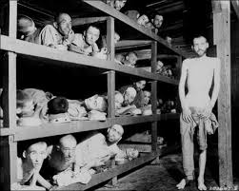

*The starving survivors of Buchenwald- one of the Nazi’s most notorious concentration camps- lie on their bunks, using their tin bowls as head rests.*

**“How Do You Think You Would Have Behaved Under Hitler?”- Looking for Good Germans (David Davidson)**

*The concentration camps posed a disturbing question for the rest of the world: how would* YOU *have acted in Hitler’s Germany? For David Davidson, who helped the US Army establish anti-Nazi communications in Germany after its surrender, the question was a literal one.*

Even before the last shots were fired in Europe in World War II and the dust had begun to settle over the ruins of Hitler’s Thousand-Year Reich, teams of Americans in Army uniform were moving into Germany to begin sitting in judgment of the defeated enemy… I was one of these moralists in khaki. A newspaperman and radio write in civil life, only a few days after the German surrender in May 1945, I took my place behind a battered pine desk in a bomb-cracked building in Munich…

Our mission… was to suspend immediately every activity in public communications- press, book, and magazine publishing, radio, theater, opera, and even the circus- and root out all practitioners tainted with Nazism. Next we would search out, investigate, and license provably anti-Nazi Germans to build up a whole new democratic establishment of communications over which there would be no need to exercise censorship… The procession of Germans who came before us were, by our rough-and-ready rule of thumb, soon classified as falling into one of three categories: black, white, or gray.

Black denoted applicants with an out-and-out Nazi background and on whom little time needed to be wasted except for a few calculated insults to themselves and their fallen Fuhrer. White denoted “good Germans,” those who had never given in to Nazism during the Hitler era.

Gray was the most tragic group, consisting of good Germans who had gone bad under pressure; people of decent anti-Nazi convictions who, because of the necessities of making a living, pursuing a career, or even staying out of the Gestapo dungeons, had finally caved in to one degree or another… Interrogating grays was always the most painful- for the interrogator as well as for the applicant. To the grays we represented the conscience they had betrayed. And the consequences of these interrogations could be painfully dramatic. One applicant, after being faced with the record of his concessions to Nazism, killed himself.

In my case, an applicant whom I had accused of fighting Hitler “with your fist in your pocket” turned on me and shot a barbed question that stings to this day: “How do you think *you* would have behaved under Hitler?”

**The United States and the Holocaust**

During WWII, rescue of Jews and others targeted by Nazi Germany was not a priority for the US government. Nor was it always clear to Allied policymakers how they could pursue large-scale rescue actions in Europe.

**IMMIGRATION TO THE UNITED STATES IN THE ERA OF THE HOLOCAUST**

US State Department policies made it very difficult for refugees to obtain entry visas. Despite the ongoing persecution of Jews in Germany, the State Department's attitude was influenced by the economic hardships of the Depression, which intensified grassroots antisemitism, isolationism, and xenophobia. The number of entry visas was further limited by the Department's inflexible application of a restrictive Immigration Law passed by the US Congress in 1924. Beginning in 1940, the United States further limited immigration by ordering American consuls abroad to delay visa approvals on national security grounds. Nevertheless in 1939 and 1940, slightly more than half of all immigrants to the United States were Jewish, most of them refugees from Europe. In 1941, 45% of all immigrants to the United States were Jewish. After the United States entered the war in December 1941, the trickle of immigration virtually dried up, just at the time that the Nazi regime began systematically to murder the Jews of Europe. Despite many obstacles, however, more than 200,000 Jews found refuge in the US from 1933 to 1945, most of them before the end of 1941.

**US STATE DEPARTMENT RESPONSE TO NEWS OF THE “FINAL SOLUTION”**

In August 1942, the State Department received a report sent by Gerhart Riegner, the Geneva-based representative of the World Jewish Congress (WJC). The report revealed that the Germans were implementing a policy to physically annihilate the Jews of Europe. Department officials declined to pass on the report to its intended recipient, American Jewish leader Stephen Wise, who was President of the World Jewish Congress. Despite the State Department's delay in publicizing the mass murder, that same month Wise received the report via British channels. He sought permission from the State Department to make its contents public. Undersecretary of State Sumner Welles asked Wise not to publicize the information until the State Department confirmed it. Wise agreed and after three months the State Department notified him that its sources had confirmation. On November 24, 1942, Wise held a press conference to announce that Nazi Germany was implementing a policy to annihilate the European Jews. A few weeks later, on December 17, the United States, Great Britain, and ten other Allied governments issued a declaration denouncing Nazi Germany's intention to murder the Jews of Europe. The declaration warned Nazi Germany that it would be held responsible for these crimes.

**US PRESS COVERAGE OF THE “FINAL SOLUTION”**

During the era of the Holocaust, the American press did not always publicize reports of Nazi atrocities in full or with prominent placement. For example, the *New York Times*, the nation's leading newspaper, generally deemphasized the murder of the Jews in its news coverage. The US press had reported on Nazi violence against Jews in Germany as early as 1933. It covered extensively the Nuremberg Laws of 1935 and the expanded German antisemitic legislation of 1938 and 1939. The nationwide state-sponsored violence of November 9-10, 1938, known as *Kristallnacht* (Night of Crystal), made front page news in dailies across the US as did Hitler's infamous prediction, expressed to the *Reichstag* (German parliament) on January 30, 1939, that a new world war would mean the annihilation of the Jewish “race.” As the magnitude of anti-Jewish violence increased in 1939-1941, many American newspapers ran descriptions of German shooting operations, first in Poland and later after the invasion of the Soviet Union. The ethnic identity of the victims was not always made clear. Some reports described German mass murder operations with the word "extermination." As early as July 2, 1942, the *New York Times* reported on the operations of the killing center in Chelmno, based on sources from the Polish underground. The article, however, appeared on page six of the newspaper. Although the *New York Times* covered the December 1942 statement of the Allies condemning the mass murder of European Jews on its front page, it placed coverage of the more specific information released by Wise on page ten, significantly minimizing its importance.

**United States Policy and its Impact on European Jews**

A number of controversies have arisen about US policy and its impact on European Jews during the era of the Holocaust.

**ADMISSION OF IMMIGRANTS**

One controversy involves the admission of immigrants from Nazi Germany into the United States. Influenced by the economic hardships of the Depression, which exacerbated popular antisemitism, isolationism, and xenophobia, the refugee policy of the US State Department and its stringent (and questionably legal) application of the 1924 Immigration Law made it difficult for refugees to obtain entry visas, despite the ongoing persecution of Jews in Germany. Although several other European countries permitted limited Jewish immigration (for example Britain, France, Belgium, and the Netherlands) before 1938, many of these refugees disappeared as Nazi Germany conquered Europe. Latin America had also been a potential destination for refugees, although after 1938 these nations increasingly refused to admit further immigrants. A significant exception was Bolivia, which admitted around 30,000 from 1938-1941. Beginning in 1940, the United States further restricted immigration by ordering US consuls to delay visa approvals on national security grounds. After the United States entered World War II in December 1941, the trickle of immigration virtually dried up, just as the Nazi regime began systematically to murder the Jews of Europe. Despite many obstacles, however, more than 200,000 Jews found refuge in the United States from 1933 to 1945, most of them before the end of 1941.

**PUBLICIZING REPORTS OF GENOCIDE**

Another controversy centers on the State Department’s delay in publicizing reports of genocide. In August 1942, the Department received a cabled report, sent by Gerhart Riegner, the representative in Geneva of the World Jewish Congress (WJC). The report revealed that the Nazis planned to murder Europe's Jews. Department officials declined to pass on the report to its intended recipient, American Jewish leader Stephen Wise, who was president of the WJC. That same month, however, Wise received the report via British channels and sought permission from the State Department to make the contents public. Undersecretary of State Sumner Welles requested that Wise refrain from disclosing the contents of the Riegner cable to the public. Wise agreed, and only released the information contained in the cable to the press on November 24, 1942, after receiving word from Welles a day earlier that the State Department had confirmed its contents. On December 17, 1942, the United States, Great Britain, and ten other Allied governments issued a declaration revealing and denouncing Hitler’s intention to murder the Jews of Europe. The declaration warned Nazi Germany that it would be held responsible for these crimes.

**RESCUE**

Other issues have arisen as well. One involves the lack of action by the United States with regard to the rescue of Holocaust victims. From 1941 to 1945, winning the war was the foremost priority for Allied governments. On April 19, 1943, US and British representatives met in Bermuda to find solutions to general wartime refugee problems, but neither government initiated any rescue programs. On July 28, 1943, Polish underground courier Jan Karski informed President Franklin D. Roosevelt about reports of mass murder that he had received from Jewish leaders in the Warsaw ghetto and in the Izbica transit ghetto. US authorities did not, however, initiate any action aimed at rescuing or providing safe haven for refugees prior to 1944, when the War Refugee Board was established. On January 22, 1944, Roosevelt, under pressure from American Jews and his own Secretary of the Treasury, Henry Morgenthau Jr., established the War Refugee Board (WRB) as an independent agency to facilitate the rescue of imperiled refugees. In August 1944, the WRB and the US Department of the Interior established the Fort Ontario Refugee Center in Oswego, New York. The facility served as a haven for 983 refugees from Yugoslavia who had managed to reach Italy. Two thirds of the residents of the Refugee Center were Jews. By the time the WRB was established, however, four fifths of the Jews who would die in the Holocaust were already dead. Nevertheless, the efforts of the War Refugee Board contributed to the rescue of approximately 200,000 Jews.

**OTHER US INSTITUTIONS**

In addition to the actions of the US government, criticism has been voiced about the behavior of other US institutions during the era of the Holocaust. One such institution is the US media, which did not always publicize reports of Nazi atrocities in full, and did not give the mass murder of the European Jews the attention it deserved. For example, the *New York Times*, the nation’s leading newspaper, consistently deemphasized the murder of the Jews in its news coverage.

**BOMBING AUSCHWITZ**

Finally, controversy has arisen about the decision not to bomb the killing facilities at Auschwitz-Birkenau. During the spring of 1944, the Allies received more explicit information about the process of mass murder by gas carried out at Auschwitz-Birkenau. Beginning in late spring, some Jewish leaders pleaded unsuccessfully with US government officials to bomb the gas chambers and the rail tracks leading to the camp. Even after the Anglo-American air forces developed the capacity to hit targets in Silesia (where Auschwitz was located) in 1944, US authorities decided not to bomb either the gas chambers or the rail lines used to transport prisoners to Birkenau. US officials explained this decision in part with the technical argument that US aircraft did not have the capacity to conduct air raids on such targets with sufficient accuracy, and in part with the strategic argument that the Allies were committed to bomb exclusively military targets in order to win the war as quickly as possible. Since the late 1960s, the Allied decision not to bomb the gas chambers in or the rail lines leading to Birkenau has been a source of lively and sometimes bitter debate both among scholars and among the general public in the US.

**DISPLACED PERSONS**

Between 1945 and 1951, the United States (along with Great Britain) became the guardian of more than a million displaced persons (DPs) in Germany, Austria, Italy, and Czechoslovakia, including 250,000 Jews at the peak period in late 1945. The United Nations Relief and Rehabilitation Agency and various private relief agencies assisted the Western Allied powers in meeting this enormous challenge. Until September 1945, Jewish and non-Jewish DPs resided together in the same camps. This sometimes required Jewish victims of the Holocaust to reside with former perpetrators or with other non-Jews, some of whom expressed antisemitic sentiments painfully reminiscent of the Holocaust. Jewish DPs, many of whom felt unsafe, protested these living conditions, as well as the harsh treatment by US military personnel and the permitting of German police into the camps to search for contraband.

These practices reflected postwar Allied insensitivity to the particular psychological plight of the European Jewish DPs. Protests about the treatment of Jews by US Army personnel in DP camps located in Bavaria induced President Harry S Truman to send Earl Harrison, Dean of the Law School at the University of Pennsylvania, to the US occupation zone in Germany to investigate. Harrison’s report, filed in August 1945, led Truman to order the separation of Jews from non-Jews and more sensitive treatment of Jewish survivors. The US authorities facilitated significant improvements in living conditions by permitting Jewish relief agencies to operate in the camps and giving greater autonomy to DP councils. After the war, President Truman favored efforts to relax US immigration restrictions for Jewish displaced persons. A December 1945 executive order allowed for 16,000 Jewish refugees to enter the United States between 1946 and 1948. With the passage of the Displaced Persons Act in 1948, US authorities granted approximately 400,000 visas to immigrants above the quota system. Jewish DPs received 80,000 of these visas.

**United States Policy Toward Jewish Refugees, 1941–1952**

Although thousands of Jews had been admitted into the United States under the combined German-Austrian quota from 1938–1941, the US did not pursue an organized and specific rescue policy for Jewish victims of Nazi Germany until early 1944. While some American activists sincerely intended to assist refugees, serious obstacles to any relaxation of US immigration quotas included public opposition to immigration during a time of economic depression, xenophobia, and antisemitic feelings in both the general public and among some key government officials. Once the United States entered World War II, the State Department practiced stricter immigration policies out of fear that refugees could be blackmailed into working as agents for Germany.

It was not until January 1944 that President Franklin D. Roosevelt, under pressure from officials in his own government and an American Jewish community then fully aware of the extent of mass murder, took action to rescue European Jews. Following discussions with Treasury Department officials, he established the War Refugee Board (WRB) to facilitate the rescue of imperiled refugees. With the assistance of the American Jewish Joint Distribution Committee and the World Jewish Congress, as well as resistance organizations in German-occupied Europe, the WRB helped to rescue many thousands of Jews in Hungary, Romania, and elsewhere in Europe. In April 1944, Roosevelt also directed that Fort Ontario, New York, become a free port for refugees. However, only a few thousand refugees were allowed there and they were from liberated areas, not from Nazi-occupied areas. They were in no imminent danger of deportation to killing centers in German-occupied Poland.

Ultimately, Allied victory brought an end to Nazi terror in Europe and to the war in the Pacific. However, liberated Jews, suffering from illness and exhaustion, emerged from concentration camps and hiding places to discover a world which had no place for them. Bereft of home and family and reluctant to return to their prewar homelands, these Jewish displaced persons (DPs) were joined in a matter of months by more than 150,000 other Jews fleeing fierce antisemitism in Poland, Hungary, Romania, and the Soviet Union.

Most sought to begin a new life outside Europe. Palestine was the most favored destination of Jewish Holocaust survivors, followed by the United States. Immigration restrictions were still in effect in the United States after the war, and legislation to expedite the admission of Jewish DPs was slow in coming.

President Harry S. Truman favored a liberal immigration policy toward DPs. Faced with congressional inaction, he issued an executive order, the "Truman Directive," on December 22, 1945. The directive required that existing immigration quotas be designated for displaced persons. While overall immigration into the United States did not increase, more DPs were admitted than before. About 22,950 DPs, of whom two-thirds were Jewish, entered the United States between December 22, 1945, and 1947 under provisions of the Truman Directive.

Congressional action was needed before existing immigration quotas could be increased. In 1948, following intense lobbying by the American Jewish community, Congress passed legislation to admit 400,000 DPs to the United States. Nearly 80,000 of these, or about 20 percent, were Jewish DPs. The rest were Christians from Eastern Europe and the Baltics, many of whom had been forced laborers in Germany. The entry requirements favored agricultural laborers to such an extent, however, that President Truman called the law "flagrantly discriminatory against Jews." Congress amended the law in 1950, but by that time most of the Jewish DPs in Europe had gone to the newly established state of Israel (founded on May 14, 1948).

By 1952, 137,450 Jewish refugees (including close to 100,000 DPs) had settled in the United States. The amended 1948 law was a turning point in American immigration policy and established a precedent for later refugee crises.

**SOURCE:**

United States Holocaust Memorial Museum. “The Holocaust.” Holocaust Encyclopedia. <http://www.ushmm.org/wlc/en/article.php?ModuleId=10005143>.

Accessed on March 13, 2014.

**READINGS- Japanese Internment**

**Japanese-American Internment: A Chronology**

**1890** Significant numbers of Japanese begin to immigrate to US, especially from Hawaii and

West Coast.

**1906** San Francisco School Board ordered segregation of Japanese-American students.

**1907/08** President TR’s “Gentlemen’s Agreement” with Japan limited Japanese immigration.

**1913** California Alien Land Law prohibited non-American citizens from land ownership (NOTE:

US law prohibited Asians from naturalization).

**1919** Oriental Exclusion League in California conducted an extensive anti-Japanese campaign.

**1921** The US Supreme Court, in *Ozawa v. US*, confirmed prohibition of Japanese naturalization

**1924** Immigration Act terminated Japanese immigration to US.

**1930** Nisei organized the patriotic Japanese-American Citizens League (JACL).

**1941** *October/November:*  Under FDR’s orders, Curtis B. Munson investigated/reported on

Japanese-American loyalty to US on West Coast and Hawaii.

*December 7:* Japan attacked Pearl Harbor.

*December 8:* US declared war on Japan.

*December 11:* Chief of Staff George C. Marshall declared the Pacific Coast a

“Theater of Operations.”

*December 15:* Secretary of the Navy Frank Knox claimed an active Japanese

“5th column” helped cause the disaster at Pearl Harbor.

**1942** *January 3:* US Army Major Karl Bendetsen called for registration,

Photographs, and fingerprints of all enemy aliens.

*February 11:* President FDR personally approved evacuation of Japanese-

Americans in a phone conversation with Secretary of War Henry

Stimson.

*February 19:* President FDR’s **Executive Order 9066** empowered military to

designate and merge restricted military areas.

*February 20:* Secretary Stimson delegated responsibility for evacuation to

Lieutenant General John DeWitt.

*March 18:* FDR created the WRA- War Relocation Authority

(a civilian agency) to manage relocation centers and

resettlement.

*August 7:* Evacuation of Japanese-Americans from West Coast completed.

**1943** *January 28:* Secretary Stimson announced decision to recruit for a Japanese-

American Combat Team.

**1944** *January 20:* Secretary Stimson announced application of Selective Service

System to Japanese-Americans.

*December 18:* WRA announced closing of all relocation centers.

US Supreme Court endorsed legality of Japanese-American

policy in *Korematsu v. US*.

**1945** *January 2:* West Coast restriction against Japanese-Americans ended.

**1980** Congressional Commission reinvestigated and judged Executive Order 9066 to be

unjustified.

**Sources**

Daniels, Roger. *Concentration Camps USA: Japanese-Americans and WWII.* NY: Holt, Rinehart & Watson, Inc. 1971

Myer, Dillon S. *Uprooted Americans: The Japanese-Americans & the War Relocation Authority During WWII.*

Tuscon: University of Arizona Press, 1971.

Zich, Arthur. “Japanese-Americans: Home at Last,” *National Geographic,* Vol. 169, No. 4, April 1986.

**Journalistic Perspectives from the 1940s**

1. Problems of Japanese Migration by Ernest K. Lindley *(Newsweek*, March 30, 1942):

For the first time since the Indians were put on reservations, a racial group within the US is being forced to migrate. All persons of Japanese blood are being removed from military zones on the Pacific Coast. They number 112,000 of whom three-fifths were born in the US and therefore are American citizens.

The exodus has been ordered for two reasons: Federal and local officials feel incapable of distinguishing between loyal and disloyal persons of Japanese descent, and, in the event of attack, sabotage, or even further reverses in the Pacific, angry white people might wreak vengeance on the innocent as well as the guilty.

Against the decision, many arguments have been presented. The first is the rights of American citizens are being violated. To this the answer given is that citizenship is not a dividing line between loyalty and disloyalty to the United States, especially among a people who have not been assimilated socially. The second is that no similar emigration has been ordered from a much more vulnerable area- the Hawaiian Islands. It is pointed out also that not a single instance of sabotage by persons of Japanese lineage has been established in Hawaii.

The answer is twofold. The practical difficulties of such an exodus from Hawaii are almost insoluble; the absence of sabotage both in Hawaii and on the Pacific Coast is the surest sign that Japanese agents will o into action later. Cases are known in which Japanese officers have exiled themselves to other lands for years, posing as humble civilians in preparation for the supreme hour.

A third argument bites deep. Loyal Japanese-Americans would be of great value in espionage and propaganda work in the Far East. The Japanese Government is trying to make this a racial war: that is implicit in the slogan: “Asia for the Asiatics.” The United Nations cannot stand for white superiority- not with the Chinese, the Filipinos, and the Indians as their allies. Their battle cry must be “democracy,” with all that it implies as to equality. As this argument goes, we are impairing the propaganda value of democracy and throwing away the services of loyal Japanese-Americans. German and Italian aliens are also being removed from certain military zones- but not American citizens of German and Italian descent.

The decision has been made, however. Responsible officials agree that it is probably wise. The best that can now be done is to make the migration as easy and fair as possible to the migrants. The President has set up the War Relocation Authority, headed by an able public official, Milton S. Eisenhower.

The first question is where to move the Japanese and how to employ them. Excepting some of the Colorado sugar-beet growers, private employers do not appear to want the immigrants. And if scattered in private jobs, loyal Japanese-Americans might be exposed to vigilante action. The alternative is to segregate them in self-supporting communities or in camps engaged in public works. Small settlements will have to be created- and the possibility is being explored of having these communities produce war goods of types requiring hand work or only simple tools.

The other main problem is to protect the property of the emigrants. Instances have been reported in which they have been frightened into selling their possessions at sacrifice prices. The danger of racketeering is obvious. However, the Treasury has made the Federal Reserve Bank of San Francisco trustee, and the latter has set up local committees of three- representing the Federal Reserve Bank, the Farm Security Administration, and the Federal Security Agency- to help the Japanese, both aliens and citizens, in the sale, lease, or storage of property. This plan is said to be working well, and it may be left undisturbed by the Alien Property Custodian.

The transplantation is a severe test for Japanese whose loyalty now lies with us. At best it will leave wounds. These can be mollified if time is permitted for an orderly movement and if the property holdings of the emigrants are scrupulously protected. Unfortunately, the same military considerations which forced the decisions probably will require that it be executed in a hurry. The price is only too likely to be the permanent alienation of a group of citizens who, if intelligently handles, could be of unique aid in our war with the imperial militarists of their fatherland.

1. When is a Jap? (*Newsweek*, May 24, 1943)

Dillon S. Myer, Director of the War Relocation Authority, sighed last week: “I would like to get out of this relocation thing tomorrow.” For he had a tough problem on his hands: what to do about the 110,000 Japanese-Americans evacuated from the West Coast last year.

The ten relocation camps, established last spring and summer by the WRA in seven Western states on the President’s order that Japanese-Americans be cleared out of the vital Pacific Coast area, have been the focus of controversy ever since. And so has the fate of the internees, of whom 65,400 are Nisei (American citizens by right of birth) and 5,680 Kibei (American-born but educated in Japan and mostly loyal to the emperor). The WRA was intended as an emergency setup, to care for the evacuees until they could be settled in jobs in other parts of the country. But movement from the Army-guarded and fence-enclosed tarpaper-barrack settlements has been slow.

By last week the reasons for that slowness had boiled up into an issue that involved some basic questions in the Japanese-American problem- and some plain racial hatred. The questions: Can any Japanese be trusted? How can the loyal be distinguished from the disloyal? News of the execution of our Tokyo raiders had aroused popular resentment and befogged the answers.

“Exposé”: The streets of Cody and Powell, Wyoming, close by the Heart Mountain relocation center, were empty of Japanese last week for the first time in months. The town councils had forbidden their appearance unless accompanied by military escort.

It all started when a Denver Post reporter visited a center and returned with Page 1 stories of waste and hoarding of rationed food. Among other things, he charged that the Japanese were being fed the almost forgotten luxury of bananas and alligator pears, and that rations were better than those in the Army. Actually the camp gets its food through the Army quarter-master, and residents have had bananas twice since the center was established last summer.

But the “exposé” had its effect. Indignation in Denver and the whole West ran high over “coddling” of the internees. The War Manpower Commission, which had hoped to place thousands of Nisei in agriculture this year, voiced fear its program would bog down. As it was, about 4,000 were employed permanently as communities in many parts of the country were refusing to put up with Nisei. And in time the government was shelling out $70 million a year for the WRA and would probably spend $80 million for 1944.

Further to complicate matters, in the pillared chamber of the Supreme Court last week charges were made that mass evacuation itself was unconstitutional. In the cases of Minoru Yasui, 26, and Gordon Hirabayashi, 24, both American-born of Japanese parents, who were convicted of violating a preinternment curfew order last year (Hirabayashi also refused to register for evacuation), attorneys charged that the evacuation order was void because it was without authority of Congress, that American citizens cannot be interned without a hearing under the due process and equal-protection clauses and that the military orders were void as no martial law had been declared.

To all this a Senate Military Affairs subcommittee, headed by Senator Albert B. Chandler and just back from an investigating tour of the camps, thought it had the solution: abolish the camps. Last week Senator Chandler planned to submit to the President for action three recommendations: (1) Make all draft laws applicable to Japanese who are American citizens, (2) Keep disloyal Japanese in regular internment camps for enemy aliens and (3) Find jobs for loyal Japanese in areas where they will be acceptable.

But Chandler’s program had its critics particularly on the Pacific Coast. For out of decades of experience with Japanese cut-rate laborers and farmers, Westerners have developed a hard core of suspicion and dislike for anything Japanese. With Lt. Gen. John L. DeWitt, head of the Western Defense Command, they feel that no matter what his citizenship “A Jap is a Jap.” They don’t like the idea of putting Japanese into our Army. Many threaten that if the Japanese return to the Coast they “will be buried” there. At defenders of the internees some hurl the epithet “Jap-lover.”

As for the internees themselves, many were once eager to be free. But now that they can’t know what to expect wherever they go, most want to stay in camp.

1. The Nisei Go Back (*Time*, December 25, 1944):

Mitsuye Endo is a loyal US citizen, born 24 years ago in Sacramento. Her eyes happen to slant upward because her ancestors were Japanese. In 1942, when the US Army uprooted 110,000 people of Japanese blood from their truck gardens and berry patches along the West Coast, Mitsuye Endo landed in a War Relocation center at Topaz, Utah.

This week the Supreme Court of the US unanimously agreed that Citizen Endo-and, by implication, any other loyal Japanese-American- has a right to live where she pleases. Justice Frank Murphy denounced “the unconstitutional resort to racism inherent in the entire evacuation program.” But the court, frankly avoiding a tough constitutional issue in wartime, almost contradicted itself.

Tacking the case of another relocated Japanese-American, the Justices ruled, 6-3, that the Army had had a right to evacuate all Japanese and Nisei in a time of national emergency. Said the court: “Exclusion of large groups of citizens from their homes… is inconsistent with our basic Government institutions. But… hardships are part of war.”

For almost two years, the right of the Government to shuffle citizens around at will had been a burning constitutional issue. But by the time the Supreme Court ruled this week, the question was academic. Day before, the Army had rescinded its mass evacuation order, told the loyal Japanese and Nisei they could return. Invasion, the Army explained, is no longer “a substantial possibility.”

Interior Secretary Harold Ickes soothingly promised Westerners that there would be “no hasty mass movement” of returning evacuees. But the difficulties of readjustment loomed large enough to give pause to all citizens of good will. Problems had already cropped up:

In Hood River, Oregon (popular 3,280), American Legionnaires daubed paint on their servicemen’s honor roll to obliterate the names of 16 Nisei soldiers.

At Brawley, California, 3,500 citizens jammed onto the high school athletic field for an anti-Japanese mass meeting, listened to an orator scream: “Do you want these yellow-bellied sneaks to return to Brawley?” The crowd roared: “No!”

In Parker, Arizona (population 456), Andy Hale put a sign in his barbershop: “Japs Keep Out You Rats,” ejected Raymond Matsuda, a Nisei veteran, wounded in Italy.

These were isolated instances, in small communities. But most of the US Japanese on the West Coast lived in such small towns. And in the larger cities, the Hearst press kept up its anti-Japanese screams. California’s Governor Warren, setting the tone for the vast majority of West Coast citizens, promised every effort to keep the return of the Nisei orderly.

**World War Two - Japanese Internment Camps in the USA**

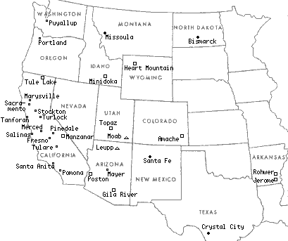**Amache (Granada), CO**   
Opened: August 24, 1942.  
Closed: October 15, 1945.  
Peak population: 7,318.  
  
**Gila River, AZ**  
Opened July 20, 1942.   
Closed November 10, 1945.  
Peak Population 13,348.    
  
**Heart Mountain, WY**  
Opened August 12, 1942.Closed November 10, 1945.  
Peak population 10,767.  
  
  
  
**Jerome, AR**      - Opened October 6, 1942. Closed June 30, 1944. Peak population 8,497  
**Manzanar, CA** - Opened March 21, 1942. Closed November 21, 1945. Peak population 10,046.  
**Minidoka, ID**   - Opened August 10, 1942. Closed October 28, 1945. Peak population 9,397  
**Poston, AZ**      - Opened May 8, 1942. Closed November 28, 1945. Peak population 17,814  
**Rohwer, AR**     - Opened September 18, 1942. Closed November 30, 1945. Peak population 8,475  
**Topaz, UT**       - Opened September 11, 1942. Closed October 31, 1945. Peak population 8,130  
**Tule Lake, CA** - Opened May 27, 1942. Closed March 20, 1946. Peak population 18,789

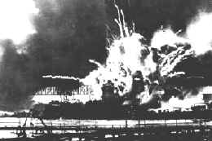On December 7th 1941, the Japanese attacked Pearl Harbor. US citizens feared another attack and war hysteria seized the country. State representatives put pressure on President Roosevelt to take action against those of Japanese descent living in the US.

On February 19th 1942 Roosevelt signed Executive Order 9066. Under the terms of the Order, some 120,000 people of Japanese descent living in the US were removed from their homes and placed in internment camps. The US justified their action by claiming that there was a danger of those of Japanese descent spying for the Japanese. However more than two thirds of those interned were American citizens and half of them were children. None had ever shown disloyalty to the nation. In some cases family members were separated and put in different camps. During the entire war only ten people were convicted of spying for Japan and these were all Caucasian.

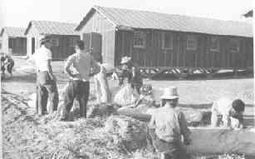Life in the camps was hard. Internees had only been allowed to bring with them a few possessions. In many cases they had been given just 48 hours to evacuate their homes. Consequently they were easy prey for fortune hunters who offered them far less than the market prices for the goods they could not take with them.

*"It was really cruel and harsh. To pack and evacuate in forty-eight hours was an impossibility. Seeing mothers completely bewildered with children crying from want and peddlers taking advantage and offering prices next to robbery made me feel like murdering those responsible without the slightest compunction in my heart."* Joseph Yoshisuke Kurihara speaking of the Terminal Island evacuation.

They were housed in barracks and had to use communal areas for washing, laundry and eating. It was an emotional time for all. *"I remember the soldiers marching us to the Army tank and I looked at their rifles and I was just terrified because I could see this long knife at the end . . . I thought I was imagining it as an adult much later . . . I thought it couldn't have been bayonets because we were just little kids."  from "Children of the Camps"*

Some internees died from inadequate medical care and the high level of emotional stress they suffered. Those taken to camps in desert areas had to cope with extremes of temperature.

The camps were guarded by military personnel and those who disobeyed the rules, or who were deemed to be troublesome were sent to the Tule Lake facility located in the North California Cascade Mountains. In 1943 those who refused to take the loyalty oath were sent to Tula Lake and the camp was renamed a segregation centre.

In 1943 all internees over the age of seventeen were given a loyalty test. They were asked two questions:

1. Are you willing to serve in the armed forces of the United States on combat duty wherever ordered? (Females were asked if they were willing to volunteer for the Army Nurse Corps or Women's Army Corps.)

2. Will you swear unqualified allegiance to the United States of America and faithfully defend the United States from any or all attack by foreign or domestic forces and forswear any form of allegiance or obedience to the Japanese emperor, to any other foreign government, power or organization?

In December 1944 Public Proclamation number 21, which became effective in January 1945, allowed internees to return to their homes. The effects of internment affected all those involved. Some saw the camps as concentration camps and a violation of the writ of Habeas Corpus, others though, saw internment as a necessary result of Pearl Harbor. At the end of the war some remained in the US and rebuilt their lives, others though were unforgiving and returned to Japan.

|  |
| --- |
| [A | More | Perfect | Union --  Japanese Americans and the U.S. Constitution](http://americanhistory.si.edu/perfectunion/index.html) |
|  |
| http://americanhistory.si.edu/perfectunion/images/ghost.gif |
| http://americanhistory.si.edu/perfectunion/images/ghost.gif   |  |  | | --- | --- | | Overview   |  | | --- | |  |   During the opening months of World War II, almost 120,000 Japanese Americans, two-thirds of them citizens of the United States, were forced out of their homes and into detention camps established by the U.S. government. Many would spend the next three years living under armed guard, behind barbed wire. This exhibit explores this period when racial prejudice and fear upset the delicate balance between the rights of the citizen and the power of the state. It tells the story of Japanese Americans who suffered a great injustice at the hands of the government, and who have struggled ever since to insure the rights of all citizens guaranteed by the U.S. Constitution. | |

|  |  |
| --- | --- |
| IMMIGRATION   |  | | --- | | [http://americanhistory.si.edu/perfectunion/non-flash/images/thumb_immigration.jpg](javascript:popImage(378)) |   The first large groups of Asian immigrants reaching Hawaii — a U.S. territory — and the United States in the late 19th century faced racial prejudice. Restrictive laws in Hawaii and the U.S. specifically limited the rights of Asian immigrants to own property and to become citizens. Before 1907, most Japanese immigrants to the U.S. settled on the West Coast and excelled in the cultivation of marginal lands. As successful farmers, fruit growers, fishermen, and small businessmen, their ability to do well with little and to overcome great odds made them objects of envy by some members of the white community. Set apart by their physical appearance, they became further isolated from the white mainstream as envy fed racial hostility. |



Between 1861 and 1940, some 275,000 Japanese people moved to Hawaii and to the U.S. mainland. Many of the first Japanese immigrants were recruited to work in the sugar cane fields of Hawaii and fruit and vegetable farms of California. The Issei, or first generation immigrants from Japan, faced the difficulty of forging a new life that included elements of their traditional culture and the culture of their newly found homes.

Few single women emigrated from Japan to the Hawaiian Islands or the continental United States before 1907. After that date, thousands of Japanese women sailed to the islands and the U.S. mainland to join husbands or to marry men already there. Many of these were "picture brides," women married by proxy to men they had never seen. Arranged marriages between brides and grooms who had never met were not unusual in Japan at the time.

**[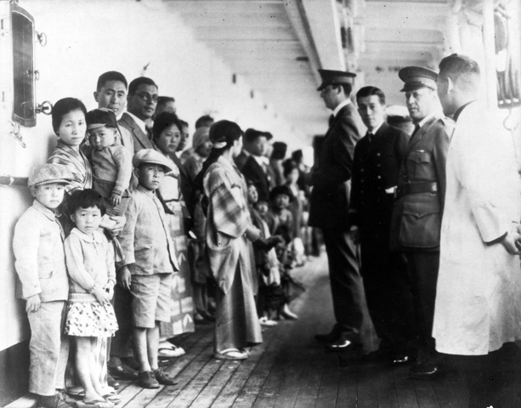](http://americanhistory.si.edu/perfectunion/collection/image.asp?ID=378&superSize=1)** 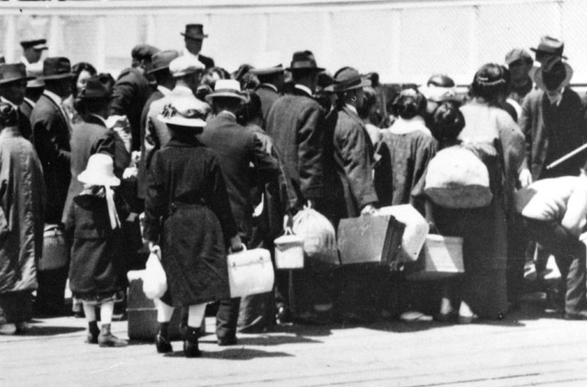

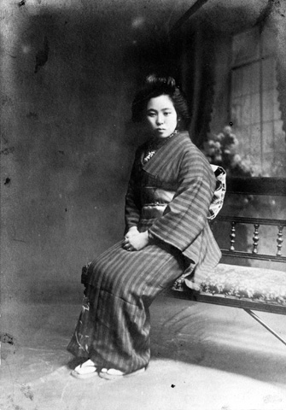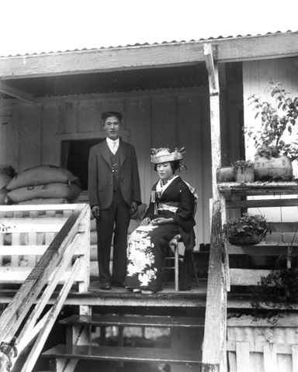



The Kingdom of Hawaii began efforts to bring Japanese laborers to work in the sugar cane fields in 1860. When their contracts expired, some of these laborers returned to Japan or eventually moved on to the United States. Those who remained in the Hawaiian Islands took up a variety of trades and businesses. A small but ambitious community developed, complete with its own schools, churches, and cultural and economic organizations.

In 1898, after Hawaii was annexed to the United States, owners of sugar plantations rushed to bring in a large number of Japanese laborers before a ban on contract labor went into effect. More than 30,000 laborers were brought to Hawaii in one year. By 1900, there were more than 61,000 Japanese living in the Hawaiian Islands.

By 1940, persons of Japanese ancestry accounted for almost 40 percent of the population of the Hawaiian Islands. The growth of the Japanese community alarmed some Hawaiians. Within seven years after the arrival of the first group of laborers, the Hawaiian legislature passed restrictive laws and tried to recruit people of other nationalities as laborers. In 1907, the U.S. Congress prohibited the immigration of Japanese from Hawaii to the U.S. mainland.

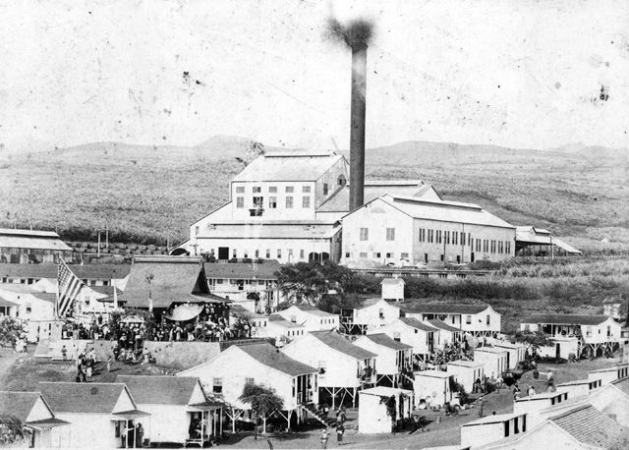 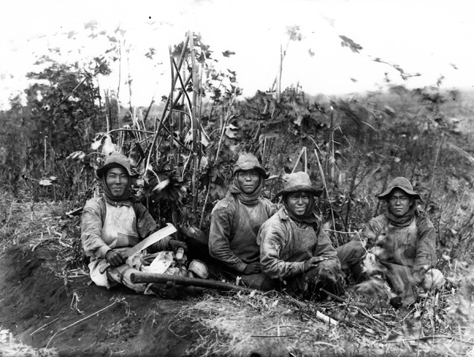



Most Japanese immigrants to the United States settled on the West Coast and worked in agriculture. They excelled in the cultivation of marginal lands and became successful farmers, fruit growers, fishermen, and small businessmen. The Japanese community's ability to overcome great hardships and succeed made them targets of envy and prejudice by many white Americans. Anti-Japanese sentiment grew throughout communities in the West, particularly in California.

In rural areas as in the cities, Issei and Nisei farmers tended to concentrate in ethnic communities. Florin, near Sacramento, was a farm community with many Japanese Americans. Most residents of the area were small truck farmers who grew fruits and vegetables. Although Japanese Americans controlled less than 4 percent of the total farmland in California before 1940, they produced 10 percent of the total value of the state's farm crops as early as 1920.

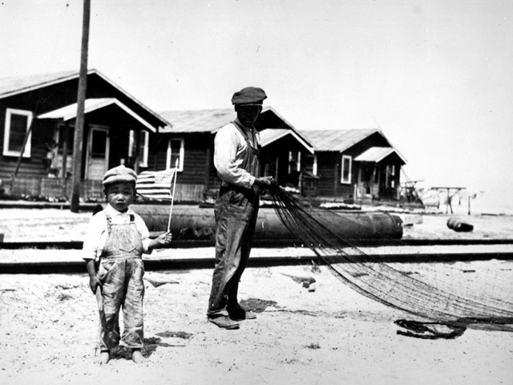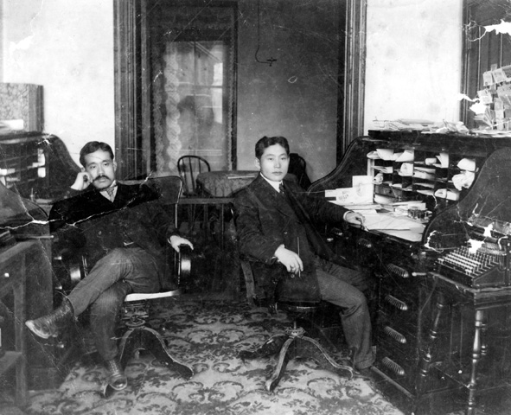

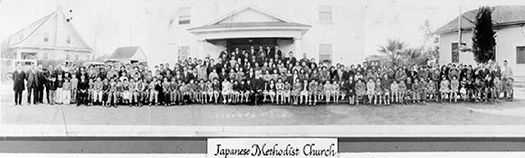



Japanese immigration to the continental United States was concentrated during the years 1900-1920, and was always governed by changing legal restrictions and relations between the two nations. As the population and success of Japanese communities grew in the United States, so did the racial prejudice against them. The anti-Japanese campaigns began with racial stereotypes and propaganda, and became institutionalized into laws that denied Japanese citizenship and prohibited property ownership. Japan's spectacular victory over Russia in the war of 1904?05 was the first defeat of a European power by an Asian nation in modern times. This victory stimulated national and racial pride among Japanese everywhere. Among white people in the United States, the rise of Japan on the world scene and a tradition of racial prejudice against Japanese led to fears of a future "yellow peril" and to predictions of an eventual war.

In 1938, Gum Inc. of Philadelphia began issuing a series of bubble-gum cards entitled "The Horrors of War," prepared by George Maull, a Sunday-school teacher and the firm's advertising counsel. Commenting on the cards, a Life magazine writer noted that: "Some future historian may trace a cause for a future U.S.-Japanese war to the fact that pre-adolescents in America received severe anti-Japanese prejudices through its curious liking for blowing bubbles with...gum."

Opponents of Japanese immigration had long contended that Asian immigrants were ineligible for naturalized citizenship. This claim rested on state and municipal laws that restricted naturalization to free whites and aliens of African descent — language based on an act of Congress from the 1790s. In a 1922 ruling, *Ozawa v. U.S.*, the U.S. Supreme Court upheld a Hawaiian statute that denied Japanese immigrants citizenship on these grounds. Following this, the Asian Exclusion Act of 1924 ended further Japanese immigration for permanent residence.

By 1940, in spite of prejudice and legal restrictions, Japanese Americans had established firm roots in the United States. Although Issei immigrants were prohibited from becoming citizens and owning property, many owned homes, farms and businesses held in the names of their children born in America, who were automatically U.S. citizens and therefore eligible to own property.

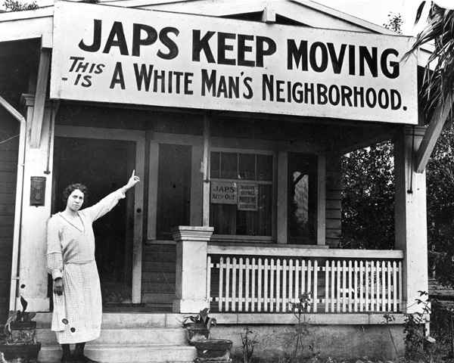

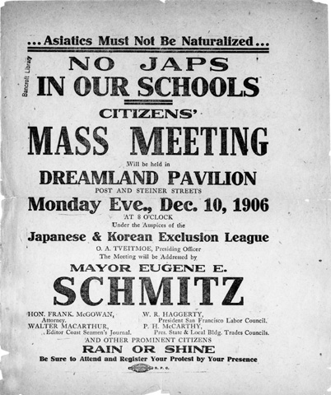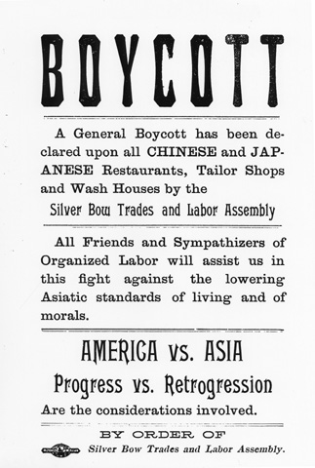

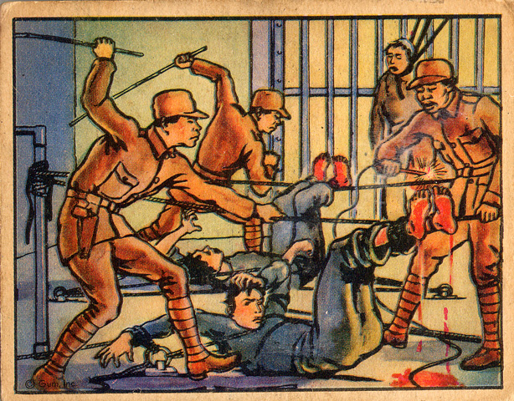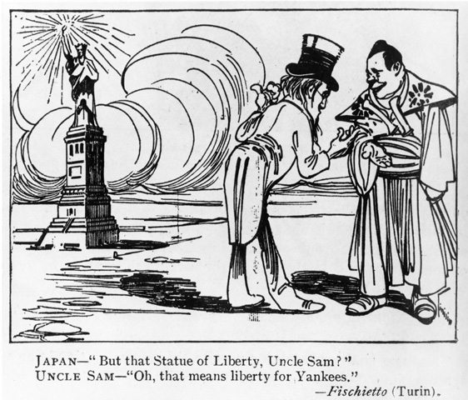



|  |
| --- |
| [http://americanhistory.si.edu/perfectunion/non-flash/images/thumb_removal.jpg](javascript:popImage(785)) |

The Japanese attack on Pearl Harbor on December 7, 1941 stunned the United States, and became a catalyst for challenging the loyalty of all Japanese people living in the U.S. On February 19, 1942, President Franklin Roosevelt signed Executive Order 9066 authorizing military authorities to exclude "any and all persons" from designated areas of the country as necessary for national defense. E.O. 9066 was the first step in a program that uprooted Americans of Japanese ancestry from their West Coast communities and placed them under armed guard for up to four years.



Japan's alliance with Nazi Germany and Fascist Italy in 1940 focused world attention on the Asian nation's military power and imperial ambition. The Japanese attack on Pearl Harbor on December 7, 1941 plunged the United States into war and planted the notion of Japanese treachery in the minds of Americans. The hysteria that enveloped the West Coast during the early months of the war, combined with long standing anti-Asian prejudices, set the stage for what was to come.

For both Japan and America, World War II had all of the ugly overtones of racial conflict. Although America was also at war with Germany and Italy, government officials did not recommend that German and Italian resident aliens (or American citizens of German or Italian ancestry) be rounded up as a group and confined for the duration of the war. While German or Italian enemies were often viewed as misguided victims of despotic leaders, Japanese people were referred to as "yellow vermin," "mad dogs," and "monkey men." Racist wartime propaganda further exacerbated fears of invasion and prejudice against people of Japanese decent. Members of the War Department argued for removal of the Issei and their Nisei children from areas regarded as vital to national security. National officials were influenced by politicians from West Coast districts, where opposition to Japanese Americans ran high.

*"Their racial characteristics are such that we cannot understand or trust even the citizen Japanese."* — Henry L. Stimson, Secretary of War, 1942 *"I'm for catching every Japanese in America, Alaska, and Hawaii now and putting them in concentration camps....Damn them! Let's get rid of them now!"* — Congressman John Rankin, Congressional Record, December 15, 1941

On the evening of December 7, 1941, FBI agents, and local and military police took 736 Japanese aliens into custody. By December 11, the number had grown to 1,370. This group included persons believed most likely to be spies or saboteurs: Shinto and Buddhist priests, newspapermen, community leaders, Japanese language teachers, and subscribers to suspect publications. Enemy Alien Hearing Boards were established to judge the loyalty of these individuals. All remained in detention during the slow course of the hearing process.

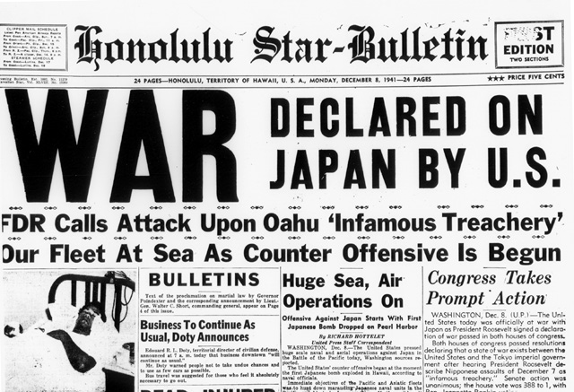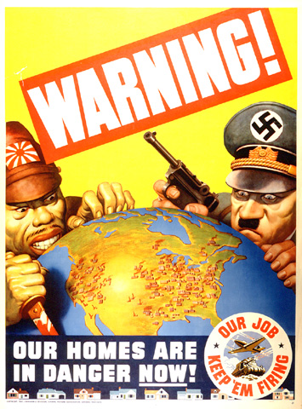

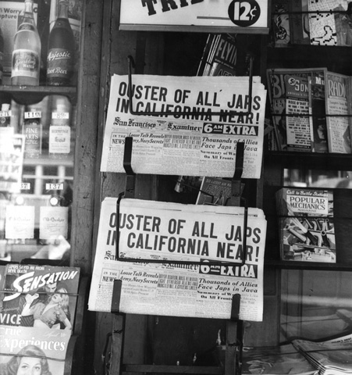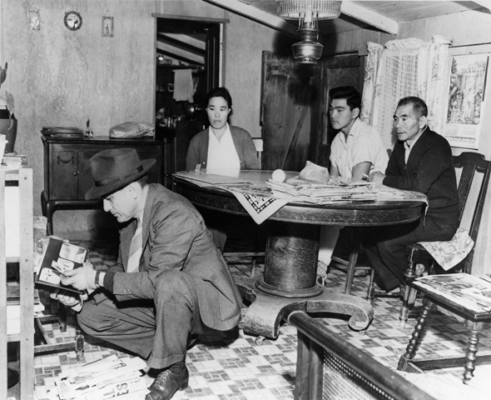



Officials in the War Department who advocated the forced removal of Japanese Americans found President Franklin Roosevelt receptive to their cause. On February 19, 1942, Roosevelt signed Executive Order 9066, which set the removal program in motion. The limited official opposition to removal centered in the U.S. Justice Department with officials such as Edward J. Ennis and the FBI's J. Edgar Hoover, who believed it was unconstitutional. Abrogation of the basic constitutional rights of nearly 120,000 Japanese Americans and resident aliens came quickly.

Fourth Amendment, 1791:

"The right of the people to be secure in their persons, houses, papers, and effects, against unreasonable searches and seizures, shall not be violated, and no warrants shall issue, but upon probable cause, supported by oath or affirmation, and particularly describing the place to be searched, and the persons or things to be seized."

Fourteenth Amendment, 1868:

"All persons born or naturalized in the United States, and subject to the jurisdiction thereof, are citizens of the United States and of the State wherein they reside. No State shall make or enforce any law which shall abridge the privileges or immunities of citizens of the United States; nor shall any State deprive any person of life, liberty or property, without due process of law; nor deny to any person within its jurisdiction the equal protection of the laws."

The Executive Order 9066 authorized the military to exclude any person from any area of the country where national security was considered threatened. It gave the military broad authority over the civilian population without the imposition of martial law. Although the order did not mention any specific group or recommend detention, its language implied that any citizen might be removed. In practice, the order was applied only to Japanese Americans.

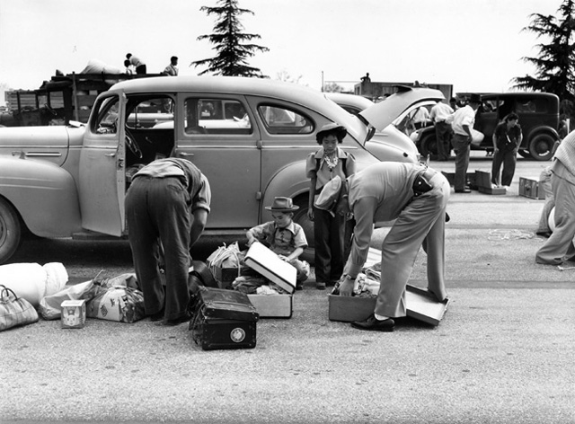 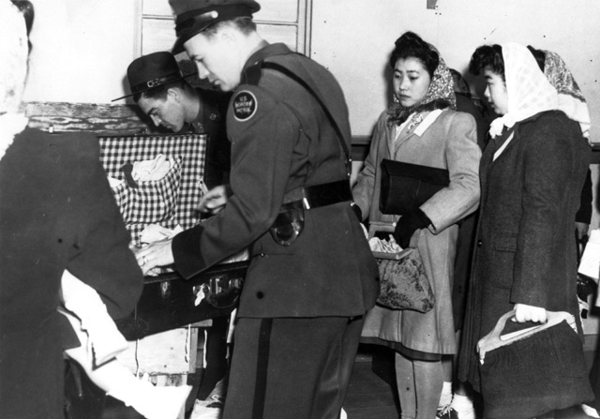

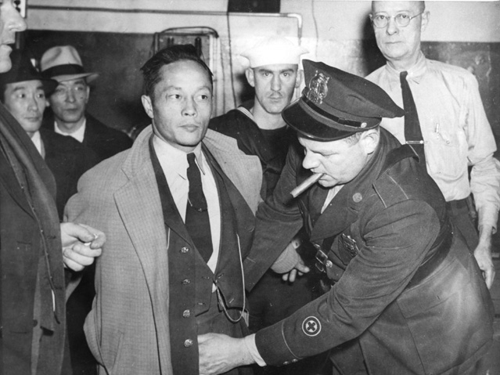 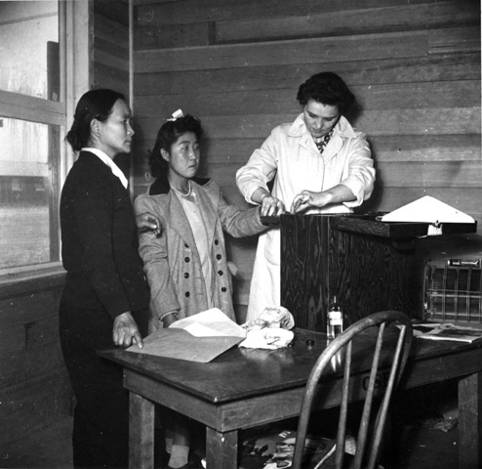



Registration of all Japanese Americans, both resident aliens and citizens, was the first step toward forced removal. In the spring of 1942, scenes like these were repeated in every Japanese American community along the Pacific Coast. General John L. DeWitt, military commander of the Western Defense Command, issued more than 100 military "Exclusion Orders" directed at civilians of Japanese ancestry living on the West Coast. These Exclusion Orders were based solely on race and ancestry.

"A Jap's a Jap. It makes no difference whether the Jap is a citizen or not." — General John L. DeWitt, Commander, Western Defense Command, 1942

"I am determined that if they have one drop of Japanese blood in them, they must go to camp." — Colonel Karl Bendetsen, Administrator, Wartime Civil Control Administration, 1942

Timeline of Events

March 2, 1942: General DeWitt issues Public Proclamation Number 1, dividing the West Coast into military areas from which groups of individuals might be excluded under E.O. 9066.

March 11, 1942: General DeWitt names Colonel Karl R. Bendetsen as director of the Wartime Civil Control Administration, which would supervise the removal of Japanese Americans under E.O. 9066.

March 21, 1942: President Roosevelt signs Public Law 503, which makes violation of military orders issued under E.O. 9066 a federal offense. The bill passed in both houses of Congress without a dissenting vote.

March 24, 1942: General DeWitt issues Exclusion Order Number 1, ordering all Japanese resident aliens and Americans of Japanese ancestry on Bainbridge Island, near Seattle, Washington, removed under military guard.

At first, the forced removal of all Japanese Americans from their homes on the West Coast was the responsibility of a newly organized Army agency, the Wartime Civil Control Administration (WCCA), headed by Colonel Karl R. Bendetsen. The WCCA divided the West Coast into 108 exclusion areas, each with a population of roughly 1,000 Japanese Americans. These residents were ordered to report to a central point in their neighborhoods from which they would be taken to an "approved destination." "Evacuees" could take only those possessions they could carry.

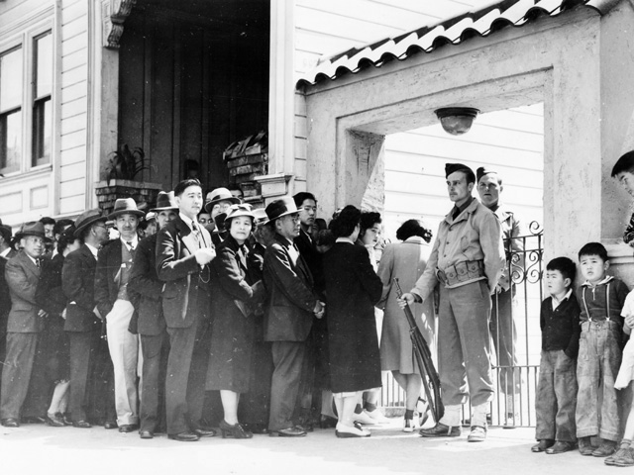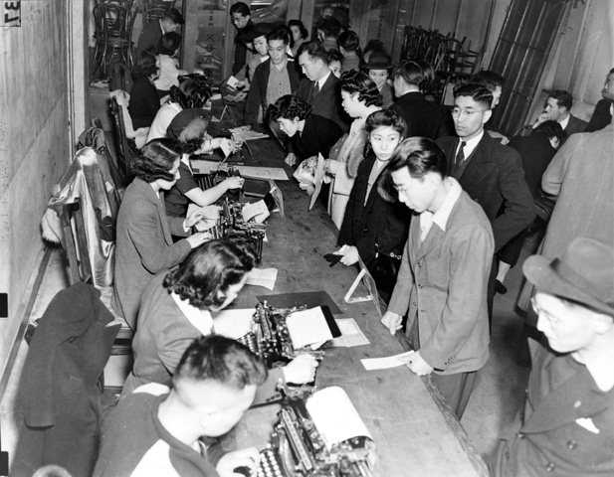

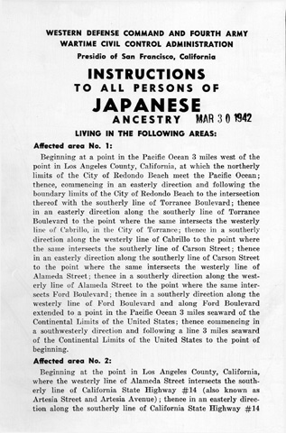



The order to prepare for the move to the assembly centers left little time for packing, selling household goods, or locating safe storage for precious personal possessions. Allowed to take only what they could carry, Japanese Americans headed for the camps had no room for toys, precious heirlooms, or other personal treasures. Family pets were left behind with memories of the old neighborhood. The patterns of daily life were shattered.

|  |  |  |  |
| --- | --- | --- | --- |
|  |  |  |  |

The government offered to store some household possessions for families "at the sole risk of the owner." The government actually stored very little. In many cases, the offer came too late. Some families were fortunate enough to have friends or neighbors who cared for houses, cars, and other possessions.

For thousands of Japanese American homeowners and small businessmen, moving out also meant selling out — quickly, and at an enormous loss. The total dollar value of the property loss has been estimated at as much as 1.3 billion dollars. Net income losses may have been as high as 2.7 billion dollars (both in 1983 dollars).

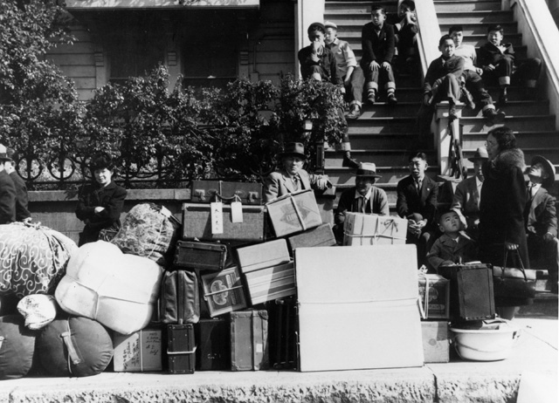

[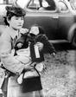](javascript:popImage(765))[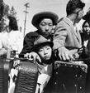](javascript:popImage(816))

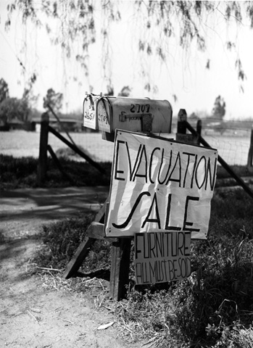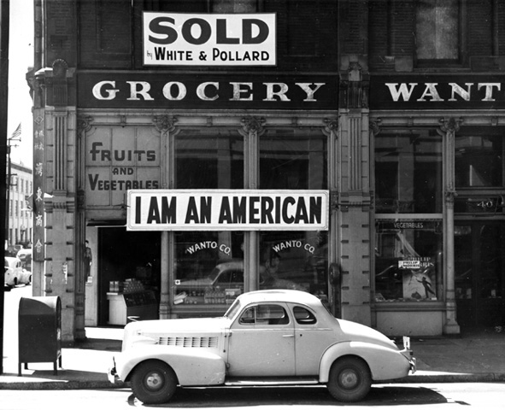



Temporary assembly centers were the first stop for most internees. Sixteen centers were established in California, Oregon, Washington State, and Arizona. Fairgrounds, racetracks, and other public facilities were pressed into service to handle the influx of Japanese Americans. Internees remained in these centers, under the control of the Army's Wartime Civil Control Administration (WCCA), until the War Relocation Authority (WRA) camps were ready.

Conditions in the WCCA assembly centers were unsanitary at best. At Tanforan and Santa Anita, California, internees were housed in stalls that only a week earlier had held horses. Sanitation, food service, and health-care facilities were beneath the lowest U.S. Army standards. Many internees had to stay in assembly centers for several months before being moved to permanent camps.

"The stall was about ten by twenty feet and empty except for three folded Army cots lying on the floor. Dust, dirt, and wood shavings covered the linoleum that had been laid over manure-covered boards, the smell of horses hung in the air, and the whitened corpses of many insects still clung to the hastily white-washed walls." — Yoshiko Uchida, *Desert Exile: The Uprooting of a Japanese American Family*

"On warm days it was unbearable in the stalls and barracks. The stench of manure returned with the heat, and this in turn brought back the horseflies. Most of the people remained outdoors on such days, and usually I did too, but there were times when I kept working inside. Later, by the order of the medical authority, all windows in the stalls were hinged so that they could be opened." — Mine Okubo, *Citizen 13660*

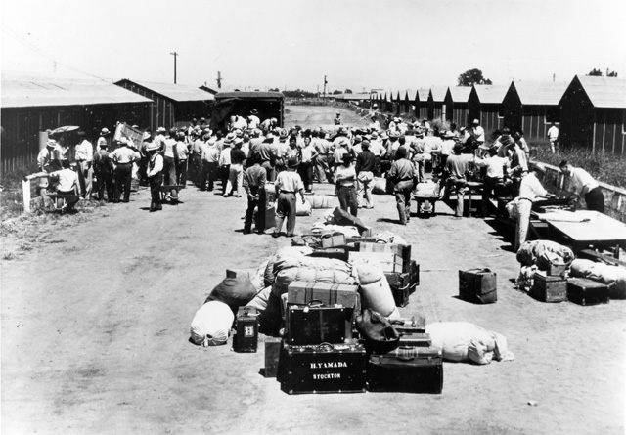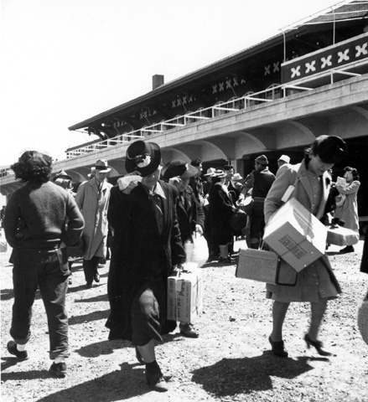

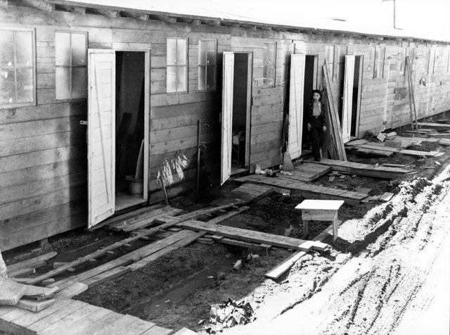 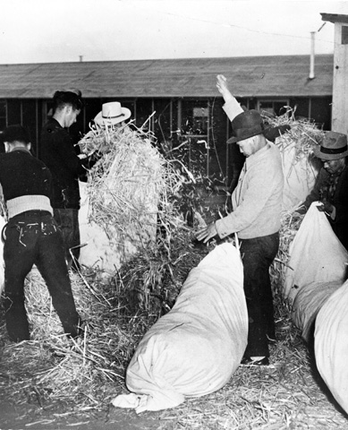



By the end of 1942, more than 120,000 men, women, and children of Japanese ancestry had been uprooted from their homes. Their final destinations would be one of 10 camps — "instant cities" — constructed by the War Relocation Authority in seven states. Deeply isolated from the rest of America, these "evacuees" — 65 percent of whom were American citizens — would spend up to four years imprisoned, working to rebuild their lives.

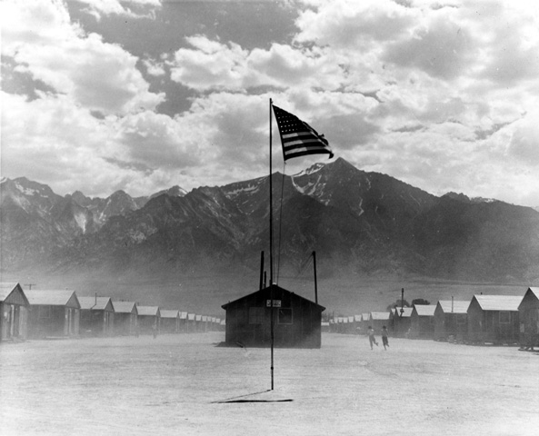



Conditions varied from the heat and dust of Manzanar, Poston and Gila River, to the rains of Jerome and Rowher, and the bitter winter cold of Heart Mountain and Minidoka. The one thing that all 10 camps had in common was geographic isolation.

"As a member of President Roosevelt's administration, I saw the United States Army give way to mass hysteria over the Japanese...Crowded into cars like cattle, these hapless people were hurried away to hastily constructed and thoroughly inadequate concentration camps, with soldiers with nervous muskets on guard, in the great American desert. We gave the fancy name of 'relocation centers' to these dust bowls, but they were concentration camps nonetheless." —Harold Ickes, Secretary of the Interior, Washington Evening Star, September 23, 1946

Individuals arriving at a camp were shocked to find that they would live behind barbed-wire fences, watched over by armed military police in guard towers.

"The sound of the camp gates closing behind us sent a searing pain into my heart. I knew it would leave a scar that would stay with me forever. At that very moment my precious freedom was taken from me." — Mary Tsukamoto, We the People

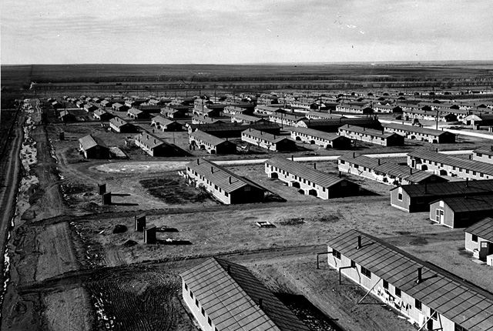 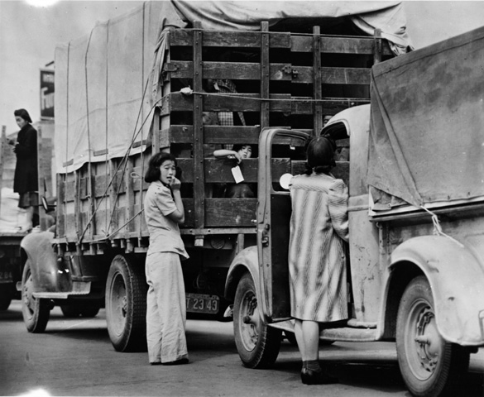

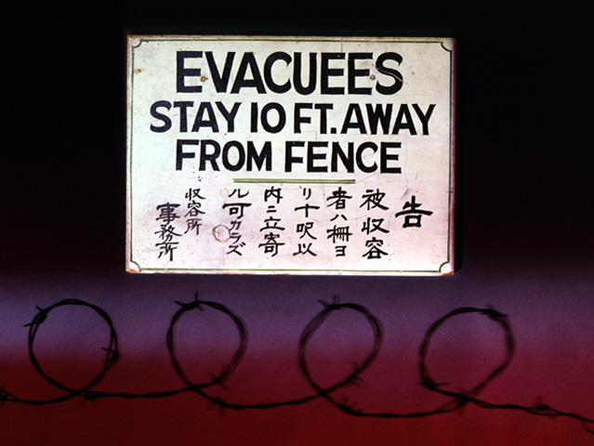 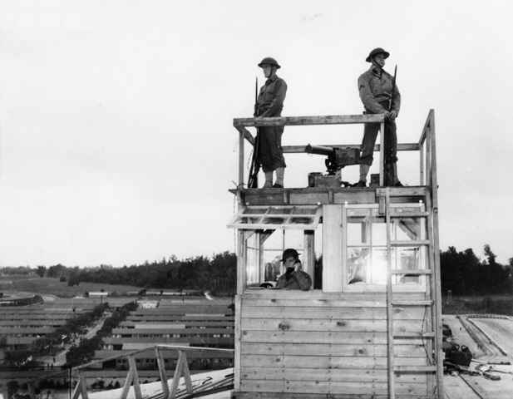

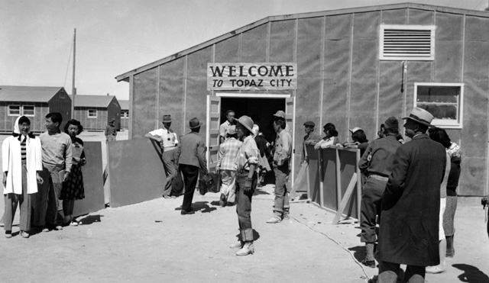



For many, the real trauma of internment was built around the scores of small indignities endured each day. Taken together, their impact on family structure and on an individual's sense of pride, dignity, and self-respect was enormous.

" ...We had another violent dust storm... Soon barracks only a few feet away were completely obscured by walls of dust and I was terrified the wind would knock me off my feet. Every few yards, I stopped to lean against a barrack to catch my breath, then lowering my head against the wind, I plodded on." — Yoshiko Uchida, *Desert Exile: The Uprooting of a Japanese American Family*

"We lined up for mail, for checks, for meals, for showers, for laundry tubs, for toilets, for clinic service, for movies. We lined up for everything." —Mine Okubo, Citizen 13660

"We had to live under the constant pressure that the food might all stop one day, and it gave me very uneasy and uncomfortable feelings to see the guards watching us from the tower. We were fenced in. I couldn't take my eyes off my children for even a moment so that they would not go outside the fence. The guards were to shoot anyone that did." — Internee

"The diet of rice, macaroni, and potato was hardly a suitable diet for... anyone." —Akiyo Deloyd, The Japanese American Family Album

"We were fed things we weren't accustomed to. Beef brains, tongue, kidneys and liver were the mainstay of the kitchens. We had very few Japanese staples." —George Sakamoto, The Japanese American Family Album

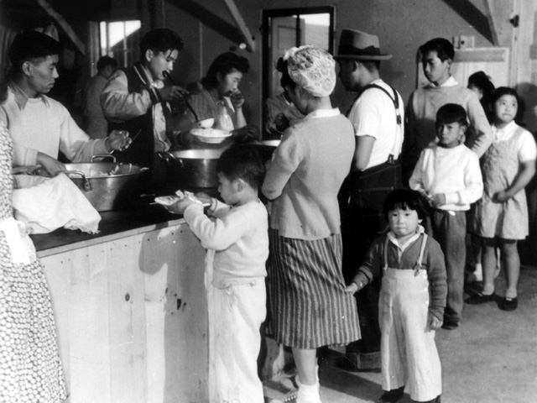 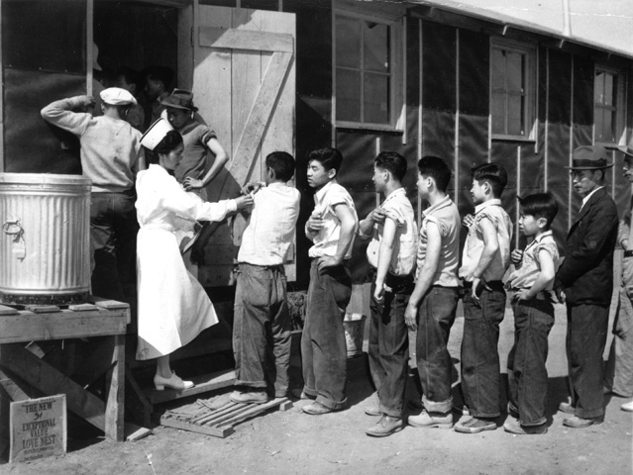

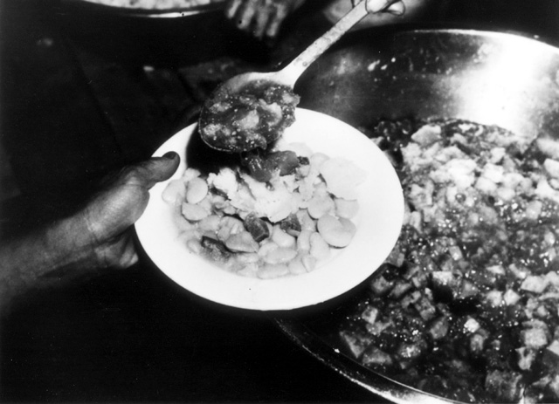 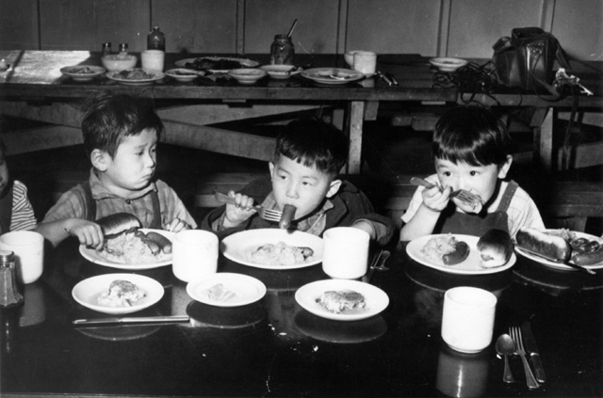



From 1942 to 1946, home for most Japanese Americans was one of 10 WRA camps, all patterned on military facilities. Hastily built, with tarpaper walls and no amenities, the barracks were hot in summer and cold in winter. Most did not meet minimal standards for military housing. A visiting judge noted that prisoners in federal penitentiaries were better housed.

"There was a lack of privacy everywhere. The incomplete partitions in the [latrine] stalls and the barracks made a single symphony of yours and your neighbors' loves, hates, and joys. One had to get used to snores, baby-crying, family troubles... The sewage system was poor, [and] the stench from the stagnant sewage was terrible." —Mine Okubo, *Citizen 13660*

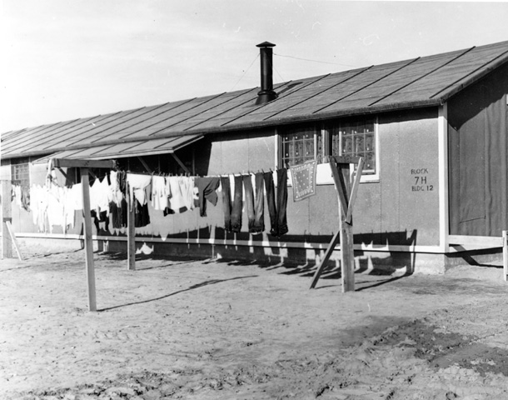 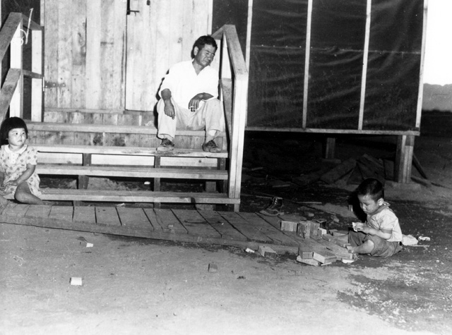

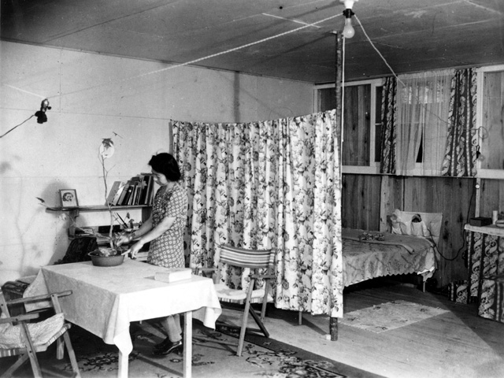



Internees were encouraged to work in camp-sponsored self-help programs. All of the relocation centers operated farms, and the food grown was often exchanged between camps. Camp administration offices also provided other opportunities for employing residents. The pay was low, ranging from $12 for a month of 48-hour weeks as an agricultural worker to $19 a month for physicians, dentists, and other professionals.

"The call went out for people with any kind of skill to offer their services. Thousands were responding, with great surges of community spirit, sometimes with outright patriotism, wanting 'to do their part.' Woody signed on as a carpenter. One of my brothers-in-law was a roofing foreman. Another ran a reservoir crew. Mama had worked as a dietician in Washington after she was married. In camp this was high-priority training... Nineteen dollars a month. This was top wage for an internee. Unskilled labor started at eight." — Jeanne Wakatsuki Houston and James D. Houston, Farewell to Manzanar

"Along the rows of barracks were planted victory gardens. Great care and attention were given to them by the owners, who were spurred by competitive pride. The best were those of former truck gardeners and nurserymen." —Mine Okubo, *Citizen 13660*

Work-release programs offered residents one route out of the camps. As early as May 1942, camp residents who were willing to work as field laborers were offered seasonal furloughs. Though elaborate investigations of "character" and "loyalty" were required of the participants, by 1943, 17,000 Japanese Americans had permanently left the WRA camps under the work-release program.

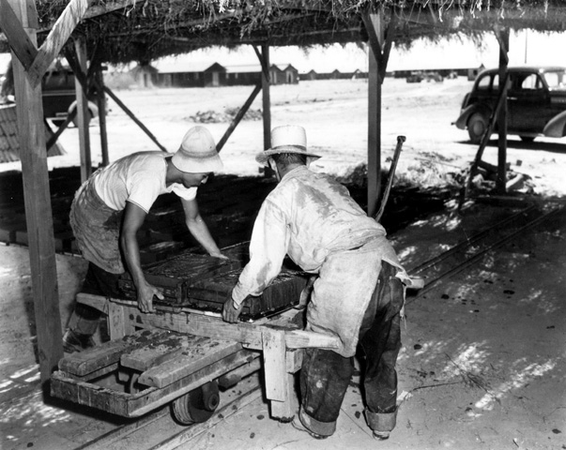 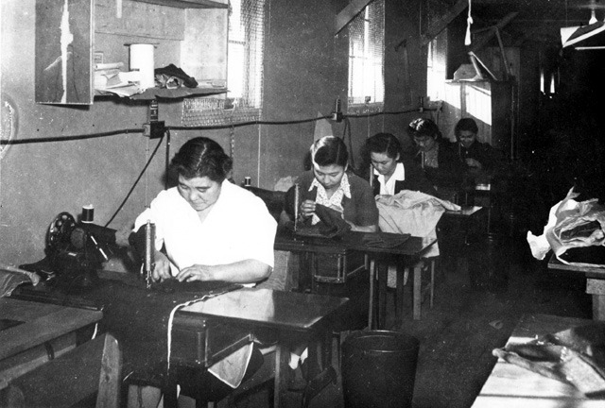 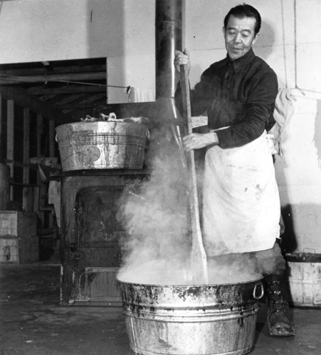

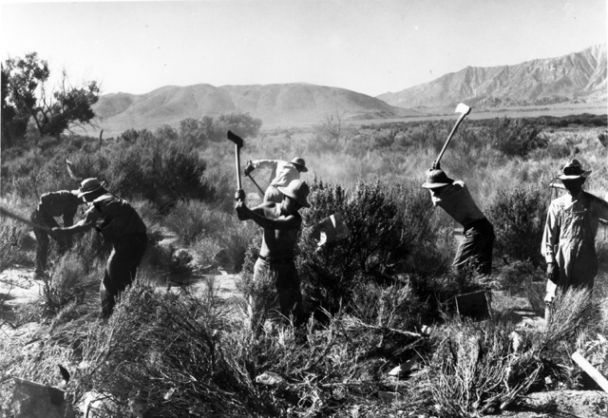 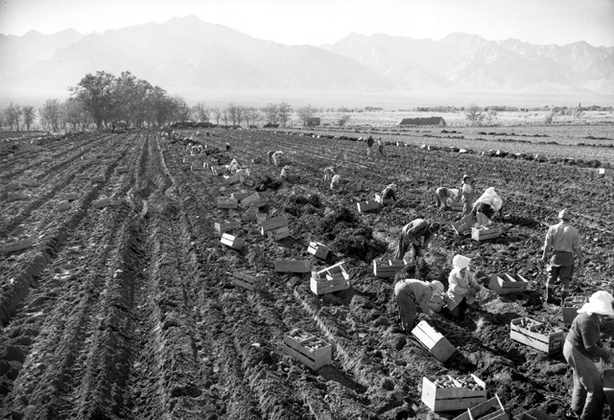

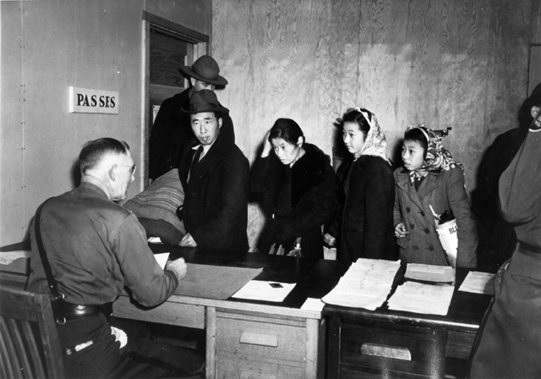



Life did continue behind the barbed wire. Though residents had been deprived of their most basic rights, Japanese Americans recreated a community structure that enabled them to live as normal a life as possible.

Civic associations, religious observances, Boy Scout troops, Parent Teacher Associations, dances, little theater companies and athletic competitions helped to ease the burdens of life in the shadow of the watchtower.

"Ping-pong, badminton, and cards were the important indoor games. Basketball, tennis, golf, football, and baseball were the outdoor games-baseball was the favorite sport." —Mine Okubo, *Citizen 13660*

Each camp functioned as a school district and offered educational programs from the first grade through high school. Caucasian administrators and teachers, and some qualified residents, were employed in these programs. Students and teachers faced a lack of appropriate books and teaching materials, typing classes with no typewriters, and other problems, but made do with what they had.

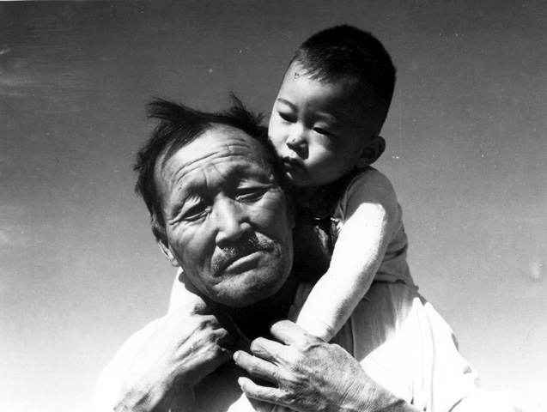 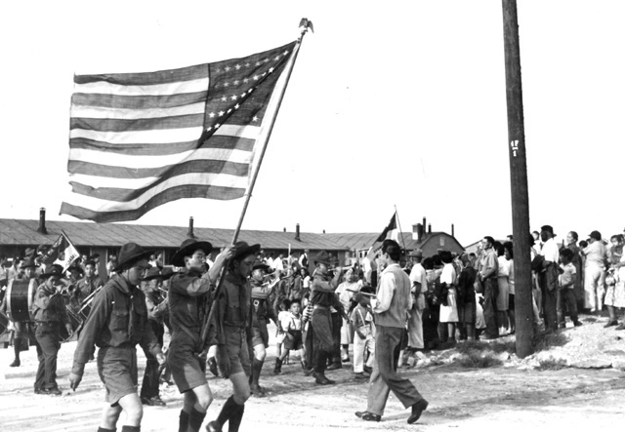

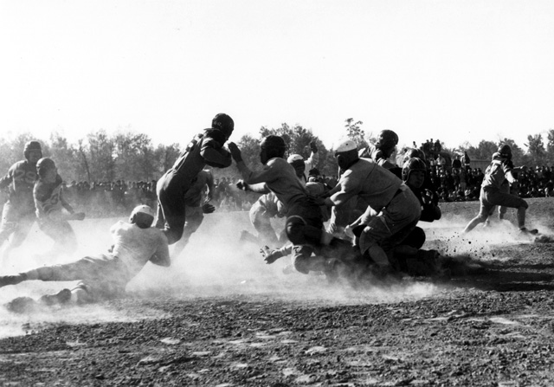 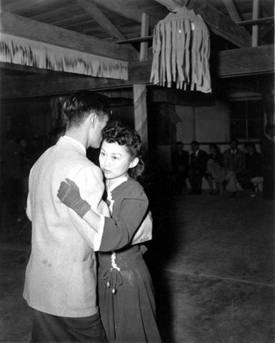

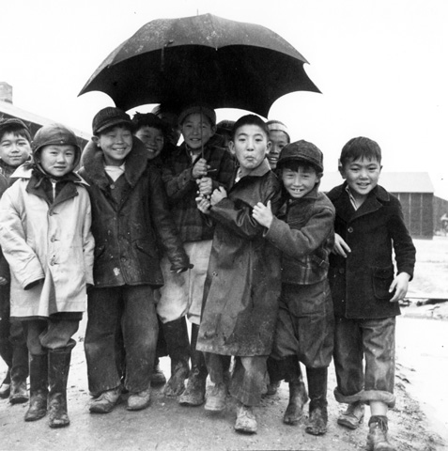 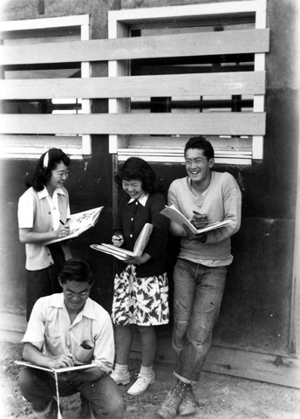

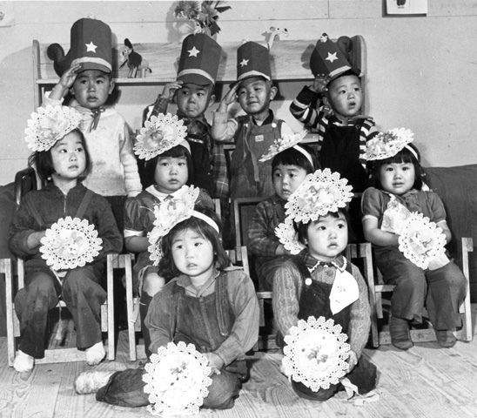



Education at the camps encompassed more than reading, writing and arithmetic. In many camps, professional artists offered art classes. All camp residents, adults and children, found themselves in an alien and threatening situation. The art created within the camps embodies their responses to life inside internment.

Internees produced a wide variety of arts and crafts objects from natural materials found in and near the camps. From Tule Lake shells to the native woods of Arkansas, Idaho, and Wyoming, local raw materials were transformed into graceful objects, some of which were shipped outside the camps to raise money.

"They had hobby shows in camp, very well received. Everybody in camp displayed their talents. They made use of everything in camp. Rocks, pebbles, fruit wrapping, seeds, cardboard, fence, anything they could find. Clever, beautiful, interesting." —Mine Okubo, *Beyond Words: Images from America's Concentration Camps*

The simple art of interned children seems to resonate all the loneliness and isolation experienced inside the camps, as well as the spirit of trying to continue a normal life.

"I taught art in camp to children... I remember the girls drew pictures about camp and camp life. The boys were more imaginative. Their pictures were on war, airplanes, circus, and subjects out of camp." —Mine Okubo, *Beyond Words: Images from America's Concentration Camps*

Pride and craftsmanship are obvious in many pieces of furniture manufactured in the camps. Using borrowed or homemade tools, artisans confined to the camps kept their skills alive and made life more comfortable for their families.

"Working largely with discarded scrap lumber, metal, and nails that they found on the grounds, they [JAs] handcrafted objects of great beauty. In addition, they made such functional items as bookends, trays, chests, bath clogs, ashtrays, and hats woven from grasses that grew in the camp grounds."—Yoshiko Uchida, *Desert Exile: The Uprooting of a Japanese American Family*

The Obatas of Berkeley, California, were among the thousands of families sent to the camps. Chiura Obata, a professional artist trained in Japan and a tenured member of the faculty at the University of California, Berkeley, kept a unique visual record of the experience. In a series of sketch books, Obata traced his family's journey from a registration center in Berkeley to the camp at Topaz, Utah.

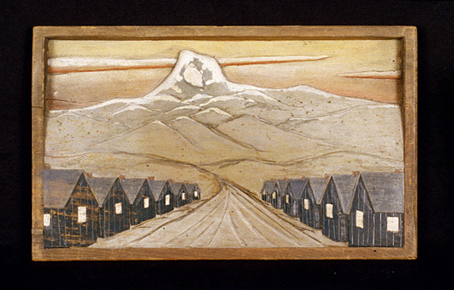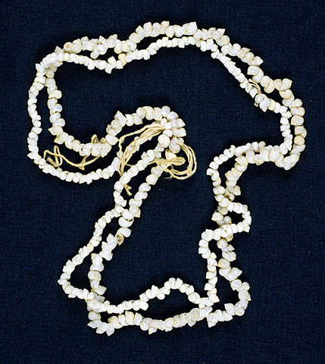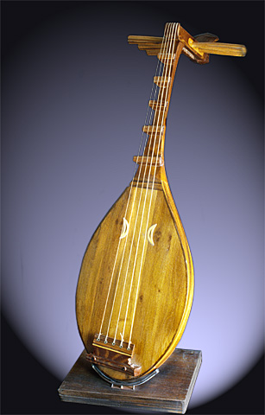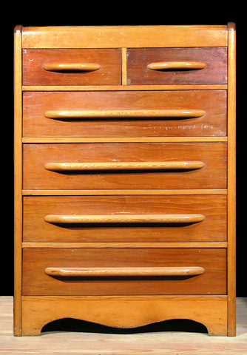



Japanese American internees struggled with the dehumanizing effects of being imprisoned, working to create as normal a life as possible behind barbed wire. But when the same government that questioned their loyalty to the United States simultaneously recruited internees to serve in the Army, the result was catalytic. Communities divided, splitting generations, families, and ideologies. Some internees chose to defy the United States government. Others chose to join its forces on the battlefields.

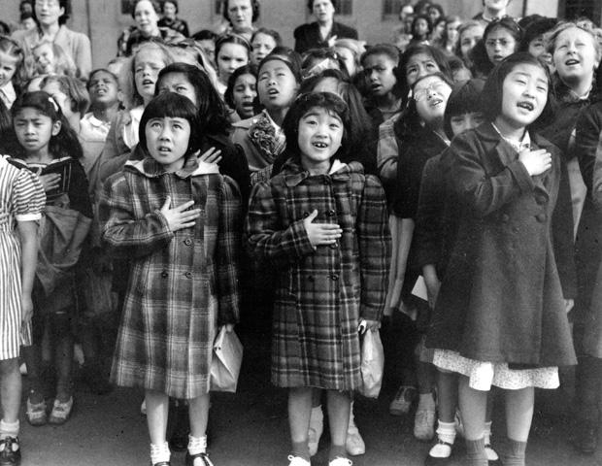



In 1943, every resident in the internment camps was required to complete one of two questionnaires misleadingly entitled "Application for Leave Clearance" to distinguish whether they were "loyal" or "disloyal". After Pearl Harbor, all citizens of Japanese ancestry had been classified 4-C: "enemy aliens." he first form was aimed at draft-age Nisei males, the second at all other residents. Many feared that even satisfactory completion of this second form might jeopardize them. If they were accepted as loyal, they might be forced to leave camp. Forbidden by law to return to their homes in the West Coast military zones, and with little or no money and virtually no hope of finding work, many internees chose to remain in camp. On both forms, Question 27 asked if an individual would be willing to serve as a combat soldier, nurse, or in the Women's Army Auxiliary Corps. This test of loyalty was by no means objective. For internees, military service would mean leaving parents and family behind in the harsh conditions of the camps. Japanese men had also been told they would serve in a segregated combat unit, a prospect many found distasteful. Finally, when the draft came to camp, many believed they should resist the draft as long as their constitutional rights were being violated.

Question 28 was even more complex: "Will you swear unqualified allegiance to the United States... and forswear any form of allegiance or obedience to the Japanese emperor, to any other foreign government, power or organization?" Many internees feared this question was a trap. Would a "yes" answer indicate that they had once sworn allegiance to Japan? Some refused to answer, or answered "no" to both questions, as a matter of principle. For Issei, who had been denied U.S. citizenship on the basis of race, the issue was even more complex, because either response could conceivably make them stateless. Almost 75,000 people filled out the questionnaires. A total of 6,700 answered "no" to questions 27 and 28. For this defiance, these residents were nicknamed "no-nos."

"Well if you want to know, I said 'no' and I'm going to stick to 'no'. If they want to segregate me they can do it. If they want to take my citizenship away, they can do it. If this country doesn't want me they can throw me out. What do they know about loyalty?" —Internee, Manzanar Community Analysis Report, 1943

"What kind of Americanism do you call that? That's not democracy. That's not the American way, taking everything away from people... Where are the Germans? Where are the Italians? Do they ask them questions about loyalty?" —Morris E. Opler, Manzanar Community Analysis Report, 1943

The loyalty forms aggravated existing tensions among camp residents. Some trusted the government, while others suspected that trick questions would be used as a basis for segregation, family separation, or other forms of punishment. Many residents, dispossessed and locked away behind barbed wire, chose the loyalty questionnaires as the issue on which to take a stand.

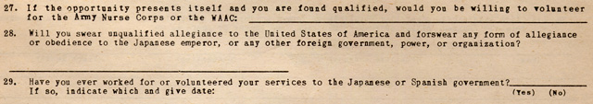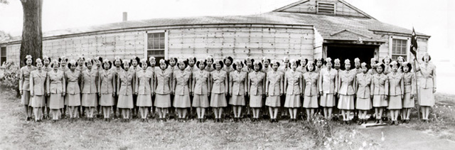

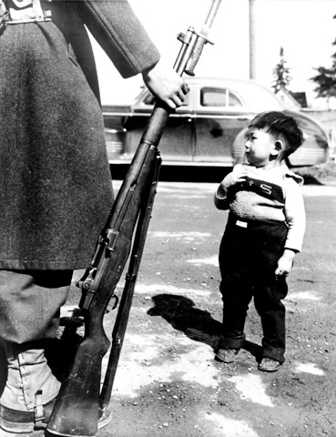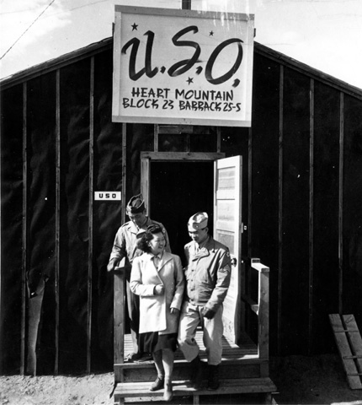



Japanese internees who proclaimed themselves loyal began the long road back to a normal life through the work-release program or military service. Those who vented their anger and frustration moved in a different direction — toward the repression and isolation of the segregation camp at Tule Lake, California.

The history of the Tule Lake camp was marked by "turmoil, idleness, impoverishment, and uncertainty," in the words of one resident. Strikers protested working conditions, riots broke out over food distribution, and the stockade quickly filled with angry, discontented men. Authoritarian tactics employed by security personnel served to make "martyrs" of protestors and increased agitation.

Of the 18,422 people finally incarcerated at Tule Lake, 69 percent were citizens, most of them minor children; 39 percent had requested repatriation or expatriation to Japan; 26 percent had answered the loyalty questionnaire "unsatisfactorily"; and 31 percent were family members of "troublemakers."

"The barbed-wire stockade surrounding the 18,000 people there [Tule Lake] was like that of the prison camps of the Germans. There were the same turrets for the soldiers and the same machine guns for those who might attempt to climb the high wiring..." —Chief Judge William Denman, Ninth Circuit Court of Appeals, Years of Infamy,1949

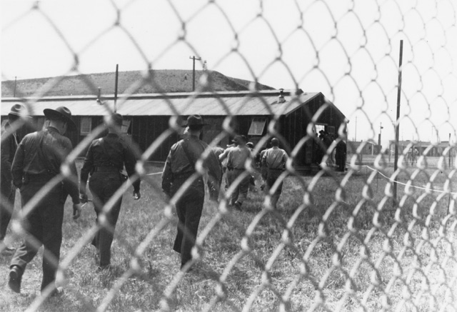 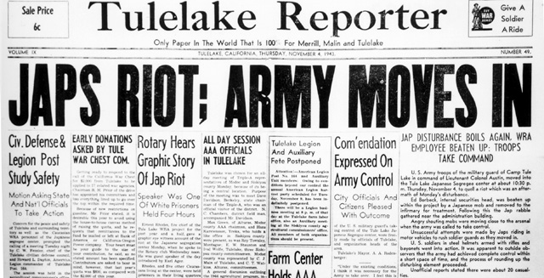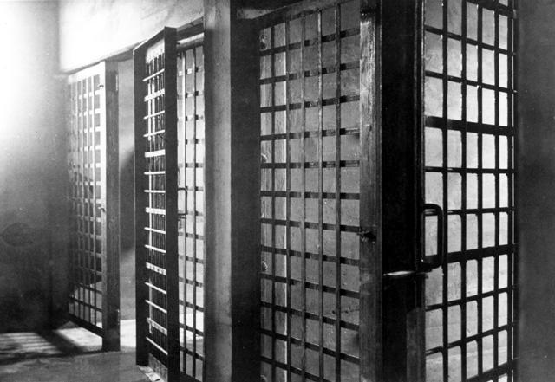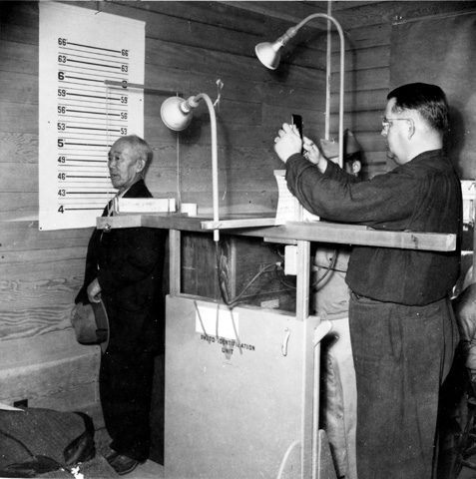

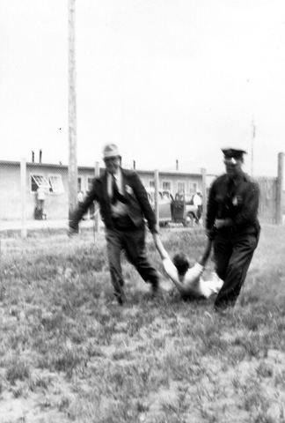 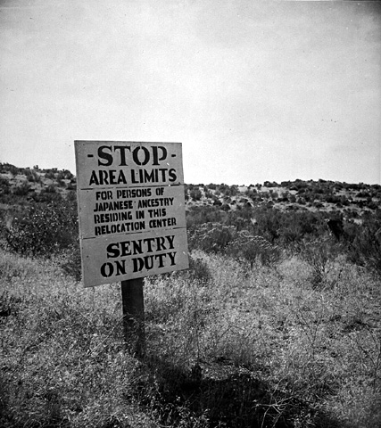 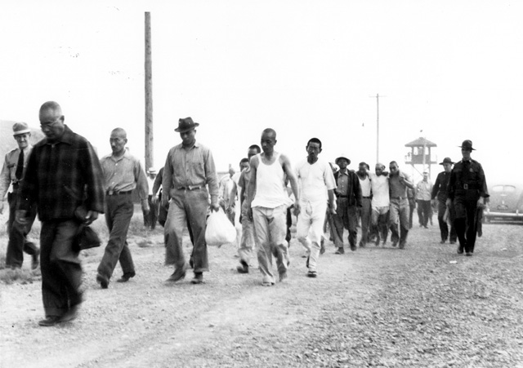



At the end of World War II, 4,724 Americans of Japanese ancestry were sent directly to Japan from the permanent War Relocation Authority camps. Within this group, 1,659 were resident aliens; 1,949 were American citizens, and all but 100 of these were children under the age of 20.

*"My sister and I were enrolled in a Japanese school in preparation for our eventual expatriation to Japan. Our teachers were generally pro-Japan and taught us not only how to read and write in Japanese but also to be proud as Japanese. Their goals were to teach us to be good Japanese so that we would not be embarrassed when we got to Japan."* —Japanese American student, Source unknown

*"And Tule Lake started wasshoi-wasshoi ('an exercise chant') running for exercise. About the summer of 1944, there were these seinendans ('young men's groups') beginning to form, and every morning in groups, they would do wasshoi-wasshoi. That to us was a very political thing — pro-Japan. That's understandable, considering they committed themselves to no-no..."* —Ben Takeshita, *And Justice for All*

A total of 1,116 adult Nisei also renounced their American citizenship. As Edward Ennis of the Department of Justice remembered: "They threw their citizenship back at us." The federal courts later ruled that the renunciations had been given under duress and were therefore void.

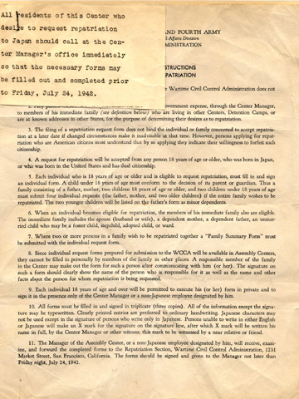

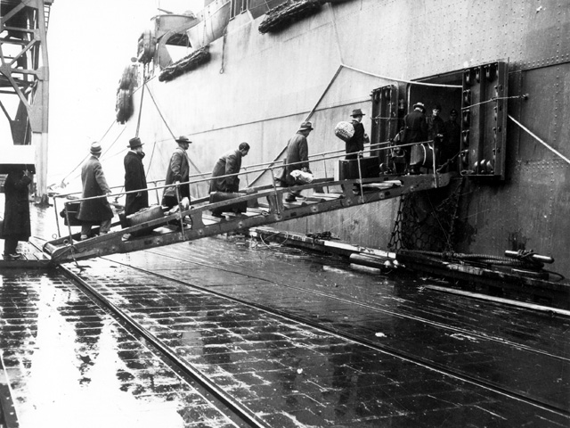 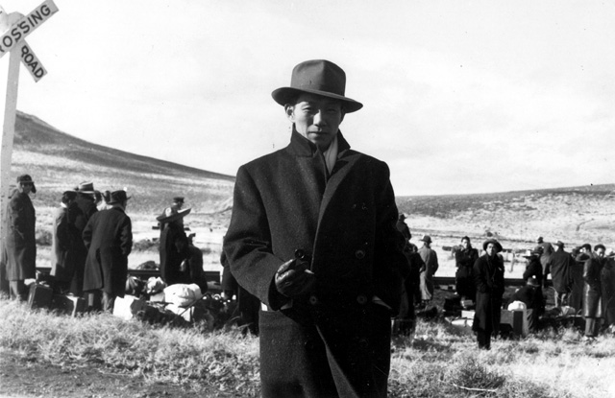



After Pearl Harbor, citizens of Japanese ancestry were classified 4-C, enemy aliens. In December 1943, it was announced that all Nisei would be reclassified and eligible for the draft. A total of 2,800 inductees were drawn from the camps in 1944 and 1945. Many young men viewed the action as a reinstatement of their rights as citizens and welcomed the opportunity to serve.

The draft of these Japanese American men did not bring about the closing of the camps, or the restoration of the rights and property of Japanese Americans. In protest, many Nisei refused to appear for their physicals. In all, 315 young men refused induction. Of this group, 263 were convicted of draft evasion.

Resistance to the draft was particularly strong at the Heart Mountain and Poston Camps. Sixty-three Nisei members of the Heart Mountain Fair Play Committee resisted the draft on constitutional grounds. The resisters were tried, convicted and sentenced to three years in federal prison. All appeals failed. Eventually, in 1947, President Truman pardoned all Japanese Americans who resisted the draft.

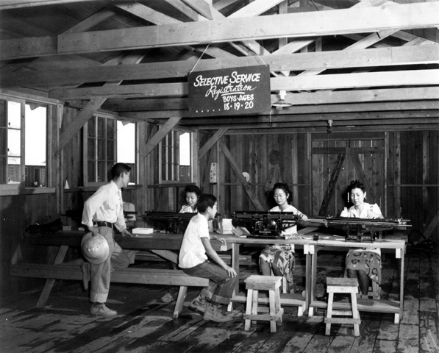 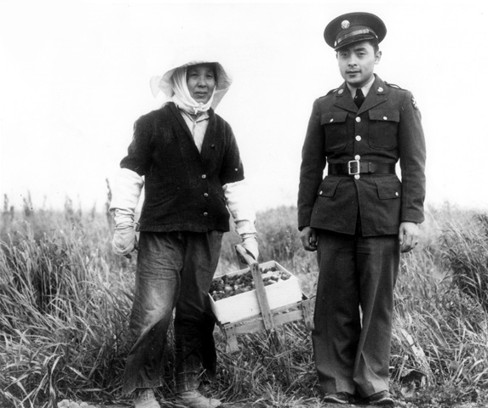

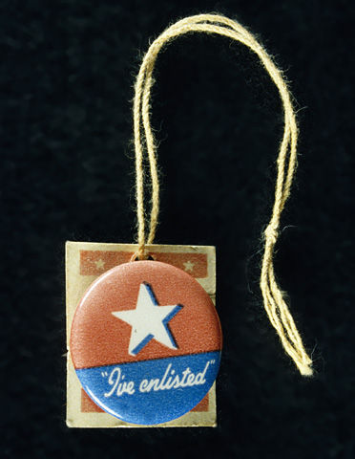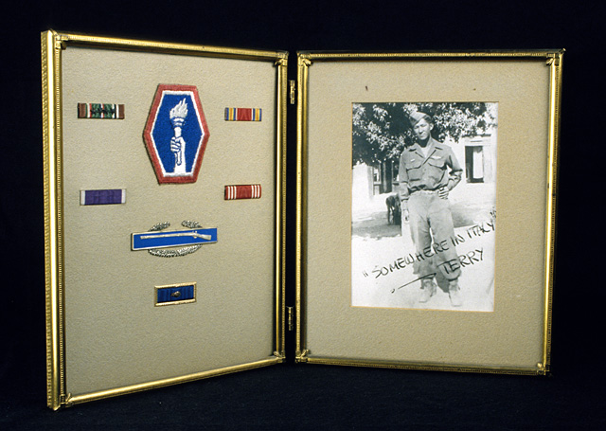

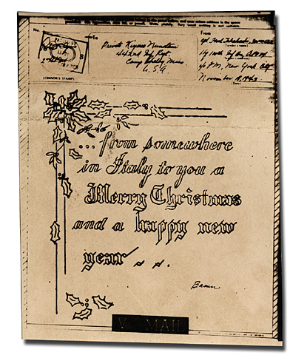 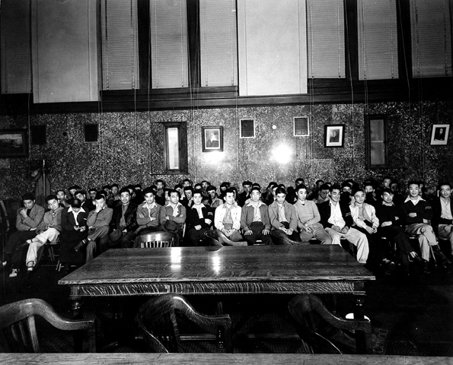



Some 25,000 Japanese Americans served in U.S. military units during World War II. The valor of these Americans, many of whom had family and friends living behind barbed wire, was extraordinary. Their combat record aided the post-war acceptance of Japanese Americans in American society and helped many people to recognize the injustice of wartime internment.

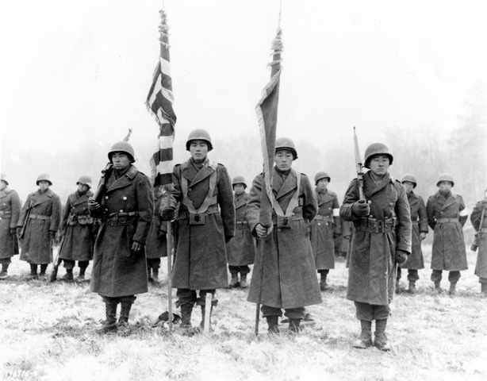

Within two months of the attack on Pearl Harbor, all American citizens of Japanese ancestry had been discharged from the Hawaiian Territorial and National Guard. The 100th Infantry Battalion, composed entirely of volunteers, came into existence because Americans of Japanese ancestry living in Hawaii demanded the chance to defend the United States. Members called it the "one puka puka", Hawaiian for one hundred.

After fighting their way up the Italian peninsula, the 100th would eventually be joined by the 442nd Regimental Combat Team, a second segregated Nisei military unit. The 100th/442nd saw action in Italy, Belgium, southern France, and Germany. At war's end, 680 members of the unit had been killed in action, 67 were missing, and 3,600 Purple Hearts including 500 Oak Leaf Clusters had been awarded for wounds suffered in combat. Their motto was, "Go for Broke."

On October 27, 1944, after 10 days of heavy fighting in southern France, the exhausted men of the 100th/442nd were awakened by orders to rescue the men of the 1st Battalion of the 141st Regiment, 36th Division, who had been surrounded by the Germans near Biffontaine. In the drizzle and darkness, the 100th/442nd moved out into an action that would be three days of hell on earth.

"In the battle for the lost battalion, every inch, every knoll and hill we took, we had to fight like hell. The Germans tried to stop us in every way... I know a lot of people say that it was a foolish campaign. But to me it was the pride of the Army... You can't allow a battalion to get surrounded and not do anything about it. You can't allow them to get wiped out." —Rudy Tokiwa, Go For Broke

*"Whenever you have been near enough to see these boys die for their country, then is the time to voice your opinion... When you have seen these boys blown to bits, going through shellfire that others refused to go through, sleep, when they could, in foxholes half full of water, and other horrors not to be mentioned — then is the time to voice opinion. Not before..."* —Letter from the "Red Bull" Division

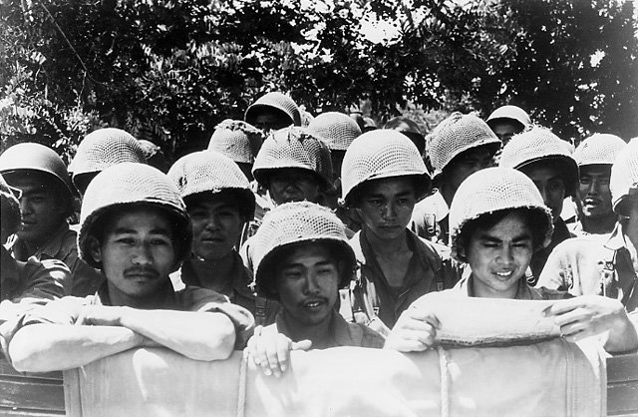 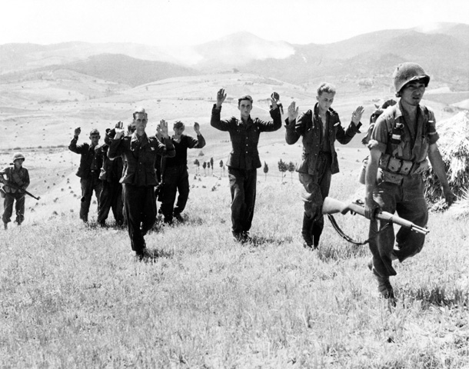

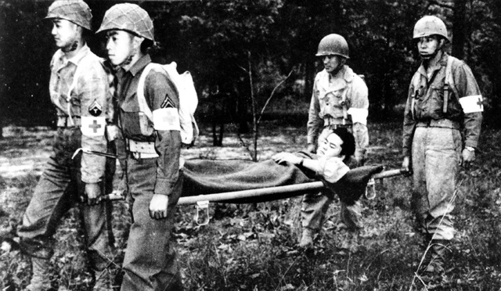 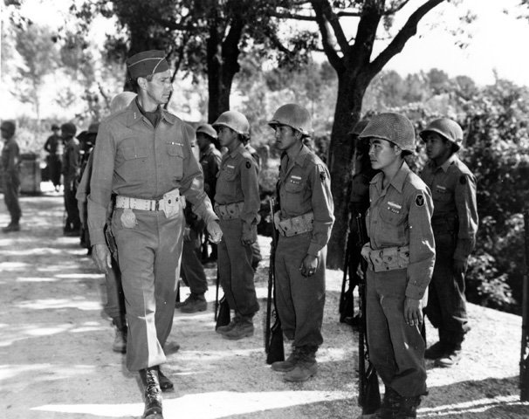



"First and foremost, they were Americans. They were like other American GIs... They ate K-rations and cursed the man who invented them. They blasted the guys in the rear echelons... They drank warm beer and were glad to get it."—Chet Tanaka, Go For Broke

Clothing the men of the 100th/442nd proved difficult. The average Japanese infantryman was 5' 4" in height and 125 pounds... The smallest standard sizes available were requisitioned. Even so, many of the uniforms had to be tailored after issue. In some cases WAAC blouses were ordered and cut down. Footwear posed a special problem; little could be done to alter a pair of combat boots. One man, Private Takeshi Kazumura of Hilo, Hawaii, wore size 2 1/2 EEE shoes. —Lyn Crost, Honolulu Star-Bulletin

"As far as food was concerned, [the Nisei soldiers] wanted a great deal more rice than was provided in the normal GI diet... When we were overseas, the supply and mess sergeants did everything they could, going to other units to exchange potatoes for rice..." —Lyn Crost, Go For Broke

The infantrymen of the combined 100th Battalion and 442nd Regimental Combat Team spent the majority of their time abroad in combat. Veterans attributed their constant willingness to engage the enemy to the support of their chaplains and medics. Men armed only with a prayer book or a medic's bag became an essential element in unit morale. To some members of the 100th/442nd these "non-combatants" were one of the U.S. Army's secret weapons.

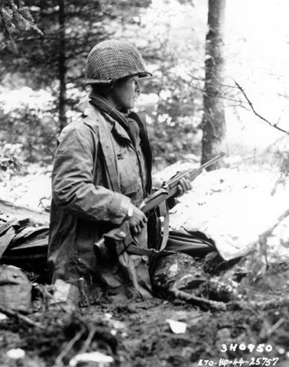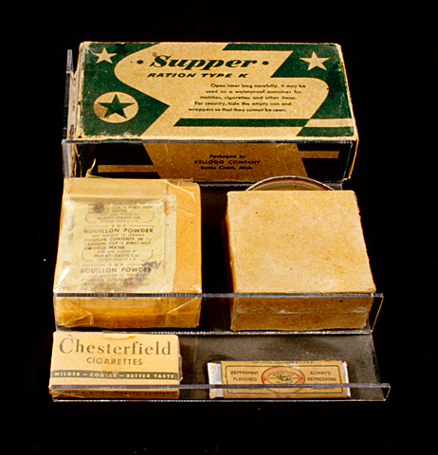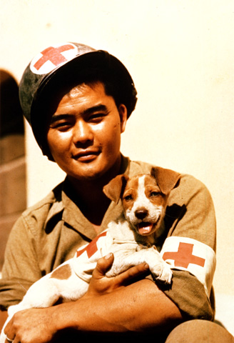



Like the Nisei who fought with the 100th/442nd in Europe, some 5,000 Japanese-Americans became Military Intelligence Service (MIS) language specialists. About 3,700 men were serving in combat zones in the Pacific and in Asia by August 1945.

Military Intelligence Service language specialists served as translators to intelligence headquarters in Hawaii, India, and Australia, and with combat units in the field. On-the-spot translations of captured documents, prisoner interrogations, and persuasion of Japanese soldiers and civilians to surrender were among the duties performed by Japanese American intelligence service troops.

MIS language specialists took part in every major Pacific campaign, seeing combat in New Guinea, the Marianas, the Aleutians, the Philippines, and on Iwo Jima and Okinawa. Their major accomplishments included translating captured communications call signs and code names for enemy naval and air units and bases. They also translated Japanese battle plans for the defense of the Philippines.

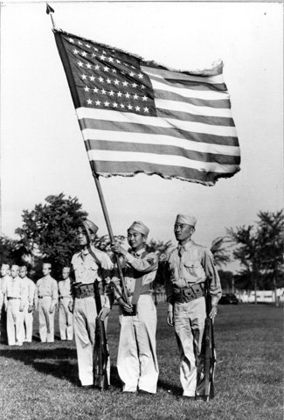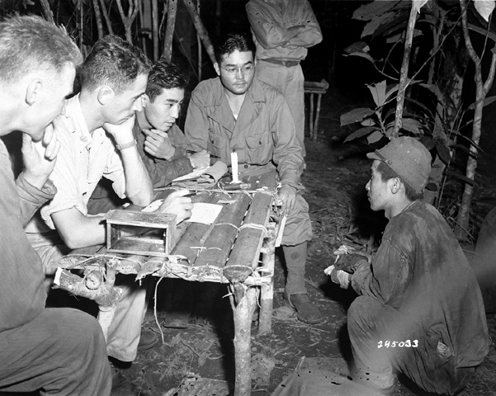

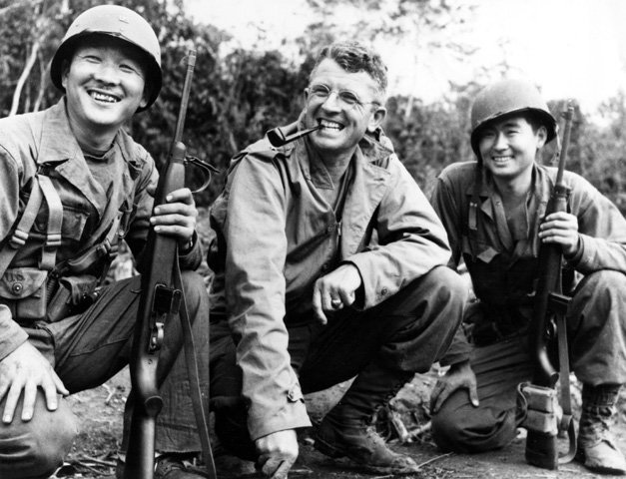



Never numbering more than 4,500 men, the 100th/442nd consisted of extraordinarily aggressive fighters. By war's end, the combined unit, composed almost entirely of Japanese Americans, was the most decorated U.S. military unit for its size and length of service. The soldiers of these units earned a total of 18,143 individual decorations and took a casualty rate of 300 percent.

**100th/442nd Unit Honors and Awards**  
7 Major Campaign Streamers  
7 Presidential Unit Citations  
36 Army Commendations  
87 Divisional Commendations  
Meritorious Service Plaques for Medical Detachment and Service Company  
  
**Individual Awards**  
1 Congressional Medal of Honor *  
52 Distinguished Service Crosses  
1 Distinguished Service Medal  
560 Silver Stars with 28 Oak Leaf Clusters  
22 Legion of Merit Medals  
16 Soldier's Medals  
4,000 Bronze Stars with 1200 Oak Leaf Clusters  
3,600 Purple Hearts including 500 Oak Leaf Clusters  
 **Foreign Awards**  
12 French Croix de Guerre with 2 Palms  
2 Italian Crosses for Military Valor  
2 Italian Medals for Military Valor  
  
*In June 2000, 20 additional Medals of Honor were awarded to men of the combined 100th/442nd Regimental Combat Team for their service during World War II.

When his squad leader was wounded, Private Sadao S. Munemori took command and led his men through a minefield to within 30 yards of a strongly entrenched machine-gun position. Armed with only a half dozen grenades, Munemori moved through the heavy fire and destroyed both machine guns and wounded two of the German gunners. Returning to his squad, a grenade bounced off his helmet. Munemori fell on the grenade and smothered the explosion with his body. The Medal of Honor commemorating Munemori's heroism was presented to his mother, Mrs. Nawa Munemori, on March 13, 1946.

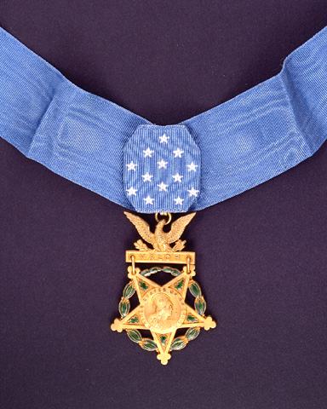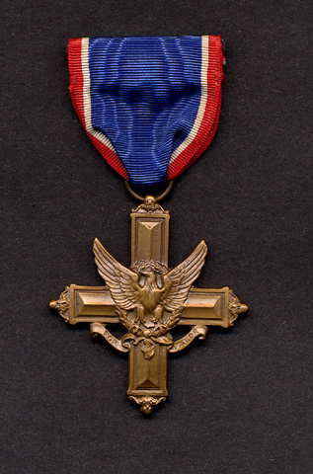 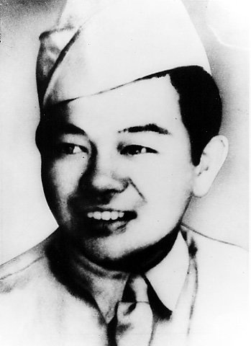



During the war, a gold star sewn on a service flag meant that a family member had been killed in service. Few images of America's participation in World War II are more poignant than that of the Japanese gold star mother or wife locked away behind barbed wire. The irony that Nisei soldiers were dying to preserve the world's freedom while their families were imprisoned is harrowing testament to their humanity in the face of prejudice.

"I was in uniform and went to visit friends in a relocation center. We checked in at the barbed-wire gate when…this guy pulls out his bayonet…mounts it on his gun and says, 'Okay Corporal, march.'... I took five steps, turned and said, ... 'You know I am in American uniform.' He said, 'Yes, I know that, but these are my orders.' So I took a swing at him…Miyamoto and the other guy held me back." —Speaker Unknown, *Go For Broke*

The original patch designed by War Department artists for the 442nd Regimental Combat Team showed a yellow arm holding a blood-red sword aloft. Dissatisfied with the racial overtones of the design, the Nisei volunteers produced one of their own. It depicted a silver hand holding the torch of liberty aloft. By August 1945, 18,000 Japanese American soldiers wore the patch with pride.

"I think we all felt that we had an obligation to do the best we could and make a good record. So that when we came back we can come back with our heads high and say, Look, we did as much as anybody else for this country and we proved our loyalty; and now we would like to take our place in the community just like anybody else and not as a segregated group of people. And I think it worked." —Speaker Unknown, *Go For Broke*

"Most of the Nisei want to fight in the Pacific. They believe that, raised in the institutions of democracy, they are better soldiers than Japanese of their own generation...Thus far they have won every fight they have been in. But their hardest fight of all is still ahead and may outlast the war. It is the fight against prejudice roused by color of skin and slant of eye. It is easy to admire them while they are still in uniform. It would be kinder to remember and reward them when the battle is over." —Editorial, *Pacific Citizen*, April 1945

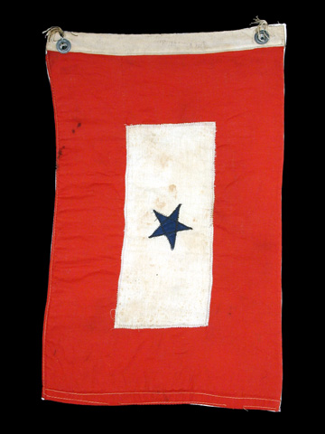 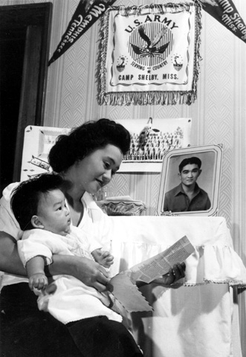

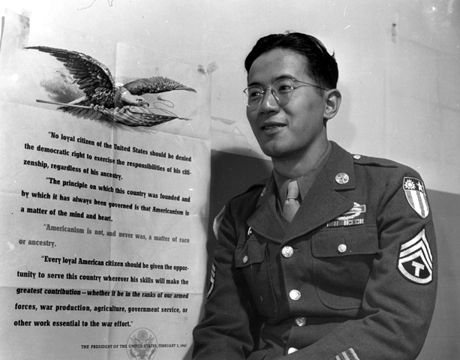 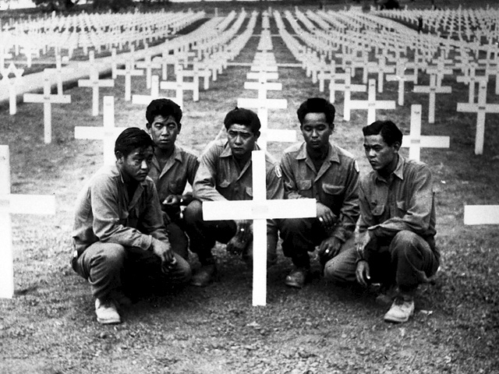



|  |
| --- |
| [http://americanhistory.si.edu/perfectunion/non-flash/images/thumb_justice.jpg](javascript:popImage(1317)) |

By 1946, Japanese Americans were released from the internment camps, but the injustice of the war years was not forgotten. Many members of the Japanese American community were determined to create a public understanding of the injustices they had suffered and to resolve the basic Constitutional issues related to their wartime incarceration. More than forty years after internment, the U.S. government finally acknowledged its wrongs with a formal apology to the Japanese American community, and passage of the Civil Liberties Act in 1988.



On December 17, 1944, Public Proclamation Number 21 ended the mass imprisonment of Japanese resident aliens and American citizens of Japanese ancestry. On the following day, the U.S. Supreme Court ruled in the case of Ex Parte Endo that claims of military necessity could not justify holding American citizens against their will. This ruling eventually would have ended the relocation program, and government officials were well aware the ruling was coming when it issued the proclamation.

Rejoining society was difficult for many. Each individual received a $25 payment and transportation tickets at the time of release. Many detainees discovered that their pre-1941 communities had vanished, and their homes and businesses were lost.

The postwar housing shortage, the competition for jobs with returning veterans, and lingering discrimination added to the difficulties. In some West Coast communities there was a special effort to welcome old neighbors home. In other areas, there were episodes of vandalism and threats against life and property.

"That which happened to the Japanese on the West Coast must not happen again... to any minority group... I am convinced that if some form of token justice is not done to the wronged loyal Japanese of the U.S., that the U. S. will be the sufferer in the long run. Not from the Japanese-rather from internal instability... A frank admission and attempt at retribution will give America more than a thousand 'slurring-overs'... I yet maintain, that in Truth there is strength... a strength that will stand the test of time and endure for the good of all." —Letter from Sgt. Chester Tanaka to friends in St. Louis, 1944

Japanese Americans began the fight for monetary compensation for losses as a result of evacuation through the early 1948 claims act, and later through a 1983 Class Action lawsuit. *Hohri et al vs. the United States*, which asked for $25.2 billion in damages from the Federal government as redress for the wrongs done to Japanese Americans during and after World War II, was set aside following the October 1988 passage of the Civil Liberties Act of 1988.

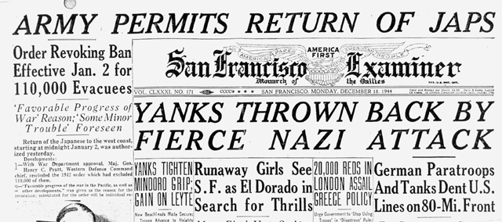

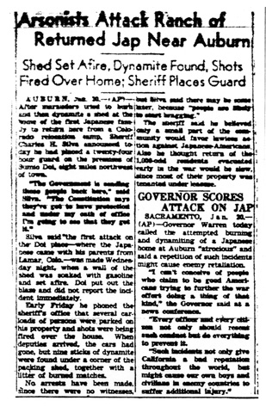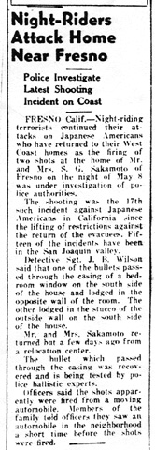

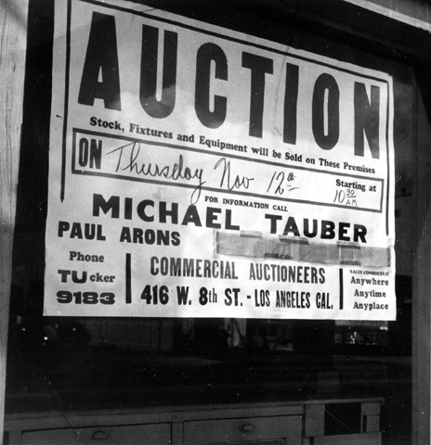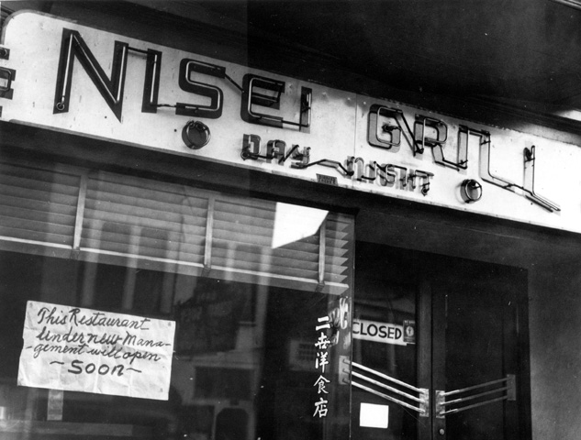



Four major court cases testing the constitutionality of wartime treatment of Japanese American citizens reached the U.S. Supreme Court in 1943 and 1944. Lawsuits brought by Minoru Yasui, Gordon K. Hirabayashi, and Fred T. Korematsu related to violations of curfew and other discriminatory regulations imposed on Japanese Americans prior to relocation.

In these cases, the justices chose to rule narrowly on the specific issues, rather than consider larger Constitutional issues of relocation. Accepting government justifications of national security and military necessity, the Supreme Court refused to block Executive Order 9066 and the programs it generated.

Mitsuye Endo's case challenged the public law of March 21, 1942, which empowered military authorities to impose a curfew, but did not mention detention. The Supreme Court ruled that military authorities had exceeded the scope of the law by imprisoning loyal American citizens. Ms. Endo and other internees could not be barred from access to writs of habeas corpus — the Constitution's guarantee to a swift hearing in which specific accusations would have to be stated.

The US Supreme Court justices who ruled on the four cases were divided over the constitutional issues in question. These differences were reflected in the legal opinions they offered on the Japanese American cases.

*"We must credit the military with as much good faith as we would any other public official. We cannot sit in judgment of the military requirements of that hour."* —Associate Justice William O. Douglas, Concurring Opinion, *Hirabayashi v. U.S.*, 1943

*"The broad provisions of the Bill of rights... are [not] suspended by the mere existence of a state of war. Distinctions based on color and ancestry are utterly inconsistent with our traditions and ideals. Today is the first time, so far as I am aware, that we have sustained a substantial restriction of the personal liberty of citizens based on the accident of race or ancestry. It bears a melancholy resemblance to the treatment accorded to members of the Jewish race in Germany. This goes to the very brink of constitutional power."* —Associate Justice Frank Murphy, Concurring Opinion, *Hirabayashi v. U.S.*, 1943

*"This is not a case of keeping people off the streets at night as was Hirabayashi...It is a case of convicting a citizen ... for not submitting to imprisonment in a concentration camp solely because of his ancestry."* —Associate Justice Owen J. Roberts, Dissenting Opinion, *Korematsu v. U.S.*, 1944

*"[There have to be] definite limits to military discretion, especially where martial law has not been declared. Individuals must not be impoverished of their constitutional rights on a plea of military necessity that has neither substance nor support."* —Associate Justice Frank Murphy, Concurring Opinion, *Ex Parte Endo*, 1944

As early as 1945 Eugene V. Rostow of the Yale Law School Faculty referred to the Supreme Court decisions as "our worst wartime mistake." "The basic issues," he urged, "should be presented to the Supreme Court again, in an effort to obtain a reversal of these wartime decisions." In American law, however, the principle of finality normally bars a reconsideration of a Supreme Court decision. Reinterpretation of the Court's decision usually occurs in another case covering the same legal principle. The incarceration of Japanese Americans was, however, a unique event. As a Presidential Commission noted in 1980, "the country has not been so unfortunate that a repetition of the facts has occurred to give the Court that opportunity." In belated recognition of the injustice done to the innocent Japanese Americans, President Gerald R. Ford made a formal apology to them in 1976. In January 1983, a legal team filed a writ of *coram nobis*, offering them the possibility of overturning the 1944 decisions of the Supreme Court, which seeks to correct an injury caused by a mistake of the court. The writ charged that in 1943-1944 federal officials had deliberately altered, suppressed, and concealed crucial evidence in prosecuting the case against Fred Korematsu. Similar writs were later filed on behalf of Minoru Yasui and Gordon Hirabayashi.

Minoru Yasui died before action was taken in his case. In 1984, the U.S. District Court for Northern California set aside Fred Korematsu's 1944 conviction. Three years later, the United States Court of Appeals for the Ninth District handed down a similar decision in the Hirabayashi case. As a result of these decisions, the Supreme Court of the United States did not have an opportunity to reverse the original 1944 rulings on the basic constitutional issues involved.

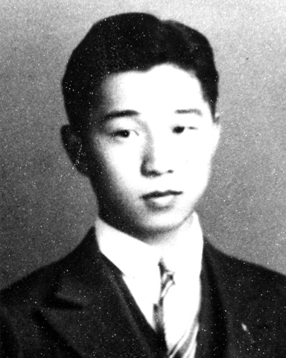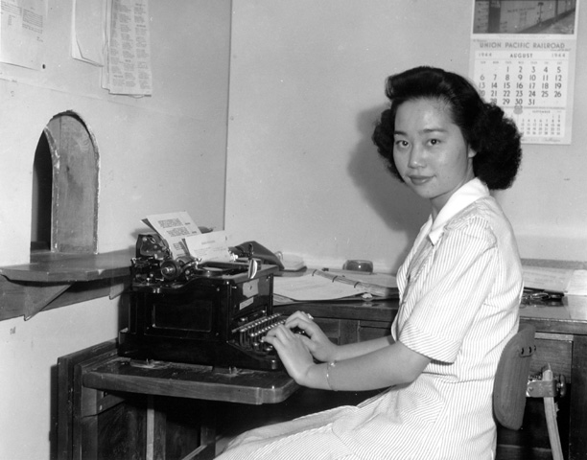

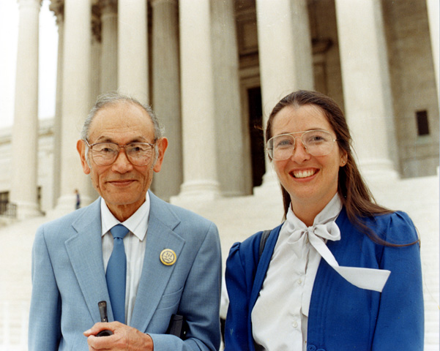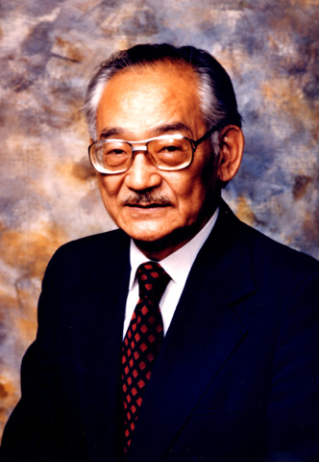



In addition to seeking to correct justice in the courts, Japanese Americans sought legislative redress for the injustice, hardships, and suffering that resulted from wartime incarceration. For these fundamental violations of the basic rights of individuals of Japanese descent, Congress apologized on behalf of the nation. Success came with the passage of the bill H.R. 442 by the 100th Congress. On August 10, 1988, President Ronald Reagan signed that bill into law; it is now known as the Civil Liberties Act of 1988.

Much of the impetus for this legislation came from the investigations and report of the Federal Commission on Wartime Relocation and Internment of Civilians, working between 1980 and 1982. The Commission concluded that the Japanese American internment was a wartime injustice based on "race prejudice, war hysteria, and a failure of political leadership," not on military necessity.

The Office of Redress Administration that oversaw the distribution of redress payments officially closed by operation of law on February 5, 1999. By that time, they had verified and delivered redress payments to 82,220 claimants. There remain a number of claimants unpaid due to failure to submit necessary paperwork. These cases are still filed as "pending" for future processing in the event that additional funding is obtained through legislation.

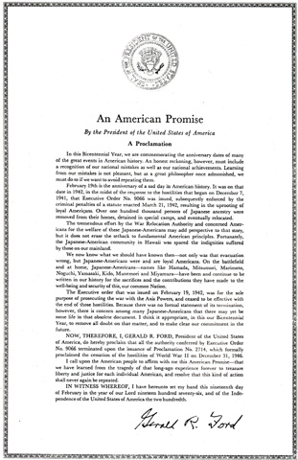

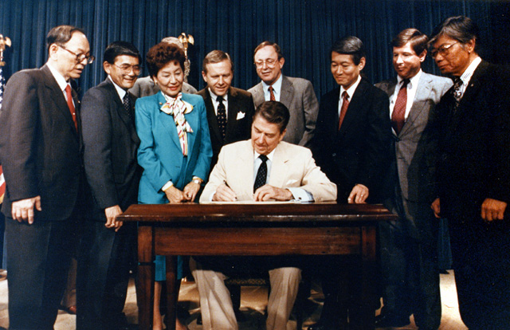



The wartime experience of Americans of Japanese ancestry holds important lessons for all Americans. Japanese Americans demonstrated the importance of courage in adversity, loyalty to the highest ideals of the U.S. Constitution, and the ability of determined citizens to effect positive change. Through their struggle to ensure that all Americans understand the importance of extending the safeguards and protections of the Constitution to every citizen, regardless of race, color, or creed, they have moved all of us a bit closer to that "More Perfect Union" envisioned by the founders of the nation.

Prior to World War II, no American of Japanese ancestry had ever held a major state or national elective office. Since 1952, Japanese Americans have filled important posts throughout local, state, and federal governments. Post-war Nisei political involvement began at the local level, as returning veterans and former camp inmates won election to city councils and state and territorial legislatures. Americans of Japanese ancestry played a particularly important role in the Hawaiian statehood movement.

Authorized by an Act of Congress in 1992, the National Japanese American Memorial Foundation (NJAMF) constructed the National Memorial to Patriotism to honor the courage and loyalty of Japanese Americans under extraordinary circumstances during World War II. It also honors the nation itself, for its admission of error to the citizens of the United States, and its formal apology to Japanese Americans through the Civil Liberties Act of 1988. The memorial opened to the public in June 2001.

"You may think that the Constitution is your security — it is nothing but a piece of paper. You may think that the statutes are your security — they are nothing but words in a book. You may think that elaborate mechanism of government is your security — it is nothing at all, unless you have sound and uncorrupted public opinion to give life to your Constitution, to give vitality to your statutes, to make efficient your government machinery." Charles Evan Hughes, Chief Justice, U.S. Supreme Court

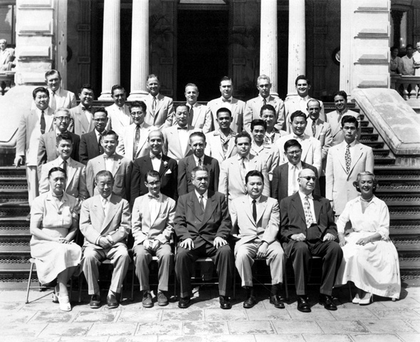 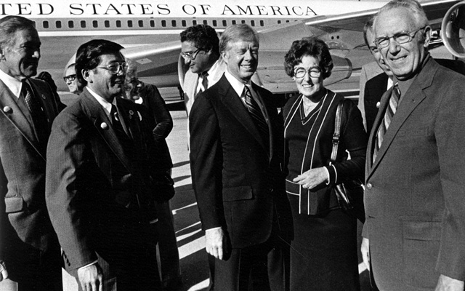

 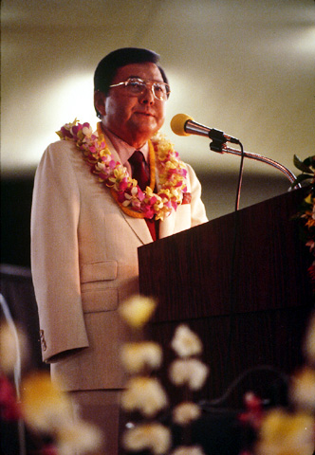

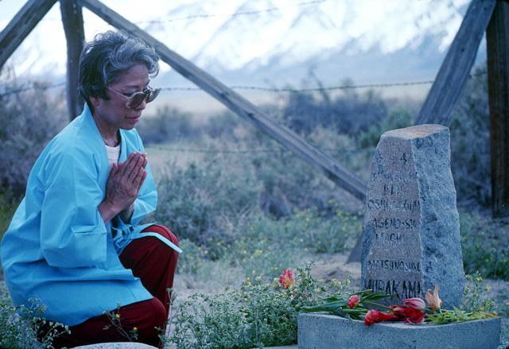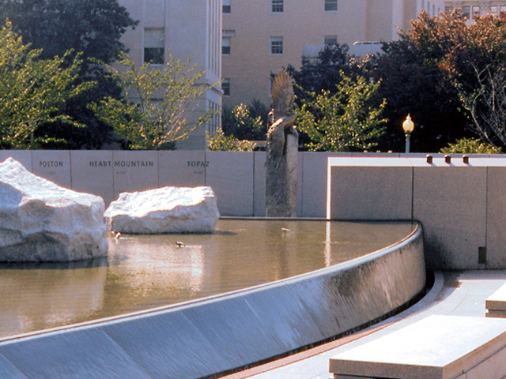

**Postscript from the Smithsonian**

The National Museum of American History, Behring Center opened the exhibit "A More Perfect Union" in celebration of the bicentennial of the U.S. Constitution in 1987. A traveling exhibit with the American Library Association then launched its tour between 1995-1998. The themes presented in this exhibit still resonate today: its story, lessons, and poignancy provide insight in a world of uncertainty and a time of national crisis. The events following the September 11, 2001 terrorist attacks on the U.S. have reminded the nation of the frailty of individual rights balanced with the need for national security. More than ever, the country needs to be mindful of the Constitutional rights of every citizen, regardless of race, color, or creed. We hope that you have enjoyed this "virtual" exhibit and hope that you will visit the physical exhibit at the Smithsonian.

**Internment Remembered by Carl Mydans**

*Posted in the Philippines for* Life *magazine in 1941, photojournalist Carl Mydans and his wife Shelly, a writer, were interned when the Japanese overran the islands. Repatriated in a prisoner exchange in December 1943, Mydans photographed a* Life *story on the Tule Lake, California, relocation center, then returned to the war, first to Europe and then to the Pacific. He was on hand to photograph the liberation of his fellow prisoners when Manila fell to General MacArthur’s forces. Mydans is surely one of the few surviving Americans who, having been interned by the Japanese, also saw firsthand the grim camps into which our government herded its own citizens. Following are some of his reflections, 50 years after Pearl Harbor [1991].*

In World War II more people became prisoners than ever before in history, and I was one of them. When the Japanese took Manila, they used the campus of Santo Tomas University as a civilian prisoner camp, interning 3,600 of us there, beginning January 2, 1942.

We were for the most part Americans, although there were many British and some Dutch, Poles, Norwegians, Spaniards, French and Egyptians- all of us “enemy nationals” in Japanese terminology. The invading army, surprised by its swift advance, had no plans to provide for large numbers of civilian prisoners. Its soldiers rounded up all Caucasian men, women, and children who fell into their hands as the battle raged past them.

We were taken from our homes and hotels, put into captured US Army trucks marked “Keep ‘Em Flying”- a reminder of our defeat and humiliation- and deposited at Santo Tomas where we were herded into empty classrooms with concrete floors, each marked in Japanese and English: “Forty women” or “Forty men.” Other than that there were no directions, no organization, no sleeping bunks, few working toilets, no arrangements for children and no food.

Not for three months did they feed us. It wasn’t that they wanted to starve us. It was just that battle plans did not include the care and feeding of prisoners. We lived on the food we carried in with us and what our Filipino friends threw over the fence to us while they were beaten and threatened by the Japanese guards for their loyalty to us.

At first we were disoriented and dismayed. Then we began to build a community in which it was possible to live, electing a prisoner committee to deal with our guards, calling on the Philippine Red Cross to bring in sacks of rice and cracked wheat from their bodegas, setting up a kitchen to serve two means a day, enlarging the toilet facilities and building showers, establishing a tiny clinic for the sick and a separate building for the women with small children. We started classes for school children and adults, held church services and published a prison newspaper. And the Japanese, who did nothing for us, watched with interest and growing respect for these American skills.

In those few early months the war raged over Bataan and Corregidor only a few miles away, while we, so close together in our barbed-wire prison, watched as waves of planes swept over in attacks against our forces. And when Bataan fell and the Japanese marched thousands of wasted, wounded and dying Americans and Filipinos in the Death March to what were to be their death camps, many passed on streets that were almost within earshot, and our camp was in despair. But we never lost our deep certainty that in the end we would win the war and regain our self-respect.

Our relationship with our captors was clear and simple: we were enemies. When Corregidor fell and American troops were to be paraded through the streets of Manila, our camp commandant called me to his office and offered me freedom to photograph them. He said that my wife and I would be released and given a house to live in. I asked him what he would think of a Japanese in America who worked for the US Army, and he sucked in his breath and nodded. “I understand,” he said, and I was not pressed further. We both knew and respected the fact that we were enemies.

My wife and I were in Santo Tomas for nearly a year. Then we were taken on a Japanese troop transport to Shanghai, where we were put into another prison camp in Chapei. After another year there, we were included in an exchange of 1,500 Americans and Canadians for 1,500 Japanese in America.

The first story *Life* sent me to cover was the large internment camp of Japanese and Japanese-Americans at Tule Lake, California. There I found myself again in a world bounded by barbed wire and among people who were walking listlessly and carrying on their lives without seeming purpose. Once again I felt the uselessness and degradation that overcome prisoners of war.

They were housed better than I had been and fed three meals a day. But the vast difference was that none of them was ever shown to be our enemy. They were men, women, and children who had made their home in America. Most were American born.

We suffered from confinement, overcrowding and starvation, but we never doubted who we were or that in the end we would be liberated by our own forces. They suffered from uncertainty, self-doubt, and the torment of injustice.

**READINGS- Decision to Drop the Bomb**

The Falling Sun: Hiroshima by Fletcher Knebel and Charles W. Bailey III

*Although the country was already in a condition of semi-mobilization in December 1941, it took a year before the United States was ready to fight a total war. At last, in November 1942, an American expeditionary army landed in North Africa and went on to help the British whip German Panzer divisions there. After that an Anglo-American force invaded Sicily and drove on to the Italian mainland.*

*Then on D-Day, June 6, 1944, an Allied invasion force- the largest ever assembled- landed at Normandy, France, in what turned out to be the beginning of the end for Hitler’s Third Reich. Thanks to German errors and Allied planning and execution, the invasion was a success. With a foothold in Normandy, American, British, and French armies drove a wedge into German defenses and poured inland. As the Western Allies pushed toward Germany from the west, Russian armies drove in from the east. By May 1945- less than a year after D-Day- German resistance had collapsed and the once mighty Reich was a smoldering ruin.*

*Meanwhile, the United States had moved from a holding action in the Pacific to an aggressive, two-pronged island-hopping campaign. It began in November 1943, with Admiral Chester Nimitz’s forces attacking at Tarawa and Kwajalein and General Douglas MacArthur’s command breaking through the Japanese barrier on the Bismarck Archipelago, islands in the South Pacific. Eventually, MacArthur recaptured the Philippines and drove toward Manila, while Nimitz pushed toward Japan from the central Pacific.*

*Japan fought back desperately, sending out kamikaze planes to slow the American advance. They took a terrible toll: 34 American ships sunk and 288 damaged. But the “Divine Wind” vengeance that the kamikazes represented also cost the Japanese heavily: their loses were estimated at 1,288 to 4,000 planes and pilots. Moreover, they could not stop American army and naval forces, which moved on relentlessly, capturing Iwo Jima and then Okinawa, located just south of Japan itself.*

*From Okinawa, the United States planned to launch an all-out invasion of the Japanese home islands, to begin sometime in November 1945. General MacArthur thought relatively light casualties would be sustained in the initial fighting but ultimately the losses would be staggering- especially if it took a year to break Japanese resistance, as some experts predicted. General George Marshall estimated that the invasion would cost the United States a half-million men.*

*But the invasion never took place, because the United States soon had an awesome and terrible alternative. On July 16, 1945, after three years of top-secret development and production, American scientists successfully detonated an atomic bomb in the New Mexico desert. Some scientists involved in the project urged privately that a demonstration bomb be dropped on an uninhabited island. But an advisory committee of scientists opposed any such demonstration and recommended that the bomb be used against Japan at once. Secretary of War Henry L. Stimson emphatically agreed: the bomb would kill thousands of civilians, he argued, but it would nevertheless shock Japan into surrender and save a half-million American lives.*

*The final decision lay with Harry Truman, who became president after Roosevelt died of a brain hemorrhage in April 1945. “I regarded the bomb as a military weapon and never had any doubt that it should be used,” Truman later wrote. “The top military advisers to the president recommended its use, and when I talked to [British Prime Minister Winston] Churchill he unhesitatingly told me that he favored the use of the atomic bomb if it might aid to end the war.” On July 25, Truman ordered that atomic bombs be dropped on or about August 3, unless Japan surrendered before that date. Then the United States, Great Britain, and China sent the Japanese an ultimatum that demanded unconditional surrender. The Japanese made no official reply. When August 3 passed and Japan fought on, Truman’s orders went into effect, and American B-29’s unleashed two of the “superhuman fireballs of destruction”- the first on Hiroshima, the other on Nagasaki- that forced Japan to surrender. Thus, the Pacific War ended as it had begun- with a devastating air raid. You may find it profitable to compare the Pearl Harbor air raid, a sneak attack against military targets, with the nuclear blast at Hiroshima, which annihilated civilian and military sectors alike.*

*Since then, many critics have questioned the wisdom of Truman’s decision, contending that the bomb was not the only alternative open to him in July and August. They point out that the invasion of Japan was not scheduled until November, so Truman had plenty of time “to seek and use alternatives.” He could have sought a Russian declaration of war against Japan, or he could have ignored the advisory committee of scientists and dropped a demonstration bomb to show Japan what an apocalyptic weapon it was. He had another bomb to drop if the Japanese remained unimpressed. But Truman, in a remarkable display of “moral insensitivity,” used the bomb because it was there to be used, and he never questioned his position.*

*Other critics maintain that Truman employed the bomb with an eye toward postwar politics. In their view, the President wanted to end the war in a hurry, before Russia could enter the conflict against Japan, seize territory, and threaten America’s role in the postwar balance of power. Still others argue that the United States could have offered the Japanese conditional surrender, or found other ways to demonstrate the bomb, and so could have ended the war before Russia entered it.*

*Many analysts, however, still defend Truman- still insist that his decision was a wise one that avoided a prolonged land invasion in which countless hundreds of thousands of people would have died. “Did we have to drop the bomb?” said a physicist who helped develop it. “You bet your life we did.” He referred to a recent demonstration in the United States in memory of Hiroshima. “No one seems to realize,” he said, “that without Pearl harbor there wouldn’t have* been *a Hiroshima.”*

*For the people of Hiroshima and Nagasaki, the questions of retribution, of political motivation and grand strategy, did not matter. Nothing mattered to them but the searing flash of light that ultimately killed 130,000 people in Hiroshima and 60,000 to 70,000 in Nagasaki, scarred and twisted thousands more, and left both cities a smoking, radioactive rubble…*

GLOSSARY:

***Enola Gay****:* nickname of the B-29 that dropped “Little Boy.”

**Little Boy**- nickname of the atomic bomb dropped over Hiroshima.

**Oppenheimer, J. Robert-** scientist and director of the top-secret project at Los Alamos, New Mexico, that built the first atomic bomb.

The sounding of the all-clear signal in Hiroshima at 7:13 A.M. on August 6 made little change in the tempo of the city. Most people had been too busy, or too lazy, to pay much attention to the alert. The departure of the single, high-flying B-29 caused no more stir than its arrival over the city twenty-two minutes earlier.

As the plane flew out over the sea, Michiyoshi Nukushina, a thirty-eight-year-old fire-truck driver at the Hiroshima Army Ordinance Supply Depot, climbed onto his bicycle and headed for home. He had received special permission to quit his post half an hour before his shift ended. Wearing an official-duty armband to clear himself through the depot gates, and carrying a new pair of wooden clogs and a bag of fresh tomatoes drawn from the depot commissary, he headed home through the narrow streets of Hiroshima.

Nukushina crossed two of the seven river channels that divided the city into fingerlike islands and finally arrived at his home in Kakomachi precinct a little more than half an hour after leaving the firehouse. Propping his bicycle by an entrance to his small combination home and wineshop he walked inside and called to his wife to go get the tomatoes.

At this same time, in a comfortable house behind the high hill that made Hijiyama Park a welcome variation in the otherwise flat terrain of Hiroshima, a mother named Chinayo Sakamoto was mopping her kitchen floor after breakfast. Her son Tsuneo, an Army captain fortunately stationed right in his home town, had left for duty with his unit. His wife Miho had gone upstairs. Tsuneo’s father lay on the straw mat in the living room, reading his morning paper.

Off to the east and south of the city, a few men in air defense posts were watching the morning sky or listening to their sound-detection equipment. At the Matsunaga lookout station, in the hills east of Hiroshima, a watcher filed two reports with the air defense center. At 8:06, he sighted and reported two planes, headed northwest. At 8:09, he saw another, following some miles behind them, and corrected his report to include it.

At 8:14, the telephone talker at the Nakano searchlight battery also made a report. His sound equipment had picked up the noise of aircraft engines. Unidentified planes were coming from Saijo, about fifteen miles east of Hiroshima, and were heading toward the city.

The anti-aircraft gunners on Mukay-Shima Island in Hiroshima Harbor could now see two planes, approaching the eastern edge of the city at very high altitude. As they watched, at precisely seventeen seconds after 8:15, the planes suddenly separated. The leading aircraft made a tight, diving turn to the right. The second plane performed an identical maneuver to the left, and from it fell three parachutes which opened and floated slowly down toward the city.

The few people in Hiroshima who caught sight of the two planes saw the parachutes blossom as the aircraft turned away from the city. Some cheered when they saw them, thinking the enemy planes must be in troubled and the crews were starting to bail out. For three quarters of a minute there was nothing in the clear sky over the city except the parachutes and the diminishing whine of airplane engines as the B-29s retreated into the lovely blue morning. Then suddenly, without a sound, there was no sky over Hiroshima.

For those who were there and who survived to recall the moment when man first turned on himself the elemental forces of his own universe, the first instant was pure light, blinding, intense light, but light of an awesome beauty and variety. In the pause between detonation and impact, a pause that for some was so short it could not register on the senses, but which for others was long enough for shock to give way to fear and for fear in turn to yield to instinctive efforts at self-preservation, the sole impression was visual. If there was sound, no one heard it.

To Nukushina, just inside his home, and to Mrs. Sakamoto, washing her kitchen floor, it was simply sudden and complete blackness. For Nukushina’s wife, reaching for the bag of tomatoes on her husband’s bicycle, it was a blue flash streaking across her eyes. For Dr. Imagawa, at his patient’s city home, it again was darkness. For his wife, in the suburban hills to the west, it was a “rainbow-colored object,” whirling horizontally across the sky over the city. To Yuko Yamaguchi, cleaning up after breakfast in the rented farmhouse where she and her in-laws now lives, it was a sudden choking black cloud as the accumulated soot and grime of decades seemed to leap from the old walls.

Hayano Susukida, bent over to pick up a salvaged roof tile so she could pass it down the line of “volunteer” workers, did not see anything. She was merely crushed to the ground as if by some monstrous supernatural hand. But her son Junichiro, lounging outside his dormitory at Otake, saw a flash that turned from white to pink and then to blue as it rose and blossomed. Others, also at a distance of some miles, seemed to see “five or six bright colors.” Some saw merely “flashes of gold” in a white light that reminded them- this was perhaps the most common description- of a huge photographic flashbulb exploding over the city. The duration of this curiously detached spectacle varied with the distance of the viewer from the point in mid-air where the two lumps of U-235 were driven together inside the bomb. It did not last more than a few seconds at the most.

For thousands in Hiroshima it did not last even that long, if in fact there was any moment of grace at all. They were simply burned black and dead where they stood by the radiant heat that turned central Hiroshima into a gigantic oven. For thousands of others there was perhaps a second or two, certainly not long enough for wonder or terror or even recognition of things seen but not believed, before they were shredded by the thousands of pieces of shattered window glass that flew before the blast waves or were crushed underneath walls, beams, bricks, or any other solid object that stood in the way of the explosion. For everyone else in history’s first atomic target, the initial assault on the visual sense was followed by an instinctive assumption that a very large bomb had scored a direct hit on or near the spot where they were standing.

Old Mr. Sakamoto, who a moment before had been lounging on the living-room floor with his newspaper, found himself standing barefoot in his backyard, the paper still in his hand. Then his wife staggered out of the house, and perhaps half a minute later, his daughter-in-law Miho, who had been upstairs, groped her way out also. Dr. Imagawa had just reached for his medical satchel to begin the examination of his patient. When the blackness lifted from his senses, he found himself standing on top o f a five-foot pile of rubble that had been the sickroom. With him, surprisingly, were both the sick man and the patient’s young son. Mrs. Susukida, flat on the ground amid the pile of old roof tiles, was left all but naked, stripped of every piece of outer clothing and now wearing only her underwear, which itself was badly torn.

Mrs. Nukushina had just time to throw her hands over her eyes after she saw the blue flash. Then she was knocked insensible. When she recovered consciousness, she lay in what seemed to her to be utter darkness. All around her there was only rubble where a moment earlier there had been her home and her husband’s bicycle and the bag of fresh tomatoes. She too was not without clothing except for her underwear. Her body was rapidly becoming covered with her own blood from dozens of cuts. She groped around until she found her four-year-old daughter Ikuko. She saw no trace of her husband. Dazed and terrified, she took the child’s hand and fled.

But Michiyoshi Nukushina was there, and was still alve, though buried unconscious inside the wreckage of his home. His life had been saved because the blast blew him into a corner where two big, old-fashioned office safes, used in the family wine business, took the weight of the roof when it fell and thus spared him from being crushed. As he came to, raised his head and looked around, everything seemed strangely reddened. He discovered later that blood from cuts on his head had gushed down over his eyelids, forming a sort of red filter over his eyes. His first conscious thought was that the emergency water tank kept on hand for fire-bombing protection was only one-third full. As his head cleared, he called for his wife and daughter. There was no reply. Getting painfully to his feet- his left leg was badly broken- he found a stick for a crutch and hobbled out of the rubble.

Hold out your left hand, palm down, fingers spread, and you have a rough outline of the shape of Hiroshima. The sea is beyond your fingertips. The back of the hand is where the Ota River comes down from the hills to the north. The spot where the bomb exploded is about where a wedding ring would be worn, just south of the main military headquarters and in the center of the residential-commercial districts of the city. Major Ferebee’s aim was nearly perfect. Little Boy was detonated little more than two hundred yards from the aiming point on his target chart, despite the fact that it was released from a fast-moving aircraft over three miles to the east and nearly six miles up in the air. Dropped with such precision, the bomb performed better than its makers had predicted. Several factors combined by chance to produce even more devastation that had been expected.

First was the time of the explosion. All over Hiroshima, thousands of the charcoal braziers that were the stoves in most households were still full of hot coals after being used for breakfast cooking. Almost every stove was knocked over by the massive blast wave that followed the explosion, and each became an incendiary torch to set fire to the wood-and-paper houses. In addition, where [J. Robert] Oppenheimer had estimated casualties on the assumption that most people would be inside their air-raid shelters, almost no one in Hiroshima was sheltered when the bomb actually fell. The recent all-clear, the fact that it was a time when most people were on their way to work, the mischance by which there had been no new alert when the *Enola Gay* approached the city, the fact that small formations of planes had flown over many times before without dropping bombs, all combined to leave people exposed. Thus more than seventy thousand persons instead of Oppenheimer’s estimate of twenty thousand were killed outright or so badly injured that they were dead in a matter of hours.

The initial flash spawned a succession of calamities. First came heat. It lasted only an instant but was so intense that it melted roof tiles, fused the quartz crystals in granite blocks, charred the exposed sides of telephone poles for almost two miles, and incinerated nearby humans so thoroughly that nothing remained except their shadows, burned into asphalt pavements or stone walls. Of course the heat was most intense near the “ground zero” point, but for thousands of yards it had the power to burn deeply. Bare skin was burned up to two and a half miles away.

A printed page was exposed to the heat rays a mile and a half from the point of explosion, and the black letters were burned right out of the white paper. Hundreds of women learned a more personal lesson in the varying heat-absorption qualities of different colors when darker parts of their clothing burned out while lighter shades remained un-scorched, leaving flower patterns of their kimonos. A dress with blue polka dots printed on white material came out of the heat with dark dots completely gone but the white background barely singed. A similar phenomenon occurred in men’s shirts. Dark stripes were burned out while the alternate light stripes were undamaged. Another factor that affected injury was the thickness of clothing. Many people had their skin burned except where a double-thickness seam or a folded lapel had stood between them and the fireball. Men wearing caps emerged with sharp lines etched across their temples. Below the line, under the cap, there was no injury. Laborers working in the open with only undershirts on had the looping pattern of shoulder straps and armholes printed on their chests. Sometimes clothing protected the wearer only if it hung loosely. One man standing with his arm bent, so the sleeve was drawn tightly over his elbow, was burned only around that joint.

The heat struck only what stood in the direct path of its straight-line radiation from the fireball. A man sitting at his desk writing a letter had his hands deeply burned because the heat rays coming through his window fell directly on them, while his face, only eighteen inches away but outside the path of the rays, was unmarked. In countless cases the human body was burned or spared by the peculiarity of its position at the moment of flash. A walking man whose arm was swinging forward at the critical instant was burned all down the side of his torso. Another, whose moving arm happened to be next to his body, was left with an unburned streak where the limb had blocked out the radiation. In scores of cases people were burned on one side of the face but not on the other because they had been standing or sitting in profile to the explosion. A shirtless laborer was burned all across his back- except for a narrow strip where the slight hollow down his spine left the skin in a “shadow” where the heat rays could not fall. Some measure of the heat’s intensity can be gained from the experience of the major of Kabe, a village ten miles outside the city. He was standing in his garden and even at that distance distinctly felt the heat on his face when the bomb exploded.

After the heat came the blast, sweeping outward from the fireball with the force of a five-hundred-mile-an-hour wind. Only those objects that offered a minimum of surface resistance- handrails on bridges, pipes, utility poles- remained standing. The walls of a few office buildings, specially built to resist earthquakes, remained standing, but they now enclosed nothing but wreckage, as their roods were driven down to the ground, carrying everything inside down under them. Otherwise, in a giant circle more than two miles across, everything was reduced to rubble. The blast drove all before it. The stone columns flanking the entrance to the Shima Surgical Hospital, directly underneath the explosion, were rammed straight down into the ground. Every hard object that was dislodged, every brick, every broken timber, every roof tile, became a potentially lethal missile. Every window in the city was suddenly a shower of sharp glass splinters, driven with such speed and force that in hundreds of buildings they were deeply imbedded in walls- or in people. Many people were picking tiny shards of glass from their eyes for weeks afterward as a result of the shattering of their spectacles, or trying to wash out bits of sand and grit driven under their eyelids. Even a blade of grass now became a weapon to injure the man who tended it. A group of boys working in an open field had their backs peppered with bits of grass and straw which hit them with such force that they were driven into the flesh.

Many were struck down by a combination of the heat and the blast. A group of schoolgirls was working on the roof of a building, removing tiles as the structure was being demolished for a firebreak. Thus completely exposed, they were doubly hurt, burned and then blown to the ground. So quickly did the blast follow the heat that for many they seemed to come together. One man, knocked sprawling when the blast blew in his window, looked up from the floor to see a wood-and-paper screen across the room burning briskly.

Heat and blast together started and fed fires in thousands of places within a few seconds, thus instantly rendering useless the painfully constructed firebreaks. In some spots the ground itself seemed to spout fire, so numerous were the flickering little jets of flame spontaneously ignited by the radiant heat. The city’s fire stations were crushed or burned along with everything else, and two-thirds of Hiroshima’s firemen were killed or wounded. Even if it had been left intact, the fire department could have done little or nothing to save the city. Not only were there too many fires, but the blast had broken open the city’s water mains in seventy thousand places, so there was no pressure. Between them, blast and fire destroyed every single building within an area of almost five square miles around the zero point. Although the walls of thirty structures still stood, they were no more than empty shells.

After heat, blast, and fire, the people of Hiroshima had still other ordeals ahead of them. A few minutes after the explosion, a strange rain began to fall. The raindrops were as big as marbles- and they were black. This frightening phenomenon resulted from the vaporization of moisture in the fireball and condensation in the cloud that spouted up from it. As the cloud, carrying water vapor and the pulverized dust of Hiroshima, reached colder air at higher altitudes, the moisture condensed and fell out as rain. There was not enough to put out the fires, but there was enough of this “black rain” to heighten the bewilderment and panic of people already unnerved by what had hit them.

After the rain came a wind- the great “fire wind”- which blew back in toward the center of the catastrophe, increasing in force as the air over Hiroshima grew hotter and hotter because of the great fires. The wind blew so hard that it uprooted huge trees in the parks where survivors were collecting. It whipped up high waves on the rivers of Hiroshima and drowned many who had gone into the water in an attempt to escape from the heat and flames around them. Some of those who drowned had been pushed into the rivers when the crush of fleeing people overflowed the bridges, making fatal bottlenecks of the only escape routes from the stricken islands. Thousands of people were simply fleeing, blindly and without an objective except to get out of the city. Some in the suburbs, seeing them come, thought at first they were Negroes, not Japanese, so blackened were their skins. The refugees could not explain what had burned them. “We saw the flash,” they said, “and this is what happened.”

One of those who struggled toward a bridge was Nukushina, the wine seller turned fireman whose life had been saved by the big office safes in his house just over a half mile from “zero,” the point over which the bomb exploded. Leaning on his stick, he limped to the Sumiyoshi bridge a few hundred yards away, where, with unusual foresight, he kept a small boat tied up, loaded with fresh water and a little food, ready for any possible emergency. “I found my boat intact,” he recalled later, “but it was already filled with other desperate victims. As I stood on the bridge wondering what to do next, black drops of rain began to splatter down. The river itself and the river banks were teeming with horrible specimens of humans who had survived and come seeking safety to the river.”

Fortunately for Nukushina, another boat came by, operated by a friend who offered to take him onboard. “With his assistance, I climbed into the boat. At that time, they pointed out to me that my intestines were dangling from my stomach but there was nothing I could do about it. My clothes, boots and everything were blown off my person, leaving me with only my loincloth. Survivors swimming in the river shouted for help, and as we leaned down to pull them aboard, the skin from their arms and hands literally peeled off into our hands.”

“A fifteen- or sixteen-year-old girl suddenly popped up alongside our boat and as we offered her our hand to putt her onboard, the front of her face suddenly dropped off as though it were a mask. The nose and other facial features suddenly dropped off with the mask, leaving only a pink, peach-like face front with holes where the eyes, nose and mouth used to be. As the head dropped under the surface, the girl’s black hair left a swirling black eddy…” Here Nukushina mercifully lost consciousness. He came to five hours later as he was being transferred into a launch that carried him, with other wounded, to an emergency first-aid station set up on the island of Ninoshima in the harbor. There he found safety but no medical care. Only twenty-eight doctors were left alive and able to work in a city of a quarter of a million people, fully half of whom were casualties.

When Hayano Susukida tried to get up off the ground onto which she and the other members of her tile-salvaging labor gang had been thrown, she thought she was going to die. Her whole back, bared by the blast, burned and stung when she moved. But the thought of her four-year old daughter Kazuko, who had been evacuated from the city after Hayano’s husband was sent overseas and the family home had been marked for destruction in the firebreak program, made her try again. This time she got to her feet and staggered home. The blast had not leveled her house, about a mile and a quarter from the zero point, and the fire had not yet reached it. Hurriedly, she stuffed a few things- a bottle of vegetable oil, some mosquito netting, two quilts, a small radio- into an old baby carriage, and started wheeling it toward the nearest bomb shelter. After going a few feet, she had to carry the carriage, for the streets were chocked with debris. She reached the shelter and passed the oil around to those inside, using the last of it to salve her own burns, which had not blistered or peeled but were nevertheless strangely penetrating and painful. She wondered what time it was. Her wrist watch was gone, so she walked home again to get her alarm clock. It was still running; it showed a little after ten. Back at the shelter, she just sat and waited. At noon someone handed out a few rice balls. As the survivors ate, an Army truck miraculously appeared and carried them to the waterfront, just beyond the edge of the bomb’s destruction. Then they were ferried over to the emergency hospital on Ninoshima Island.

Dr. Imagawa, a little further from the center of the blast, was not seriously injured, although he was cut by flying glass in a number of places. His first reaction was annoyance. His clothes were in tatters, and he wondered how he would find the new pair of shoes which he had left at his patient’s front door. Helping the small boy down off the five-foot rubble pile that had been the sickroom, he asked the youngster to take him to the front door. Oddly enough, they could not even find where the front of the house had been. Imagawa, much to his disgust, was out a new pair of shoes. At an artesian well with a pump that was still operating, he washed as best he could and set out for suburban Furue where his wife and children should be. He stopped frequently in response to appeals for help from the injured. One was a woman who wandered aimlessly in the street holding her bare breast, which had been split open. She pleaded with him to tell her whether she would live. The doctor, although positive she could not survive, assured her that a mere breast injury would not be fatal. Later, he drew water for a score of wounded from another well pump. Down the street, a trolley car burned briskly. Finally he got clear of the city and climbed the hill to Furue, where he found his family safe and uninjured. The walls of the house had cracked, in some places fallen, but his wife and the two little children had escaped injury, while the oldest girl had walked home from school without a scratch after the blast. The doctor ate, washed thoroughly, painted his cuts with iodine and worked till dark with his wife cleaning up their house. That evening the somewhat sybaritic physician sat down to dinner and then relaxed, as he had done the night before in Hiroshima- twenty-four hours and an age earlier- over a few cups of wine.

The doctor sipping his wine that night had one thing in common with Mrs. Susukida and Michiyoshi Nukushina, both lying injured and untended in the emergency hospital on Ninoshima Island. None of them knew what it was that had destroyed their city. Nor did they yet have either time or inclination to wonder. But others, outside Hiroshima, were anxiously trying to find out what the *Enola Gay* had dropped on the city. The search for information was a frustrating one.

At first there had been no indication that anything unusual had happened in Hiroshima. A moment after 8:16 A.M., the Tokyo control operator of the Japanese Broadcasting Corporation noticed that his telephone line to the radio station in Hiroshima had gone dead. He tried to reestablish his connection, but found that he could not get a call through to the western city. Twenty minutes later the men in the railroad signal center in Tokyo realized that the mainline telegraph had stopped working. The break seemed to be just north of Hiroshima. Reports began to come in from stations near Hiroshima that there had been some kind of explosion in the city. The railroad signalmen forwarded the messages to Army General Headquarers.

It was almost ten o’clock when Ryugen Hosokawa, managing editor of the *Asahi* vernacular newspaper in Tokyo, received a telephone call at his home. It was the office, reporting that Hiroshima had “almost completely collapsed” as the result of bombing by enemy planes. Hosokawa hurried to the office and sifted through the reports collected by *Asahi’s* relay room. Every one of them sounded to him like something quite different from any previous bombing. This must have been caused, he thought to himself, by very unusual bombs.

At about the same time Major Tosaku Hirano, a staff officer of the II Army Corps, was in General Headquarters in Tokyo. He had come up from Hiroshima a week earlier to report on the status of military supplies in the port city, and had been scheduled to fly back on Sunday. But he had put his departure off for a day or two and thus was still in the capital. Now his telephone rang. It was a call from Central Command Headquarters in Osaka, an installation under the control of the II Army Corps in Hiroshima, reporting that its communications to Hiroshima and points west had failed.

Tokyo GHQ tried several times to raise the Hiroshima communications center, in the earth-and-concrete bunker next to the moat of an old castle, but could not get through. There was no explanation. The succession of reports from the radio network, from the railroad signal center, from *Asahi’s* newsroom and from Osaka indicated that something serious had happened, but no one could find out what it was. Then, shortly after 1 P.M., General Headquarters finally heard from the II Army Corps. The message was short but stunning: “Hiroshima has been annihilated by one bomb and fires are spreading.”

This flash came not from Corps Headquarters but from the Army shipping depot on the Hiroshima waterfront, which was outside the blast area and was not reached by the fire that followed. There was considerable damage at the shipping depot, something in the neighborhood of 30%, but officers there were able to get a message out as far as Kure, where the naval station relayed it to Tokyo. There was no word at all from the II Army Corps Headquarters at the old castle in the northern part of town. Reports continued to trickle in. By the middle of the afternoon, the Army knew that only three enemy planes had been over Hiroshima when the bomb exploded. It had been told that two of these did not drop any bombs. This information supported the startling assertion in the first flash that there had been only one bomb exploded. Something very big, and very frightening, had hit Hiroshima.

In mid-afternoon the managing editors of the five big Tokyo newspapers, plus their counterpart in the Domei news agency, were called to the office of the government Information and Intelligence Agency, which had charge of press and radio censorship. An Army press officer addressed the little group of newsmen: “We believe that the bomb dropped on Hiroshima is different from an ordinary one. However, we have inadequate information now, and we intend to make some announcement when proper information has been obtained. Until we issue such an announcement, run the news in an obscure place in your papers and as one no different from one reporting an ordinary air raid on a city.” In other words, the lid was on. The Army already had a strong suspicion that the Hiroshima bomb might be an atomic weapon. Japanese Naval intelligence had reported US work on the bomb in late 1944, noting the interest of the American government in buying up all available pitchblende (uranium ore). Thus, although the best scientists in Japan had agreed that there was no chance of the United States producing a fission bomb in less than three to five years, there was now an immediate suspicion that an atomic bomb had fallen. But the Army, anxious to keep the war going on so it could fight a showdown hand-to-hand battle with the Americans on Japanese soil, was determined to withhold the news from the Japanese people as long as it could.

The editors protested mildly, but the decision stood. At six o’clock that evening, the radio gave the people of Japan their first hint that Hiroshima had been chosen for a place in history as the spot where man first proved he could tear apart the basic structure of his world. A listener, however, would have been hard put to deduce the true story from the first news item as it was read: “A few B-29s hit Hiroshima city at 8:20 A.M. August 6, and fled after dropping incendiaries and bombs. The extent of the damage is now under survey.” This cryptic item was repeated several times between six and nine o’clock without further explanation. On the nine o’clock program in Osaka, the sound of the musical chime that signaled the switch from national to local news was followed by this item: “An announcement by the Osaka railway bureau in regard to changes in various transportation organs and changes in handling of passenger baggage: First of all, the government lines. Regarding the down train, trains from Osaka will turn back from Mihara on the Sanyo line. From Mihara to Kaitichi, the trains will take the route around Kure…”

Mihara was about halfway from Osaka to Hiroshima. Kaitichi was on the southeastern edge of Hiroshima. Trains headed there from Osaka on the main line ordinarily ran through the Hiroshima yards and station before swinging back to the smaller community. The morning *Asahi* in Tokyo on August 7 carried a long front-page story with a sizable headline reporting “Small and Medium Cities Attacked by 400 B-29s.” At the end of this story, there was a four-line item tacked on. It read: “*Hiroshima Attacked by Incendiary Bombs.* Hiroshima was attacked August 6th by two B-29 planes, which dropped incendiary bombs. The planes invaded the city around 7:50 A.M. It seems that some damage was caused to the city and its vicinity.”

Those who survived Hiroshima still did not know what it was that had struck them so viciously the day before. Merely keeping alive was a fulltime job. Some thought, as they fled the burning city, that the Americans had deluged their homes with “Molotov flower baskets,” as the unhappily familiar incendiary clusters were nicknamed. Others, sniffing the air and detecting a strong “electric smell,” decided that some kind of poison gas had been dropped. Another explanation was that a magnesium powder had been sprayed on the city, exploding wherever it fell on trolley wires and other exposed electrical conductors.

The prefectural government did what it could to bring order in the city. Somehow almost two hundred policemen were found for duty on August 7. They set to work, with whatever help they could commandeer, to clear the streets of bodies and debris. Police stations became emergency food depots, doling out hastily gathered supplies of rice, salt, pickled radishes, matches, canned goods, candles, straw sandals, and toilet paper. The governor of Hiroshima prefecture, Genshin Takano, issued a proclamation: “People of Hiroshima Prefecture: Although damage is great, we must remember that this is war. We must feel absolutely no fear. Already plans are being drawn up for relief and restoration measures… We must not rest a single day in our war effort… We must bear in mind that the annihilation of the stubborn enemy is our road to revenge. We must subjugate all difficulties and pain, and go forward to battle for our Emperor.” But most people in Hiroshima, if they could overcome their pain on this second day of the atomic age, were more concerned with finding their loved ones than with battling for their Emperor.

Yuko Yamaguchi, waiting out the war in the rented suburban farmhouse while her husband served overseas in the Army, was unhurt. So were her three little children. But her father-in-law, who had driven into the city Sunday for the meeting of his gas company board of directors, and her mother-in-law, who had left early Monday morning to fetch more supplies from their requisitioned city house, had not been heard from since the bomb fell. Yuko had had no word, either, from her own parents. So at 6:30 this Tuesday morning, she left her children and set out for the city, walking the whole way because the suburban rail lines were not running. It was a long walk. But the time she reached the Red Cross Hospital, where she thought her in-laws might have been taken, it was noon.

Yuko did not find her husband’s parents there. But, by sheerest chance, she found her own father, lying untended on the floor with an ugly wound in the back of his head. He begged his grief-stricken daughter for some water. When she did her best and filled a broken cup with stagnant water from a nearby pond, the delirious eye specialist was furious, insisting that ice and a slice of lemon be added to make it more palatable. Somehow, she found both in the wrecked hospital kitchen and made him as comfortable as possible. Then she started through the little, jammed wards and halls to search for her other relatives. Again she found no trace of her in-laws, but at five o’clock she came on her own mother, lying unconscious, her face smashed almost beyond recognition and her intestines bared by a savage stomach wound.

Daughter dragged mother through the corridors to her father’s side so the two could at least be together. There was little enough time. Near dusk the mother died, and Yuko had to carry the body outside, build a crude pyre and cremate it herself. At about dawn her father also died. This time, there were enough other corpses on hand to the hospital arranged a makeshift mass cremation, and Yuko left. She spent the day searching again for her husband’s parents, but there was no trace of them, and she finally walked home to the hills to join her children. It was to be more than a month before she found any trace of her in-laws. Then she got only the stub of a commutation ticket bearing her mother-in-law’s name, recovered from the wreckage of the train she had been riding at 8:16 A.M. Monday. A few charred bones uncovered still later in the burned-out office of the gas company president were the only trace ever found of her father-in-law.

Some who survived seemed to accept with stoicism the death of their loved ones. Miho Sakamoto, who with her husband’s parents had escaped the blast and fire because their homes was protected by the city’s only high hill, was told on August 7 that her husband’s military unit had been completely wiped out. She shed no tears and showed no emotion. Four days later, she visited the ruins of the building in which he had died, found a bent ash tray which she recognized as his and brought it home. That night, she seemed in good spirits when she went upstairs to the room she had shared with her Tsuneo. The next morning she did not come down to breakfast. Her mother-in-law found her lying in front of a little altar, the ash tray in front of her besides a photograph of her dead husband, the razor with which she had cut her throat still clutched in her hand. She left a note of apology to “My Honorable Father and Mother”:

What I am about to do, I do not do on sudden impulse; nor is it due to temporary agitation. It is a mutual vow exchanged with my husband while he still lived. This is the road to our greatest happiness and we proceed thereon. Like a bird which has lost one wing, we are crippled birds who cannot go through life without one another. There is no other way. Please, do not bewail by fate. Somewhere both of us will again be living happily together as we have in the past… My honorable Tsuneo must be anxiously awaiting me and I must rush to his side.”

Sixteen-year-old Junichiro Susukida, at his factory-school dormitory in Otake, sixteen miles west of Hiroshima, had seen the fireball and the great cloud that rose over the city Monday morning. When the first refugees arrived with the news that the city had been badly hit, he was one of many students who demanded permission to go to their homes, and he was one of five finally allowed to go into the city to contact authorities at the main school building and seek news of the students’ families. By the time they reached Miya-jima, on the southwestern edge of the city, the students could see the fires still burning in the bright late afternoon. As they came closer, they began to realize the full extent of the calamity. It was dark before the boys reached their home neighborhood and began their search for relatives. Junichiro, though unable to find either his mother or younger brother, did at last encounter neighbors who told him his brother had survived, though wounded, and had been taken to the home of other relatives in Fuchu. He could learn nothing about his mother, however, and finally headed back to his dormitory in Otake. Dead tired when he arrived at 2 A.M., he was nevertheless too distraught to sleep. He sat in the school auditorium and incongruously played the piano until fatigue finally subdued his nerves just before dawn on Tuesday, August 7.

Junichiro was not the only one who did not sleep that night. In Tokyo, the truth about Hiroshima was beginning to be revealed in ways that made it clear that the facts could not be kept from the people of Japan much longer. A little before midnight on the sixth, the Tokyo office of Domei, the quasi-governmental news agency that served the whole nation, much as the Associated Press or Reuters do in the West, received a bulletin from Okayama prefecture, just east of Hiroshima. It was followed by a longer dispatch: the first eye-witness account of the bombing by a professional newsman.

Bin Nakamura, sub-chief of Domei’s Hiroshima bureau, had been eating breakfast in his suburban garden when the bomb’s explosion lifted him off the straw matt on which he was sitting and sent a wave of “immense” heat washing over his face. Once Nakamura discovered that the concussion and head had not been caused by the nearby explosion of a “blockbuster”- his first reaction had been the typical one- he went to work as a reporter. On his bicycle and on foot, he spent the day in the city and talking to the refugees who streamed through his suburb. Then, at 10 P.M., like the experienced press-association man he was, he found communications at the suburban Haramura radio station and dictated a story to Okayama, the only point he could reach. In his dispatch, he said there was no way to tell what kind of a bomb had caused such havoc.

But before the night was much older the editors of Domei, and the leaders of Japan, had a way of telling much more about the bomb. In Saitama prefecture outside Tokyo, Domei operated a big monitoring station where nearly fifty workers, many of them Nisei girls born in the United States, listened to broadcasts from American stations. About 1 A.M. on the 7th of August (noon on the 6th in Washington, D.C.), Hideo Kinoshita, chief of the monitoring room, was awakened by the Japanese youth who had charge of the operation that night. The boy reported that US stations were all broadcasting a statement by President Truman, describing the weapon that had been dropped on Hiroshima as “an atomic bomb.” Kinoshita listened to the account and the boy’s explanation of what “atomic bomb” might mean. Then he quickly called his own superior, Saiji Hasegawa, Domei’s foreign news chief. Hasegawa was asleep in his hotel. When he was told of an “atomic bomb,” he had no idea what it was, but although he was irritated at being awakened he hustled to his office. When he saw the text transcripts that were beginning to come through from the Saitama monitors, he was glad he had come to work. He reached for his telephone and called Hisatsune Sakomizu, chief secretary of the cabinet.

Sakomizu sleepily answered his bedside telephone, then came suddenly wide awake as he listened to the Domei executive. He already knew, from the first confused reports on the 6th, that the Americans had used some kind of new weapon. Now, learning that it was an atomic bomb, something the cabinet had discussed briefly almost a year earlier, he knew it meant just one thing: the war was over. Sakomizu quickly called Prime Minister Suzuki, with whom he had been working in the effort to arrange a peace settlement by negotiation. They knew immediately, he said later, “… that if the announcement were true, no country could carry on a war. Without the atomic bomb it would be impossible for any country to defend itself against a nation which had the weapon. The chance had come to end the war. It was not necessary to blame the military side, the manufacturing people, or anyone else- just the atomic bomb. It was a good excuse.”

The Army, however, was unwilling to accept this attitude, despite the urgings of the peace group that the bomb gave military leaders a chance to save face by blaming the “backwardness of scientific research” for Japan’s inability to counter the new American bomb. The generals, sitting in an emergency cabinet meeting on the seventh, pointedly recalled an old Japanese legend about an Army commander who became a laughingstock because he mistook the fluttering of a flight of birds for the sound of the approaching enemy and fled. They argued that the bomb was not atomic but was merely a huge conventional projective. They flatly refused Foreign Minister Togo’s proposal to take up for immediate consideration the possibility of surrender on the terms of the Potsdam ultimatum, and insisted on keeping the Truman atomic statement from the Japanese people until the Army could conduct an “investigation” on the ground at Hiroshima.

The military had already started such a check. Major Hirano, the staff officer from the Hiroshima headquarters whose desire to spend a couple of extra nights in Tokyo had saved his life, called Yoshio Nishina, the nation’s ranking nuclear scientist. He told him of the Truman claims and asked him to ride down to Hiroshima in his little liaison plane to investigate the matter. Nishina agreed to make the trip. The scientist was already pretty well convinced, on the basis of Hirano’s report and further excerpts from the Truman statement given him a few minutes later by a reporter, that the bombs had indeed been the fission weapon which he and his colleagues had believed the United States could not manufacture so quickly. Truman’s claim of a destructive power equal to twenty thousand tons of TNT coincided exactly with theoretical calculations made recently by one of Nishina’s laboratory associates on the yield of an atomic bomb.

But the Army high command was keeping the lid on tight. When the Tokyo managing editors met again with the Information Agency censors that afternoon, they all had seen the text of Truman’s statement. But they got nowhere with requests for permission to print it. The Army grudgingly allowed use of the phrase “a new-type bomb,” but not the word “atomic.” The editors argued had this time, but to no avail. The end result of the wrangle was this communique from Imperial General Headquarters at 3:30 P.M. on Tuesday, August 7: “(1)- A considerable amount of damage was caused by a few B-29s which attacked Hiroshima August 6th; (2) It seems that the enemy used a new-type bomb in the raid. Investigation of the effects is under way.”

By evening, the newsmen were stretching the Army embargo as far as they could. A home service broadcast at 7 P.M. amplified the cryptic communique by adding that “a considerable number of houses were reduced to ashes and fires broke out in various parts of the city… investigators are now being made with regard to the effectiveness of the bomb, which should not be regarded as light.” The broadcast went on to attack the Americans for “inhuman and atrocious conduct” and to urge the Japanese not to be “misled” by “exaggerated propaganda” such as “an announcement regarding the use of a new-type bomb” by Truman.

One man who was not likely to be “misled” by ay announcement that night was Major Hirano, who finally had started back to Hiroshima in his five-seater liaison plane late in the afternoon. He had arrived at the Tokyo airport with the hurriedly assembled team of investigators earlier in the day, but had been ordered to wait until afternoon to avoid the US Navy fighter planes that were now operating over Japan daily. There was some top brass in the inspection group which apparently was not anxious to hasten the day of personal contact with American invaders. Thus it was almost seven in the evening when Hirano’s plane came down over Hiroshima. It was still light, however, so he got the full picture which shocking suddenness: “Being a soldier, my eye had been inured to the effects of bombing by that time. But this was a different sight. *There were no roads in the wastes that spread below our eyes:* that was my first impression. In the case of a normal air raid, roads were still visible after it was over. But in Hiroshima, everything was flattened and all roads were undiscernibly covered with debris.”

When Hirano stepped from his plane, the first person he saw was an Air Force officer who came out on the runway to meet the team from Tokyo. His face was marked by a sharp dividing line right down the middle. One side was smooth and unhurt. The other, the one that had been toward the explosion, was burned, blistered, blackened. The investigators picked their way through the city to the wreckage of II Army Corps headquarters. Nobody was there. They finally found what was left of the headquarters- a few officers holed up in a hillside cave. By the time they began their formal investigation the next morning, the men from Tokyo knew the truth anyway. Hirano, in fact, had known it the moment he caught sight of what was left of Hiroshima from his circling plane.

SOURCE:

Knebel, Fletcher, and Charles W. Bailey, II. "The Falling Sun: Hiroshima." *Portrait of America.* By Stephen B. Oates. 6th  ed. Vol. II. Boston: Houghton Mifflin, 1995. 279-97. Print.

**Decision to Drop the Bomb (AFTER THE FACT)**

*Just before dawn on July 6, 1945, only a few clouds hung over the still New Mexico desert. The air possessed that lucid clarity which skews all sense of distance and space. Out on the desert stood several large towers, yet from the perspective of the block house, where the observers anxiously waited, they appeared as little more than a few spikes stuck in the sand.*

*Suddenly, one of the towers erupted into a brilliant fireball, searing the air and instantly replacing the dawn’s pastels with a blazing radiance. With the radiance came heat: an incredible, scorching heat that rolled outward in waves. Where seconds before the sand had stretched cool and level in every direction, now it fused into glass pellets. The concussion from the fireball completely vaporized the tower at its center, created a crater a quarter of a mile wide, and obliterated another forty-ton steel tower one-half mile away. Above the fireball an ominous cloud formed, shooting upward, outward, then back upon itself to form the shape of a mushroom, expanding until it had reached eight miles in the air. The effects of the fireball continued outward from its center: the light followed by the waves of heat, and then the deadening roar of the concussion, sharp enough to break a window over 125 miles away. Light, heat, concussion- but first and foremost, the brilliance of the light. At the edge of the desert a blind woman was facing the explosion. She saw the light.*

*In the blockhouse at Alamogordo, where scientists watched, feelings of joy and relief were mixed with foreboding. The bomb had worked. Theory had been turned into practice. And devastating as the explosion appeared, the resulting fireball had not ignited the earth’s atmosphere, as some scientists had predicted. But the foreboding was impossible to shake. Humankind now had in its hands unprecedented power to destroy.*

*General Leslie R. Groves, director of the atom bomb project, shared none of the scientists’ fears. Groves could barely contain his joy when he wired the news to President Harry Truman, who was meeting allied leaders at Potsdam outside the conquered city of Berlin. “The test was successful beyond the most optimistic expectations of anyone,” reported Groves. Buoyed by the message, Truman returned to the conference a changed man. British Prime Minister Winston Churchill noticed the president’s sudden self-confidence. “He stood up to the Russians in a most decisive and emphatic manner,” Churchill remarked. “He told the Russians just where they got on and got off and generally bossed the whole meeting.” Since the British were partners on the bomb project, Churchill soon learned what had so lifted Truman’s spirits.*

*Less than three weeks later, on August 6, 1945, a second mushroom cloud rose, this time above Hiroshima in Japan. That explosion destroyed an entire city, left almost 100,000 people dead and thousands more dying from radiation poisoning. Three days later another bomb leveled the city of Nagasaki. Only then did World War II come to an end, the bloodiest and most costly war in history. Ever since, the world has living with the stark prospect that in anger or in error, some person, group, or government might again unleash the horror of atomic war.*

The New Mexico test of the first atom bomb marked the successful conclusion of the Manhattan Project, the code name for one of the largest scientific and industrial efforts ever undertaken. Between 1941 and 1945 the United States spent over $2 billion to build over three atom bombs. Twenty years earlier that would have equaled the entire federal budget. The project required some 37 factories and laboratories in 19 states and Canada, employed more than 120,000 people, and monopolized many of the nation’s top scientists and engineers during a period when their skills were considered essential to national survival. Leading universities, as well as some of the nation’s largest corporations- Du Pont, Eastman Kodak, and General Electric- devoted substantial resources to the undertaking.

Even before the Manhattan Project, physicists and other scientists had experienced the trend in modern industrial society toward ever more human work, creativity, and important decisions to take place from within large organizations. For much of the 19th century, scientists, like artists, worked alone or in small groups, using relatively simple equipment. Thomas Edison, however, led the way toward rationalized, business-oriented research and development, establishing his own “scientific” laboratory at Menlo Park, New Jersey, in 1876. Like a manufacturer, Edison subdivided research tasks among inventors, engineers, and toolmakers. By the first decades of the 20th century, Westinghouse, Du Pont, US Rubber, and other major corporations had set up their own industrial labs.

Then too, World War I demonstrated that organized, well-funded science could be vital to national security. During the war scientists joined in large research projects to develop new explosives, poison gases, optical glass for lenses, airplane instruments, and submarine detection devices. In less than 2 years, physicists and electrical engineers had doubled the advances of radio technology over the previous 10 years. The government, for the first time, funded research on a large scale. But scientists were as much committed to the notion of laissez-faire as any conservative robber baron. They were suspicious of any “scheme in which any small group of men, appointed as a branch of the government, attempt to dominate and control the research of the country,” as one scientist put it.

The end of the war halted government interference and financial support. Still, like most Americans, scientists shared in the prosperity of the 1920s. Economic boom meant increases in research budgets. Success in the laboratory attracted contributions from private foundations and wealthy individuals. Americans science began to produce both theoretical and applied results that rivaled the quality of science in Europe.

The Depression of the 1930s forced researchers to tighten their belts and lower their expectations. The government, though seldom an important source of funding, drastically cut the budgets for it scientific bureaus. Even when the New Deal created jobs for scientists, it did so primarily to stimulate employment, not research. One of their most prominent beneficiaries was Ernest Lawrence, a physicist with a flair for showmanship who had established himself as the most famous, most funded, and most bureaucratically organized scientist in the United States. During the 1930s Lawrence built what he called a cyclotron, a machine designed to accelerate atomic particles in a focused beam, in order to penetrate the nucleus’ shell and unravel its structure and dynamics. By 1939, his Radiation Lab at the University of California at Berkeley was raising the unprecedented sum of $1.5 million to build an enormous, 100-million-volt cyclotron.

The movement of science toward organization and bureaucracy reflected similar forces at work elsewhere in American society. As Lawrence expanded his laboratory at Berkeley, the New Deal was establishing new regulatory agencies, social welfare programs, and other government organizations that reached into many areas of daily life. Furthermore, much that the New Deal instituted through government and politics in the 1930s, large corporations had accomplished in the preceding era. Centralized slaughterhouses, with their elaborate distribution system involving railroads, refrigerated warehouses, and trucks, Armour an Swift did for meatpacking, Heinz did for the pickle, Henry Ford for the automobile, and other corporations for the multitude of food, clothing, and goods used in American homes and industry. To understand the nature of the modern era, to grasp an undertaking as vast as the making of an atomic bomb or a decision as complex as how to use it, historians must understand how large organizations work.

**MODELS OF DECISION MAKING**

“Truman dropped the atomic bomb in order to win the war as quickly as possible.” Historians routinely use such convenient shorthand in their historical narratives. Yet physically, of course, Truman was nowhere near Japan or the bomb when it was dropped. He was halfway around the world, returning from the Potsdam Conference with Stalin and Churchill. The actual sequence of events was rather more complicated. President Truman did give an order. It passed through the Pentagon to an airbase on the island of Tinian in the western Pacific. The base commander ordered a specially trained crew to arm an American airplane with a single atom bomb, designed and built by scientists and technicians, under the authority of the War Department. The pilot of the plane then followed an order, conveyed through the military chain of command, to proceed to a target in Japan, selected by the secretary of war in consultation with his military advisers, in order to destroy a Japanese city and thereby hasten the end of the war.

The difference in meaning between “Truman dropped” and what actually happened encapsulates the dilemma of a historian trying to portray the workings of a systematized, bureaucratic modern society. The first explanation is coherent, clear, and human. It accords with Harry Truman’s own well-known maxim, “the buck stops here”- implying that the important, truly difficult decisions were his and his alone. The second explanation is cumbersome and confusing, but more comprehensive and descriptive. It reflects the fact that the president stood at the tip of a pyramid of advisers, agencies, bureaus, offices, and committees, all going about their own business. And such organizations create their own characteristic ways of gathering information, planning, working, and acting. To a large extent, what Truman decided or did not decide depended on what he learned from those organizations. To that extent also, the shorthand “Truman dropped the bomb…” conceals as much as it reveals.

To better analyze the working of organizations, historians have borrowed a technique from the social sciences. They work with interpretive models. For many people the term “model” might bring to mind an object like a small plastic airplane or an electric train. For social scientists a model, not unlike the small plane, reduces the scale of reality and increases the researchers’ capacity to describe the characteristics of what they observe. Models can be applied to systems as basic as individual behavior or as grand as the world’s climate. If the average daily temperature goes up, will we have more or less rain? A computer model of weather patterns allows meteorologists to test the relationship between such variables in the climate. Even so, the number of variables is so great, meteorologists are forced to speak in probabilities, not certainties. While their model provides insights into several components of a weather system, it inevitably simplifies as well. In that sense, models too have limits.

The phrase “Truman dropped the bomb…” typifies the application of what some social scientists have called a “rational actor” model. This is perhaps the interpretive framework that historians most often adopt without even thinking about models. Rational actor theory treats the actions of governments and large organizations as the acts of individuals. Further, it assumes that the individual actor, like Adam Smith’s capitalist, behaves rationally, in that he or she uses the most efficient means to pursue ends that are in his or her self-interest. When forced to choose among a range of possible actions, government leaders will select the option that achieves the best result at the lowest cost. One does not use a bat to swat a fly, nor would a government go to war to collect a small debt, unless war served some larger purpose.

The appeal of this model lies in its predictive powers. Often enough, governments do not make clear why they act. On other occasions, they announce their goals but keep their strategies for achieving them secret. By applying standards of rational behavior, an analysis can make inductive leaps about a government’s unclear goals or hidden actions. If we know that a government has suddenly ordered highly mobile assault troops to the borders of its nations, but we lack evidence about goals, we might still conclude that a rational actor would not use mobile assault troops merely to defend borders: an invasion is planned. The process works in reverse as well. If analysts know what goals a nation has at hand, they can guess with some confidence what its leaders might to in a situation, given their resources.

Franklin Roosevelt’s decision to launch the Manhattan Project presents historians with an example of how rational actor analysis can help reveal motivations and goals. Roosevelt was not an easy person to read- either for his advisers or for historians. Often enough, his orders to different people seemed contradictory. Or he would encourage competing bureaucracies to implement the same policy. In setting in motion the bomb project, Roosevelt left little evidence about why he made his decision. But the rational actor model suggests that Roosevelt recognized the military potential of nuclear fission; calculated that the United States had the financial, industrial, and scientific resources needed; and concluded that the nation’s security demanded full-scale research and development.

The available evidence does support that conclusion. The Manhattan Project owed its beginnings to several physicists, primarily refugees from fascist Germany and Italy, who feared that recent atomic research would allow the Nazis to develop a weapon of unparalleled destructive force. In March 1939 Enrico Fermi, a Nobel-prize-winning physicist who had fled from Mussolini’s Italy, paid his own way to Washington to warn the military. Fermi himself had been on the verge of discovering fission reactions in 1934, but had not then recognized the meaning of his results. If he had, the fascist powers might have appropriated his results and put the process of fission to military use. Though Fermi had become an American citizen and a faculty member at Columbia University, Navy technical experts ignored his warning. Other refuges physicists, led by Leo Szilard, joined the campaign. Szilard persuaded Albert Einstein, the world’s most admired scientist, to lend his name to a letter explaining their concern to President Roosevelt. Alexander Sachs, an economic adviser to the president, acted as their emissary. After Roosevelt read the letter and head Sachs out, he remarked, “Alex, what you are after is to see they don’t blow us up.”

The president took immediate action, but he did not yet set in motion a massive research project. That would have been irrational, for as Sachs had made clear, the scientists had not yet found a way to harness the power of fission for war. Instead, he merely created a Uranium Committee to promote American research on a fission bomb. The research got under way slowly, for the committee requested only $6,000 for its first year of operations. Other more promising experimental efforts competed for research funds that were particularly scarce since the United States was not yet at war.

In England, however, two German emigrés were making progress in understanding how a “super-bomb” might work. When war broke out in September 1939, British security restrictions barred former German scientists like Otto Frisch and Rudolph Peierls from being involved in sensitive projects. Thus they were free to do their own research. In June 1941 they determined that the fast neutrons needed to set off an explosive chain reaction could be produced using either plutonium or uranium 235, a fissionable isotope that could be separated from uranium 238. They also suggested ways to separate uranium 235 from uranium 238. The amount of fissionable material needed would be small enough to fit into a bomb that existing aircraft could carry. Such a bomb, Frisch and Peierls calculated, could probably be built within two years. What was more frightening, German physicists were known to have made similar discoveries. Their high-quality physics programs might have put them as much as two years ahead of Allied efforts.

The British passed this information along to the American administration supervising war research, the National Defense Research Committee (NDRC). Its head, Vannevar Bush, wasted no time in bringing the news to Roosevelt in June 1941. “If such an explosive were made,” he told the president, “it would be thousands of times more powerful than existing explosives, and its use might be determining.” The British research had given the rational actor- in this case President Roosevelt- cause to commit the United States to a larger project. To accelerate the research effort, Roosevelt replaced the ineffective Uranium Committee with a group called S-1. The membership of this committee reflected the new priority of the bomb project. It included Bush, now head of the Office of Scientific Research and Development; his successor at NDRC, James Conant (the president of Harvard University); Vice President Henry Wallace; Secretary of War Henry Stimson; and Chief of Staff General George Marshall. Bush and Conant assumed primary responsibility for overseeing the project and keeping the president informed. In September 1942, they were joined by General Leslie Groves, who had been appointed to command construction and operation of the rapidly expanding facilities that were named the Manhattan Project.

For three years, American, British, and émigré scientists raced against time and what they feared was an insurmountable German lead. At first, research focused on the work of scientists at the Chicago Metallurgical Lab (another code name). There, on a squash court under the old University of Chicago football stadium, Fermi and his associates achieved the first self-sustaining chain reaction. The next goal was the separation of enough pure uranium 235 or sufficient plutonium to build a bomb. That required the construction of huge plants- an expense that now seemed rational, in light of the work at Chicago. Conant authorized Groves to begin building facilities at Oak Ridge, Tennessee, and Hanford, Washington.

Actual design of the bomb took place at a remote mountain site near Los Alamos, New Mexico. Los Alamos was the choice of physicist Robert Oppenheimer. As director of the design laboratory, Oppenheimer sought a place to isolate the most outstanding collection of experimental and theoretical physicists, mathematicians, chemists, and engineers ever assembled. Free from the intrusions of the press and inquisitive colleagues, world-renowned scientists rubbed elbows with brilliant, eager young graduate students, all brining to bear the abstract theories of physics to the question of how to produce an atomic weapon.

By the summer of 1944, the race with the Nazis had ended. Spies discovered that German physicists had long since given up hope of building a bomb. As Allied forces marched into Berlin in April 1945, scientists knew that peace would come to Europe before the bomb was ready to be used. Still, the war against Japan seemed far from over. As Allied troops approached the home islands, Japanese resistance grew more intense. Fearing heavy American casualties during an invasion, President Roosevelt had asked Stalin to enter the war against Japan. Yet as the tide of battle began to favor the Allies, the president became more reluctant to draw the Soviets into Japan. If the bomb could win the war for the United States, all the sacrifices of time, personnel, and materials would not have been in vain. Oppenheimer, Groves, and the Manhattan Project scientists redoubled their efforts to produce a working bomb.

Thus the rational actor model explains adequately the progression of events that brought about the bomb’s development: (1) physicists saw the potential of nuclear fission and warned the president; (2) Roosevelt ordered a speed-up in research; (3) scientific breakthroughs led to greater certainty of eventual success, causing the president to give bomb research top priority; (4) the race with Germany, and then Japanese resistance in the Far East, encouraged scientists to push toward success.

Although this outline of key decisions proceeds logically enough, there are troubling features to it. Suggesting limits to the rational actor model. Certainly Roosevelt can be viewed as the rational actor. But we have already seen that a host of committees and subgroups were involved in the process. And the model becomes murkier when we seek answers to a number of controversial questions surround the decision actually to *use* the bomb. Did the military situation in the summer of 1945 justify launching the attacks without warning Japan? Could a nonmilitary demonstration of the bomb’s power have persuaded the Japanese to surrender without immense loss of life? Why drop a second bomb on Japan so soon after the first? And finally, who did the United States really want to shock with its atomic might- Japan or the Soviet Union? To be sure, rational actor analysis provides answers to these questions. The problem is, it provides too many. Historians have offered contradictory answers to the way a rational actor might have been expected to behave under the circumstances.

To begin with, what was the most crucial problem to be solved by a rational actor in that summer of 1945? On the one hand, convincing Japan to surrender was the primary goal of the war- something the use of atomic bombs would be expected to hasten. On the other hand, military and diplomatic planners had already begun to focus on the transition from war to peace. Increasingly, they worried about the postwar conduct of the Soviet Union. Following the surrenders of Italy and Germany, the Russians had begun consolidating control over Eastern Europe. Many British and American officials feared that Stalin saw victory as a way to extend the global reach of communism. The larger the role assumed by the Soviets in the Pacific, the greater their opportunity for expansion there too.

But what if the bomb were used to end the war before Stalin’s troops could make any headway in the Far East? Wasn’t it likely Stalin would become more cooperative once he saw the awesome power of such a weapon? That “rational” line of reasoning raises an unsettling possibility. Did the United States drop the bomb primarily to send a warning to the Soviet Union? So concluded historian Gar Alperovitz. Alperovitz argued that after Franklin Roosevelt’s untimely death in April 1945, President Truman was more concerned with containing the Soviet Union than with defeating Japan.

Alperovitz came to that conclusion by examining the information available to Truman and his advisers in the summer of 1945. That data, he argued, should have convinced Truman (or any rational actor) that the United States had no compelling military reason to drop atomic bombs on Japan. The American navy had already established a tight blockade around Japan, cutting off delivery of raw materials and isolating Japan’s army in Manchuria from the hone islands. Allied land-based bombers had leveled whole sections of Tokyo without opposition from Japanese fighters. By July 1945, Japan was ready to consider capitulation, expect that in 1943, Roosevelt had laid down uncompromising terms of “unconditional surrender.” The Japanese feared that the United States would insist that their emperor leave his throne, a humiliation they wished at all costs to avoid. Their only hope was to negotiate terms of surrender, using the Russians as intermediaries, to obtain a guarantee that the institution of the emperor would be preserved.

Truman knew that the Japanese had made overtures to the Soviet Union. “Unconditional surrender is the only obstacle to peace,” the Japanese Foreign Minister had abled his emissary in Moscow, in a coded message intercepted by American Intelligence. Still, Truman refused to deviate from Roosevelt’s policy of unconditional surrender. At the Potsdam conference, Allied leaders issued a vaguely worded proclamation warning the Japanese that they faced “prompt and utter destruction” if they fought on. Nowhere did the proclamation mention the existence of a new super-bomb. Nor did it offer hope that the Allies might permit the Japanese to keep their emperor. When the Japanese ignored the warning, the Americans concluded that Japan had resolved to continue fanatic resistance.

If fact, the emperor himself had taken unprecedented though cautious steps to undermine the war party. He had decided that the military extremists must accept surrender on Allied terms. Bu the bombing of Hiroshima, on August 6, followed 2 days later by a Russian declaration of war, threw the Japanese government into confusion. Before it could digest this double shock, Nagasaki was leveled on August 9. Even then, the Japanese surrendered only when the United States made an implicit commitment to retain the emperor. Despite Truman’s insistence on an “unconditional” surrender, in the end it had been conditional.

Alperovitz’x conclusion is sobering. If ending the war had been Truman’s *only* goal, the rational response would have been to give Japan the extra few days or weeks to negotiate a surrender. There would have been no need to drop the bomb. But of course it *was* dropped. Therefore (so the logic goes) the president’s primary goal must have been to intimidate the Soviets. This was a possibility that Alperovitz understandably condemned, for it would have meant that Truman had wantonly incinerated hundreds of thousands of Japanese for reasons that had nothing to do with the war itself. Furthermore, if Truman had hoped to intimidate the Russians into cooperating, he seriously erred- for the Soviet Union became, if anything, more intractable after Japan’s surrender. Failure to achieve a nuclear arms control agreement with Stalin, while the United States and Britain had a monopoly on atomic weapons, led to a postwar arms race. Possession of the atom bomb resulted finally in a decrease in American security and a loss of moral stature. Those are no the desired results of rational decision making.

Alperovitz’s reconstruction of Truman’s choices placed most emphasis on the diplomatic effects of dropping the bomb. But were these the factors that weighed most heavily in the minds of Truman and his advisers? Other historians have placed more emphasis on the military factors behind the development of the bomb- not only in 1945 but in the years preceding it. In doing so, they have constructed an alternate set of motivations that might have influenced a rational actor.

Franklin Roosevelt was the first president who had to consider whether the bomb would actually be used. And merely by approving the massive effort to build a weapon, there was an implicit assumption on the president’s part that it would be used. “At no time,” recalled former Secretary of War Stimson, “did I ever hear it suggested by the President, or by any other responsible member of the government, that atomic energy should not be used in the war.” Robert Oppenheimer, whose leadership at Los Alamos played a critical role in the success of the project, confirmed Stimson’s point about the bombs: “… we always assumed if they were needed, they would be used.”

In fact, Roosevelt was proceeding a bit more cautiously. He discussed the delicate subject with British Prime Minister Winston Churchill when the two men met at Roosevelt’s home in Hyde Park, in September 1944. At the end of their private interview, with only the two of them present, they signed a memorandum summarizing their attitudes. Both men agreed that the bomb would be kept a secret from the Russians, an action that made it clear (as Aplerovitz contended) that they recognized how valuable a lever the weapon might be in postwar negotiations. As for the war itself, Roosevelt and Churchill agreed that the bomb might be used against Japan after “mature consideration,” while warning the Japanese “that this bombardment will be repeated until they surrender.”

If Roosevelt had lived, conceivably he might have proved more cautious then Truman. But if he had any serious doubts about using the bomb, they died with him. None of his military and diplomatic advisers were aware of the Hyde Park memorandum. After Roosevelt’s death, responsibility for atomic policy shifted largely to Secretary of War Stimson, the cabinet officer in charge of the Manhattan Project. The new president, Truman, knew nothing about the bomb or, for that matter, most other critical diplomatic and military matters. Roosevelt had seldom consulted the vice president or even met with him. Once, while acting as chair of a Senate Committee, Truman had stumbled onto information about the vast sums being spent on some unknown project, only to be persuaded by Stimson that secrecy should prevail. As the war approached its end and the new president faced a host of critical decisions, Stimson cautiously introduced him to the bomb. “I mentioned it to you shortly after you took office,” the secretary prompted him on April 23, 1945, “but have not urged it since on account of the pressure you have been under. It, however, has such bearing on our present foreign relations… I think you ought to know about it without further delay.”

To present his case, Stimson prepared a memorandum setting out his two most pressing concerns. He wanted Truman to recognize the monumental importance of the bomb for postwar relations, particularly with the Soviet Union. And he wanted to emphasize the bomb’s capacity to shorten the war. Stimson displayed no qualms about using against Japan and considered no steps to avert a postwar nuclear arms race. But the two men did agree that Stimson should form a committee to formulate further policy options. This, it would seem, was the rational actor at work: If Truman wanted to weigh all his options, the committee would provide him with a full range from which to choose.

The Interim Committee, as the group was known, met three times. It also created a scientific panel including Oppenheimer, Fermi, Lawrence, and Arthur Compton (head of the Chicago lab) to advise the committee. During its meetings, it scarcely touched the question of whether to drop the bomb on Japan. “It seemed to be a foregone conclusion that the bomb would be used,” Arthur Compton recalled. “It was regarding only the details of strategy and tactics that differing views were expressed.” When those issues were debated, some members briefly considered a nonmilitary demonstration in place of a surprise military attack. They asked Oppenheimer how such a demonstration might be prepared. Since the bomb had yet to be tested, Oppenheimer could only estimate its power. He replied that he could not conceive any demonstration that would have the impact of an attack on a real target of factories and buildings. Furthermore, the committee had to consider what might happen if Japanese representatives were taken to a test site and the mighty atomic “demonstration” fizzled. And if the Japanese were given advance warning about a superbomb, wouldn’t that allow them to prepare their defenses or move American prisoners of war to likely bombing targets?

For all those reasons the Interim Committee decided against giving any advance warning. In addition, it made several assumptions about Japan that predetermined its recommendations to the president. First, committee members considered the military leadership of Japan so fantastic that only a profound shock such as an atomic attack would persuade them to surrender. Kamikaze attacks by Japanese pilots as well as other resistance continued to claim a heavy toll in American lives. General Douglas MacArthur, who had led the Western Pacific campaign against Japan, discounted the effectiveness of either a naval blockade of the home islands or continued air raids with conventional bombs. Only a full-scale invasion, MacArthur argued, would compel surrender. The army continued to organize an invasion for November 1, anticipating as many as a half million American casualties. In any case, by 1945 committee members had become somewhat hardened to the idea of killing enemy soldiers or civilians. Conventional firebombing had already proved as horrifying as the atom bomb promised to be. In one incendiary raid, American bombers leveled one-quarter of Tokyo, left 83,000 people dead, and wounded another 40,000. Having lived with the fear that the Germans might use an atom bomb against the United States, committee members had ample reason to see it as a potential weapon against the Japanese. Since it promised to save American lives, the committee sensed that the public would want, even demand, combat use. And finally, though the members were far from agreed, the committee decided that a combat demonstration would facilitate negotiations with the Russians. From those assumptions they reached three conclusions: (1) the bomb should be used as quickly as possible against Japan; (2) to maximize the shock value, the target should be a war plant surrounded by workers’ homes; (3) no warning should be given. When Stimson communicated those views to Truman, he included a recommendation that both bombs scheduled for completion by August should be dropped in separate raids, in order to maximize the shock and convince Japanese leaders that further resistance meant certain destruction.

In only one small but vital way did Truman deviate from the committee’s determination of how and why to use the bomb. A group of scientists at the Chicago laboratory, led by Leo Szilard, had become persuaded that combat use of the bomb without warning would lead to a postwar arms race between the Soviets and the Americans. They argued Truman and his advisers to tell the Russians about the bomb and to plan a demonstration before using it in combat. In a concession to Szilard and his colleagues, the Interim Committee recommended that Truman disclose the bomb to Stalin in order to help gain his cooperation after the war. At Potsdam, Truman chose not to discuss the bomb or atomic energy. But he did make an oblique reference to Stalin “that we had a weapon of unusual destructive force.” Stalin was equally cryptic in his reply: “He was glad to hear it and hoped we would make ‘good use of it’ against the Japanese,” the president recalled. And so Truman acted.

By retracing the series of decisions made over the entire year preceding the attack on Hiroshima, it becomes clearer that, for Truman, military considerations about how to end the war with a minimum number of casualties remained paramount. Resolution of Soviet-American difference was a secondary goal, though rapidly becoming the administration’s chief concern. Using the bomb would also forestall any criticism in Congress for having spent $2 billion on the secret Manhattan Project. Thus the bombing of Hiroshima and Nagasaki appeared to be the optimum way to reach the administration’s primary objective, with the additional virtue of promoting secondary goals as well. When applied at the level of presidential decision making, rational actor analysis suggests that the decision to drop the bomb was consistent with perceived American goals.

**A MODEL OF ORGANIZATIONAL PROCESS**

Despite those results, the rational actor model exhibits definite limitations. It leads us to focus attention on the policy-making debates of key actors like Roosevelt and Truman, or even on scientists like Szilard and Oppenheimer. But in truth, our narrative of events has involved numerous committees far from the top of the organizational pyramid: the Uranium Committee, S-1, the National Defense Research Council, the Interim Committee. Roosevelt and Truman relied on the recommendations of those groups in making decisions. Should that make any difference to our explanations?

Imagine, for a moment, the government as a kind of giant clock. Rational actor analysis would define the telling of time as the visible movements of the hands controlled by a closed box. Inside are the gears, springs, and levers that move the clock’s hands: the bureaucracy supporting decision makers at the top. In the rational actor model, these gears are seen as neutral cogs in the machine, passing along the energy (or in the government, the information) that allows the hands to do their highly visible work. But suppose we look at the decision-making process using a model that focuses on the organizational processes themselves. Is there something about their structure or behavior that influences the outcome of decisions made by supposedly rational actors?

Of course, the actions of bureaucracies and agencies are usually less regimented than the movements of a clock. Often enough, the subgroups that make up a government end up working at cross purposes or pursuing conflicting objectives. While the Surgeon General’s office warns that cigarette smoking is “hazardous to your health,” the Department of Agriculture produces films on the virtues of American tobacco. Perhaps, then, it would be better to envision not a clock but a football team. If we observe a game from the stands, the players can be seen moving in coordinated patterns, in an effort to control the movement of the ball. Rational actor analysis suggests that the coach, or another centralized decision maker like the quarterback, has selected the strategies best suited to winning the game. That larger strategy, in turn, determines the plays that offense and defense use.

After closer observation, we begin to sense that the play is not as centrally coordinated as we anticipated. Different groups of players move in patterns determined by their positions as well as the team strategy. We come to understand that the team is made up of subgroups that execute regularly assigned tasks. Lineman block, ends run pass patterns. On each down, the players do not try to think anew of the best imaginable play. Rather, they repeat actions they have been trained to perform. A halfback will generally advance the ball by running and leave the passing to the quarterback. On some plays, we observe that a few players’ actions seem inappropriate. A halfback runs when he should be blocking. Where the rational actor model might interpret such a move as a purposeful attempt to deceive the opposing team, a model focusing on organizational processes might recognize it as a breakdown of coordination among subgroups. What one model treats as planned, the other treats as a mistake.

Thus the organizational process model leads the historian to treat government behavior not as centralized acts and choices, but as the actions of bureaucracies functioning in relatively predictable patterns. Organizations begin by breaking problems into parts, which are assigned to the appropriate subgroup to solve. The subgroups do not have to understand the larger problem, only the piece assigned to them. They follow what the military refers to as SOP- standard operating procedure. If the quarterback decides on a sweep to the right, the lineman’s SOP is to block left. On a sweep to the left, he blocks right; for a pass, straight ahead. SOPs allow organizations to coordinate the independent activities of many groups and individuals.

While SOPs make coordination possible, they also limit the actions of organizations. The more specialize a subgroup, the fewer tasks it is able to perform. Its training is more narrowly focused, its equipment is more specialized, the information available to it is more limited. All those factors make it more difficult for the group to deviate from regular routines. The weather bureau, for example, would find it impossible to apply its computer programs and specialized knowledge to predicting changes in the economy rather than the weather. Furthermore, where the rational actor is presumed to weigh all available choices to select the best one, in the real lives of organizations, SOPs determine the range and pattern of choices that are considered. Specialized groups are generally content to choose standardized and previously determined policies rather than searching for the optimum one.

Since organizations are generally more concerned with avoiding failure than with gambling on success, they also tend to be more conservative. Where the rational actor might weigh the potential benefits against possible consequences, and then make a bold new departure, organizations tend to change in small, incremental steps. Corporations, for example, like to test-market a product before investing in expensive new plants, distribution networks, and advertising. And we have already seen that the American government moved relatively slowly in producing an atomic bomb. In authorizing the quest for a bomb, Roosevelt was ordering the government to do something it had never done before: conduct nuclear research. He soon discovered that the military and scientific bureaus could not readily execute such an unprecedented decision. They lacked the scientific personnel, equipment, and research routines that made the Manhattan Project possible in the end, Roosevelt and project managers like Groves, Conant, Bush, and Oppenheimer had to create new organizations and routines.

By treating the decision to drop the bomb not as a single act but as the outcome of many organizational routines, historians can see more clearly why progress on the bomb cam slowly. In fact, the project could not have gotten under way in the first place if émigré scientists had not broken through the bureaucratic chain of command. When Fermi first approached Navy officials, none of them could even comprehend the concept of nuclear power. Only by writing the president directly did scientists attract the support they needed. To get the project under way, Roosevelt was forced to create an ad hoc committee to investigate the military potential of nuclear fission. His decision to appoint Lyman Briggs, a government physicist, as head of the Uranium Committee may have delayed the project by at least a year. As the director of the Bureau of Standards, Briggs knew little about nuclear physics. He was by temperament “slow, conservative, methodical”- ideal bureaucratic qualities totally unsuited to the bold departure Roosevelt sought. Not until the president created the National Defense Research Committee did nuclear physics gain adequate support.

As chairman of NDRC, Vannevar Bush made the farsighted decision to keep his organization independent of the military bureaucracies. He knew generals and admirals would fight against civilian interference and that scientists would balk at military regulation of their research. Under Bush, scientists remained free to pursue the research that they and not the military thought was important. Traditional definitions of missions and military needs would not cut off funds for new research projects. Furthermore, Bush wisely chose to operate under the jurisdiction of the War Department rather than the Navy. The Navy had repeatedly shown either indifference or hostility to advice from civilian scientists. The Army and particularly its Air Corps branch proved far more receptive to new research. Consequently, the atom bomb was developed with the Army’s mission and routines in mind. Bush’s skillful negotiation of organizational bottlenecks was a crucial factor in shifting the Manhattan Project into high gear.

In other areas, organizational conflicts resulted in delays. President Roosevelt had established two incomparable priorities for Bush: speed and security. The scientists felt speed should come before security; military administrators like Groves opted for security over speed. Military SOP had well-established ways to safeguard classified material. Officers were required to operate strictly within the chain of command and were provided information only on a “need-to-know” basis. Thus, each soldier performed only a portion of a task without knowledge of the larger mission and without talking with anyone beyond his or her immediate circle. In that way, information was “compartmentalized”- securely protected so that only a few people at the top of the chain of command saw the entire picture.

To maximize security, Groves proposed placing the laboratory at Los Alamos under military control. All scientists would don uniforms and receive ranks based on their importance. As a group, however, scientists were among the least likely candidates for military regimentation. Their dress was more informal than most working professionals (*sloppy* might have been the adjective that jumped to the military mind). In their laboratories, they operated with a great deal of autonomy to pursue research as they saw fit. Oppenheimer could not recruit many scientists to come to Los Alamos until he assured them the project would not be militarized.

Compartmentalization, also promoted by Groves, seriously inhibited research. Physicists insisted that their work required access to all relevant information. They thought best when they understood the wider implications of their work. Groves disdained their habit of engaging in creative, freewheeling discussions that regularly drifted far afield of the topic at hand. Scientists should stick to their jobs and receive information only on a need-to-know basis. “Just as outfielders should not think about the manager’s job of changing pitchers,” Groves said to justify his system, “… each scientist had to be made to do his own work.” While compartmentalization promoted security, it denied researchers vital information from other areas of the project. Some scientists, like Szilard, simply violated security procedures whenever they chose to. Oppenheimer eased the problem at Los Alamos by conducting seminars where his staff could exchange ideas and information. But information never flowed freely among the many research and production sites.

Security procedures indicate, too, that long before the war ended many policymakers saw the Soviet Union as their chief enemy. Few precautions were designed against Japanese or even German agents. Military intelligence concentrated its counterespionage against Soviet and communist spies. Known communists or scientists with communist associations were kept under constant surveillance. Had intelligence officers prevailed, they would have barred Oppenheimer from the project because of his previous involvement with communist-front organizations. To his credit, Groves overruled the nearsighted sleuths in Army intelligence and saved the project’s most valuable member. In the meantime, security precautions against a wartime ally continued to work to the advantage of the Nazis by delaying the project.

The military was not solely responsible for project bottlenecks. The procedures of organized science caused delays as well. Scientists recruited from private industry did not share their academic colleagues’ preoccupation with speed. Work in industry had conditioned them to move cautiously, with an eye toward efficiency, permanence, and low risk. Academic scientists felt such industrial values “led to a considerable retardation of the program.” But the traditions of academic science also created problems. The bulk of research money had most often been directed to the celebrities in each field. Ernest Lawrence’s reputation made him a magnet for grants and contributions. Manhattan Project administrators automatically turned to him as they sought methods to refine the pure uranium 235 needed for the bomb. Much of the money spent at Oak Ridge, Tennessee, went into Lawrence’s electromagnetic process based on the Berkeley cyclotron.

In the end, Lawrence’s program proved to be a conspicuous failure. By 1944, Oppenheimer had the design for a uranium bomb, but scarcely any uranium 235. In desperation he looked toward a process of gas diffusion developed four years earlier by Harold Urey and a young, relatively unknown physicist named John Dunning. Lawrence had been so persuaded of the superiority of his own method that Groves gave it priority over the process developed by Urey and Dunning. And compartmentalization prevented other physicists from learning more about gas diffusion. As Dunning recalled, “compartmentalization and security kept news of our program from filtering in to Ernest and his laboratory [the Radiation Lab at Berkeley].” Physicists soon acknowledged that electromagnetic separation was obsolete, but in the meantime, the completion of the uranium bomb, “Little Boy,” was delayed until July 1945.

**A MODEL OF BUREAUCRATIC POLITICS**

Clearly, bureaucratic structures and SOPs played major roles in determining how the bomb was developed. Yet the example of an energetic and forceful Vannevar Bush makes clear that within that organizational framework, not all bureaucrats were created equal. Powerful individuals or groups can often override the standard procedures of organizations as well as the carefully thought-out choices of rational actors. It makes sense, then, for historians to be alert to decisions shaped by the politics within government institutions.

If we return to our vantage point in the football stadium, we see linebackers blocking and receivers going short or long- all SOPs being executed as parts of a complex organization. The team’s coach- the rational actor- remains prominent, pacing the sidelines, deploying forces. But we notice now that often an assistant sends in a play or the quarterback makes a decision at the line of scrimmage. There is not just one decision maker, but many. And the play finally chosen may not reflect rational choice, but bargaining and compromise among the players and coaches. Although final authority may rest with a coach or the quarterback, other players, such as a star halfback, gain influence and prestige from the skill with which they play their position.

A historian applying those insights, in what might be called a model of bureaucratic politics, recognizes that a person’s official position as defined by the organizations does not alone determine his or her bargaining power. According to an organizational flowchart, the most influential members of the executive branch, after the president, would be the secretaries of state, defense (war and Navy), and treasury. Yet American history abounds with examples, where power has moved outside normal bureaucratic channels. Sometimes a political actor, through astute jockeying, may convert a relatively less influential office into an important command post, as Henry Kissinger did when he was Richard Nixon’s national security advisor. Kissinger, through forceful advocacy, shaped foreign policy far more than Secretary of State William Rogers. Colonel Edward M. House, the most influential advisor to Woodrow Wilson, held no formal position at all. House achieved his power by maintaining a low profile and offering the president seemingly objective counsel. For Attorney General Robert Kennedy, it was family ties and political savvy, not the office, that made him a powerful figure in his brother’s administration.

In the case of the atom bomb, the lines of political influences were shifted by President Roosevelt’s untimely death. When Harry Truman assumed the presidency, all the old institutional and informal arrangements of decision making had to be readjusted. This was especially true in Truman’s case, since few members of Roosevelt’s administration had less access to information and decision-making channels. Ignorance of Roosevelt’s policies forced Truman to rely far more heavily on a wider circle of advisers. Stimson, for one, suddenly found that for several months the need to initiate the president into the secrets of S-1 or the Manhattan Project greatly enhanced his influence.

Thus, during the same months that Truman was trying to set up his own routines for decision making, individuals within various bureaucracies were jockeying for influence within the new order. And amid all this organizational turmoil, key decisions about the bomb had to be made- decisions that were neither clearcut not easy. Would a Soviet entry into the war force Japan to surrender? Would conventional bombing raids and a blockade prove sufficient to end the war? Did Japan’s peace initiatives indicate victory was at hand? Would a compromise on unconditional surrender, specifically a guarantee for the emperor, end the war? Would a demonstration on the bomb shock the Japanese into suing for peace?

As critics of Truman’s decision have pointed out, each of those options had significant advocates within government circles. And each presented policy-makers with reasons to avoid dropping the bomb- something which, as historian Barton Bernstein pointed out, was “preceisely what they were not trying to do.” But why not? Why did the decision makers who counseled use of the bomb outweigh those who championed these various alternatives? By applying the bureaucratic politics model, historians can better explain why the alternatives were never seriously considered.

The chief advocates for continued conventional warfare came from the Navy. From the beginning, Navy leaders had been skeptical of nuclear fission’s military potential. Admiral William Leahy, the senior Navy representative on the Joint Chiefs of Staff and also an expert on explosives, always doubted the bomb would have anywhere near the force scientists predicted. The Alamogordo test lad his argument to rest. Chief of Naval Operations, Admiral Ernest King, believed a naval blockade would successfully end the war. King had no qualms about developing the bomb, but as a loyal Navy officer, he hated to see the Air Force end a war that his service had dominated for four years. He knew, too, that the bomb might undermine the Navy’s defense role after the war. Among military brass, Admirals Leahy and King had somewhat less influence than General George Marshall, Army Chief of Staff. Marshall, along with General Douglas MacArthur, felt that further delay would necessitate an invasion and an unacceptable loss of American lives. Since they favored using the bomb instead, the Navy lost that round.

Some members of the State Department, led by Acting Secretary of State Joseph Grew, believed that diplomacy should end the war. As early as April 1945, Grew had urged administration officials to extend some guarantee that the imperial throne would not be abolished. Without that assurance, he felt, the peace party could never overcome the military’s determination to fight on. As former ambassador to Japan, Grew knew more about Japanese politics and culture than any major figure in the Truman administration. On the other hand, he had spent much of his career as a foreign service officer far from Washington. Thus he could exert little personal influence over Truman or key advisers. Even within the State Department, Assistant Secretaries Dean Acheson and Archibald MacLeish, both more influential that Grew, opposed his position. They considered the emperor as the symbol of the feudal military tradition they hoped to see destroyed. By the time of the Potsdam conference, Grew had made just one convert for negotiations- Secretary Stimson- and a partial convert- Harry Truman. “There was [sic] pretty strong feelings,” Stimson recalled, “that it would be deplorable if we have to go through the military program with all its stubborn fighting to the finish.” Truman showed sufficient interest to arrange talks between Grew and the military chiefs, but he did not feel he could bring congressional and public opinion in line with Grew’s position on the emperor.

The ghost of Franklin Roosevelt proved to be Grew’s major opponent. Lacking Roosevelt’s prestige, popularity, and mastery of government, Truman felt bound to pursue many of FDR’s policies. Any move away from “unconditional surrender” posed political risks at home and military risks abroad that Truman did not feel strong enough to take. Acheson and MacLeish reminded their colleagues that Americans despised Emperor Hirohito as much as they did Hitler. The Joint Chiefs of Staff argued that premature compromise might reduce the emperor’s incentive to subdue military extremists after the armistice.

James Byrnes emerged as the leading defender of unconditional surrender. In contrast to Grew, Byrnes had little training in foreign affairs. His important in the government reflected his consummate skill at domestic politics. During the war, many people considered him second in power only to Roosevelt. In fact, Truman himself had risen to prominence as Byrnes’ protégé and had repaid his debt by making Byrnes secretary of state. Deep down, Byrnes could not help feeling that he, not Truman, was the man best qualified to be president. He never got over thinking of himself as Truman’s mentor.

Byrnes got exceptionally sensitive to the political risks of modifying unconditional surrender. More important, among Truman’s advisers he was the most preoccupied with the growing Soviet threat. Using the bomb quickly would minimize Russian demands for territorial and political concessions in Asia, he believed, as well as strengthen the United States in any postwar negotiations. Since Byrnes’ chief opponents, Grew and Stimson, were old and near retirement, and since he had strong support in both the military and State Department, his position carried the day. If the Japanese “peace feelers” to Moscow had been followed by more substantive proposals, either to the Russians or the Americans directly, perhaps some compromise might have been reached. But no other proposals were forthcoming. Thus at Potsdam, Byrnes and Truman remained convinced that the peace party in Japan would never marshal enough support against the military unless American attacks made further resistance seem futile. And it was again Byrnes who persuaded Truman to delete a provision in the Allied declaration that would have guaranteed the institution of the emperor.

By now it must be obvious why none of Truman’s advisers wanted to rely on Soviet entry into the wear as an alternative to dropping the bomb. By the time of the Potsdam conference, Japan’s military position had become hopeless. Why encourage Stalin’s imperial ambitions, especially when the bomb was available for use?

Some Americans proposed that the bomb be demonstrated before a group of international observers instead of being dropped on Japan without warning. But advocates of this alternative were found largely among scientist working at the Chicago Metallurgical Laboratory. This group had been the first to finish its work on the bomb. While the Los Alamos lab rushed to complete the designs for “Little Boy” and “Fat Man,” the Chicago lab began discussing the postwar implications of nuclear weapons and the threat of an international arms race. The eminent scientist Niels Bohr had already raise those issues with Roosevelt and Churchill. Yet, as we have seen, Churchill and Roosevelt agreed at their 1944 Hyde Park meeting to keep the bomb secret from Stalin, hoping to use it to advantage in any postwar rivalry with the Russians.

Unaware of the Hyde Park agreement, scientists continued to press their case. Ironically it was Leo Szilard, the physicist who marshaled support for creating the bomb, who six years later led the opposition to use it against Japan. The chain of command required Szilard to make any appeal outside the Chicago lab through its director Arthur Compton. Instead, Szilard violated security rules and tried to reach Truman through his newly appointed secretary of state. After all, it had been earlier unorthodox appeal that first persuaded Roosevelt of the bomb’s importance. But this time, James Byrnes acted as the gatekeeper. A man of shallow mind and deep prejudices, he had little patience with an intellectual like Szilard and almost no understanding of the scientists’ concerns about a nuclear arms race. To Byrnes, the bomb was a weapon that would cripple Japan and shock the Russians. He refused to take up Szilard’s concerns with Truman. The internal politics of the situation proved determinative.

Nonetheless, scientists at the Chicago lab continued to speak out on bomb policy. Arthur Compton had organized a series of committees to make further recommendations, the most important of which was headed by émigré James Franck. The Franck Committee concluded that a surprise attack against Japan would destroy the trust and good will of other nations for the United States, as well as “precipitate the race for armaments, and prejudice the possibility of reaching an international agreement on the future control of such weapons.” When Franck went to present the report to Stimson, the secretary avoided a meeting. The Interim Committee then steered the report to their scientific panel, whose members were Karl Compton, Fermi, Lawrence, and Oppenheimer. Those scientists, all of whom had greater prestige and influence, concluded that they could “propose no technical demonstration likely to bring an end to the war… and no acceptable alternative to direct military use.”

That conclusion came before the first test of the bomb, and Oppenheimer later regretted the panel’s shortsightedness. The explosion over the New Mexico desert so profoundly moved him that its eerie glow recalled an image from the *Bhagavad-Gita*: “I am become death, the shatterer of worlds.” Perhaps after Alamogordo, the scientific panel might have concluded that a demonstration would be worthwhile, but by then the time for deciding had passed. The momentum of the bureaucracy proceeded inexorably toward launching the missions over Japan. Scientists lacked the political influence to alter the assumptions of leading policymakers.

It remained, then, only to decide where specifically to drop the bombs and when to use them. Here, too, our models reveal both organizational processes and bureaucratic politics at work. To select the targets, Groves appointed a target committee composed of scientists and ordnance specialists. Their priorities reflected both the military’s desire to end the war quickly and the scientists’ hope to transmit a dramatic warning to the world. They sought cities that included military installations, but they also wanted a site with a large concentration of structures subject to the blast, in case the bomb missed its primary target. Kyoto, the ancient cultural and political center of Japan, topped their list.

Secretary of War Stimson vetoed that choice. As a former secretary of state and a person of broad cultural and political experience, he believed that the destruction of Kyoto would engender in the Japanese an underlying bitterness toward the United States. Any hopes of integrating a revitalized and reformed Japan into a healthy postwar Asia might die with Kyoto. Stimson’s position near the top of the organizational hierarchy gave him a different perspective from lower-level planners who weighed other issues. On the final target list Hiroshima ranked first, Nagasaki ranked fourth, and Kyoto not at all.

It was the weather and the routines of organizations, not diplomatic or military strategy, that sealed Nagasaki’s fate. After the bombing of Hiroshima and the Russian declaration of war, Japanese leaders decided to sue for peace. Advocates of surrender needed only enough time to work out acceptable terms and to reconcile military officers to the inevitable. As the Japanese discussed policy, the Americans followed standard military procedure. Control shifted from the commander in Washington, President Truman, to the commander of the bomber squadron on the island of Tinian in the Pacific. Plans called for Fat Man, a plutonium bomb, to be ready by August 11. Since work went faster than expected, the bomb crew advanced the date to the ninth. The forecast called for clear skies on the ninth, followed by five days of bad weather. Urged on by the squadron commander, the crew had Fat Man armed and loaded on the morning of the ninth. And again following military SOP, the pilot shifted his attack to Nagasaki when clouds obscured his primary target.

Had the original plan been followed, Japan might well have surrendered before the weather cleared. Nagasaki would have been spared. But the officer who ordered the attack had little appreciation of the larger military picture that made Nagasaki a target or that made the Soviet Union a diplomatic problem connected with the atom bomb. He weighed factors important to a bomb squadron commander, not to diplomats or political leaders. The bombing of Nagasaki slipped from the hands of policymakers not because of some rogue computer or any power-made, maniacal general, but simply because of military SOPs.

And so two bombs were dropped and the world entered the atomic age.

If historians based their interpretations on a single model, they would never satisfy their desire to understand the sequence of events leading to Nagasaki. Each model provides its own particular perspective, both clarifying and at the same time limiting. The use of several models allows the historian the same advantage enjoyed by writers of fiction who employ more than one narrator. Each narrator, like each model, affords the writer a new vantage point from which to tell the story. The facts may not change, but the readers sees them in another light. As organizations grow more complex, models afford historians multiple perspectives from which to interpret the same reality.

And yet, we must remind ourselves that models do not work miracles, for their potential to reveal new insights depends on the skills of the people who build and apply them. If poorly applied, their seeming precision, like reams of computer printouts, conveys a false sense of empirical legitimacy. Data specialists have coined the acronym GIGO to suggest the limits of such mechanical devices- “garbage in, garbage out.” In the end historians must remember that organizations are open systems existing within a broader historical and cultural context. Even when our models have accounted for goals, strategies, SOPs, and political influence, there remain those pieces of the picture which are still irreducible: from Robert Oppenheimer’s uneasy, almost mystical vision out of the *Bhagavad-Gita* to the inanimate, complex meteorological forces that combined to dissipate the clouds over Nagasaki in August 1945.

Some elements of history will always remain stubbornly intractable, beyond the reach of the model builders. The mushroom clouds over Japan did not merely serve as a dramatic close to World War II. The afterglow of their blasts destroyed a sense of security that Americans had enjoyed for almost 150 years. After the war, the nuclear arms race turned the United States into an armed camp. Given the limits of human understanding, who in 1945 could have appreciated all the consequences that would result from the decision to drop the atomic bomb?

**QUESTIONS- World War I and Treaty of Versailles Readings**

1. “German submarine warfare was the single most important factor in causing the US to enter WWI.” Evidence supporting this position includes all of the following EXCEPT:
   1. The sinking of the *Lusitania*
   2. The Zimmerman Telegram
   3. The *Sussex* pledge
   4. Wilson’s decision to break off diplomatic relations with Germany
2. Which of the following was NOT involved in Woodrow Wilson’s decision to ask Congress for a declaration of war?
   1. The influence of Henry Cabot Lodge c. Sympathy for the democracies of Britain and France
   2. The Russian Revolution d. Germany’s plans for military victory
3. Which of the following could NOT be an explanation for Wilson’s reelection in 1916?
   1. Henry Cabot Lodge’s opposition to the League of Nations c. Wilson’s policy of neutrality
   2. The Democratic slogan: “He kept us out of war” d. Prosperity resulting from increased exports to Britain
4. Which of the following is a correct statement about the US during the years 1919 and 1920?
   1. The Democratic Party controlled the White House and Congress
   2. Republicans were united in their opposition to the Treaty of Versailles
   3. The president was partially incapacitated by illness
   4. There was a marked improvement in race relations
5. Those who question whether US policy from 1914-1916 was truly neutral point to:
   1. The sinking of unarmed ships by German submarines c. Increased US trade with Britain and France
   2. The president’s prejudices on racial issues d. Germany’s secret diplomacy with Mexico
6. The Treaty of Versailles was defended by President Wilson on the grounds that:
   1. Large war reparations would satisfy the Allies
   2. It represented the best thinking of the world’s political leaders
   3. It provided for the League of Nations committed to preserving the peace
   4. Germany deserved to be treated harshly
7. Which of the following was a major effect of WWI on American society in 1917 and 1918?
   1. Migration of African Americans to the North c. Increase in unemployment rate
   2. Increased in amount of consumer goods d. Entry of large numbers of women into the military
8. A historian writing about Wilson’s foreign policy after the Armistice would be LEAST interested in examining:
   1. The Zimmerman Telegram c. The covenant of the League of Nations
   2. The Treaty of Versailles d. Senate debates of 1919
9. Going into war, Wilson said: “The world must be made safe for democracy.” Someone wishing to argue that democracy in the US was *less* safe after WWI would point to:
   1. The Senate debate on the Treaty of Versailles c. The Republican control of Congress
   2. The Red Scare d. Adoption of the 19th Amendment
10. “German policy after January 1917 forced the US to declare war.” Assess the accuracy of this statement. Give specific examples from the reading.
11. Explain the impact of US involvement in WWI on the following:

* African Americans
* Women
* Civil Liberties
* Business
* Labor Unions

1. Compare and contrast US foreign policy from 1914-1917 with US foreign policy from 1901-1912.
2. “Woodrow Wilson’s illness and refusal to compromise were chiefly responsible for the defeat of the Treaty of Versailles.” Assess the accuracy of this statement. Give specific examples from the reading.
3. If you had been a US Senator in 1919, how would you have cast your vote on this issue of US ratification of the League of Nations Covenant? Why? Give specific examples from the reading.

**QUESTIONS- The 1920s Readings**

1. All of the following were notable trends and movements of the 1920s EXCEPT:
   1. Increase in union membership c. Consumerism
   2. Business prosperity d. Urbanization
2. Which of the following was the LEAST important consideration in US foreign policy during the 1920s?
   1. Repayment of debts by European nations c. Promoting worldwide peace efforts
   2. Negotiating disarmament treaties d. Developing strong alliances
3. During the 1920s, the group who generally did NOT prosper were:
   1. Owners of small businesses c. Professionals
   2. Farmers d. Residents of western cities
4. Which of the following was the focus of a dispute between modernists and traditionalists in the 20s?
   1. Ford assembly lines c. Teapot Dome Scandal
   2. Washington Conference d. Scopes Trial
5. Which of the following had contrasting points of view on events and issues of the 1920s?
   1. Calvin Coolidge-Herbert Hoover c. William Jennings Bryan-Clarence Darrow
   2. Charles Lindbergh-Henry Ford d. Sinclair Lewis- F. Scott Fitzgerald
6. Which source would be MOST important to a historian investigating the effects of the protective tariff from 1922-1930?
   1. Memoirs of Henry Ford
   2. Commerce Department statistics on imports/exports
   3. Editorial pages of major city newspapers
   4. Election date from various states
7. Prohibition lead to all of the following EXCEPT:
   1. Defiance of the law by many people c. Widespread smuggling
   2. Rise of organized crime d. Greater tolerance of temperance reformers
8. “We in America today are nearer to the final triumph over poverty than ever before in the history of any land.” This statement by presidential candidate Herbert Hoover in 1928 could BEST by supported by:
   1. The speeches of Al Smith c. Graphs on farm income
   2. Statistics of the US automobile industry d. Editorials on Sacco and Vanzetti
9. “Isolationism characterized US foreign policy in the 1920s.” Which of the following might be used to REFUTE the above claim?
   1. Harding’s praise of the League of Nations c. US military/naval buildup
   2. Landslide victory of Hoover in 1928 d. US leadership of the Washington Conference
10. Analyze the source of Ford’s tremendous popularity in the 1920s. Was it true, as Nash argues, that despite the revolutionary social changes Ford’s cars brought to American society, Ford’s commitment to old-fashioned values comforted Americans who felt anxious about the effects of modernization?
11. In what ways were the young women of the 1920s unlike their mothers? How did the image of the “working girl” change in the 1920s, and what was her “ultimate goal”?
12. Why have the 1920s been labeled, among other things, the Age of Disillusionment?
13. Explain the controversy between religion and science in the US in the 1920s. Why, do you think, were the laws that were passed in the 1920s preventing the teaching of evolution in public schools eventually repealed?
14. Was prohibition a justified limitation on individual freedom? Why or why not? Compare Prohibition with the current “War on Drugs”.
15. Should there be any limits to freedom of speech? Why or why not?

**WORKSHEET- Chapter #25, The Great Depression and the New Deal, 1929-1941**

1. As a result of the Great Depression:
   1. The Communist party became a major political force at the national level
   2. The divorce rate soared
   3. The number of marriages declined and the birthrate fell
   4. Shortages of basic agricultural commodities caused famine
2. The reactions of Americans to the Great Depression indicate which of the following?
   1. Most Americans blamed the depression on the polices of the federal government
   2. Anger at the capitalist system placed society on the verge of anarchy
   3. Disillusionment with the American system caused the masses to think seriously of revolution
   4. Many Americans blamed themselves for the depression
3. Hoover responded to the Bonus March by:
   1. Calling out troops to disperse the marchers c. Encouraging Congress to authorize immediate payment
   2. Establishing a comprehensive pension plan for future army veterans d. Meeting with the marchers and negotiating a settlement
4. The Reconstruction Finance Corporation was based on the theory that:
   1. An increase in supply leads to a corresponding increase in demand
   2. The government must not interfere in the natural economic laws governing society
   3. Aid made available at the top of the economic ladder will trickle down to those at the bottom
   4. Taxes are a disincentive to economic recovery
5. Franklin Roosevelt’s actions as governor of New York demonstrate that he:
   1. Accepted the theory that government should engage in deficit spending to combat an economic depression
   2. Was willing to use the government to combat the depression
   3. Believed that government should embark on a new trust-busting program to end bigness in industry
   4. Rejected the extension of direct government aid to the poor
6. Both the Agricultural Adjustment Act and the National Industrial Recovery Act were based on the belief that:
   1. The problems of the depression could best be solved by dealing with the problem of overproduction
   2. Prices of industrial and agricultural goods had to be lowered
   3. Deficit spending would result in an economic rebound
   4. The depression could best be dealt with by state and local authorities
7. As a result of Section 7(a) of the National Industrial Recovery Act workers were:
   1. Provided with unemployment insurance c. Guaranteed the right to unionize and bargain collectively
   2. Guaranteed pension plans were required by all major corporations d. Required to join company-sponsored unions
8. Conservative critics charged that the New Deal:
   1. Cooperated too closely with business interests c. Exercised too little control over economic forces
   2. Extended too little aid to the lower classes d. Destroyed individual initiative
9. Through the Share Our Wealth program, Huey Long advocated that the government should:
   1. Nationalize all major industry in the United States c. Provide a guaranteed income to all American families
   2. Distribute free land to all families requesting it d. Get rid of the New Deal programs entirely
10. In 1935, the Supreme Court ruled part of the NIRA unconstitutional because it:
    1. Violated the First Amendment c. Discriminated against small businesses
    2. Delegated excessive legislative power to the executive branch d. Violated the due process clause of the 14th Amendment
11. The Second New Deal differed from the First in that it:
    1. Adopted a more aggressive, less cooperative approach toward big business c. Rejected the concept of deficit spending
    2. Returned to the concept of laissez faire d. Emphasized the importance of state action
12. Which of the following is true of the Social Security Act?
    1. It established an old-age insurance plan for all workers in the United States
    2. Through its enactment, the government acknowledged some responsibility toward the aged, the dependent, and the disabled
    3. It established a national health insurance program for all Americans
    4. All benefits were paid by employers and the government
13. Roosevelt’s 1937 decision to cut federal spending resulted in:
    1. A balanced budget c. Renewed spending by business on capital improvements
    2. A lowering of interest rates d. A new recession
14. During the 1930s, the growth of organized labor was most impressive among:
    1. Skilled workers c. Farm workers
    2. Industrial workers d. White-collar workers
15. Analysis of the AAA, the FHA, the CCC, and TVA indicates which of the following?
    1. These measures were quite effective in bringing about a redistribution of wealth in the United States
    2. Money spend on such programs went mainly to the wealthy
    3. All of these programs extended benefits to people in the city but not to the people in rural areas
    4. Some New Deal measures functioned in ways that were discriminatory toward African Americans

**QUESTIONS- Depression and New Deal Readings**

1. In combating the Depression, President Herbert Hoover favored all of the following EXCEPT:
   1. Federal relief programs for the unemployed
   2. State and local relief programs
   3. Business maintaining wages and employment
   4. Private volunteer efforts
2. “The New Deal brought sweeping changes in American politics and society.” Each of these actions supports this statement EXCEPT:
   1. Roosevelt’s use of federal deficit spending
   2. A majority of African Americans voting for Democratic candidates
   3. Passage of the Social Security Act
   4. Increased spending by consumers
3. The New Deal legislation that has had the widest impact over the past 70 years is the:
   1. Wagner Act
   2. Banking Act (FDIC)
   3. National Housing Act (FHA)
   4. Social Security Act
4. “Economic indicators during Hoover’s presidency reached new lows.” Which of these indicators went UP instead of down?
   1. Farm prices c. National income
   2. Unemployment d. GNP
5. Of the following, the greatest threat to Franklin D. Roosevelt and the New Deal was:
   1. Huey Long c. Mary McLeod Bethune
   2. Father Coughlin d. Herbert Hoover
6. Which of the following pairs of people is closely identified with the bonus march?
   1. Herbert Hoover and Douglas MacArthur
   2. Franklin Roosevelt and Eleanor Roosevelt
   3. John J. Lewis and John Maynard Keynes
   4. Alf Landon and Al Smith
7. All of the following were passed or created by Congress during the second New Deal EXCEPT:
   1. The Wagner Act
   2. The Works Progress Administration
   3. The Resettlement Administration
   4. The National Recovery Administration
8. All of the following played a role in causing the Great Depression EXCEPT:
   1. Uneven distribution of wealth
   2. Weak farm economy
   3. Low tariffs
   4. Practice of buying stocks with borrowed money
9. The New Deal implemented theories of John Maynard Keynes that stressed the importance of:
   1. A balanced budget c. A laissez-faire policy toward business
   2. Deficit spending for “pump priming” d. High-tariff protectionism
10. In response to conservative rulings of the Supreme Court, President Roosevelt took action that resulted in:
    1. His first major legislative defeat
    2. His reelection in 1936
    3. New Deal laws being declared unconstitutional
    4. Enactment of legislation known as the Third New Deal
11. Analyze the role of the following in explaining the Great Depression:

* Farm Problems-
* Income Distribution-
* World Trade and Finance-
* Government Policy-
* Stock Market-

1. Analyze President Herbert Hoover’s response to the Great Depression. Why do historians often refer to his actions as “too little, too late.” Cite specific examples form the readings.
2. What does Norman Thomas mean by the statement that the New Deal represented a shift “from laissez-faire to state capitalism”?
3. Analyze the opposing views of Norman Thomas who opposed the New Deal as being too capitalistic with Al Smith who opposed the New Deal as being too socialistic. Cite specific evidence to support both theories.
4. Is the Bears’ analysis of the New Deal valid? Why or why not?

**WORKSHEET: Chapter #26- The USA in a Troubled World, 1920-1941**

1. Secretary of State Charles Evans Hughes encouraged US economic expansion abroad because he believed such expansion:
   1. Would promote world stability c. Would bring power/glory to the US at the expense of the European nations
   2. Would foster healthy competition and rivalry d. Would promote economic nationalism
2. As a result of the Five-Power Treaty:
   1. Britain, the USA, Japan, France, and Italy agree to limits on the number of submarines that each nation could build
   2. Britain, the USA, and Japan dismantled some capital ships to meet the tonnage ratio agreed to in the treaty
   3. Provisions for the enforcement of the Open Door policy were accepted by Britain, USA, Japan, France, and Italy
   4. Britain, the USA, France, Italy, and the Soviet Union agreed to impose economic sanctions against Nazi Germany
3. The Kellogg-Briand Pact:
   1. Placed limits on the number of submarines and destroyers to be built by the world’s five major powers
   2. Called for an end to international arms sales
   3. Made the USA an official observer at the League of Nations
   4. Renounced war as an instrument of national policy
4. Which of the following conclusions may be drawn from an examination of the war debts and reparation issues?
   1. The USA handled the issue in a selfless manner
   2. The triangular arrangement that emerged was economically destabilizing in the long run
   3. The European nations demonstrated a willingness to forgive Germany in the aftermath of the First World War
   4. The German government used the issue to create tensions between the USA and Great Britain
5. In response to the Hawley-Smoot Tariff:
   1. European states raised tariffs against American imports, causing economic nationalism to gain momentum
   2. European nations exported inexpensive goods to the USA in record numbers
   3. European states pledged to support the Open Door policy
   4. Japan imposed an embargo against all American-made goods
6. The central feature of the Reciprocal Trade Agreement Act of 1934 was:
   1. The adoption of free trade by the USA c. The most-favored-nation principle
   2. Low-interest loans to foreign countries agreeing to buy American goods d. Establishment of a free trade zone in the Western Hemisphere
7. The Good Neighbor policy meant that:
   1. The USA would strictly adhere to the doctrine of nonintervention in Latin America
   2. The USA would be less blatant in dominating Latin America
   3. American businesses in Latin America would invest their profits there rather than in the USA
   4. The USA would practice isolationism in Latin America
8. Both the Trujillo regime in the Dominican Republic and the Somoza regime in Nicaragua are evidence that:
   1. American concepts of government were planted in fertile soil in Latin America
   2. The USA was careful to support Latin American rulers who were strongly supported by the masses
   3. Latin American dictators often rose through the ranks of a US-trained national guard
   4. The USA continued to live up to its own revolutionary tradition by supporting liberation movements in Latin America
9. As a result of the Munich Conference:
   1. Britain and France accepted Hitler’s seizure of the Sudeten region of Czechoslovakia
   2. Britain agreed to extend financial and military aid to France in the event of German aggression
   3. Britain, France, and the Soviet Union entered into a defensive alliance against Nazi Germany
   4. Germany and France agreed to withdraw their troops from Austria and the Rhineland
10. Records from the 1920s and 1930s concerning American business practices abroad indicate that:
    1. All major American corporations strongly supported arms control in the belief that fewer armaments would generate peace and prosperity
    2. American petroleum exports to Italy increased after that country’s attack on Ethiopia
    3. All major American corporations severed their business ties with Germany when the Nazis gained power
    4. All American firms severed economic ties with Germany after learning about the persecution of Jews
11. The Neutrality Acts of 1935 and 1936:
    1. Were attempts to provide aid to the Allies while avoiding war with Hitler
    2. Imposed a unilateral freeze on further deployment of destroyer-class vessels
    3. Allowed the president to intervene in the Spanish Civil War
    4. Prohibited arms shipments and loans to nations declared by the president to be in a state of war
12. As a result of the outbreak of war in Europe in September 1939:
    1. FDR promised the US would involve itself in the conflict if British defeat seemed imminent
    2. Congress, at Roosevelt’s urging, approved arms exports on a cash-and-carry basis
    3. The USA broke diplomatic relations with the Soviet Union
    4. Roosevelt asked Congress for a declaration of war against Germany
13. In response to the Japanese invasion of Manchuria, the USA:
    1. Issued the Stimson Doctrine to refuse to recognize any impairment of Chinese sovereignty
    2. Froze Japanese assets in this country
    3. Called for economic sanctions against Japan through the League of Nations
    4. Signed a defensive treaty of alliance with China
14. By the Lend-Lease Act:
    1. The USA traded 50 old destroyers to the British for leases to four British bases
    2. The provisions of the Neutrality Acts were revoked
    3. Roosevelt was authorized to ship war material to the British
    4. The USA canceled Allied debts from WWI
15. The Roosevelt administration:
    1. Plotted to start a war with Japan
    2. Was completely surprised by the Japanese decision in favor of war
    3. Was aware of Japanese war plans but did not conspire to leave Pearl Harbor vulnerable
    4. Expected a Japanese attack against the American mainland

**QUESTIONS- Isolationism and Neutrality Readings**

1. “The makers of US foreign policy in the 1920s believed in taking unilateral action to advance American interests and maintain peace.” Assess the validity of this statement in reference to the following:

* Business Interests in Latin America
* Kellogg-Briand Pact
* Tariffs
* War Debts and Reparations
* Washington Conference

1. Compare and contrast US foreign policy from the days of President George Washington with President Franklin D. Roosevelt.

**QUESTIONS- WWII Readings**

**Pearl Harbor:**

1. In what ways was the attack on Pearl Harbor a surprise? In what ways was it not? What does this say about American hopes, preparedness, and history?
2. Why does the author, Otto Friedrich, conclude that “if Pearl Harbor seemed an American disaster, it proved a Japanese disaster as well”? Could Japan have done anything to avert this disaster? What were the longer-term effects on the positions of the US and Japan in the world community?

**Holocaust**

1. Describe the US response when it learned of the acts of genocide being committed by Hitler’s Nazi forces.
2. Was the US response an appropriate response? Why or why not?
3. How were the lives of the survivors of the Holocaust changed after the war? What happened to the refugees?

**QUESTIONS- Japanese Internment Readings**

1. Summarize the arguments given in favor of the relocation and internment of Japanese-Americans during WWII. Cite specific examples from the readings.
2. Summarize the arguments given in opposition to the relocation and internment of Japanese Americans during WWII. Cite specific examples from the readings.
3. SYNTHESIS: Relate the experience of Japanese Americans to another group of people in American history. Describe the similarities and differences.

**QUESTIONS- Decision to Drop the Bomb Readings**

1. What chance factors at Hiroshima added to the inherent destructiveness of the atomic bomb and produced more deaths and devastation than American scientists had experienced?
2. What was the immediate reaction of the Japanese army and government to the news of what had happened at Hiroshima? Why was the true nature of the American attack kept from the Japanese people?
3. Discuss the responsibility of the Japanese high command for prolonging the war after the bombing of Hiroshima.
4. Give the present-day proliferation of atomic weapons, what lessons can be drawn from the firsthand accounts of the Japanese who experienced the horrors at Hiroshima more than 70 years later?
5. Why did the US say it was necessary to use an atomic weapon on Japan?

**NOTES- Chapter 23: World War One**

Long Term Causes:

1. *Imperialism-* Europe competed for colonies in Africa and Asia; increased competition/mistrust and often led to war.
2. *Militarism-* competition led to a European arms race; by 1914 all but Britain had large standing armies that could quickly mobilize troops for war. European generals had developed highly detailed plans in case of war.
3. *Nationalism-* love of country and pride in one’s nation also increased the competition in Europe.
4. *Alliances-* the growing rivalries led to the establishment of several military alliances designed to keep the peace but instead helped push Europe towards war.

|  |  |
| --- | --- |
| **TRIPLE ALLIANCE** | **TRIPLE ENTENTE** |
| Germany  Austria-Hungary  Italy  *Otto von Bismarck was afraid France would wage war against them.* | Great Britain  France  Russia  *Great Britain was afraid of Germany’s quick rise to power.* |

1908: Austria annexed Bosnia & Herzegovina, which had a large Slavic population; Slavic leaders were outraged/wanted war.

1914: Serbia had won several local conflicts and gained some new territories; wanted to take Bosnia and Herzegovina back; Austria-Hungary threatened to destroy all Serbian nationalist efforts.

Immediate Cause of WWI:

*Assassination of Archduke Franz Ferdinand, heir to the throne of Austria, & his wife by a Serbian nationalist on June 28, 1914.*

* July 23, 1914: Austria-Hungary gave Serbia an ultimatum.
  + End all anti-Austrian activities
  + Allow Austria-Hungary to conduct the investigation into the assassination.
    - Serbia wanted an international conference.
* July 28, 1914: Austria-Hungary declares war on Serbia
* August 1, 1914: Germany declared war on Russia
* August 3, 1914: Germany declared war on France
* September 1, 1914: Great Britain declared war on Germany
* **WWI BEGINS!!**

|  |  |  |
| --- | --- | --- |
| CENTRAL POWERS | ALLIES | NEUTRAL |
| Germany  Austria-Hungary  Bulgaria  Ottoman Empire | Great Britain  France  Russia  Japan  Italy  Greece  Romania  Serbia  Montenegro  Belgium  Portugal  *United States* | Spain  Switzerland  Netherlands  Denmark  Sweden  Albania |

|  |  |
| --- | --- |
| WESTERN FRONT | EASTERN FRONT |
| Northern France along the France/Germany border | Along the border of Russia and Germany. |

August 1914: Germany had overrun Belgium and invaded France.

September 3, 1914- Germany was outside of Paris (Major German victory was likely); French army discovered Germany’s plans.

New Weapons of War

*Poison Gas-* introduced by Germany but used by both the Allies and Central Powers

Caused stinging, blinding, and severe blisters, choking, and suffocation.

*Machine Guns-* rapid firing that could take out huge groups of the enemy which made it difficult to advance (STALEMATE)

*Tanks-* introduced by the British in 1916 at the Battle of the Somme; armored combat vehicles that moved on chain tracks.

*Airplanes-* invented in 1903; first time planes were used in combat. Used to take pictures of enemy lines, drop bombs on the enemy, and shoot at each other in the air.

*Submarines-* introduced by the Germans in 1914 (“U-boats”); underwater warships that used torpedoes to sink enemy ships.

*Trench Warfare*

|  |  |  |  |  |  |  |  |  |
| --- | --- | --- | --- | --- | --- | --- | --- | --- |
|  |  |  |  | **NO MAN’S**  **LAND**    **↓↓** |  |  |  |  |
| **ALLIES** | **T**  **R**  **E**  **N**  **C**  **H** | **XXX**  **XXX**  **XXX**  **XXX**  **XXX**  **XXX**  **XXX**  **XXX**  **XXX**  **XXX**  **XXX**  **XXX**  **XXX**  **XXX**  **XXX**  **XXX** | **→** |  | **←** | **XXX**  **XXX**  **XXX**  **XXX**  **XXX**  **XXX**  **XXX**  **XXX**  **XXX**  **XXX**  **XXX**  **XXX**  **XXX**  **XXX**  **XXX**  **XXX** | **T**  **R**  **E**  **N**  **C**  **H** | **CENTRAL**  **POWERS** |

Sussex Pledge

* President Wilson had sent several warnings to Germany about U-boats.
  + March 1916- U-boat torpedoed the French passenger ship *Sussex*; injured several Americans
* *Sussex Pledge-* Wilson issued a final warning to Germany to abandon submarine warfare or risk war with the US
  + Germany offered to compensate America because of the *Sussex* attack and promised not to attack any more US passengers without warning.

Unrestricted Submarine Warfare

* 1917- Germany established a naval blockade around Great Britain
* Jan 1917- Germany announced a policy of unrestricted submarine warfare around Great Britain
  + Germany believed a British blockade would starve Britain/force them to surrender before the US got involved.
* Germany ignored warnings from President Wilson and sank three American ships.

US Enters WWI

* *Sinking of the Lusitania-* May 7, 1915
  + German U-boats sank the British luxury liner, killing 1,198 people, including 128 US citizens.
    - US was outraged and sent a strong protest to Germany.
    - Germany agreed NOT to attack neutral/passenger ships.
* *Zimmerman Note-* February 1917
  + Great Britain intercepted a telegram from the German foreign secretary Arthur Zimmerman to the German ambassador to Mexico.
    - Germany would help Mexico reclaim land lost to the US if Mexico would ally with Germany.
  + Great Britain gave the message to the US government.
    - Americans called for war with Germany; stirred anti-Germany sentiments.
    - US had strong economic ties with both Great Britain and France.
* April 2, 1917- US declared war on Germany and became a member of the Allies.

Paris Peace Conference (January 18-June 28, 1919)

* Held at the Palace of Versailles in Paris
* Delegates from 32 nations attended the conference

**GOAL: DETERMINE THE TERMS OF PEACE!**

* *“Big Four”*- major participants in the peace conference
* Woodrow Wilson (United States)
* David Lloyd George (Great Britain)
* Georges Clemenceau (France)
* Vittorio Orlando (Italy)

*CENTRAL POWERS DID NOT PARTICIPATE IN THE CONFERENCE AT ALL!!*

Wilson’s Fourteen Points

* January 1918: President Wilson outlined a plan to establish LASTING PEACE.

1. End secret treaties and alliances
2. Establish freedom of the seas
3. Establish free trade
4. Demilitarize (reduce the size of the armies and navies)
5. Establish less colonial control
6. – 13.Gave specific suggestions for changing borders and creating new nations (specifically the concept of SELF-DETERMINATION, which is allowing people to choose their own system of government).

14. Creation of a *League of Nations* (an international peace organization designed to prevent another world war).

*Arguments AGAINST Wilson’s Fourteen Points:*

* Great Britain and France both disliked Wilson’s plan
* Both were concerned with demilitarizing

Treaty of Versailles

* Signed June 28, 1919 (Five years to the DAY after the assassination of the Archduke)
  + It was a treaty between Germany and the Allied powers ONLY

**TERMS OF THE TREATY:**

* *League of Nations:*
  + Membership would include an Executive Council controlled by the United States, Great Britain, France, Italy, and Japan.
  + Membership would include a General Assembly with representatives from 32 Allied and Neutral nations.
  + Purposely EXCLUDED Germany and Russia from membership.
* *Territorial Losses (PUNISH GERMANY!!):*
  + **GERMANY** was forced to return the territories of Alsace-Lorraine to France, which extended the French border to the Rhine River.
  + **GERMANY** was forced to surrender all of its colonies in Africa and the Pacific.
* *Demilitarization (Prevent GERMANY from starting another war!):*Limited the size of the **GERMAN** army
  + **GERMANY** was not allowed to import or make weapons
  + **GERMANY** was prohibited from building or buying submarines
  + **GERMANY** was not allowed to have an air force
* *War Guilt (PUNISH GERMANY!):*
  + **GERMANY** was blamed for the entire war
  + **GERMANY** was forced to pay the Allies $33 BILLION in reparations (money paid by a defeated nation to compensate for damage or injury during a war) and had 30 years to pay those reparations (NEVER PAID).

Other WWI Treaties:

Allies and Austria • Allies and Bulgaria

Allies and Hungary • Allies and the Ottoman Empire

Those treaties created new nations:

* + Austria, Hungary, Czechoslovakia, Yugoslavia, Finland, Estonia, Latvia, and Lithuania became INDEPENDENT nations.
  + The Ottoman Empire was reduced to the nation of TURKEY.
  + The Allies divided the rest of the Ottoman Empire between GREAT BRITAIN (gained control of IRAQ, PALESTINE, and TRANS-JORDAN) and FRANCE (gained control of SYRIA and LEBANON).
  + Russia LOST territory to Romania and Poland.

The Treaty is a FAILURE (“A Peace Built on Quicksand”)

* The USA REJECTED the Treaty of Versailles and signed a separate treaty with Germany.
  + Congress wanted to stay out of Europe’s problems
  + Congress did NOT want the USA to be part of the League of Nations
* Germany was punished for the WHOLE WAR- established a legacy of hate and bitterness against the Allied nations.
* Territories in Asia and Africa were angered that they did not gain their independence.
  + Trade one colonial power (Germany) for another (France or Britain)
* Italy and Japan were angered that they did not receive as much territory as they had been promised.
* Russia was angered that they lost territory.
* The LEAGUE OF NATIONS collapsed because it did not have the support it needed to be effective
* ***THE TREATY OF VERSAILLES WOULD DIRECTLY LEAD TO WWII!!!***

Impact of the War

* *Total Cost-* $338 billion
  + War destroyed farmland, homes, villages, and towns
  + Economic depression hit many European nations, especially Germany
* *Casualties:* 8.5 million dead; 21 million wounded

**Austria:** 800,000 **British Empire:** 900,000

**France:** 1, 385,000 **Germany:** 1,600,000

**Italy:** 462,000 **Russia:** 1,700,000

**USA:** 53,000

* *An entire generation was killed- created a sense of a “lost generation”*

1. **Introduction**

As the war began, America declared its neutrality. When events drew the nation into the contest, Woodrow Wilson announced that the country would fight to make the world safe for democracy

II.    **Precarious Neutrality**

1. *Outbreak of the First World War*  
   The war began following the assassination of the heir to the Austro-Hungarian throne.
2. *Taking Sides*

Wilson sought to maintain neutrality, but objections came from German-Americans and Irish-Americans. Wilson’s administration had considerable sympathy for the Allies, providing another impediment to neutrality

1. *Trade and Loans*

American economic ties to the Allies, especially commercially and financially, made neutrality difficult.

1. *Wilsonianism*

Wilson believed the US was the only nation that could lead the world into a new, peaceful era. British victory seemed crucial to these principles

1. *British Violations of Neutral Rights*

Britain used its navy in an effort to sever all neutral trade with Germany and cripple the German economy.

1. *The German Submarine and International Law*   
   German naval tactics relied on submarines. Wilson interpreted international law to insist they surface before firing on ships. Germany disagreed.

    III**.    Submarine Warfare and Wilson’s Decision for War**

1. *Secretary Bryan’s Resignation*

When 128 Americans died on the British passenger ship *Lusitania*, Wilson resisted calls for war. When Wilson rejected Secretary of State William Jennings Bryan’s advice that Americans be prohibited from travel on belligerent ships, Bryan resigned.

1. *Gore-McLemore Resolution*

A congressional resolution would have prohibited Americans from traveling on belligerent merchant ships, but Wilson’s pressure caused the resolution to fail

1. *Peace Advocates*

A strong peace movement existed in the United States because many believed that business profited from war

1. *Unrestricted Submarine Warfare*

Feb 1917, Germany resumed unrestricted submarine warfare. Germans hoped to defeat Britain before US troops entered the war.

1. *Zimmermann Telegram and Mexican Revolution*

When British intelligence released the Zimmermann Telegram, US took the threat from Germany seriously because of bad relations with Mexico.

1. *War Message and War Declaration*   
   Wilson asked for war because of German violations of freedom of the sea/ assaults on human rights. “Make the world safe for democracy.”

IV.    **Taking Up Arms and Winning the War**

1. *The Draft and the Soldier*

Congress passed the Selective Service Act that made all men between 20 and 30 subject to the draft. Most soldiers were draftees, in their early twenties, and poorly educated. Blacks, at the urging of the NAACP, joined in the U.S. war effort.

1. *Native American Enlistees*

Most of the 15,000 Native Americans who served sought to escape lives of poverty and prove their patriotism

1. *Commission on Training Camp Activities*

A federal commission, est. out of concern over saloons/brothels near training camps, coordinated efforts for alternative forms of entertainment.

1. *Trench Warfare*

The nature of World War I combat was marked by a futile stalemate in the trenches.

1. *AEF Battles in France*

American Expeditionary Force remained independent from the Allies; when they entered the lines they tipped the balance of the war to the Allies

1. *Casualties*

About 16 million European soldiers/civilians died as a result of the war. 50,000 Americans died in battle; 62,000 died from disease.

    V.    **Mobilizing and Managing the Home Front**

1. *Business-Government Cooperation*

When the war began, government and industry had a strong partnership, with executives serving on war committees. Abuses, however, led to disbanding the committees and to the creation of the War Industries Board.

Government agencies were created to manage the task of shifting the nation’s resources to the Allies, the AEF, and war-related production. The largest such agency was the War Industries Board which coordinated the national economy.

1. *Economic Performance*

Despite mistakes, the mobilized economy delivered enough men and materiel to France to defeat the Central Powers.

1. *Inflation/Paying for the War*

Government policy of liberal credit and setting high prices contributed to wartime inflation

The government financed one-third of the war through taxes. The other two-thirds came from loans.

1. *Labor Unions and the War*

Labor unions like the AFL advanced their cause and the cause of their members by entering into a partnership with government. The NWLB was created in 1928 to discourage strikes and urge management to negotiate with existing unions.

1. *Women and the Work Force*

With much of the work force in the military/ immigration interrupted, women filled many jobs. When the war ended, women lost many of the gains

1. *African American Migration North and Race Riots*

Many African Americans moved north to work in industry. This migration changed the community; northerners vented their anger on the emigrants.

Whites in northern cities reacted violently to the influx of African American migrants.

1. *Influenza Pandemic*

An influenza pandemic engulfed the world between 1918 and 1919, killing 700,000 Americans.

    VI.    **Emergence of the Civil Liberties Issue**

1. *Committee on Public Information*

Headed by journalist George Creel, the Committee on Public Information acted as a propaganda agency.

1. *Espionage and Sedition Acts*

These acts gave the government wide authority to crack down on dissenters. 2,000 people faced prosecution under these laws

1. *Imprisonment of Eugene V. Debs*

Socialist Party leader Eugene Debs gave a speech extolling freedom of speech/criticizing Wilson. Federal agents arrested him; sentenced to 10 years

1. *Roger Baldwin and Free Speech*

This activist advanced the idea that free speech should be aggressively defended.

    VII.    **The Bolshevik Revolution, Labor Strikes, and the Red Scare**

1. *Intervention in Russia against Bolsheviks*

Wilson sent 15,000 troops into Russia during the Russian Revolution. The US also enacted an economic blockade to try to destroy the Bolsheviks.

1. *Labor Strikes, the Red Scare, and the Palmer Raids*

More than 4,000,000 workers went out on strike in 1919, sparking a Red Scare

Attorney General A. Mitchell Palmer staged illegal raids on meeting halls and homes of alleged Communists. 4,000 jailed, and many were deported.

    VIII.    **The Peace Conference, League Fight, and Postwar World**

1. *Paris Peace Conference and Obstacles to a Wilsonian Peace*

Wilson’s 14 Points provided a foundation for peace talks. They summarized Wilson’s international view of a stable world order based on American principles. However, in negotiating a treaty Wilson faced obstacles erected by his political enemies, by the Allies, and by himself.

Wilson underestimated his task in Paris. The victors demanded reparations from Germany; most of Wilson’s 14 Points failed to gain Allied support.

1. *League of Nations and Article 10*

Wilson worked hardest on establishing the League of Nations to provide for collective security.

1. *Critics of the Treaty*

Henry Cabot Lodge led opposition to the treaty. Wilson campaigned for ratification but he suffered a stroke that ended any hope for a compromise.

1. *Senate Rejection of the Treaty and League*

The Senate rejected the Treaty of Paris and the United States refused to join the League of Nations.

1. *Collective Security and Unilateralism*

Americans preferred the tradition of nonalignment and chose to act unilaterally in world affairs.

1. *Unstable International System*

Spread of Wilsonian ideals resulted in the rise of anti-colonialism. German resentment of the peace treaty increased the threat of international instability.

**NOTES- Chapter 24: The 1920s**

CHARACTERISTICS OF THE PERIOD (1920-1932)

1. *Political Conservatism-*

* During the 1920s, Progressivism as a movement came to an end.
* People wanted a “return to normalcy”.
* Disillusionment with WWI- world NOT made safe for democracy.
* Public looked upon reformers with suspicion.
* Hostile attitude strengthened by the “Red Scare” of 1919-1920.

1. *Economic Conservatism-*

* During the 1920s, conservative Republicans dominated national politics.
* Presidents Harding, Coolidge, and Hoover favored closer relations between business and government.
* They favored “laissez faire” and “rugged individualism”.

1. *Boom and Bust-*

* After a brief postwar boom and depression, the nation moved into a period of unparalleled economic growth and prosperity.
* Most Americans shared in the rise in the nation’s standard of living with the exceptions of the farmer and the unskilled worker.
* The businessman became a national hero.
* “Golden Twenties” came to an end in 1929, when, after an unprecedented stock market crash, the nation slid into its longest and most disastrous depression.

1. *Cultural Changes-*

* The 1920s were also characterized by rebellion against traditional standards, new forms of cultural expression, and important advances in science and thought.

1. *A Mixed Foreign Policy*-

* The nation’s foreign policies in the 1920s reflected the division of opinion between those who favored isolation and those who preferred international cooperation. Thus, while the US did not join the League or World Court, it participated in disarmament conferences and treaties, and helped sponsor a pact to outlaw war.

**Modernists vs Fundamentalists**

|  |  |
| --- | --- |
| **“Roaring 20s”**  **Modernists** | **Conservative 20s**  **Fundamentalists** |
| Flappers  Jazz Age  Alcohol/Speakeasies  Harlem Renaissance  Affordable Products  Automobile Age  Women’s Rights (vote)  Consumerism/Credit  Advertising/Capitalism  Mass entertainment/ sports  Mass urbanization  Electrical Age  Movie Stars  KKK | Immigration Laws/KKK/ nativism  Fundamentalism vs. Darwinism  Prohibition  Generation Gap  Anti-flapper/Anti-Jazz |

PRESIDENTS AND POLICIES (1920-1032)

1. *Warren G. Harding* *(Republican 1921-23)*

* US Senator who was elected to succeed Woodrow Wilson.
* In Senate- member of the anti-League group.
* Much of Harding’s term of office, which ended in his sudden death in 1923, was occupied with problems of postwar adjustment.
* Because of his general lack of leadership and the many scandals that were uncovered in high office, Harding is considered one of the nation’s least effective Chief Executives.

**Noteworthy Events and Achievements of the Harding Administration:**

* Veterans Bureau created in 1921
* Bureau of Budget was established
* Broad tax reduction program (pleased big business)
* Congress adopted severe restrictions on immigration
* President Harding signed a separate peace treaty with German
* Washington Disarmament Conference in 1921-22
* Harding refused to sign the bonus bill for veterans in 1920
* Administration plagued by scandal and corruption (Teapot Dome/Interior Secretary Albert Fall)

1. *Calvin Coolidge (Republican, 1923-1929)*

* Upon Harding’s death, Vice President Calvin Coolidge became President and went on to serve an additional term in his own right.
* Had been Governor of Massachusetts (ended Boston police strike)
* Was a popular president
* His administration coincided with the prosperity of the 1920s and the materialism and frenzy of the “Jazz Age”
* Coolidge believed in “laissez faire”

**Noteworthy events/achievements in the Coolidge Administration:**

* Characterized by reduction in taxes and the national debt
* Ending a dispute with Mexico over threatened seizure of American oil properties
* The drafting of several arbitration treaties
* Signing of the Kellogg-Briand Pact to outlaw war
* Over Coolidge’s veto, Congress passed a veterans bonus bill
* Like Harding, Coolidge was unsuccessful in getting the Senate to approve US entry into the World Court

1. *Herbert Hoover (Republican, 1929-1933)*

* President Coolidge chose not to run for President again in 1928.
* Secretary of Commerce Herbert Hoover succeeded him in the White House.
* Reputation as a humanitarian, an administrator, and a mining engineer.
* Favored a minimum of government intervention to business and was a strong supporter of “rugged individualism.”
* His administration ended with the nation deep in depression
* Hoover was forced to introduce programs of government assistance.

**Noteworthy Events/Achievements of the Hoover Administration:**

* Immigration restricted by quota system based on national origins.
* Agricultural Marketing Act of 1929 (purchase farm surpluses)
* Hawley-Smoot Tariff (highest tariff in the history of the nation)
* Accomplishments in Foreign Affairs (London Disarmament Conference; opposed Japanese imperialism in China; took steps to end US intervention in Latin America)
* Everything overshadowed by the stock market crash of 1929 and the Great Depression that followed.
* Establishment of the Reconstruction Finance Corporation (lend money to business)
* Beginning of public works programs to provide employment
* Growing public bitterness (“too little, too late”).

   I.    **Big Business Triumphant**

1. *Business Consolidation and Lobbying*

* The consolidation movement that began in the late 19th century continued into the 1920s.
* Business and professional associations began to engage in “the new lobbying.”

1. *Fate of Organized Labor*

* Public opinion continued to be generally hostile toward unions.
* Some large corporations attempted to counter the appeal of union through what is known as welfare capitalism.

II. **Politics and Government**

1. *Harding and Coolidge Administrations*

* Harding began his presidency as a reformer. Scandals and corruption (Teapot Dome Scandal) plagued his admin.
* Calvin Coolidge, aided by Andrew Mellon, helped private enterprise, a stance that helped him win election in 1924.
* Interest in reform faded in the 1920s, but some innovations occurred on the state and local levels.

1. *Indian Affairs*

* During the 1920s, the government conferred citizenship on all Indians and restructured the Bureau of Indian Affairs.

1. *Women and Politics*

* After gaining suffrage, many women continued to maintain their own organizations through which they engaged in pressure-group politics.
* Most women, like most men, did not vote.

1. **Materialism Unbound**
2. *Expansion of Consumer Society, Advertising, and Radio*

* Technological advances, modern marketing, and higher wages helped increase the number of consumers.
* As most Americans acquired a radio, it became an influential advertising and entertainment medium.
* Cars brought more independence, spurred road building, and increased oil consumption.

1. **Cities, Migrants, and Suburbs**
2. *Farm-to-City Migration*

* By the 1920s, over half the people of the US lived in urban areas. Industrial jobs lured thousands of migrants to the cities.
* African Americans made up a significant percentage of those moving to urban areas.

1. *Marcus Garvey*

* Jamaican immigrant- headed the Universal Negro Improvement Association; called for black separatism, racial pride, and equal rights.

1. *Mexican and Puerto Rican Immigrants*

* During the 1920s, large numbers of immigrants from Mexico and Puerto Rico entered the United States.

1. *Growth of the Suburbs*

* Advances in transportation allowed many people to flock to the suburbs to escape the crowded cities.

1. **New Rhythms of Everyday Life**
2. *Family Time*

* Birth rates declined, divorce rates rose, life expectancy increased.
* Adult Americans devoted less time to raising children.

1. *Household Management*

* Ready-made clothes/processed food/mass-produced furniture provided more leisure time; wives still worked hard.

1. *Nutrition, Older Americans and Retirement*

* An emphasis on nutrition led to better diets.
  + That coupled with improved sanitation led to increased life expectancy.
* Improved health lead to increased retirees and the need for some minimal assistance for the poor elderly.

1. *Social Values*

* A loosening of social values in the 1920s occurred as traditional ideas of proper behavior came under criticism.

1. *Women in the 1920s*

* Millions of women continued to move into the work force after WWI, despite gender discrimination.
  + The percentage of minority women who worked for pay was double that of white women.
* Women experimented with new images of femininity, such as the “flapper” look.
  + These changes marked a sharp break with the restraint of the 19th century.

1. *Gay and Lesbian Culture*

* An underground homosexual culture began to expand in some cities, despite general intolerance from society.

1. **Lines of Defense**
2. *Ku Klux Klan*

* The Ku Klux Klan revived in 1915 to ensure the survival of “Native, white, Protestant supremacy.”

1. *Immigration Quotas and Nativist Sentiments*

* Congress responded to nativist pressure and set quotas that blocked large numbers of eastern and southern Europeans.
  + Nativist sentiment characterized the arrest, trial, & execution of Nicola Sacco and Bartolomeo Vanzetti.

1. *Fundamentalism, Scopes Trial, and Revivalism*

* Many Americans turned to fundamentalist religious beliefs in reaction to the skepticism and materialism of American society.
  + In 1925, fundamentalism clashed with science when John Scopes stood trial for teaching evolution.
* Through the use of modern advertising techniques, revivalist preachers attracted more followers.

1. **The Age of Play**
2. *Movies, Sports, and Stars*

* Movies became a premier American medium; many films, esp. comedies, included social commentary.
  + Movie stars satisfied America’s want of romance/adventure
* Spectator sports boomed
  + Sports personalities had hero status.

1. *Prohibition*

* Prohibition proved successful at first, but bootleggers soon made the illicit liquor industry into a thriving business in the 1920s.
  + Al Capone met the demand for liquor, gambling, and prostitutes; best-known gangster of the era.

1. **Cultural Currents**
2. *Literature of Alienation*

* Disillusioned writers of the 1920s, known as the “Lost Generation,” indicted modern American society.

1. *Harlem Renaissance and Jazz*

* Black artists asserted pride in their heritage.
  + Harlem became the Mecca for many African Americans.
* Jazz grew from their urban experiences & blurred the line between composer/performer
  + Influenced a generation of artists.

1. **The Election of 1928, and the End of the New Era**
2. *Election of 1928*

* Herbert Hoover advocated the old values of hard work along with the new ideas of associationalism.
* The Democrats nominated NY Governor Al Smith, a Catholic and 2nd generation immigrant
  + Appealed to urban ethnic groups.
* Hoover won the election and began his term with high hopes and with an emphasis on personal responsibility.

1. *Stock Market Crash*

* The stock market crash in 1929 led to further dumping of stock.
  + Hoover believed the economy would stabilize, but the crash instead helped begin a devastating depression.

1. *Declining Demand and Corporate Debt*

* Overproduction prevented economic expansion, forcing producers to fire workers, which exacerbated problems.
  + Oligopolies dominated American industry, and once the pyramids started to fail, corporate structures collapsed.

1. *Speculation on the Stock Market*

* Widespread speculation based on margin buying characterized the bull market.
  + When the market crashed brokers called in loans, adding to the panic.

1. *International Economic Troubles*

* International economic conditions affected Americans, and crises abroad aggravated the deepening depression.

**NOTES- Chapter 25: The Great Depression and New Deal**

|  |  |  |  |
| --- | --- | --- | --- |
| **3 Aug 1923** | Coolidge sworn in as president | **31 Mar 1930** | Congress adopts Public Buildings Act |
| **13 Aug 1923** | US Steel inaugurates 8-hour day | **4 Apr 1930** | Congress votes 300 million to build state roads |
| **18 Mar 1924** | Soldiers’ Bonus Bill | **4 June 1930** | Hawley-Smoot Tariff bill passed |
| **26 Feb 1926** | Revenue Act becomes law | **Oct 1930** | Unemployment at 4.5 million; federal government must remain aloof |
| **11 Feb 1927** | McNary-Haugen Bill | **2 Dec 1930** | Hoover recognizes problem and asks Congress for $150 million for constructing public works |
| **2 Feb 1929** | Federal Reserve Board forbids its member banks to make loans to anyone who wants to buy stock on margin | **11 Dec 1930** | Bank of United States (a private NY bank with 60 branches and 400,000 depositors) closes; 1300 bank closure sin 1 year |
| **4 Mar 1929** | Hoover becomes President | **2 Jan 1931** | Unemployment at 5 million |
| **15 June 1929** | Congress passes Agricultural Marketing bill | **27 Feb 1931** | Congress overrides Hoover’s veto and passes Bonus Loan Bill |
| **22 Oct 1929** | President of NY’s National City Bank states “I know of nothing fundamentally wrong with the Stock Market” | **3 Mar 1931** | Hoover vetoes Muscle Shoals bill |
| **23 Oct 1929** | Steady decline in stock market; signs of panic in NY’s Stock Exchange | **22 July 1931** | Kansas farmers produce a bumper crop of wheat; prices collapse |
| **24 Oct 1929** | Black Thursday; collapse of NYSE; 13 million shares sold | **Oct 1931** | 827 more US banks close |
| **29 Oct 1929** | Black Tuesday; it’s too late! | **27 Feb 1932** | Glass-Steagall Banking Act |
| **13 Nov 1929** | $30 billion lost in value of stocks on NYSE; Chicago Market collapses | **21 July 1932** | Hoover signs Relief and Reconstruction Act |
| **31 Dec 1929** | Hoover delivers his annual message to Congress and declares that confidence in Nation’s business has now been restored | **22 July 1932** | Federal Home Loan Bank Act |
| **2 Jan 1930** | Economy sinking; prices falling; national income collapsing; unemployment at 4 million; Hoover meets with Congressional leaders to discuss public works plan | **8 Nov 1932** | Roosevelt wins election; 13 million unemployed |

**Introduction**

The stock market crash in 1929 touched off a crisis that left 13 million Americans (25% of the workforce) unemployed by the time Franklin D. Roosevelt took office. The New Deal transformed the role and power of the federal government, but the Great Depression ended only with the outbreak of WWII.

1. **Hoover and Hard Times: 1929-1933**
   1. *No Food, No Home*

The deepening of the Great Depression left many Americans jobless and often homeless. Deteriorating diets left many vulnerable to malnutrition, starvation, and disease.

* 1. *Farmers and Industrial Workers*

The economic crisis not only affected people in urban areas but caused great social disruption in the farm community as well. Almost 25% of industrial workers were unemployed. Industrial workers who had employment say the average wage fall by almost one-third.

* 1. *Marginal Workers*

Ethnic and racial minorities felt both the economic impact of the depression and racism.

* 1. *Middle-Class Workers and Families*

Many middle-class families had to make do with less. The depression had a deep psychological impact on many Americans.

* 1. *Hoover’s Limited Solutions*

At first, Hoover expressed hostility at calls for direct government relief and put faith in “associationalism” to combat the ills of the depression. As conditions worsened, Hoover created the President’s Organization on Unemployment Relief (POUR) to generate private contributions for relief of the destitute. Ultimately, Hoover began to endorse limited federal action. Hoover approved a tariff increase by signing the Hawley-Smoot Tariff into law in 1930. Hoover believed it would protect American farmers and manufacturers. Instead, the tariff further weakened the economy. The Hoover Administration’s most forceful action came with the creation of the Reconstruction Finance Corporation, which provided federal loans to banks, insurance companies, and railroads. This effort attempted to stimulate the economy from the top down but enjoyed little success. Hoover continued to believe in a balanced budget and he vetoed a variety of relief bills.

* 1. *Protest and Social Unrest.*

The Farmer’s Holiday Association encouraged farmers to keep products off the market to drive up prices. Unemployment Councils, created and led by Communist Party members, led numerous protests against conditions in America, which often turned violent. Racial violence also increased. Although the Socialist Party feared somewhat better, they won few election victories.

* 1. *Bonus Army*

15,000 WWI veterans marched on Washington to support immediate payment of cash bonuses, but the Senate refused. President Hoover sent in the US Army, under the command of General Douglas MacArthur, which attacked the veterans and their families that remained in Washington and destroyed their camps.

1. **Franklin D. Roosevelt and the Election of 1932**
   1. *Franklin D. Roosevelt and the “Brain Trust”*

FDR appealed to a broad spectrum of Americans- admired the optimism that he maintained despite obstacles, especially his paralysis from polio.

As NY’s Governor in 1928, FDR responded vigorously to the Great Depression. He and his advisors believed in government regulation of big business and in the need to create scarcity to save the economy.

* 1. *1932 Election Results*

The Democrats carried the election in 1932. Economic troubles continued for “lame-duck” President Hoover during the four-month period between FDR’s election in November and inauguration in March.

1. **FDR and the Launching of the New Deal** 
   1. *Banking Crisis*

In an effort to deal with the collapse of the banking industry, FDR declared a four-day “bank holiday” and called Congress into emergency sessions. Congress quickly passed the Emergency Banking Relief Bill. On March 12, FDR addressed the nation by radio in his first “fireside chat”, reassuring the people that banks were again safe.

* 1. *First One Hundred Days*

Congress began the massive legislative output of the First New Deal. Although FDR and his Brain Trust had no single, coherent plan, their two basic strategies were national economic planning and the creation of “relief” programs to help those in need.

* 1. *National Industrial Recovery Act*

The NIRA was the industrial cornerstone for the New Deal. The wide-ranging law revealed the New Deal’s faith in national economic planning. It created the National Recovery Administration for enforcement of the law.

* 1. *Agricultural Adjustment Act*

The AAA paid farmers to reduce production in exchange for government subsidies. Government subsidies proved to be a disaster for tenant farmers and sharecroppers.

* 1. *Relief Programs*

New Deal programs emphasized “work relief.” The Civil Works Administration gave work to 4 million people; the Civilian Conservation Corps (CCC) served as a jobs corps for young men; the Public Works Administration was established. Additional legislation was passed in late 1933 and in the spring and summer of 1934 that benefited farmers, the unemployed, investors, homeowners, workers, and the environment.

* 1. *Beer-Wine Revenue Act*

This was a deflationary measure which legalized the sale of low-alcohol wines and beers and imposed taxes on those products to raise revenue. This led the way for the repeal of prohibition under the 21st amendment.

* 1. *Interest-Group Democracy*

The New Deal seemed to promise something for everybody. As the economy began to improve, the president enjoyed great popularity.

* 1. *End of the First 100 Days*

Congress approved 15 major laws by the time it adjourned in June 1933.

1. **Political Pressure and the Second New Deal**
   1. *Business Opposition*

With the arrival of partial economic recovery, many businesspeople and conservatives sharply criticized the New Deal. Criticism was leveled against codes established by the NIRA and the subsidies given to the AAA also came under attack. FDR decided that if business would not cooperate with government it should be “cut down to size” through anti-trust suits and corporate taxes.

* 1. *Demagogues and Populists*

The most notable critics included Father Charles Coughlin, Dr. Francis E. Townsend, and Senator Huey Long.

* 1. *Left-Wing Critics*

As the Depression continued, some Americans gravitated toward left-wing parties.

* 1. *Shaping the Second New Deal*

Within the Roosevelt Administration, activists such as Eleanor Roosevelt and the “Black Cabinet” were committed to progressive causes and social justice. These activists had a voice in the shaping of the Second New Deal. In shaping the Second New Deal, FDR was also cognizant of the upcoming 1936 presidential election.

* 1. *Works Progress Administration*

The Emergency Relief Appropriation Act allowed the president to establish massive public works programs for the unemployed. Cultural programs such as the Federal Theater Project and the Federal Writers Project provided employment for artists, musicians, writers, and actors.

* 1. *Social Security Act*

The Social Security Act established old-age insurance for some Americans, a measure that acknowledged a greater social responsibility for the government.

* 1. *FDR’s Populist Strategies*

Roosevelt began to use Populist language and decided that business should be “cut down to size” through antitrust suits and corporate taxes. In the 1936 election, FDR won a landslide over Alf Landon. FDR had forged the New Deal coalition, which consisted of urban voters, organized, labor, the “Solid South,” and northern African Americans.

1. **Labor**
   1. *National Labor Relations Act*

The Wagner Act granted workers the right to unionize and bargain collectively with management. It also created the NLRB.

* 1. *Rivalry Between Craft and Industrial Unions*

Craft unions and industrial unions fought bitterly over control of the labor movement. This created a clash between the CIO and the AFL.

* 1. *Sit-Down Strikes*

The United Auto Workers staged a successful sit-down strike against GM, leading to wide use of the tactic.

* 1. *Memorial Day Massacre*

Violence at the Republic Steel Plant exemplified the intense animosity between labor and management.

1. **Federal Power and the Nationalization of Culture**
   1. *New Deal in the West*

The Bureau of Reclamation oversaw the construction of large multipurpose dams that reshaped the economy and environment of the American West and gave the federal government a great deal of control over water and hydroelectric power in the region. In an attempt both to prevent agricultural and livestock prices from further decline and to combat the environmental disaster of the Dust Bowl (a situation created by a severe drought and poor farming practices in the southern plains), the federal government brought millions of acres of western land under its control in the 1930s.

* 1. *New Deal for Native Americans*

John Collier, founder of the American Indian Defense Agency, was named head of the Bureau of Indian Affairs. Although not supported by all Native American peoples, the Indian Reorganization Act of 1934 aided many Native Americans by, among other things, ending forced assimilation, restoring Native American lands to tribal ownership, and extending federal recognition to tribal governments (reversing parts of the Dawes-Severalty Act).

* 1. *New Deal in the South*

The Tennessee Valley Authority was created to foster economic revitalization of the entire Tennessee River Valley. Although the goal of economic revitalization was achieved, the TVA was a disaster for the environment. New Deal programs began the process of fully integrating the South into the national culture and economy.

* 1. *Mass Media and Popular Culture*

Rio offered people access to political news and to entertainment and helped create a more homogeneous mass culture. Hollywood movies helped create a national culture by offering Americans shared experiences. New Deal programs were intended to provide jobs for male heads of households. As a result, fewer teenagers were employed and more young people completed high school. This, in turn, caused youth culture to spread more widely among America’s young.

1. **The Limits of the New Deal**
   1. *Court-Packing Plan*

The Supreme Court ruled against the New Deal in several cases. FDR sought to gain control over the courts, but Congress refused to accept his Judiciary Reorganization Bill (to appoint a new justice to replace anyone 70.5 years or older). In the end, swing-vote justices on the Supreme Court began to vote in favor of liberal, pro-New Deal rulings anyways.

* 1. *Roosevelt Recession*

The economy improved by 1937, but a recession ensued when FDR ordered cutbacks in government spending and the Federal Reserve Board tightened credit.

* 1. *Election of 1940*

FDR ran for a historic third term in 1940, mainly because of the threat of the rise of dictators in Europe. The New Deal coalition handily defeated Wendell Willkie.

* 1. *Race and the Limits of the New Deal*

Although non-white Americans benefited from the New Deal, they did not receive benefits equal to those of white Americans. In the case of the Scottsboro Boys in 1931, eight African Americans were convicted of rape in Alabama, even though medical evidence revealed that the female witness had lied. Additionally, the New Deal did little to help Mexican Americans.

* 1. *African American Support*

Under Herbert Hoover, the Republican Party had followed discriminatory practices and African American organizations emerged that actively fought for black rights. In an unprecedented move, FDR had established the “Black Cabinet,” a group of prominent African American advisers. Although African Americans did not receive their fair share, the New Deal did benefit them in some ways. Eleanor Roosevelt’s public commitment to racial equality was very important to African Americans but FDR never fully committed himself to civil rights and some of the programs of the New Deal were actually detrimental to African American. African Americans realized the limits of the New Deal and organized self-help and direct-action movements. As a protest, many African Americans, under the leadership of A. Philip Randolph, threatened to march on Washington. FDR responded with Executive Order No. 8802, which established the Fair Employment Practices Committee.

* 1. *Women, Work, and the Great Depression*

Despite public attitudes against it, more women entered the labor force. Although a significant number of employers adopted policies against hiring married women, there was an increased in the number of married women entering the labor force but this did not improve the status of women in American society. The New Deal made a number of historic appointments, including the first female cabinet member, Frances Perkins, (Secretary of Labor). Still, the New Deal provided only limited advances for women.

* 1. *An Assessment of the New Deal*

Assessments of Roosevelt vary widely, but scholars agree that he profoundly transformed the presidency. Eleanor Roosevelt, often referred to as the conscience of the New Deal, worked tirelessly for social justice and human rights and reshaped the role of the First Lady. Under the New Deal, the federal government assumed new and far-reaching responsibilities and laid the foundations of America’s welfare system.

**New Deal Legislation**

Employment Projects:

**CCC**- Civilian Conservation Corps (1933)- provided jobs for single males on conservation projects.

**FERA**- Federal Emergency Relief Administration (1933)- helped states to provide aid for the unemployed.

**PWA**- Public Works Administration (1933)- created jobs on government projects.

**CWA**- Civil Works Administration (1933)- provided work in federal jobs.

**WPA**- Works Progress Administration (1935)- quickly created as many jobs as possible- ranged from construction jobs to positions in symphony orchestras.

**NYA**- National Youth Administration (1935)- provided job training for unemployed young people and part-time jobs for needy students.

Business Assistance and Reform:

**EBRA**- Emergency Banking Relief Act (1933)- banks were inspected by the Treasury Department and stable banks could reopen.

**FDIC**- Federal Deposit Insurance Corporation (1933)- protected bank deposits up to $5,000

**NRA**- National Recovery Administration (1933)- established codes for fair competition.

**SEC**- Securities and Exchange Commission (1934)- supervised the stock market and eliminated dishonest practices.

**Banking Act of 1935**- created seven-member board to regulate the nation’s money supply and the interest rates on loans.

**FDC**- Food, Drug, and Cosmetic Act (1938)- required manufacturers to list ingredients in food, drugs, and cosmetic products.

Farm Relief and Rural Development:

**AAA**- Agricultural Adjustment Administration (1933)- aided farmers and regulated crop production.

**TVA-** Tennessee Valley Authority (1933)- developed the resources of the Tennessee Valley.

**REA-** Rural Electrification Administration (1935)- provided affordable electricity for isolated rural areas.

Housing:

**HOLC**- Home Owners Loan Corporation (1933)- loaned money at low interest to homeowners who could not meet mortgage payments.

**FHA-** Federal Housing Administration (1934)- insured loans for building and repairing homes.

**USHA**- United States Housing Authority (1937)- provided federal loans for low-cost public housing.

Labor Relations:

**National Labor Relations Board (Wagner Act)-** 1935: defined unfair labor practices and established the National Labor Relations Board (NLRB) to settle disputes between employers and employees.

**Fair Labor Standards Act (1938)-** established a minimum hourly wage and a maximum number of hours in the workweek for the entire country. set rules for the employment of workers under 16 and banned hazardous factory work for those under 18.

Retirement:

**SSA-** Social Security Administration (1935)- provided a pension for retired workers and their spouses and aided people with disabilities.

**NOTES- The Dust Bowl**

Perhaps no image of the Great Depression has endured as long and as clearly as that of the Dust Bowl. Americans became painfully conscious of the huge “black blizzard” dust storms and the plight of the “Okies” forced to leave their farms because the wind had literally blown their farms away. The Pulitzer-Prize Winning *Grapes of Wrath* by John Steinbeck made many people aware of the tragedy, and John Ford’s classic film starring Henry Fonda deserves credit for burning a picture deep into the nation’s mind. Many people today may not understand the powerful hold the crisis had on the nation’s psyche and how it shaped Americans’ perceptions. Beginning in 1933, massive dust storms plagued the Great Plains for a decade. The Southern Plains (parts of Texas, Oklahoma, and Kansas) were hardest hit, and this region became known as the Dust Bowl. The area had always had limited rain, and the early 1930s saw even less. Vegetation began to dry up. Temperatures of more than 100 degrees for weeks at a time made conditions worse. When the wind began to blow, tons of topsoil were picked up and carried thousands of miles away. Days became as black as night and hundreds of people suffered and died from respiratory ailments. Millions more abandoned their farms and headed into the cities or out west to California. Overgrazing and overfarming had created an environmental disaster. The Southern Plains were verdant grasslands for centuries. Millions of buffalo had roamed the region, but their unrestricted movements had ensured the survival of the ecozone. As drought and heat set in, the bison would wander to more favorable areas, allowing the tough sod to remain in place and protect the topsoil. The slaughter of the buffalo in the late 19th century set the stage for profound changes. Farmers emigrated to the region, and these “sodbusters” plowed up the Plains’ protective covering to plant crops. With drought, or after harvest, the surface lay vulnerable. Open-range cattle had provided little threat, but fencing led to problems. Confined livestock often overgrazed pasturage, opening up thousands of acres to erosion. Agricultural demand at the beginning of the 20th century pressured farmers and ranchers to increased productivity, exacerbating the situation. The winds always blew on the Plains, and when the dry cycle set in during the early 1930s, the Dust Bowl began.

The Dust Bowl had a tremendous influence on the US. Obviously, vast areas suffered environmental damage. The national government responded by creating the Soil Conservation Service in 1935, and states established their own soil and water conservation agencies. For some Americans, the 1930s marked the beginning of an ecological awareness. The crisis also had demographic ramifications. Close to a million migrants moved to California, boosting that state’s population by a remarkable degree while at the same time creating social tensions still evident 50 years later. Less apparent, but as important, the crisis had a profound psychological effect. The American tradition held that people migrated to seek opportunity, but the folks driven off their farms were fleeing, running away from disaster. People found that, like the soil, they too were vulnerable to powerful forces they could not control. The Depression shook the confidence of many Americans; the Dust Bowl deepened their fears and doubts.

**NOTES- Chapter 26: The Interwar Years, 1920-1941**

1. **Searching for Peace and Order in the 1920s** 
   1. *Peace Groups*

Several peace organizations began working after WWI to ensure international stability.

* 1. *Washington Naval Conference*

Nine countries met in Washington DC in 1921-1922. Set arms limits in a rare example of disarmament.

* 1. *Kellogg-Briand Pact*

1928- renounced war. Had no provisions for enforcement; more a statement of moral preference than actual diplomatic policy.

1. **The World Economy, Cultural Expansion, and Great Depression** 
   1. *Economic and Cultural Reparations*

The US underwent great economic expansion in the 1920s. American culture, aided by mass production, began to influence the world

* 1. *War Debts and German Reparations*

Many European nations wanted US to cancel the war debts they owed but American leaders insisted on payment. When Germany defaulted on reparations, American investors offered loans to Germany (Dawes Plan).

* 1. *Decline in Trade*

By the 1930s, the international economy faced collapse. Economic nationalism manifested itself through tariff wars. At the urging of Cordell Hull, Congress passed the Reciprocal Trade Agreements Act to stimulate trade. 1934- Hull helped create the Export-Import Bank to provide loans to foreigners for the purchase of American goods

* 1. *US Recognition of the Soviet Union*

US businesses profited from Soviet purchases in the early 1930s. FDR recognized the USSR (1933) to improve trade and deter Japanese aggression

1. **US Dominance in Latin America** 
   1. *American Economic Muscle*

Critics saw American involvement in Latin America as imperialistic. Many people feared reprisals against American-owned businesses in the region.

* 1. “*Good Neighbor” Policy*

FDR called his approach of exerting more subtle control in Latin America as the “Good Neighbor” Policy. American popularity and economic influence increased throughout the hemisphere. FDR’s administration continued to support dictators in Latin America; they believed it would promote stability and preserve US economic interests

* 1. *Clash with Mexican Nationalism*

1938- Mexico nationalized foreign-owned petroleum companies. FDR acquiesced to move, fearing Mexico’s oil would end up in Germany or Japan.

1. **The Course to War in Europe** 
   1. *Hitler*

1936- German troops moved into the Rhineland. Hitler formed an alliance with Italy and Japan. Anti-Comintern Pact united Germany and Japan against Russia. Hitler convinced representatives from Britain and France to not oppose his annexation of Czechoslovakia.

* 1. *Isolationist Views in the USA*

Isolationism was expressed by both conservatives and liberals. Although strongest in the Midwest, isolationism sentiment was a nationwide phenomenon accepted by the majority of Americans.

* 1. *Nye Committee Hearings*

Isolationists in the 1930s believed that American involvement in WWI had been a mistake. They feared that business interests might take the nation into war because of ties to Germany and Italy. FDR supported isolationism; reflected in the passage of the Neutrality Acts of 1935, 1936, and 1937

* 1. *FDR’s Evolving Views*

FDR became increasingly troubled by the aggressive behavior of Germany, Italy, and Japan.

* 1. *Poland and the Outbreak of WWII*

Britain/France announced they would defend Poland. 1939- Hitler invaded Poland; Britain/France declared war on Germany. 1939- at FDR’s request, Congress repealed the arms embargo; approved cash-and-carry export of arms.

1. **Japan, China, and a New Order in Asia**
   1. *Jiang Jieshi*

1920s- Jiang Jieshi ousted Mao Zedong; won the support of the US. Increased Japanese suspicions of Chinese-American relations.

* 1. *Manchurian China*

1931- Japan seized Manchuria. US responded with the Stimson Doctrine; US did not recognize Japanese control of Manchuria

FDR’s Quarantine Speech: October 1937- FDR denounced international aggression

1. **US Entry into WWII**
   1. *The Fall of France (1940)*

Isolationist sentiment in the US declined. FDR began to aid the Allies with the sale and lease of US military surpluses

* 1. *First Peacetime Military Draft*

Selective Training and Service Act of 1940; 16 million young men signed up for the draft.

* 1. *Lend-Lease Act of 1941*

Act went into effect to help Britain avoid defeat. “Arsenal for democracy”; lent/leased US military goods to Allies.

* 1. *Atlantic Charter*

August 1941- FDR/Winston Churchill (British P.M.) set war aims- collective security, self-determination, economic cooperation, freedom of the seas. A German U-boat fired at US destroyer; US entered into an undeclared war with Germany. *Kearny* (October 1941: US/German relations deteriorated further after the German torpedoing of the destroyer. Sinking of the *Reuben James*- Congress scrapped the cash-and-carry policy; revised the Neutrality Acts.

* 1. *US Demands on Japan*

Japan signed the Tripartite Pact; US stopped selling Japan aviation fuel and scrap metal. Japanese occupation of French Indochina- America froze Japanese assets and US ended most trade with Japan (including oil)

* 1. *Surprise Attack on Pearl Harbor*

Dec. 7, 1941 Japan made a surprise attack on Pearl Harbor, Hawaii; US sentiment turned sharply against Japan.

US was caught off guard by Japan. FDR did not conspire to leave the entire Pacific fleet vulnerable to attack; no one thought Japan would attack so far from home. On December 8, 1941- US declared war on Japan. Three days later, Germany and Italy declared war on the US

Could more flexibility in the US negotiating posture in the fall of 1941 have delayed a showdown with Japan??

**NOTES Chapter 27- WWII 1941-1945**

1. **The United States At War**
   1. *A Nation Unprepared*

FDR’s 1941 survey of war preparedness estimated that the US could not be ready to fight before June 1943.

* 1. *The War in the Pacific*

At first the war in the Pacific, largely the responsibility of the US, did not go well. The Japanese enjoyed early successes but the Battle of Midway in June 1942 was the turning point in the Pacific war.

* 1. *“Europe First” Strategy*

War plans called for the US to work first with Britain and the Soviet Union to defeat Germany, then to deal with Japan. From the beginning Allied leaders had differences. In particular over how the Americans and the British would carry the war into Europe.

1. **The Production Front and American Workers**
   1. *Businesses, Universities, and the War Effort*

Americans mobilized quickly to meet the war needs. Wartime policy encouraged the growth of big business, academia, and labor which had both beneficial and detrimental results.

* 1. *Manhattan Project*

Wartime needs led to a new relationship between science and the US military. Universities benefited from government grants to aid the war effort, with the Manhattan Project being the most important focus of government-sponsored scientific research. The government set up a secret community in Los Alamos, New Mexico where scientists worked to develop an atomic bomb.

* 1. *New Opportunities for Workers and Women*

With millions of young men drafted and taken out of the labor pool, women, African Americans, Mexican Americans, and poor whites streamed into jobs in defense plants. Many African Americans, under the leadership of A. Philip Randolph, threatened to march on Washington in 1941 to demand equal access to jobs in defense industries. FDR responded with Executive Order No. 8802, which established the Fair Employment Practices Committee. Through the BRACERO program, the US turned to Mexican farm workers to fill agricultural jobs. Mexicans and Mexican Americans were employed in other defense-related industries also. Women participated in war production on an unprecedented scale. Wartime needs made millions of jobs available; many women went to work for the 1st time (“Rosie the Riveter”). Discrimination often characterized the workplace.

* 1. *Organized Labor During Wartime*

Shortly after Pearl Harbor, a White House labor-management conference agreed to a no-strike/no-lockout pledge. The National War Labor Board (1942) was created to settle disputes. Despite a “no-strike” agreement some workers staged walkouts during the war. Congress responded with the War Labor Disputes Act; placed limits on labor.

* 1. *Success on the Production Front*

Largely due to the assembly-line, the US was producing 40% of the world’s weaponry by the end of the war.

1. **Life on the Home Front**
   1. *Supporting the War Effort*

Civilians supported the war in a variety of ways. The Office of Price Administration established a nationwide rationing system for some consumer goods.

* 1. *Propaganda and Popular Culture*

The Office of War Information directed the domestic propaganda effort to build public support for the war. Popular culture also reinforced wartime messages.

* 1. *Wartime Prosperity*

In the years from 1939 to the end of the war in 1945, per capital income rose from $691 to $1,515. The government relied primarily on deficit spending rather than taxes to finance the war.

* 1. *A Nation in Motion and Racial Conflicts.*

Many Americans moved to take advantage of wartime opportunities. The federal government prohibited discrimination in defense jobs. Thousands of African Americans migrated north to find work and racial tensions began to develop. Most riots involved African Americans and Anglo-Americans. Racial warfare broke out in Detroit in June 1943. The “zoot-suit riots” in Los Angeles in 1943 involved attacks on young Mexican Americans.

* 1. *Families in Wartime*

Marriages, births, and divorces rose markedly. The new social dynamic had long-term consequences for women.

1. **The Limits of American Ideals**
   1. *The Issue of Civil Liberties*

Overall, the US is credited with handling the issue of civil liberties “well” but there were several exceptions:

* 1. *Internment of Japanese Americans*

Many in the US saw the war against Japan as a struggle against the “Japanese race.” Many Japanese Americans were placed in internment camps because they were seen as potential “enemies” and “spies.” Life in the internment camps was bleak and demoralizing. Despite this, Japanese Americans fought valiantly for the US, as evidenced by the 442nd Regimental Combat Team.

* 1. *African Americans and “Double V”*

Almost one million African Americans served in the armed forces. African Americans, more militant and more willing to protest, waged a “Double V” campaign. The Congress of Racial Equality (CORE), which advocated nonviolent direct action, was founded. They made some advances towards equality during the war but there were still a number of racist incidents during the war.

* 1. *A Segregated Military*

The US military remained segregated throughout the war. African Americans served in the armed forces and distinguished themselves on the battlefield (i.e. The Tuskegee Airmen).

* 1. *America and the Holocaust*

Six million Jews and six million others died in concentration camps. The US and other Allies did too little, too late. At the urging of Secretary of the Treasury Henry Morgenthau Jr., FDR finally acted by creating the War Refugee Board in 1944.

1. **Life in the Military**
   1. *Selective Service*

Although the Selective Service Act provided for deferments, they did not disproportionately benefit the well-to-do. Some 12% of the total population served in the military. The interaction of people from all over the US facilitated an exchange of ideas causing many American servicemen to become less prejudiced and less provincial.

1. **Winning the War**
   1. *Tensions Among the Allies*

The “2nd-front” controversy caused disagreement/tension among the Allies. At the Teheran Conference, the Allies agreed to launch Operation Overlord; USSR agreed to enter the war against Japan when Germany was defeated.

* 1. *War in Europe*

The 2nd-front offensive began with Allied landings (Normandy, June 44). In less than a year Germany surrendered.

* 1. *The Yalta Conference*

The Yalta Conference of February 1945 shaped the postwar world. As the meeting convened, each of the Allies had its own agenda; Soviet Union wanted a friendly Poland to serve as a buffer state. The allies agreed to accept a coalition government in Poland and agreed to resolve the disputed borders at a later date. Military positions of the Allies at the time of the conference helped shape the negotiations.

* 1. *Harry Truman*

In apparent ill health, FDR defeated Thomas Dewey for a 4th term in 1944 but died in April 1945; VP Harry Truman became president. At the Potsdam Conference, Truman, aware of US atomic capability, showed less deference to Stalin than had FDR.

* 1. *War in the Pacific*

Facing intense fighting, American forces “island-hopped” across the Pacific and bypassed a number of strongly held Japanese islands. The Japanese and Americans engaged in especially bloody combat on Iwo Jima and Okinawa.

* 1. *Bombing of Japan*

Using conventional bombs, the US bombed some 66 Japanese cities from March to August 1945. Japan began to send out peace feelers in the summer of 1945 but was unwilling to accept the “unconditional surrender” terms of the Allies. America had a variety of military, scientific, and political reasons for dropping two atomic bombs. The Japanese surrendered after the US dropped 2 atomic bombs on the Japanese cities of Hiroshima and Nagasaki.

* 1. *Postwar*

The US experienced far less damage and suffering than the other belligerents. The US emerged from the war in a commanding position. The USA and the USSR would become the two strongest nations in the post-WWII world (COLD WAR). The Allies had shared a commitment to defeating the enemy during the war but they also had a number of differences; the fate of Eastern Europe posed the greatest problem. In 1944, diplomats established the framework for the United Nations.

**KEY EVENTS- WWII**

*D-Day*

On June 6, 1944, thousands of Allied troops landed in France. In a sense, D-Day meant that the long-awaited second front had begun. Allied efforts in North Africa and in Italy posed little threat to Germany, and Stalin certainly believed that the assaults had failed to produce any pressure on the Nazis. Having landing on the Continent, however, the soldiers moved rapidly- the conflict ended less than a year later- and the invasion became one of the most famous incidents of the war. Less well-known, yet crucial to the attack’s success, were Allied efforts to maintain secrecy. The Allies considered tactical surprise critical to the operation. In any assault, entrenched defenders have the advantage over the exposed invaders. Hitler, moreover, had occupied France for four years, and he boasted that he had created a “Fortress Europa” by building impregnable defenses along the coast. Eisenhower wanted to counteract German strength by keeping the date of the invasion secret, but more importantly, he wanted to fool the enemy into believing the attack would be at Pas de Calais rather than Normandy. Allied intelligence officers performed their task admirably. For one thing, the Germans always assumed the target would be Calais. The beaches there provided better landing conditions than most places on the coast, and Calais sat across from England at the narrowest point of the Channel. Since Hitler already believed he knew where the attack would come, the Allies did not have to change Germany thinking, they just had to convince the Germans that they were right. To do so, massive dummy camps were built in the northern and eastern regions of England, the logical staging grounds for a move against Calais. The camps of empty troop tents and hundreds of plywood and cardboard trucks and tanks distracted attention from the real bivouacs throughout Britain. The Germans believed that General George Patton would lead the troops, so the Americans used him as a decoy by assigning him to the false staging areas. In reality, General Omar Bradley would be the American field commander, but the Germans were too busy watching the flamboyant Patton to pay any attention to Bradley. The British helped out by obtaining the corpse of an English soldier, handcuffing a briefcase containing “secret documents” to his wrist, and dumping his body into the Mediterranean where currents would carry it to Nazi territory. They assumed, correctly, that the Germans would find the documents that indicated an invasion would occur at Calais. The efforts paid off. When troops landed at Normandy, Hitler remained convinced that the operation was merely a diversionary tactic. He refused to release reinforcing troops and tanks from the Calais sector, thereby giving the Allies the opportunity to secure their beach heads. Instead of meeting the invaders at the beach with full force, the Germans waited too long. The Allies soon broke out of Normandy and began to sweep across France and into Germany.

*The Holocaust*

Anti-Semitism did not originate with the Nazis, but rather that the malaise runs deep into Western history. The Hebrews suffered persecution throughout ancient times, beginning with the Egyptians, continuing through the Chaldeans who carried them to Babylon in 586 BC, and on to the Roman sack of Jerusalem in AD 70. The roots of the enmity toward Jews remain difficult to understand, but certainly the exclusiveness of their religion generated animosity. Designated the Chosen of God through the Covenant with Abraham, the Jews found cultural strength in their faith. They did not always find political stability, however, leaving them vulnerable to other tribes and empires. Anti-Semitism continued into the modern era. Christian fervor often led to violent pogroms. Seen as the murderers of the Messiah, Jews found themselves outcasts in Europe. Many Jews met the demand for banking services, since they did not fall under the church ban on usury, and their fortunes made them the object of envy and contempt. Social and religious tensions, such as those following the Crusades, the Reconquest of Spain, and the Reformation, often found release in attacks on Jews. Many Jews migrated into the Russian empire, where they found relative peace until the late 19th century. The assassination of Czar Alexander II in 1881, inaccurately blamed on Jewish terrorists, led to massive retaliations that sparked the huge emigration to America. Hitler had personal reasons for hating Jews since he believed them responsible for his failure as an architect and artist in Vienna, but he also tapped into centuries of discrimination. As others had done before, he made the Jews scapegoats- in this case for losing the war, for the harsh treaty of 1919, for the problems of the Weimar Republic. The Nazis effectively crystallized the anti-Semitic traditions into an environment in which mass murder could take place.

*Mobilization*

One notable effect of mobilization came with rationing. To ensure supplies for the troops, the government limited the sale of critical items. Americans had to use rationing coupons to purchase gasoline, and drivers had to take good care of their tires since new ones might be impossible to obtain. Food items were also diverted to the military. Since buying meat required coupons, the tradition of meatless Tuesdays developed during the war. Acreage previously devoted to vegetables went into staple crops, leading many folks to plant “Victory Gardens” at home to grow their own. Americans also “recycled.” The military demanded huge amounts of strategic materials at a time when those items could not be obtained readily from overseas. Tin, for instance, was hard to get, and people saved cams to donate to the war effort. Rubber shipments from Asia had been interrupted, so Americans drove less and turned to conservation measures such as retreading tires to conserve that precious product. One of the most striking efforts came with the collection of toothpaste tubes in order to obtain the metal in them. Boy Scout troops around the nation conducted drives to save them, and thousands of Americans encouraged one another to “squeeze from the bottom” to provide a clean tube, and, in spite of the day, to get the most out of what they had. Mobilization meant that people played some role, no matter how small, in winning the war. Everybody was expected to do his/her part. Ironically, Americans had to limit their use of, or do without, many items at a time when wartime production sparked economic growth. Consequently, at the end of the war pent-up demand would help set off a massive economic boom.